Program-6 Write a Program to find factorial of a number

int countStudents(vector<int>& A, vector<int>& B) {

int count[] = {0, 0}, n = A.size(), k;

for (int a : A)

count[a]++;

for (k = 0; k < n && count[B[k]] > 0; ++k)

count[B[k]]--;

return n - k;

}

Output-



Program-7 Write a Program to print Fibonacci series upto ‘n’

import java.io.*;

class Fibo{

    public static void main(String args[])throws IOException {

        BufferedReader br = new BufferedReader(new InputStreamReader(System.in));

        System.out.print("Enter a number: ");

        int n = Integer.parseInt(br.readLine());

        int a = 0, b = 1;

        if(n == 1) System.out.print(a);

        else if(n == 2) System.out.print(a+" "+b);

        else{

            for(int i = 0; i<n; i++){

                System.out.print(a+" ");

                int c = a+b;

                a = b;

                b = c;

            }

        }

    }

}

Output-



Program-8 Write a program to find HCF | GCD of two numbers

import java.io.*;

class Hcf{

    public static void main(String args[]) throws IOException {

        BufferedReader br = new BufferedReader(new InputStreamReader(System.in));

        System.out.print("Enter first number(bigger): ");

        int a = Integer.parseInt(br.readLine());

        System.out.print("Enter second number(smaller): ");

        int b = Integer.parseInt(br.readLine());

        while(a%b > 0){

            int temp = a%b;

            a = b;

            b = temp;

        }

        System.out.println("HCF or GCD: "+b);

    }

}

Output-

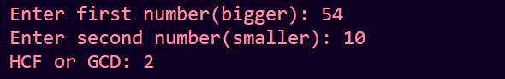

Program-9 Write a Program to find Largest and Smallest among ‘n’ numbers

import java.io.*;

class LargeSmol{

    public static void main(String args[]) throws IOException {

        BufferedReader br = new BufferedReader(new InputStreamReader(System.in));

        System.out.print("Enter how many numbers: ");

        int num = Integer.parseInt(br.readLine());

        int big = 0, smol = Integer.MAX_VALUE;

        do{

            System.out.print("Enter number: ");

            int n = Integer.parseInt(br.readLine());

            if(n > big) big = n;

            if(n < smol) smol = n;

        }while(--num > 0);

        System.out.println("Biggest Number: "+big);

        System.out.println("Smallest Number: "+smol);

    }

}

Output-

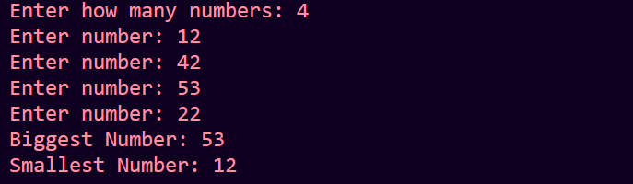

Program-10 Write a Program to find how many Negative, Positive, Zero numbers are there among ‘n’ numbers

import java.io.*;

class NegPosZero{

    public static void main(String args[]) throws IOException {

        BufferedReader br = new BufferedReader(new InputStreamReader(System.in));

        int pos = 0, neg = 0, zero = 0;

        System.out.println("Enter 5 Numbers: ");

        for(int i = 0; i<5; i++){

            System.out.println("Enter "+(i+1)+" number");

            int num = Integer.parseInt(br.readLine());

            if(num > 0) pos++;

            else if(num < 0) neg++;

            else zero++;

        }

        System.out.println("You have entered "+pos+" positive numbers");

        System.out.println("You have entered "+neg+" negative numbers");

        System.out.println("You have entered "+zero+" zeroes");

    }

}

Output-

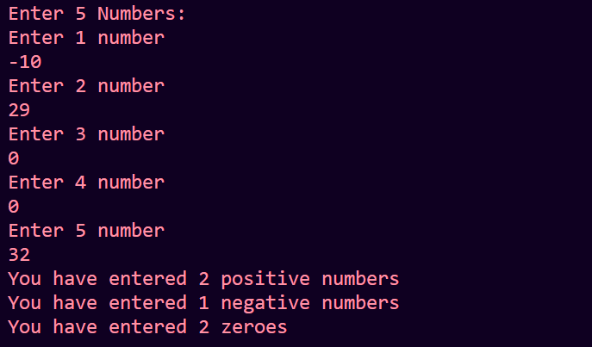

Program-11 Write a Program to input ‘n’ numbers and tell if they are Odd or Even

import java.io.*;

class OddEven{

    public static void main(String args[]) throws IOException {

        BufferedReader br = new BufferedReader(new InputStreamReader(System.in));

        System.out.print("Enter how many Numbers: ");

        int num = Integer.parseInt(br.readLine());

        //this is wrong as sopl returns void

        //int a = (num%2 == 0)? System.out.println("Even") : System.out.println("Odd");

        //valid, ternary opr is used to assign value and we can't use it without assigning

        //int a = (num%2 == 0)? 1 : 0;

        //System.out.println(a);

        while(num-- > 0){

            System.out.print("Enter number: ");

            int n = Integer.parseInt(br.readLine());

            if(n % 2 == 0) System.out.println("Even");

            else System.out.println("Odd");

        }

    }

}

Output-

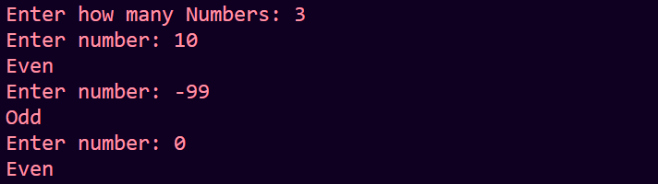

Program-12 Write a Program to print Increasing Star ‘*’ Pattern

import java.io.*;

class Pattern{

    public static void main(String[] args) throws IOException {

        BufferedReader br = new BufferedReader(new InputStreamReader(System.in));

        System.out.print("Enter a number: ");

        int num = Integer.parseInt(br.readLine());

        int i = 0;

        do{

            int j = 0;

            do{

                System.out.print("*");

                j++;

            }while(j<i+1);

            i++;

            System.out.println();

        }while(i<num);

    }

}

Output-

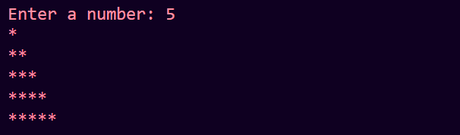

Program-13 Write a Program to Input Base and Exponent and print the generated number

import java.io.*;

class Power{

    public static void main(String args[])throws IOException {

        BufferedReader br = new BufferedReader(new InputStreamReader(System.in));

        System.out.print("Enter the Base: ");

        int base = Integer.parseInt(br.readLine());

        System.out.print("Enter the Exponent: ");

        int expo = Integer.parseInt(br.readLine());

        int answer = base;

        for(; expo>1; expo--){

            answer *= base;

        }

        System.out.print("Answer: "+answer);

    }

}

Output-

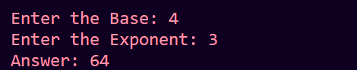

Program-14 Write a Program to print ‘n’ random numbers

import java.io.*;

import java.util.Random;

class RandomNums{

    public static void main(String args[]) throws IOException {

        BufferedReader br = new BufferedReader(new InputStreamReader(System.in));

        Random rand = new Random();

        System.out.print("Enter a how many Numbers: ");

        int n = Integer.parseInt(br.readLine());

        while(n-- > 0){

            System.out.println(rand.nextInt(5));

        }

    }

}

Output-

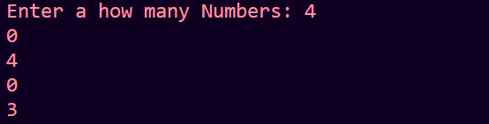

Program-15 Write a Program to input a number and reverse it

import java.io.*;

class Reverse{

    public static void main(String args[])throws IOException{

        BufferedReader br = new BufferedReader(new InputStreamReader(System.in));

        System.out.print("Enter a number to reverse: ");

        int num = Integer.parseInt(br.readLine());

        int ans = 0;

        int temp = num;

        do{

            int digit = temp % 10;

            ans *= 10;

            ans += digit;

            temp /= 10;

        }while(temp > 0);

        System.out.println("Reverse of "+num+ " is "+ans);

    }

}

Output-

