
STUDENT mANAGEMENT
SYSTEM
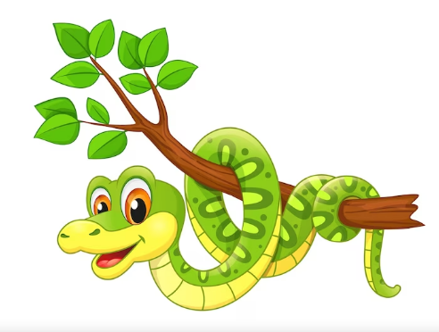



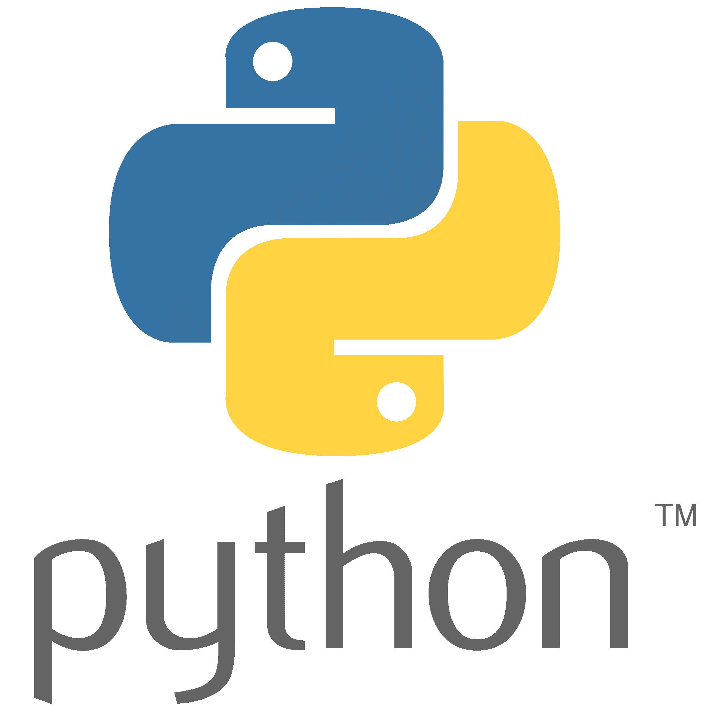

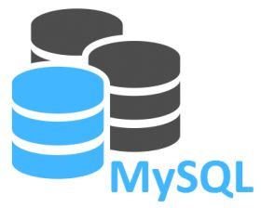




Certifcate
This is to certify that “STUDENT MANAGEMENT SYSTEM” Informatics Practcices project is developed by Priyanshu Kumar under my supervision in the computer lab of WALIA GLOBAL ACADEMY, NAJIBABAD in the session 2023-2024.

teacher sign Principal Sign
Acknowledgement
I would like to express my sincere gratitude to my computer teacher Mr. Vishesh Verma, for her vital support, guidance, and encouragement without which this project would not come forth from my side, who helped me completing the project by giving, ideas, thoughts and made this project easy and accurate.
We wish to thank my parents for their undivided support, and interest who inspired me and encouraged me to go my own way, without which I would be unable to complete my project.

