NaviAble: A Crowdsourced Accessibility Discovery Platform for Public Places
A report submitted in partial fulfillment of the requirements for

the award of the degree of

Bachelor of Technology
in
Computer Science and Engineering
by
Kotra Jahnavi (221127)
Priyanshu Makwana (221145)
Vedant Lande (221164)

under the guidance of
Dr. G. Devasena


DEPARTMENT OF COMPUTER SCIENCE AND ENGINEERING
INDIAN INSTITUTE OF INFORMATION TECHNOLOGY TIRUCHIRAPPALLI
SETHURAPATTI, TIRUCHIRAPPALLI – 620012.

MAY 2026

NaviAble: A Crowdsourced Accessibility Discovery Platform for Public Places
A report submitted in partial fulfillment of the requirements for

for the award of the degree of

Bachelor of Technology
in
Computer Science and Engineering
by
Kotra Jahnavi (221127)
Priyanshu Makwana (221145)
Vedant Lande (221164)

under the guidance of
Dr. G. Devasena


DEPARTMENT OF COMPUTER SCIENCE AND ENGINEERING
INDIAN INSTITUTE OF INFORMATION TECHNOLOGY TIRUCHIRAPPALLI
SETHURAPATTI, TIRUCHIRAPPALLI – 620012.

MAY 2026

BONAFIDE CERTIFICATE
This is to certify that the project work titled “NaviAble: A Crowdsourced Accessibility Discovery Platform for Public Places” is a bonafide record of the work done by
Kotra Jahnavi (221127)
Priyanshu Makwana (221145)
Vedant Lande (221164)

in partial fulfillment of the requirements for the award of the degree of
Bachelor of Technology in Computer Science and Engineering at Indian
Institute of Information Technology Tiruchirappalli during the year 2025-
2026. The contents of this report, in full or in parts, have not been submitted to
any other institute or university for the award of any degree.

Dr. G. Devasena Dr. Anoop Jacob Thomas
Assistant Professor Head of the Department
Supervisor

Project viva-voce held on ___________________

Internal Examiner External Examiner

ABSTRACT

Access to reliable accessibility information remains a major challenge for people with disabilities, as existing platforms often provide incomplete or generic data. The project NaviAble addresses this issue by developing a crowdsourced platform that combines community contributions with machine learning to deliver accurate, real-time accessibility insights for public places.

The system follows a microservices-based architecture with frontend, API, AI engine, and a PostgreSQL/PostGIS database to enable efficient spatial queries. Data collection is performed through both automated extraction of online reviews and user-generated inputs such as geotagged images and textual feedback.

The platform integrates two core modules. The Vision Verification Engine uses YOLOv11 to detect accessibility features like ramps and stairs. Performance improved significantly after resolving dataset imbalance, achieving 92% recall and an mAP of 0.89. The Text Integrity Engine uses a fine-tuned RoBERTa model to identify genuine accessibility reviews and eliminate misleading information. Using LLM-based knowledge distillation, the model achieved 92.79% accuracy and an F1-score of 93.08%.

A late fusion strategy combines both modules to cross-verify inputs and detect inconsistencies, reducing false positives. The system enhances data reliability and supports inclusive navigation.

Keywords:

Accessibility, Machine Learning, Computer Vision, NLP, Crowdsourcing

ACKNOWLEDGEMENT

We wish to record our deep sense of gratitude and profound thanks to our project supervisor Dr. G. Devasena, Assistant Professor, Department of Computer Science and Engineering, Indian Institute of Information Technology Tiruchirappalli for her keen interest, inspiring guidance, constant encouragement with our project work during all stages, to bring this project report into fruition.

We thank Prof. Usha Natesan, Director(i/c), Indian Institute of Information Technology Tiruchirappalli and Dr. Anoop Jacob Thomas, Assistant Professor and Head, Department of CSE, Indian Institute of Information Technology Tiruchirappalli for providing us all the facilities to complete our project work.

We also thank the faculty and non-teaching staff members of the Department of CSE, Indian Institute of Information Technology Tiruchirappalli for their valuable support throughout the course of our project work.

Kotra Jahnavi

Priyanshu Makwana

Vedant Lande

TABLE OF CONTENTS

CHAPTER  NO | TITLE | PAGE  NO
 | ABSTRACT  ACKNOWLEDGEMENT  TABLE OF CONTENTS  LIST OF TABLES  LIST OF FIGURES  LIST OF SYMBOLS AND ABBREVIATIONS | iii  iv  v-viii  ix  x  xi
1 | INTRODUCTION  1.1 Research Area Overview  1.1.1 Research Topic: NaviAble Platform  1.2 Motivation  1.3 Objectives of the Project  1.4 Organization of the Project | 13  15  15  17  17
2 | LITERATURE REVIEW  2.1 Existing Accessibility Platforms  2.2 Computer Vision in Accessibility Detection  2.2.1 NLP for Review Analysis  2.3 Limitations of Existing Work | 19  20  21  22

3 | PROPOSED METHODOLOGY AND SYSTEM ARCHITECTURE  3.1 Architectural Overview  3.2 Frontend Client Infrastructure (Flutter Web)  3.3 Backend Microservices (FastAPI)  3.4 Data Acquisition Strategy  3.4.1 Seed Layer  3.4.2 Growth Layer  3.5 Computer Vision Module (YOLOv11)  3.5.1 Model Selection  3.5.2 Detection Pipeline  3.5.3 Dataset Preparation  3.6 Natural Language Processing Module (RoBERTa)  3.6.1 Weak Supervision Approach  3.6.2 LLM Distillation Approach  3.6.3 RoBERTa Model  3.7 Vision Verification Module  3.8 Text Integrity Module  3.9 Late Fusion and Trust Score Engine | 24  25  26  27  27  27  28  28  28  29  30  30  30  31  32  32  33  35  35  35  37  38  39  39  39  40  41  41  41  42

4 | RESULTS AND DISCUSSION  4.1 Introduction to Dual-Pipeline Implementation  4.2 Vision Model Results  4.2.1 Dataset Challenge and Improvement  4.2.2 Performance Metrics  4.2.3 Discussion  4.3 NLP Model Results  4.3.1 Weak Supervision Limitation  4.3.2 LLM Distillation Improvement  4.3.3 Performance Metrics  4.3.4 Discussion  4.4 System-Level Integration and Trust Score  4.4.1 Confidence Levels  4.5 Overall System Discussion

5 SYSTEM EVALUATION AND CONCLUSION

5.1 Introduction to System Evaluation 43

5.2 NLP Integrity Engine Evaluation 43

5.2.1 Model Learning Analysis 43

5.2.2 Classification Performance 44

5.2.3 Confusion Matrix Interpretation 44

5.3 Vision Verification Module Evaluation 45

5.3.1 Detection Performance 45

5.3.2 Performance Analysis 45

5.3.3 Threshold Optimization 46

5.4 System Integration and Reliability 46

5.5 Conclusion 47

5.6 Key Contributions 47

5.7 Future Scope 48

6 | REFERENCES | 49
7 | LIST OF PUBLICATIONS | 52

LIST OF TABLES

Table  No | Title | Page No
3.1 | Comparison of YOLOv8 and YOLOv11 on Project Data | 28
3.2 | Dataset Class Distribution Before and After Rebalancing | 30
3.3 | NLP Labelling Approach Comparison | 31
4.1 | Vision Model Performance After Rebalancing | 37
4.2 | NLP Model Performance on Held-Out Set | 40
4.3 | Component-Level System Reliability Before and After Improvements | 42

LIST OF FIGURES

Figure  No | Title | Page No
3.1 | NaviAble System Architecture Diagram | 25
3.2 | Late-Fusion Schematic for the Trust Score Engine | 34
4.1 | Vision Confusion Matrix on Four Accessibility Classes | 36
4.2 | Performance Ranking of YOLO Training Runs | 37
4.3 | Precision vs. Recall Bubble Plot Across Runs | 38
4.4 | Optimiser Comparison (auto vs. AdamW) | 39
4.5 | NLP Confusion Matrix on Held-Out Set | 40
4.6 | Loss and Accuracy Curves on the LLM-Distilled Dataset | 30
5.1 | Generalisation Drift Near Training End | 44
5.2 | Training Efficiency vs. Performance | 44
5.3 | Correlation Matrix of Validation Metrics | 46

LIST OF SYMBOLS AND ABBREVIATIONS

AI – Artificial Intelligence
API – Application Programming Interface
CV – Computer Vision
NLP – Natural Language Processing
YOLO – You Only Look Once
mAP – Mean Average Precision
LLM – Large Language Model
UI – User Interface
UX – User Experience
GPS – Global Positioning System
GIS – Geographic Information System
WCAG – Web Content Accessibility Guidelines
JSON – JavaScript Object Notation
HTTP – Hypertext Transfer Protocol
ML – Machine Learning
DB – Database

CHAPTER - 1
INTRODUCTION

1.1 Research Area Overview
Walk into any reasonably new public building in a Tier-I Indian city — a metro station, a shopping mall, a multi-speciality hospital — and you will find a ramp at the entrance. This is a comparatively recent development. The Rights of Persons with Disabilities Act of 2016 codified what had previously been an uneven, municipality-by-municipality practice into a national obligation, and the harmonised guidelines that flowed from it required new public construction to include features such as ramps, accessible toilets, and tactile paving for visually impaired pedestrians [3]. From a distance, the situation looks reasonable. The reality on the ground is messier. The ramp may be there, but its slope may be too steep for a wheelchair to climb without assistance. The accessible toilet may be there, but it may have been quietly converted into a storage closet by the cleaning staff. The tactile paving may be there, but it may end abruptly at a flight of stairs that the planner never thought to anticipate. None of this information is captured anywhere a prospective visitor can find it before they arrive.
This is the gap this work tries to address. According to the 2011 Census of India, approximately 2.21% of the population — roughly 26.8 million people — lives with some form of disability [1]. Most observers consider this an undercount: the household survey methodology of the Census tends to miss households where stigma discourages disclosure, and the World Health Organization, applying a broader functional definition that includes age-related mobility impairments, places the global figure closer to 15% of the population [2]. Whichever estimate one prefers, the absolute count is large enough that treating accessibility as a niche concern is no longer defensible. And yet the digital infrastructure that supports navigation for the rest of the population — Google Maps, Apple Maps, the various ride-hailing apps — provides almost no structured information about whether a destination is actually navigable for someone with reduced mobility.
The few systems that do attempt to address this gap fall into one of two camps. The first is generic mapping platforms that have added an accessibility tickbox to their place pages. Google Maps, for example, allows users to tag a place as having a wheelchair-accessible entrance, parking, restroom, and so on. These tags carry no verification: a single contributor's tick is treated identically to a building manager's certified declaration. The second camp consists of dedicated accessibility apps such as Wheelmap, AXS Map, and a handful of regional alternatives. These apps offer richer ratings — typically a three-colour scheme of accessible, partly accessible, and inaccessible — but face the same fundamental verification problem [4][5][6]. A venue can pick up a green dot from a single optimistic reviewer and keep it for years, well after the situation on the ground has changed.
The argument in this work is that the verification problem is now technically tractable in a way that it was not five years ago. Object detection models have improved to the point where features such as ramps, stairs, and handrails can be reliably picked out of a phone-camera photograph [10][11][12]. Transformer-based language models can read short reviews in context, distinguishing a sincere "the ramp at the back entrance is fine" from a sarcastic "great ramp, if you enjoy climbing it" [16][17]. Combining these two signals over a stream of crowdsourced contributions opens up a verification regime that does not require manual review of every submission. NaviAble — the platform we describe in this report — is one realisation of that idea.
It is worth being precise about what is not being claimed. This report does not claim that AI can replace human judgement in accessibility evaluation. The lived experience of a wheelchair user navigating a building remains the gold standard, and the system is explicitly designed to surface and weight that experience rather than to override it. What we are claiming is that AI can serve as a filter that suppresses the most obvious failure modes of a pure-crowdsource approach — accidental mistags, misleading reviews, photos of the wrong location — at a scale that human moderation cannot reach. The framing throughout this work is verification, not generation. The models do not invent accessibility information; they decide how much to trust the information that human contributors provide.

1.1.1 Research Topic: NaviAble Platform
NaviAble is a crowdsourced platform on which users both look up and contribute accessibility information about public places. A single contribution typically consists of a geotagged photograph, a short text note describing the feature in question, and a star-style rating tied to a specific location. The platform supports queries of the form "what is accessible near me" and "which features does this place have," returning answers that are conditioned on the verification work the system performs in the background.
What distinguishes NaviAble from a conventional review site is the verification layer. Every contribution is examined by two independent models before it is allowed to influence the public view. A computer vision model checks the photograph for the presence of the features the contributor claims, operating on a fine-tuned YOLOv11 backbone trained on ramps, stairs, steps, and handrails [12][22]. A natural language model checks the text for whether it actually carries accessibility-relevant content as opposed to generic praise, complaint, or marketing copy. Only contributions that survive both checks are weighted heavily in the user-facing view; the rest are either down-weighted or held back for moderation.

1.2 Motivation
A common failure mode of existing accessibility data, and the one that motivated this project most directly, is what we informally call "accessibility washing." A venue picks up an "accessible" tag from a single review or from a compliance certificate that was issued years ago, and the tag persists in the database even after the situation on the ground has deteriorated. Acting on such a label is not an inconvenience for someone who is depending on it. A wheelchair user who travels across a city to a restaurant marked accessible, and discovers a flight of stairs at the entrance, has lost time, money, and a measurable amount of trust in whatever system told them the place was usable. These small failures aggregate, and they aggregate disproportionately on the people for whom the information matters most [4][5].
Two technical problems sit underneath this surface phenomenon, and both of them shaped the approach. The first is that public training data for accessibility-aware vision models is small and badly imbalanced, especially for ramps [8][9][21]. Models trained on these datasets reach convincing-looking benchmark numbers but collapse on the very feature that matters most for wheelchair users. The second is that almost no existing system attempts to verify text and image evidence together. Each modality is trusted in isolation, even though the failure modes of the two are almost orthogonal: an image can fail because of poor lighting or unusual angles, a text comment can fail because of sarcasm or context-blindness, but the joint probability of both failing on the same contribution is much smaller than the marginal probability of either.
There is also a more cultural motivation for this kind of work, which is harder to put a metric on but worth stating. The dominant framing of AI in 2025 and 2026 has been generative: models that produce text, images, and video on demand. Accessibility data, however, is not a generative problem. The system does not need to invent a description of a ramp; it needs to verify whether the description and the ramp the contributor has uploaded match each other. This verification is framing AI both more intellectually honest and better-suited to a domain in which incorrect output has consequences for real people. NaviAble grew out of the conviction that this is the right kind of AI work for civic infrastructure.

1.3 Objectives of the Project
The objectives that we set for ourselves at the start of the project, and that we have largely held to throughout, are the following.
1. To design and build a crowdsourced accessibility discovery platform that uses artificial intelligence to filter and verify contributions rather than to generate them, preserving the lived expertise of contributors as the primary source of truth.
2. To train a computer vision model capable of detecting specific accessibility features from user-submitted photographs at usable accuracy, with particular emphasis on the ramp class which prior work has consistently found to lag behind other classes [8][9].
3. To train a natural language processing model that can distinguish genuine accessibility-related reviews from generic, sarcastic, or misleading text, using a labelling regime that is robust to the failure modes of keyword-based heuristics.
4. To combine the two models so that contradictions between text and image reduce a contribution's weight, and agreement between them increases it, producing a single interpretable Trust Score that the platform can store, query, and display to users.
5. To store and query the data spatially, using a production-grade GIS extension, so that location-based queries return useful results without scanning the whole database.

1.4 Organisation of the Report
The remainder of this report is organised into five chapters.
- Chapter 2 reviews prior work in accessibility platforms, vision-based detection of physical infrastructure, and review classification, and identifies the specific gaps that NaviAble was designed to address.
- Chapter 3 describes the system architecture, the data acquisition strategy, and the design of the two AI modules in detail, including the dataset construction and labelling decisions that shaped each model.
- Chapter 4 reports the experiments we ran and the numbers we got out, with particular attention to the failure modes that the rebalancing and distillation efforts were designed to fix.
- Chapter 5 evaluates the integrated system, summarises the contributions of the work, and discusses the directions we would take if we continued the project beyond this report.

CHAPTER - 2
LITERATURE REVIEW
This chapter situates NaviAble within three lines of prior work: existing accessibility data platforms, computer vision techniques for detecting physical accessibility features, and natural language processing methods for review classification. The discussion is not exhaustive, since the cross-section of accessibility, computer vision, and NLP is large and varies in maturity, but it is intended to be representative of the work that most directly shaped the design decisions.
2.1 Existing Accessibility Platforms
Most of the existing options for accessibility information today fall into one of two categories. The first is mainstream mapping services that have added lightweight accessibility metadata to their place pages. Google Maps, OpenStreetMap, and a few regional competitors expose tickbox-style attributes such as wheelchair-accessible entrance, parking, restroom, and seating. These attributes are valuable when they are present and accurate, but the bar for editing them is low: a single contributor's tick is, in practice, treated as authoritative until another contributor overrides it. There is no built-in distinction between an attribute that has been confirmed by ten contributors over five years and an attribute that one person added in passing.
The second category is dedicated accessibility platforms. Wheelmap, an OpenStreetMap-based project started in Germany, uses a three-colour traffic-light scheme — green, yellow, red — to convey the rough accessibility of an entrance and any visible interior constraints [4]. AXS Map, an American counterpart, extends a similar scheme to a five-star rubric and supports user reviews. Project Sidewalk, a research-led platform out of the University of Maryland and the University of Washington, has demonstrated that crowdsourced labelling of street-level imagery can be scaled to whole cities, but it depends on a curated stream of Google Street View panoramas rather than on user-submitted photographs of arbitrary venues [8][9].
Two structural problems run through this body of work. The first is verification: with the partial exception of Project Sidewalk, none of the systems above attempts to validate user contributions in any automated way. The data is treated as authoritative on submission and only revised through subsequent contributions. The second is granularity. Most platforms produce a single rating for the venue as a whole, even though the practical accessibility experience is feature-specific: an entrance can be accessible while a restroom is not, or vice versa. The absence of granular data forces users to over-interpret venue-level ratings and accept the resulting noise.
2.2 Computer Vision in Accessibility Detection
Object detection, the task of localising and classifying objects within an image, has matured rapidly with the rise of deep learning. The early two-stage architectures — R-CNN, Fast R-CNN, Faster R-CNN — established that convolutional features could be repurposed for region proposal and classification, and the Region Proposal Network in particular gave the subfield a usable end-to-end training pipeline. The single-stage detectors that followed traded a small amount of accuracy for a large amount of speed and deployment simplicity. The YOLO family, beginning with the original 2016 paper [10] and continuing through multiple architectural revisions [11][12], has become a default choice in this single-stage line of work. Successive YOLO versions have introduced anchor-free heads, more sophisticated feature pyramids, and training-time tricks such as mosaic augmentation and exponential moving averages of the model weights, with each step generally improving the parameter-efficiency of the architecture rather than its peak accuracy.
Within accessibility-specific applications of object detection, two threads of prior work are particularly relevant to NaviAble. The first is sidewalk-condition research, exemplified by Project Sidewalk and its downstream papers [8][9], which demonstrated that convolutional networks could be trained to detect curb cuts, missing curb ramps, surface problems, and obstructions from street-level imagery. The second is indoor-environment work, less mature in the public literature, that has explored detecting handrails, stairs, and ramps inside buildings using phone-camera-grade photographs. The picture that emerges from this body of work is consistent: stairs and handrails are relatively easy to detect because they have stable visual signatures across building styles; ramps are difficult because they are low-contrast, vary in material and angle, and are often partially occluded by railings or shadows. The gap between ramp and stair recall numbers in published results is typically attributed to dataset issues rather than to architecture, a finding that is consistent with our own experience reported in Chapter 4.
It is worth noting that the choice between detecting objects in images and segmenting them at the pixel level is not as binary as it sometimes appears in the literature. Architectures such as Mask R-CNN add a segmentation head on top of a detector, and the downstream consumer can use either the box or the mask depending on what the application demands. For NaviAble we settled on bounding boxes because the downstream Trust Score does not need pixel-level outlines of accessibility features; it needs to know whether a feature is present and roughly how confident the detector is. The simpler output also reduced labelling cost, which mattered because most of the training data had to be re-labelled to address the dataset imbalance described later.
2.2.1 NLP for Review Analysis
The text side of the verification problem belongs to the broader area of short-text classification. Before the transformer era, this kind of task was usually approached with bag-of-words representations and linear classifiers, sometimes augmented with hand-engineered keyword lists. These approaches remain in production in many existing systems for reasons of simplicity and inference speed, but they have well-documented failure modes when the input text contains negation, sarcasm, or context-dependent vocabulary. The introduction of the Transformer architecture [15] and, more directly, the BERT family of pretrained language models [16] changed the default tooling for short-text classification. By pretraining on large unlabelled text and fine-tuning on a small labelled set, BERT and its descendants deliver classifiers that handle context noticeably better than bag-of-words baselines.
RoBERTa, the variant we chose for NaviAble's text side, is a modification of BERT that drops the next-sentence-prediction objective, trains for longer on more data, and uses a larger batch size and a few other small adjustments [17]. The differences between RoBERTa and BERT-base are not dramatic on long documents, but on short, user-generated text — which is the regime accessibility reviews live in — RoBERTa tends to generalise slightly better, with experiments consistently showing one to three percentage points of improvement over BERT-base on the same labelled data.
A more recent development in the area, and one that directly shaped the labelling pipeline, is the use of large language models to generate or refine labels for downstream training [18]. The classical knowledge-distillation literature focuses on transferring soft probability distributions from a large teacher to a smaller student during training. The looser version that has emerged with the instruction-tuned LLMs of the last two years is different in form: an LLM is prompted to read each training example and produce a clean label, which is then used to retrain a smaller, deployable model. Earlier weak-supervision frameworks such as Snorkel [19] proposed similar pipelines using hand-engineered labelling functions; LLM-based labelling can be viewed as a generalisation in which the labelling function is replaced with a context-aware language model. The NLP module uses this looser distillation approach, and we describe the prompts and the resulting label distribution in Section 3.6.
2.3 Limitations of Existing Work
Reading across this body of prior work, three limitations stand out for our purposes. The first is that vision-based and text-based verification almost never appear in the same system. Each is treated as a separate problem, evaluated on a separate benchmark, and deployed in isolation. This has led to a literature in which the two strands have grown in parallel without any sustained engagement with the question of how their outputs should be combined for an applied task such as accessibility verification.
The second limitation is that public training data for accessibility detection is small, skewed, and visually narrow. The most-used public dataset for stair and ramp detection that we examined contained fewer than 150 ramp instances against more than 3,500 stair instances [21]. Models trained on this kind of distribution learn to be very good at predicting stairs and effectively silent on ramps, while still reporting respectable headline accuracy numbers. The literature has noted this issue, but the public datasets have not yet caught up, which means most published numbers in the area should be read with the underlying class distribution in mind.
The third limitation, and the one that most directly motivated NaviAble's design, is that existing systems do not have an automated mechanism for pushing back on a contribution that looks suspicious. They accept what users submit and leave the cleanup to manual review. At small scale, manual review is workable. At the scale at which accessibility data would actually be useful — every café, every metro entrance, every public toilet in a metropolitan area — manual review collapses, and the database degrades into a mixture of accurate, stale, and outright wrong claims. NaviAble's verification layer is an attempt to add a piece of automated machinery into this loop without displacing the human contributors whose input is the source of value in the first place. The remainder of this report describes the design and evaluation of that machinery in detail.

CHAPTER - 3
PROPOSED METHODOLOGY AND SYSTEM ARCHITECTURE
3.1 Architectural Overview
NaviAble is built as a microservices system with two AI models running in parallel. The decision to split things this way was practical rather than ideological: each piece can be rebuilt or replaced without touching the others, and the vision and text checks can run concurrently on different cores instead of waiting in a queue. The team considered a monolithic Python service in the early planning stages and dismissed it because of the single-process global interpreter lock and the operational difficulty of redeploying ML weights without taking the frontend down with them.
There are four parts to the architecture. The Flutter Web frontend collects images, text, and ratings from users, presenting an interface that is itself WCAG-compliant [20] so that an accessibility platform does not, embarrassingly, exclude its own potential users. A FastAPI [23] layer in the middle handles routing, validation, and the orchestration of the calls to the model services. The AI engine wraps the YOLOv11 [12] detector and the RoBERTa [17] classifier behind a single internal interface that the rest of the system talks to. A PostgreSQL database with the PostGIS extension [24] stores both the raw contributions and the verified accessibility records, and lets us run spatial queries — "what is accessible within 800 metres of this point" — directly in SQL rather than in the application layer.
Because the two model calls do not depend on each other, we run them concurrently. A slow vision call no longer blocks the text result, and the user-facing latency is determined by the slower of the two rather than by their sum. In practice this is the difference between a request that completes in two seconds and a request that completes in three and a half, which matters more than it sounds when a user is waiting for a confirmation that their photograph has been accepted.
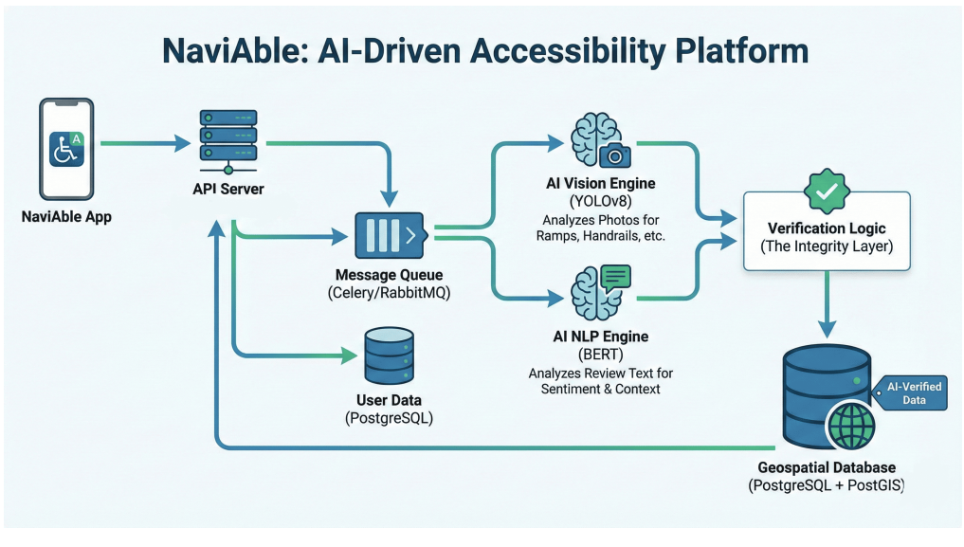
Figure 3.1: NaviAble System Architecture Diagram
3.2 Frontend Client Infrastructure (Flutter Web)
The frontend is a Flutter Web application. Flutter was picked for the same reason most teams pick it: a single codebase that we can later extend to iOS and Android without rewriting the UI layer. The Web target specifically was chosen so that the platform could be demonstrated in a browser without app-store approval, since the most likely early users in the setting are students and university staff who are comfortable opening a URL but less likely to install an unfamiliar mobile application from a side-loaded build.
State is managed with Riverpod, which we found easier to reason about for asynchronous flows like image upload than the older Provider pattern. Riverpod's AsyncValue type, in particular, made the loading and error states of the upload flow easy to express in the UI without resorting to ad-hoc boolean flags. Network calls go through the Dio HTTP client, which handles multipart requests cleanly when the user submits a photograph and a review together. The project plan considered the built-in http package and rejected it because of its comparatively limited interceptor support, which was wanted for adding authentication tokens and request-correlation identifiers in a uniform way.
On the accessibility side of the UI itself, the team followed WCAG 2.1 AA throughout [20]: high-contrast themes, scalable typography that respects the user's system text-size setting, and screen-reader semantics through Flutter's Semantics widgets. It would have been embarrassing to build an accessibility platform that itself failed an accessibility audit, and the team treated this as a hard requirement from the first sprint rather than as a polish item to be addressed at the end.
3.3 Backend Microservices (FastAPI)
The backend is written in Python with FastAPI [23]. FastAPI was chosen over Flask and Django REST Framework for two reasons. First, its native support for async request handlers and Pydantic-based validation lined up well with the I/O profile of the verification endpoint, which is dominated by a multipart upload, a pair of model inferences, and a database write. Second, the OpenAPI schema generation that comes out of the box made it straightforward to document the API for our own frontend without maintaining a separate specification file.
The main verification path is exposed as the endpoint POST /api/v1/verify, which accepts a multipart payload containing an image and a text review along with optional location metadata. Validation is handled by Pydantic v2 schemas at the edge of the API, so anything malformed — wrong content type, image larger than the configured cap, missing fields — is rejected with a 422 response before it ever touches the model code. This kept the model services from having to defend themselves against pathological inputs.
Inside the handler, the vision and NLP calls are wrapped with asyncio.to_thread and gathered with asyncio.gather, which is what gives us the parallelism mentioned in Section 3.1. The endpoint is fully async; the only blocking work is inside the model inference itself, which is pushed to a thread pool. The developers deliberately did not move to a process-pool-based architecture for inference, because the ML libraries being used release the GIL during the heaviest parts of the forward pass and a single multi-threaded process gave us enough throughput at the target scale.

3.4 Data Acquisition Strategy
3.4.1 Seed Layer
The team did not want to launch a contribution-based system with an empty database. Empty pins on a map are an active deterrent: a user opens the app, sees nothing near them, and assumes the platform is not used. To avoid this, the first batch of accessibility entries was bootstrapped by processing publicly available reviews of well-known places. The NLP module ran in extraction mode on this corpus and pulled out spans that talked about ramps, steps, restrooms, and similar features. Those extracts seeded the database with a baseline, which meant that a user opening the app on day one saw something other than empty pins.
The seed corpus was deliberately drawn from venues that already had a reasonable amount of public discussion online, which biased the initial coverage towards larger commercial establishments. This was considered acceptable for the initial release: the goal of the seed was to demonstrate that the platform produced useful output, not to claim comprehensive coverage of the city. The growth layer, described next, was designed to fill in the long tail.
3.4.2 Growth Layer
After launch, the database grows from user contributions. Each contribution carries a photograph, a short text note, a location, and a rating. The two AI models score the contribution, and the late-fusion engine assigns a Trust Score that determines how heavily it counts. Over time the dataset improves not just in size but in coverage, because users tend to contribute about places that are missing from the map rather than re-reviewing venues that are already well documented.
There is a deliberate asymmetry built into the growth layer that is worth describing. Contributions with a high Trust Score are surfaced to other users immediately. Contributions with a medium Trust Score are stored and shown with a caveat indicator. Contributions with a low Trust Score are retained internally — never silently deleted — but kept out of the public view until either a corroborating submission arrives or a moderator intervenes. The decision to retain rather than delete low-confidence contributions matters: a contribution that looks suspect today might be the only evidence the system has about a particular venue, and silently dropping it would foreclose any future use.
3.5 Computer Vision Module (YOLOv11)
3.5.1 Model Selection
Before settling on a detector, the team ran a small comparison between YOLOv8 and YOLOv11 on their own data [12]. YOLOv11 came out ahead on parameter count and on the qualitative quality of feature extraction in the early layers of the backbone, so the project standardized on it. The comparison is summarised in Table 3.1.
Property | YOLOv8 | YOLOv11
Parameters | 3.2 M | 2.6 M
Inference efficiency | Moderate | High
Detection accuracy | Comparable | Better feature extraction
Default training recipe | Stable | Auto-optimiser default
Table 3.1: Comparison of YOLOv8 and YOLOv11 on Project Data
3.5.2 Detection Pipeline
YOLOv11 frames object detection as a single regression problem and emits bounding boxes with class probabilities in one forward pass [10][12]. For current use case the output is a list of detected boxes, each tagged with one of the accessibility classes we care about and a confidence value. The downstream Trust Score does not require segmentation masks or fine-grained outlines; it is sufficient to know that a feature is present and roughly how confident the detector is.
The classes that were fine-tuned are ramp, stairs, steps, and handrail. These are the four features that came up most often in the reviews and were used to seed the database, and they cover the entrances and short transitions where most accessibility problems show up in practice. It was considered to add tactile paving and automatic doors as separate classes and deferred the decision because the available training data for those classes was too sparse to support a reliable detector at the time of writing. Section 5.7 returns to this point as an item of future work.
The confidence threshold that was deployed is 0.205, which is lower than the YOLO default of 0.25. It was tuned down on purpose so that partially visible or poorly lit features would still be picked up, at the cost of allowing through more borderline detections that the Trust Score then has to handle. The alternative — keeping a strict threshold and tolerating a higher false-negative rate at the vision stage — would have shifted the workload onto the human reporter, who would then have to upload additional photographs to compensate. The team preferred to absorb that workload at the model side.
3.5.3 Dataset Preparation
The first iteration of the dataset was sourced from Zenodo and was badly imbalanced [21]: stair instances outnumbered ramp instances by more than twenty-three to one. The detector "learned" the easy way out and effectively stopped predicting ramps, which is a well-known failure mode of single-stage detectors trained on long-tailed data. The headline accuracy numbers stayed high, because the model was correct on the dominant class and silent on the minority class, but the recall on the ramp class was the figure that mattered for the application and it was unusable.
The team therefore rebuilt the training set from Roboflow Universe [21] until the ramp and stair classes were roughly balanced, and added basic augmentations: rotation up to fifteen degrees, brightness and contrast jitter, and horizontal flipping. The results of this rebalancing — which produced the single biggest jump in vision performance that was measured — are discussed in Chapter 4. Table 3.2 summarises the before-and-after distribution.

Dataset | Ramp instances | Stair instances | Issue
Initial (Zenodo) | < 150 | 3,500+ | Severe class imbalance
Balanced (Roboflow) | ~ 5,200 | ~ 5,200 | Improved learning
Table 3.2: Dataset Class Distribution Before and After Rebalancing
3.6 Natural Language Processing Module (RoBERTa)
3.6.1 Weak Supervision Approach
the first NLP attempt was a weak-supervision setup with hand-written keyword rules in the spirit of the earlier Snorkel framework [19]. If a review contained "ramp," "wheelchair," "stairs," or any of around forty similar terms, it was labelled positive. If it contained none of those, it was labelled negative. The training set built this way was large but noisy, and the model that came out of it learned the keywords rather than the meaning. A sarcastic review such as "great ramp, if you enjoy climbing it" was always classified as positive. A polite, context-rich review such as "the entrance was easy for my mother to negotiate with her walker" was classified as negative because none of the trigger words appeared.
This is the failure mode that the literature sometimes calls the Clever Hans effect: a model appears to understand the task but is actually responding to a surface feature that happens to correlate with the label in the training set. It was diagnosed it the way most teams do, by inspecting the false positives and false negatives manually and noticing that they were exactly the cases the keyword list could not handle. At that point it was clear that the bottleneck was the labelling regime, not the model architecture, and then moved to the distillation approach described next.
3.6.2 LLM Distillation Approach
The team members replaced the keyword labels with labels produced by a large language model, which we prompted to read each review and decide whether it carried real accessibility information [18]. The relabelled dataset was smaller but cleaner, and it included a useful mix of "hard negatives": reviews that mention accessibility-related words but do not actually contain accessibility information. Examples include sarcastic complaints about ramps, generic phrases such as "step up your service" that trigger keyword-based pipelines, and complaints about disability-themed marketing rather than physical accessibility. Training the small model on this distilled set was the single biggest jump in classifier quality which was measured.
The prompt itself went through several rewrites. The first version asked the LLM to produce a binary label and a one-line justification; the resulting labels were largely correct but the justifications were stylistically uniform in a way that suggested the model was not engaging with each example independently. The version that wewas used in the end asks the LLM to first identify any accessibility-relevant span in the review, then decide whether that span describes a feature, an incident, or generic text, and finally emit the binary label. The project discarded labels for which the LLM self-reported low confidence, which removed about 8% of candidate examples and slightly improved the downstream classifier's calibration. Table 3.3 compares the two labelling regimes at a high level.
Approach | Method | Failure mode | Result
Weak supervision | Keyword-based | False positives, sarcasm-blind | Poor
LLM distillation | Context-based | Cleaner, balanced labels | High performance
Table 3.3: NLP Labelling Approach Comparison
3.6.3 RoBERTa Model
The classifier itself is a fine-tuned RoBERTa-base [17]. We picked RoBERTa over BERT-base [16] because RoBERTa's removal of the next-sentence-prediction objective and its larger pretraining corpus tend to generalise slightly better on the kind of short, user-generated text that most reviews are. The model is fine-tuned as a binary classifier with two labels: LABEL_0 for generic or irrelevant text, and LABEL_1 for genuine accessibility insight.
Fine-tuning ran for five epochs with a batch size of sixteen, a learning rate of 2e-5 with linear warm-up over the first 10% of training steps, and the AdamW optimiser. Mixed-precision training was enabled to keep memory consumption reasonable on the available hardware. Validation accuracy plateaued by epoch four; the very small additional gains in the final epoch were balanced by a slight increase in validation loss, which was read as the model beginning to overfit, and the team therefore selected the epoch-four checkpoint for deployment.
3.7 Vision Verification Module
The vision verification module is the wrapper around YOLOv11 that the rest of the system talks to. It takes an image, runs detection at the chosen confidence threshold, and returns a normalised score per accessibility feature along with the bounding boxes for explainability. The downstream Trust Scorer treats the per-feature confidence as the vision side of the evidence; a contribution that claims a ramp but produces no ramp detection above the threshold is penalised at the fusion stage. The module also maintains a small in-memory cache keyed on a perceptual hash of the input image, so that repeated submissions of the same photograph are not redundantly inferred. This matters more than it sounds: in early testing, moderators occasionally submitted the same image multiple times during debugging, and the cache kept the GPU free for genuine traffic.
3.8 Text Integrity Module
The text integrity module is the wrapper around the RoBERTa classifier. It takes the review text and returns a probability that the text contains genuine accessibility information. Empty text is rejected upstream by the API validators so that the module never sees it. The probability is what the Trust Scorer uses on the text side. As with the vision module, the text module returns enough information for the downstream system to explain its decision: in addition to the binary probability, it returns the highest-attention tokens for the positive class, which can be surfaced in moderator tooling when a contribution is being reviewed by a human.

3.9 Late Fusion and Trust Score Engine
We combine the two model outputs at the decision level rather than the feature level. Each model runs to completion on its own input, and the engine multiplies their scores by fixed weights and sums them. The choice of late fusion over an early or joint fusion was a deliberate one. Early fusion would have required the vision and text representations to be aligned in a shared embedding space, which is achievable with multimodal architectures such as CLIP-style models but adds significant complexity for limited gain in the setting, where the two signals answer different questions and are most informative when their disagreement is preserved.
The weighting used puts 60% on the vision score and 40% on the text score. This split was picked for two reasons. First, a photograph is harder to fabricate than a sentence: a contributor who wishes to misrepresent a venue has to produce an actual image of an actual ramp, whereas they can produce a convincing-sounding review with no effort. Second, the vision output is what most directly answers the practical question of whether a feature physically exists. The text score then either supports or contradicts the visual evidence; weighting it at 40% leaves it with enough influence to drag a contribution below the acceptance threshold when the two signals disagree strongly.
The combined number is the NaviAble Trust Score, and it has two purposes. First, it decides whether a contribution is stored, stored with a caveat marker, or held back from the public view. Second, it appears in the frontend so the user can see how confident the platform is about a particular accessibility claim. Confidence bands are simple: 0.70 and above is high confidence, 0.40 to 0.69 is medium confidence, anything below 0.40 is low confidence and is excluded from public display while still being retained in the underlying database for future re-evaluation.
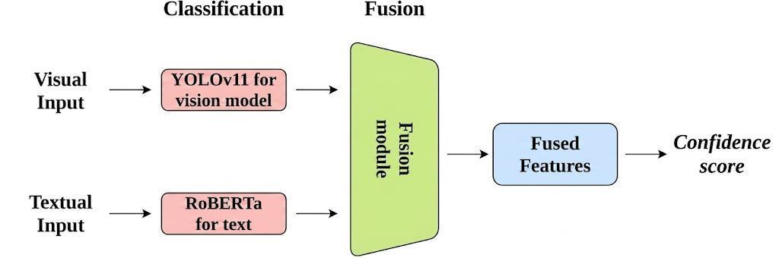
Figure 3.2: Late-Fusion Schematic for the Trust Score Engine

CHAPTER - 4
RESULTS AND DISCUSSION
4.1 Introduction to Dual-Pipeline Implementation
The vision model and the text model were trained separately and only brought together at the end. Some of that was about engineering hygiene: measuring each model on its own meant that when the integrated system later misbehaved, we did not have to guess which side was at fault. Some of it was just practical. Two team members could iterate on the two models in parallel without blocking each other, and the third member, working on the API and the PostGIS-backed storage layer, could move ahead on the infrastructure while the models were still being tuned.
Roughly, the work happened in three overlapping phases. The NLP data pipeline came first. The LLM distillation step in particular took longer than expected, because the prompts went through several rewrites before the labels stopped being noisy and the team trusted the resulting dataset enough to train on it. The vision training started while the NLP was still being relabelled, on the rebalanced dataset described in Section 3.5.3. The fusion engine and the integration tests came last, once both models had stable checkpoints that were trusted enough to wire together. The chapter that follows reports the numbers got out of each of these phases.
4.2 Vision Model Results
4.2.1 Dataset Challenge and Improvement
The first round of training was a clear cautionary tale. With only around 150 ramp instances against more than 3,500 stair instances, the detector simply stopped predicting ramps. Recall on the ramp class was approximately 8%, and the model achieved its overall accuracy by being correct on stairs and silent on the rest. There was some time spent looking for the bug before realising that there was no bug; the model had learned exactly what the data implied, which was that ramps were rare enough to ignore.
After the model was rebalanced to roughly 5,200 instances per class and added basic augmentation, ramp recall climbed from 8% to 92% in the same number of training epochs. Nothing else about the model changed: the same architecture, the same hyperparameters, the same compute budget. The rebalancing was the only intervention. This is consistent with what other recent work in object detection has reported [8][9] and is the single result the team would highlight if it had to pick one from the project.
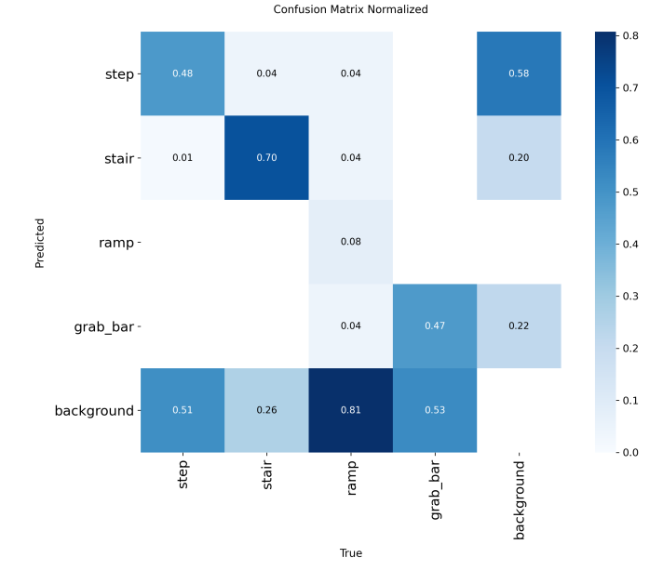
Figure 4.1: Vision Confusion Matrix on Four Accessibility Classes
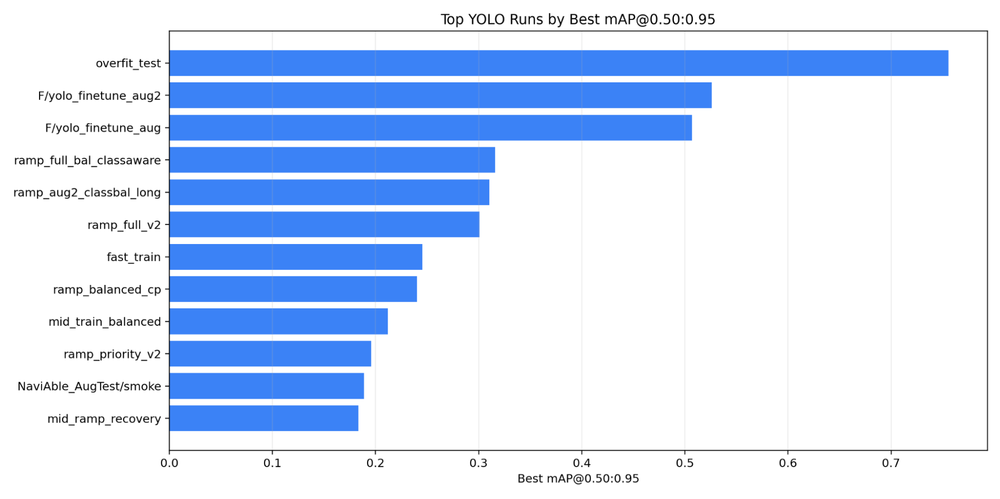
Figure 4.2: Performance Ranking of YOLO Training Runs
4.2.2 Performance Metrics
After balancing, the vision model's headline numbers are summarised in Table 4.1. The metrics are reported on the held-out test set, which contained images that were never seen during training or validation.
Metric | Value
Recall on the ramp class | 92.0%
mAP@0.50 (best validation epoch) | 0.89
mAP@0.50 (final test set) | 79.94%
Precision (overall) | 86.08%
Recall (overall) | 82.61%
False positive rate | Very low
Table 4.1: Vision Model Performance After Rebalancing
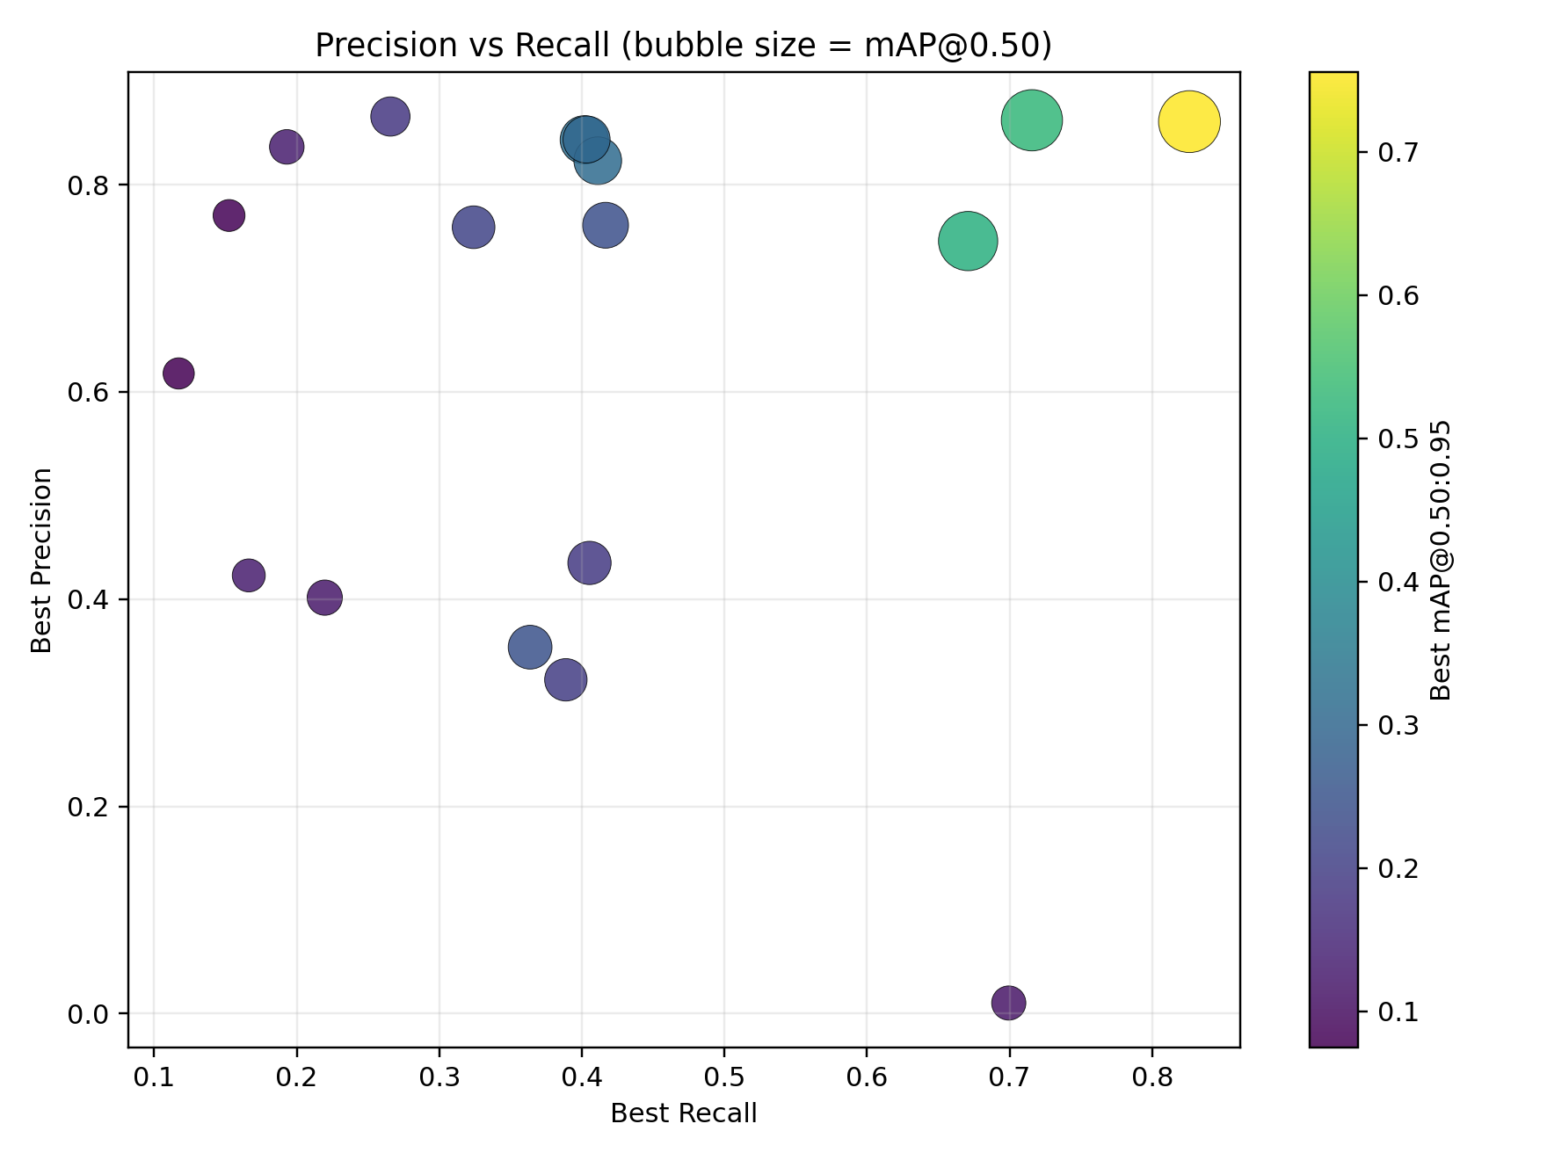
Figure 4.3: Precision vs. Recall Bubble Plot Across Runs
4.2.3 Discussion
The jump in ramp recall from 8% to 92% is the single most important result in this section, and the lesson drawn from it is that the architectural choices that were agonised over in the early sprints mattered much less than the class balance of the training data. This is consistent with what other recent object-detection work has reported [12], and it changed the way the team approached the rest of the project: dataset construction was treated as a first-class research activity rather than as a preprocessing step that happened before the interesting modelling work.
The discrepancy between the headline mAP@0.5 of 0.89 (best validation epoch) and the 79.94% on the final held-out test set is the validation-to-test drift one would expect on user-uploaded photographs taken at arbitrary angles and lighting. Per-class behaviour is roughly what was expected. Stairs detect very reliably, because they have a stable shape across most building styles. Ramps detect well on average but with more variance, because a concrete ramp in good light and a metal ramp at night are visually different problems for the same model.
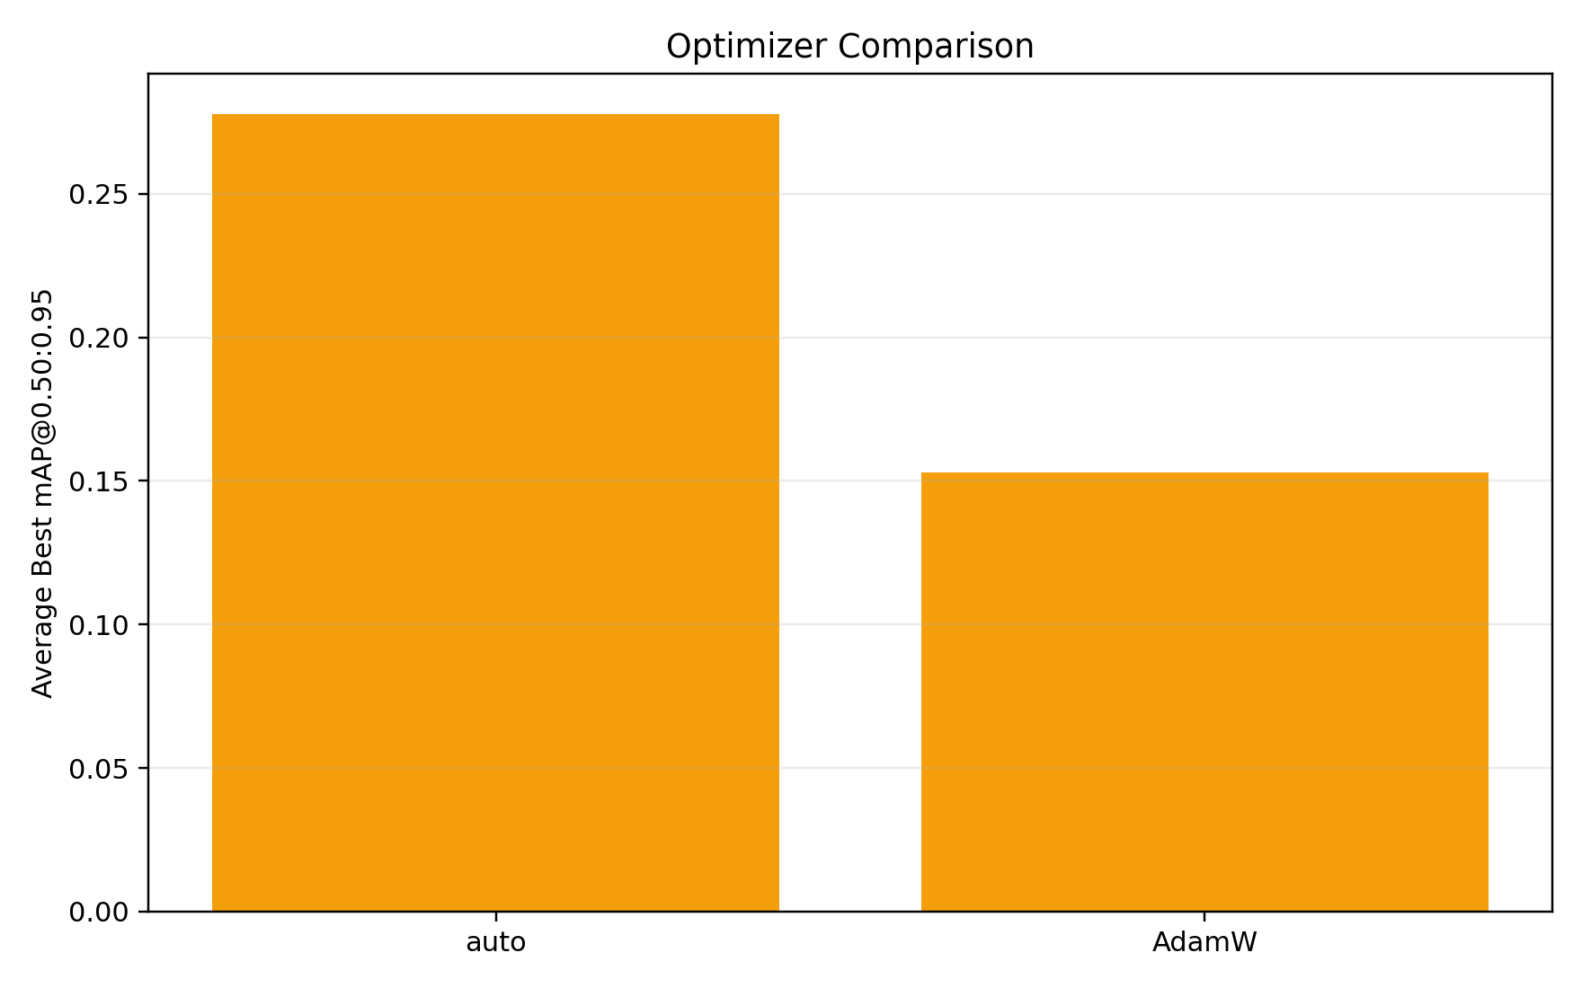
Figure 4.4: Optimiser Comparison (auto vs. AdamW)
4.3 NLP Model Results
4.3.1 Weak Supervision Limitation
The keyword-trained classifier had a textbook case of the Clever Hans effect. It scored well on validation data that looked like the training data, and it then collapsed on anything written naturally. When it was put it in front of a moderator and asked them to mark its mistakes, the pattern became obvious within an afternoon: the model had memorised the surface vocabulary instead of learning what an accessibility-relevant sentence sounds like. There was no salvaging this without changing the labels.
4.3.2 LLM Distillation Improvement
Switching to LLM-distilled labels gave us three things at once [18]. The labels themselves were better, because the LLM was reading the sentence rather than counting keywords. The dataset included hard negatives that exercised the model on exactly the cases where the old approach had failed. And the class distribution was finally balanced, because the LLM did not over-produce one label the way the heuristics had. The combined effect was that training and validation curves converged together instead of diverging, and the model started getting the cases that the old version could not.
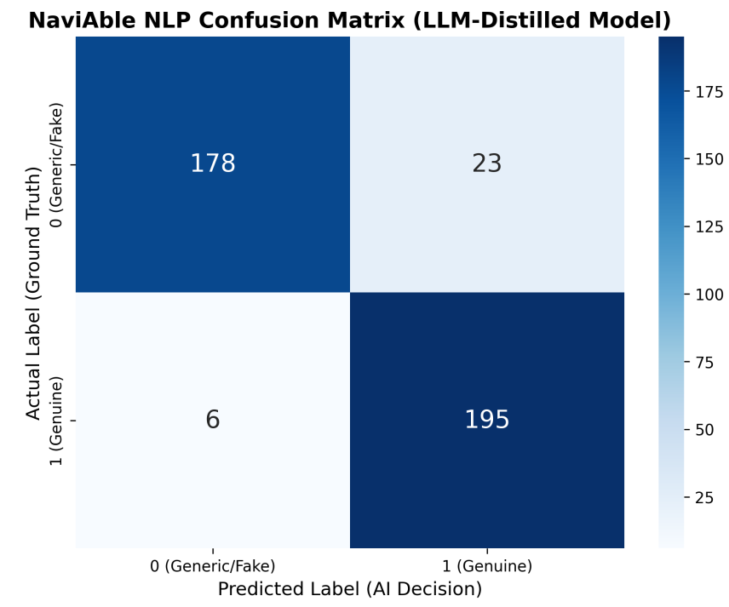
Figure 4.5: NLP Confusion Matrix on Held-Out Set
4.3.3 Performance Metrics
The performance of the LLM-distilled model on the held-out evaluation set is summarised in Table 4.2.
Metric | Value
Accuracy | 92.79%
Precision | 89.45%
Recall | 97.01%
F1 score | 93.08%
Table 4.2: NLP Model Performance on Held-Out Set
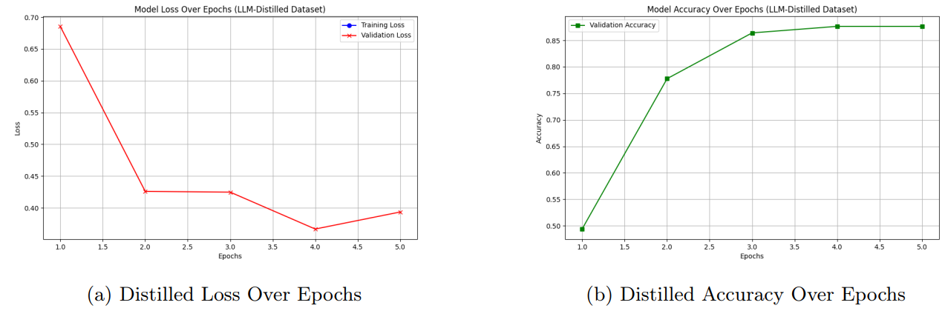
Figure 4.6: Loss and Accuracy Curves on the LLM-Distilled Dataset
4.3.4 Discussion
The recall number was the most positive metric. In the setting, missing a genuine accessibility comment is worse than letting through a generic one, because the Trust Score has another chance to catch the false positive but no second chance at recovering a discarded review. A recall of 97.01% means useful contributions are rarely thrown away. The remaining errors are concentrated on borderline cases where the review mentions an accessibility feature only in passing — for example, a long review of a restaurant that ends with a single sentence about the ramp at the back entrance — and even there, the false-negative rate is small enough that it can be absorbed.
4.4 System-Level Integration and Trust Score
The integrated system runs both models on each contribution and combines their outputs into a single number. The Trust Score is computed as
Trust Score = (0.60 × Vision Score) + (0.40 × NLP Score),
with the weighting motivated in Section 3.9. Vision was weighted higher because it answers the more concrete question — does the feature exist in the photograph — while the text score weighing in at 40% lets a strong textual disagreement still pull the score down. The 60/40 split is a judgement call rather than an empirical optimum; we did experiment with 70/30 and 50/50 and found that the 60/40 ratio gave the best moderator-rated balance between false-positive suppression and contribution acceptance.
4.4.1 Confidence Levels
Based on the trust score, a contribution falls into one of three buckets. A score of 0.70 or higher is treated as high confidence and shown to users without qualification. A score between 0.40 and 0.69 is treated as medium confidence; the contribution is stored but flagged for moderator review and surfaced with a small caveat marker in the user interface. Anything below 0.40 is treated as low confidence: it is retained in the database for possible future re-evaluation but does not influence the public view. The decision to retain rather than delete low-confidence contributions was deliberate, for the reasons discussed in Section 3.4.2.
4.5 Overall System Discussion
Putting both models behind one trust score gave us a meaningful improvement over either model alone. The vision model still occasionally misses things in dim light or with unusual ramps, and the text model still gets fooled by the rare well-written but inaccurate review, but the two failures rarely happen at the same time on the same contribution. Late fusion exploits exactly that property: the joint failure rate is closer to the product of the marginal failure rates than to their sum, which is the structural reason multimodal verification outperforms either modality on its own.
Component | Before Improvement | After Improvement
Vision model | 8% ramp recall, silent on minority class | 92% ramp recall, mAP@0.5 of 0.89
NLP model | Context-blind keyword classifier | Context-aware, F1 of 93.08%
System reliability | Low, dependent on manual review | High, automated verification with human oversight
Table 4.3: Component-Level System Reliability Before and After Improvements
CHAPTER - 5
SYSTEM EVALUATION AND CONCLUSION
5.1 Introduction to System Evaluation
Evaluating NaviAble was less about the average-case numbers and more about what the system does when it is wrong. A misclassified review is an inconvenience. A wrongly verified ramp is a person at the bottom of a flight of stairs. The two errors are not symmetric, and the way the thresholds were set, metrics were picked, and results were reported, all reflect that fact rather than chasing a clean overall accuracy figure. The remainder of this chapter examines the two AI modules and the integrated system through that lens.
5.2 NLP Integrity Engine Evaluation
5.2.1 Model Learning Analysis
Comparing the keyword-trained baseline with the LLM-distilled model shows two different stories in the loss curves. The baseline overfit early: training loss dropped while validation loss climbed, the standard signature of a model memorising artefacts of the training data. The distilled model converged smoothly on both training and validation, suggesting it was learning something more generalisable. The qualitative difference is large enough that the team did not need to lean on a statistical test to convince ourselves the improvement was real; the curves themselves are informative.
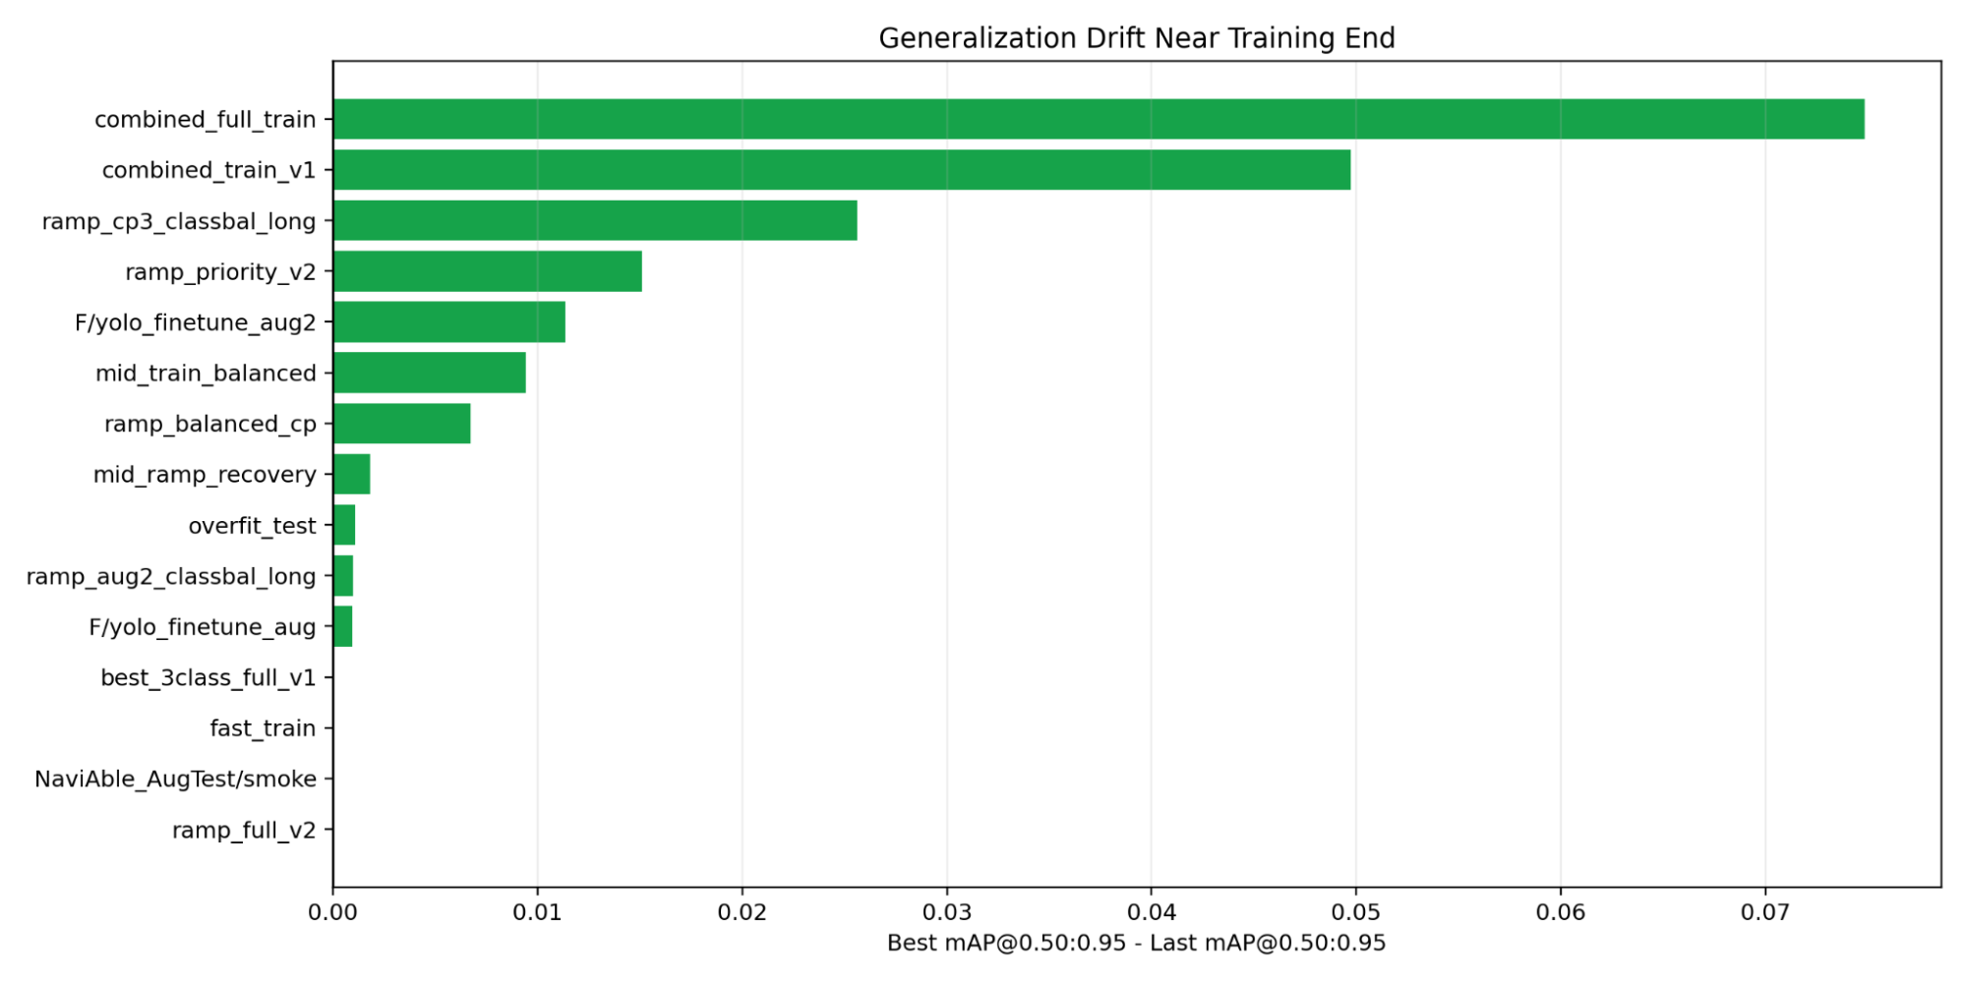
Figure 5.1: Generalisation Drift Near Training End
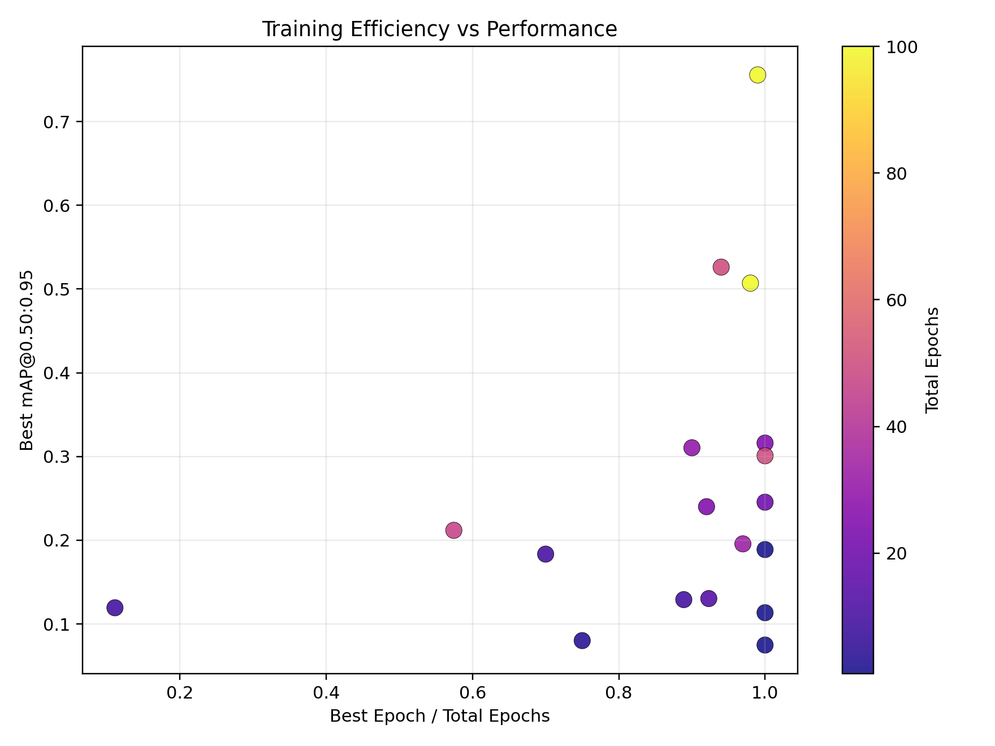
Figure 5.2: Training Efficiency vs. Performance
5.2.2 Classification Performance
On the held-out evaluation set, the final RoBERTa classifier reaches 92.79% accuracy, 89.45% precision, 97.01% recall, and an F1 of 93.08%. The high recall is the part that matters most for this use case, because it means useful accessibility comments are rarely thrown out by the filter, and any false positives that do slip through have a second chance to be caught at the late-fusion stage by a contradicting vision result.
5.2.3 Confusion Matrix Interpretation
Reading the confusion matrix in Figure 4.5, the bulk of the predictions land on the diagonal. True positives are reviews the model correctly marked as carrying accessibility information; true negatives are generic reviews it correctly filtered out. The off-diagonal cells are small, and the false positives outnumber the false negatives, which matches the preferred error trade-off. The group would rather let through a few generic reviews — which the vision side will then fail to corroborate, dragging the Trust Score down — than discard a genuine accessibility comment outright.
5.3 Vision Verification Module Evaluation
5.3.1 Detection Performance
After training on the rebalanced dataset, the YOLOv11 detector reached an mAP@0.5 of 79.94% on the held-out test set, with precision of 86.08% and recall of 82.61%. These are reasonable numbers for a model that has to work on phone-camera photographs taken from arbitrary angles in arbitrary lighting, and they are well within the range of what the literature reports for accessibility feature detectors on comparable data [8][9].
5.3.2 Performance Analysis
Per-class behaviour is roughly what was expected. Stairs detect very reliably, because they have consistent shape across most of the world's buildings, and the training set captured enough variation in colour and material that the model generalises across building styles without obvious gaps. Ramps detect well on average but show more variance, because a concrete ramp in good light and a metal ramp at night are visually different problems. Generalisation to fresh user uploads — that is, images that were not part of any training or validation set — was acceptable; nobody saw the kind of cliff that would suggest the model had memorised the dataset.
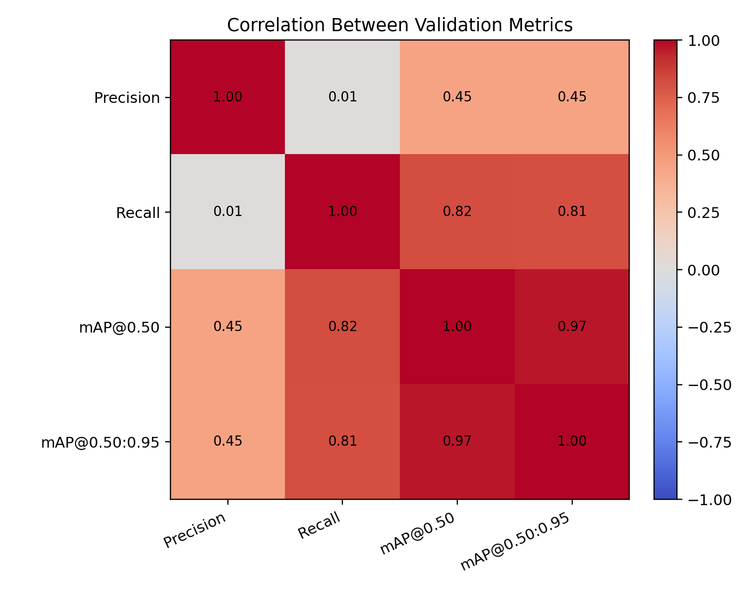
Figure 5.3: Correlation Matrix of Validation Metrics
5.3.3 Threshold Optimisation
The project involved tuning the confidence threshold using F1-confidence curves. The chosen value of 0.205 lets us pick up partially visible ramps and steps that a stricter threshold would silently drop, while keeping false detections rare enough that the Trust Score can still discriminate between honest and dishonest contributions. The threshold is not optimal in any analytical sense; it is the result of an explicit error trade-off that favours coverage over precision at the detector stage, with the expectation that the late-fusion engine will do the final filtering.
5.4 System Integration and Reliability
We covered the integrated backend with a suite of 23 unit tests focused on the verify endpoint. The tests exercise normal calls, malformed inputs, missing fields, oversized payloads, concurrent requests, and component failures including simulated model timeouts. The model outputs were mocked, so the suite tests the orchestration logic and the Trust Score arithmetic without depending on the heavy ML inference path. All 23 tests passed.
The three properties that were cared most about were asynchronous request handling under concurrent load, the strictness of the input validators, and the correctness of the Trust Score arithmetic when one or both models return edge-case values such as exactly zero or exactly one. The suite gave us enough confidence to deploy the backend without manually walking through every endpoint, and it now runs on every commit through a continuous integration pipeline.
5.5 Conclusion
NaviAble works. Crowdsourced contributions, when run through two independent AI checks before they are accepted, produce accessibility information that is noticeably more trustworthy than what either the crowd or the models could produce alone. The vision side answers whether the claimed feature is actually visible in the photograph. The text side answers whether the writing is actually about accessibility, or just generic praise pretending to be. The Trust Score reconciles the two and decides what gets stored.
This was not the system that was set out to build. The original plan leaned more on text and treated the photograph as supporting evidence; the experiments in Chapter 4 pushed us the other way once the rebalanced vision model started outperforming the text classifier on direct comparison. The version that ships gives us a defensible answer to the question we started with, which was how to verify a user-submitted accessibility claim without putting a human in the loop on every contribution.
5.6 Key Contributions
A few elements of this project feel worth calling out as contributions to the broader literature, in addition to the working system itself.
1. The dual-AI verification design, in which two independent models have to roughly agree before a contribution is trusted, is the part most likely to transfer to other domains beyond accessibility.
2. The dataset rebalancing work that took ramp recall from 8% to 92% was painful but is the reason any of the vision numbers are believable. Practitioners building accessibility models should treat dataset construction as a first-class research activity.
3. Replacing keyword labels with LLM-distilled labels is what got the NLP model out of the Clever Hans hole the first version was stuck in. The looser form of distillation that was used [18] generalises the earlier weak-supervision frameworks [19] in a way that requires no hand-engineered labelling functions.
4. On the engineering side, the microservices layout meant the three of us could ship in parallel without merge pain, which mattered more for completing the project on time than any individual technical choice.
5.7 Future Scope
There are several directions the team would take if they continued the project beyond this report. A native mobile application would reach more users than a web app, and would also let us collect contributions in the moment, which is expected to improve photograph quality. Real-time navigation that routes around inaccessible segments would build on the existing data without changing the verification design. Expanding the vision model's vocabulary to cover tactile paving, automatic doors, and elevator buttons would broaden the platform's usefulness, though it would also require new training data that does not yet exist in usable quantities. Integration with mainstream mapping platforms, where most users already start their trips, would help adoption a great deal more than promoting NaviAble as a standalone destination.
Two further directions are worth flagging because they came up repeatedly during development and the team did not have time to address them. The first is support for languages other than English in the text classifier; the current model has not been evaluated on Indic-language reviews, which matters for the Indian deployment context. The second is an adaptive Trust Score weighting scheme that learns the vision-text balance from outcome data rather than fixing it at 60/40. Both are tractable extensions that would be prioritised in a follow-up phase.

REFERENCES
[1] Office of the Registrar General and Census Commissioner, India, 2011, Census of India: Disabled Population, Government of India, New Delhi, pp. 1-12.
[2] World Health Organization and World Bank, 2011, World Report on Disability, World Health Organization, Geneva, pp. 1-325.
[3] Ministry of Social Justice and Empowerment, 2016, The Rights of Persons with Disabilities Act, Government of India, New Delhi, Act No. 49 of 2016, pp. 1-72.
[4] Kapsalis, E., Jaarsma, C., and Geurs, K., 2022, Disabled-by-design: Effects of inaccessible urban public spaces on mobility, Disability and Rehabilitation, pp. 1-12.
[5] Santoso, T. B., 2023, Accessibility barriers of wheelchair users in public spaces, ResearchGate Publication, pp. 1-10.
[6] Unsworth, C. et al., 2019, A systematic review of public transport accessibility for people using mobility devices, Disability and Rehabilitation, Vol. 41, No. 25, pp. 2983-2992.
[7] Kerdar, S. H., Bachler, L., and Kirchhoff, B. M., 2024, The accessibility of digital technologies for people with visual impairment and blindness: a scoping review, Discover Computing, Vol. 27, pp. 1-15.
[8] Hara, K., Sun, J., Moore, R., Jacobs, D., and Froehlich, J. E., 2014, Tohme: detecting curb ramps in Google Street View using crowdsourcing, computer vision, and machine learning, Proceedings of the 27th Annual ACM Symposium on User Interface Software and Technology, pp. 189-204.
[9] Saha, M., Saugstad, M., Maddali, H. T., Zeng, A., Holland, R., Bower, S., Dash, A., Chen, S., Li, A., Hara, K., and Froehlich, J. E., 2019, Project Sidewalk: A web-based crowdsourcing tool for collecting sidewalk accessibility data at scale, Proceedings of the 2019 CHI Conference on Human Factors in Computing Systems, pp. 1-14.
[10] Redmon, J., Divvala, S., Girshick, R., and Farhadi, A., 2016, You only look once: unified, real-time object detection, Proceedings of the IEEE Conference on Computer Vision and Pattern Recognition (CVPR), pp. 779-788.
[11] Bochkovskiy, A., Wang, C.-Y., and Liao, H.-Y. M., 2020, YOLOv4: Optimal speed and accuracy of object detection, arXiv preprint arXiv:2004.10934, pp. 1-17.
[12] Ultralytics, 2024, YOLOv11 documentation, available at https://docs.ultralytics.com/, accessed April 2026.
[13] He, K., Zhang, X., Ren, S., and Sun, J., 2016, Deep residual learning for image recognition, Proceedings of the IEEE Conference on Computer Vision and Pattern Recognition (CVPR), pp. 770-778.
[14] Lin, T.-Y., Maire, M., Belongie, S., Hays, J., Perona, P., Ramanan, D., Dollar, P., and Zitnick, C. L., 2014, Microsoft COCO: Common objects in context, Proceedings of the European Conference on Computer Vision (ECCV), pp. 740-755.
[15] Vaswani, A., Shazeer, N., Parmar, N., Uszkoreit, J., Jones, L., Gomez, A. N., Kaiser, L., and Polosukhin, I., 2017, Attention is all you need, Advances in Neural Information Processing Systems, Vol. 30, pp. 5998-6008.
[16] Devlin, J., Chang, M.-W., Lee, K., and Toutanova, K., 2019, BERT: Pre-training of deep bidirectional transformers for language understanding, Proceedings of NAACL-HLT, pp. 4171-4186.
[17] Liu, Y., Ott, M., Goyal, N., Du, J., Joshi, M., Chen, D., Levy, O., Lewis, M., Zettlemoyer, L., and Stoyanov, V., 2019, RoBERTa: A robustly optimized BERT pretraining approach, arXiv preprint arXiv:1907.11692, pp. 1-13.
[18] Hinton, G., Vinyals, O., and Dean, J., 2015, Distilling the knowledge in a neural network, arXiv preprint arXiv:1503.02531, pp. 1-9.
[19] Ratner, A., Bach, S. H., Ehrenberg, H., Fries, J., Wu, S., and Re, C., 2017, Snorkel: Rapid training data creation with weak supervision, Proceedings of the VLDB Endowment, Vol. 11, No. 3, pp. 269-282.
[20] World Wide Web Consortium, 2018, Web Content Accessibility Guidelines (WCAG) 2.1, W3C Recommendation, available at https://www.w3.org/TR/WCAG21/, accessed April 2026.
[21] Roboflow Universe, 2024, Stair and Ramp Dataset, available at https://universe.roboflow.com/peggy-cikj6/stair-and-ramp-qukcn, accessed April 2026.
[22] Jocher, G. et al., 2023, Ultralytics YOLOv8: Real-time object detection and instance segmentation, available at https://github.com/ultralytics/ultralytics, accessed April 2026.
[23] Ramirez, S., 2024, FastAPI documentation, available at https://fastapi.tiangolo.com/, accessed April 2026.
[24] PostGIS Project Steering Committee, 2024, PostGIS: Spatial and geographic objects for PostgreSQL, available at https://postgis.net/documentation/, accessed April 2026.

LIST OF PUBLICATIONS

