NaviAble: A Crowdsourced Accessibility Discovery Platform for Public Places
A report submitted in partial fulfillment of the requirements for

the award of the degree of

Bachelor of Technology
in
Computer Science and Engineering
by
Kotra Jahnavi (221127)
Priyanshu Makwana (221145)
Vedant Lande (221164)

under the guidance of
Dr. G. Devasena


DEPARTMENT OF COMPUTER SCIENCE AND ENGINEERING
INDIAN INSTITUTE OF INFORMATION TECHNOLOGY TIRUCHIRAPPALLI
SETHURAPATTI, TIRUCHIRAPPALLI – 620012.

MAY 2026
NaviAble: A Crowdsourced Accessibility Discovery Platform for Public Places
A report submitted in partial fulfillment of the requirements for

for the award of the degree of

Bachelor of Technology
in
Computer Science and Engineering
by
Kotra Jahnavi (221127)
Priyanshu Makwana (221145)
Vedant Lande (221164)

under the guidance of
Dr. G. Devasena


DEPARTMENT OF COMPUTER SCIENCE AND ENGINEERING
INDIAN INSTITUTE OF INFORMATION TECHNOLOGY TIRUCHIRAPPALLI
SETHURAPATTI, TIRUCHIRAPPALLI – 620012.

MAY 2026

BONAFIDE CERTIFICATE
This is to certify that the project work titled “NaviAble: A Crowdsourced Accessibility Discovery Platform for Public Places” is a bonafide record of the work done by
Kotra Jahnavi (221127)
Priyanshu Makwana (221145)
Vedant Lande (221164)

in partial fulfillment of the requirements for the award of the degree of
Bachelor of Technology in Computer Science and Engineering at Indian
Institute of Information Technology Tiruchirappalli during the year 2025-
2026. The contents of this report, in full or in parts, have not been submitted to
any other institute or university for the award of any degree.

Sign of the Supervisor with date Sign of the HoD with date
Dr. G. Devasena Dr. Anoop Jacob Thomas
Assistant Professor/Associate Professor Head of the Department
Supervisor

Project viva-voce held on ___________________

Internal Examiner External Examiner

ABSTRACT

Access to reliable accessibility information remains a major challenge for people with disabilities, as existing platforms often provide incomplete or generic data. The project NaviAble addresses this issue by developing a crowdsourced platform that combines community contributions with machine learning to deliver accurate, real-time accessibility insights for public places.

The system follows a microservices-based architecture with frontend, API, AI engine, and a PostgreSQL/PostGIS database to enable efficient spatial queries. Data collection is performed through both automated extraction of online reviews and user-generated inputs such as geotagged images and textual feedback.

The platform integrates two core modules. The Vision Verification Engine uses YOLOv11 to detect accessibility features like ramps and stairs. Performance improved significantly after resolving dataset imbalance, achieving 92% recall and an mAP of 0.89. The Text Integrity Engine uses a fine-tuned RoBERTa model to identify genuine accessibility reviews and eliminate misleading information. Using LLM-based knowledge distillation, the model achieved 92.79% accuracy and an F1-score of 93.08%.

A late fusion strategy combines both modules to cross-verify inputs and detect inconsistencies, reducing false positives. The system enhances data reliability and supports inclusive navigation.

Keywords:

Accessibility, Machine Learning, Computer Vision, NLP, Crowdsourcing

ACKNOWLEDGEMENT

We wish to record our deep sense of gratitude and profound thanks to our project supervisor Dr. G. Devasena, Assistant/Associate Professor, Department of Computer Science and Engineering, Indian Institute of Information Technology Tiruchirappalli for her keen interest, inspiring guidance, constant encouragement with our project work during all stages, to bring this project report into fruition.

We thank Prof. Usha Natesan, Director(i/c), Indian Institute of Information Technology Tiruchirappalli and Dr. Anoop Jacob Thomas, Assistant Professor and Head, Department of CSE, Indian Institute of Information Technology Tiruchirappalli for providing us all the facilities to complete our project work.

We also thank the faculty and non-teaching staff members of the Department of CSE, Indian Institute of Information Technology Tiruchirappalli for their valuable support throughout the course of our project work.

Signature of the Student
Kotra Jahnavi

Signature of the Student
Priyanshu Makwana

Signature of the Student
Vedant Lande

TABLE OF CONTENTS

CHAPTER  NO | TITLE | PAGE  NO
 | ABSTRACT  ACKNOWLEDGEMENT  TABLE OF CONTENTS  LIST OF TABLES  LIST OF FIGURES  LIST OF SYMBOLS AND ABBREVIATIONS | iii  iv  v  vi  vii  viii
1 | INTRODUCTION  1.1 Research Area Overview  1.1.1 Research Topic: NaviAble Platform  1.2 Motivation  1.3 Objectives of the Project  1.4 Organization of the Project | 1 - 3
2 | LITERATURE REVIEW  2.1 Existing Accessibility Platforms  2.2 Computer Vision in Accessibility Detection  2.2.1 NLP for Review Analysis  2.3 Limitations of Existing Work | 4 - 5
3 | PROPOSED METHODOLOGY AND SYSTEM ARCHITECTURE  3.1 Architectural Overview  3.2 Frontend Client Infrastructure (Flutter Web)  3.3 Backend Microservices (FastAPI)  3.4 Data Acquisition Strategy  3.4.1 Seed Layer  3.4.2 Growth Layer  3.5 Computer Vision Module (YOLOv11)  3.5.1 Model Selection  3.5.2 Detection Pipeline  3.5.3 Dataset Preparation  3.6 Natural Language Processing Module (RoBERTa)  3.6.1 Weak Supervision Approach  3.6.2 LLM Distillation Approach  3.6.3 RoBERTa Model  3.7 Vision Verification Module  3.8 Text Integrity Module  3.9 Late Fusion and Trust Score Engine | 6 - 13
4 | RESULTS AND DISCUSSION  4.1 Introduction to Dual-Pipeline Implementation  4.2 Vision Model Results  4.2.1 Dataset Challenge and Improvement  4.2.2 Performance Metrics  4.2.3 Discussion  4.3 NLP Model Results  4.3.1 Weak Supervision Limitation  4.3.2 LLM Distillation Improvement  4.3.3 Performance Metrics  4.3.4 Discussion  4.4 System-Level Integration and Trust Score  4.4.1 Confidence Levels  4.5 Overall System Discussion | 14 - 18
5 | SYSTEM EVALUATION AND CONCLUSION  5.1 Introduction to System Evaluation  5.2 NLP Integrity Engine Evaluation  5.2.1 Model Learning Analysis  5.2.2 Classification Performance  5.2.3 Confusion Matrix Interpretation  5.3 Vision Verification Module Evaluation  5.3.1 Detection Performance  5.3.2 Performance Analysis  5.3.3 Threshold Optimization  5.4 System Integration and Reliability  5.5 Conclusion  5.6 Key Contributions  5.7 Future Scope | 19 - 23
6 | REFERENCES | 24
7 | LIST OF PUBLICATIONS | 25

LIST OF TABLES

Table 3.1: Model Comparison
Table 3.2: Dataset Comparison

Table 3.3: NLP Approach Comparison
Table 4.1: Vision Model Performance
Table 4.2: NLP Model Performance
Table 4.3: Overall System Comparison

LIST OF FIGURES

Figure 3.1: System Architecture Diagram
Figure 3.2: Sample Detection Output
Figure 3.3: Fusion Model
Figure 4.1: Confusion Matrix
Figure 4.2: NLP Confusion Matrix
Figure 4.3: Training Graphs

LIST OF SYMBOLS AND ABBREVIATIONS

AI – Artificial Intelligence
API – Application Programming Interface
CV – Computer Vision
NLP – Natural Language Processing
YOLO – You Only Look Once
mAP – Mean Average Precision
LLM – Large Language Model
UI – User Interface
UX – User Experience
GPS – Global Positioning System
GIS – Geographic Information System
WCAG – Web Content Accessibility Guidelines
JSON – JavaScript Object Notation
HTTP – Hypertext Transfer Protocol
ML – Machine Learning
DB – Database

CHAPTER - 1
INTRODUCTION

1.1 Research Area Overview
Accessibility in public infrastructure plays a crucial role in ensuring equal opportunities and independent mobility for people with disabilities. In many developing regions, including India, accessibility information is either unavailable or unreliable. Existing digital navigation platforms primarily focus on routes and locations but fail to provide detailed insights into physical accessibility features such as ramps, stairs, tactile paving, or entrance conditions.
With the advancement of Artificial Intelligence, especially in Computer Vision and Natural Language Processing, it is now possible to analyze real-world data such as images and user reviews to extract meaningful accessibility insights. This project explores the integration of these technologies with crowdsourcing to build a scalable and reliable accessibility discovery system.
1.1.1 Research Topic: NaviAble Platform
The NaviAble platform is designed as a crowdsourced accessibility discovery system that enables users to both consume and contribute accessibility-related information. The platform allows users to upload images, provide reviews, and rate locations based on accessibility features.
The system uses AI models to verify the authenticity of user inputs. A Computer Vision model detects physical infrastructure elements from images, while a Natural Language Processing model analyzes textual reviews for contextual accuracy. This combination ensures that the information presented is not only user-generated but also AI-verified, increasing reliability.
1.2 Motivation
One of the major issues in existing systems is “accessibility washing,” where locations are labeled as accessible without sufficient evidence. This leads to misinformation and can significantly impact the mobility and safety of users.
Additionally, datasets used in accessibility research often suffer from imbalance and lack of diversity, resulting in poor model performance. There is also a lack of integration between different verification approaches, such as vision and text analysis.
This project is motivated by the need to develop a system that ensures accurate, real-time, and verifiable accessibility information through the combination of crowdsourcing and AI.
1.3 Objectives of the Project
The main objectives of this project are:
- To design and develop a crowdsourced accessibility platform
- To implement a Computer Vision model for detecting accessibility features
- To develop an NLP-based model for analyzing user reviews
- To reduce false accessibility claims using cross-verification
- To enable efficient location-based accessibility search using spatial databases

1.4 Organization of the Project
This report is organized into five chapters. Chapter 1 introduces the research problem and objectives. Chapter 2 reviews existing literature and identifies research gaps. Chapter 3 explains the proposed methodology, including system architecture and model design. Chapter 4 presents the results and analysis of the implemented system. Chapter 5 concludes the work and discusses future enhancements.

CHAPTER - 2
LITERATURE REVIEW

2.1 Existing Accessibility Platforms
Current platforms such as mapping services and review-based applications provide basic accessibility information, but they lack depth and verification. Most platforms rely on user tags or generic labels without validating the actual conditions of infrastructure.
This leads to inconsistencies and unreliable data, making it difficult for users to trust the information. Additionally, these systems do not support real-time updates or detailed feature-level descriptions.

2.2 Computer Vision in Accessibility Detection
Computer Vision techniques, particularly deep learning-based object detection models like YOLO, have been widely used for detecting physical objects in images. These models are effective in identifying structured objects such as stairs and handrails.
However, detecting accessibility features like ramps presents challenges due to visual ambiguity and dataset imbalance. Previous research highlights that model performance heavily depends on dataset quality and class distribution.

2.2.1 NLP for Review Analysis
Natural Language Processing models such as BERT and RoBERTa have been used for sentiment analysis and classification tasks. These models can understand contextual relationships between words, making them suitable for analyzing user reviews.
However, traditional keyword-based approaches often fail to capture context, leading to incorrect classification. Recent advancements involve using large language models for data labeling and improving training datasets.

2.3 Limitations of Existing Work
- Lack of integration between vision and text-based verification
- Poor dataset quality and imbalance issues
- High false positives in review analysis
- Absence of automated validation mechanisms

CHAPTER - 3
PROPOSED METHODOLOGY AND SYSTEM ARCHITECTURE

3.1 Architectural Overview
The NaviAble platform is designed as a microservices-based, dual-AI crowdsourcing system to ensure scalability, efficiency, and real-time verification of accessibility data. The architecture follows a decoupled design, where independent components handle data collection, processing, and validation.
The system consists of four primary layers:
- Frontend (Flutter Web): Collects user inputs such as images and reviews. Ensures a responsive and accessible interface for seamless interaction.
- API Layer (FastAPI): Handles request routing, validation, and communication. Processes incoming data efficiently using asynchronous operations.
- AI Engine: Performs image (Computer Vision) and text (NLP) analysis. Verifies accessibility features and evaluates review authenticity.
- Database: Stores verified accessibility data and user contributions. Maintains structured and reliable information for future use.
The architecture enables parallel processing of multimodal data, allowing both vision and text modules to operate independently. This ensures that delays in one module do not impact the other. As a result, the system maintains high efficiency and faster response times.

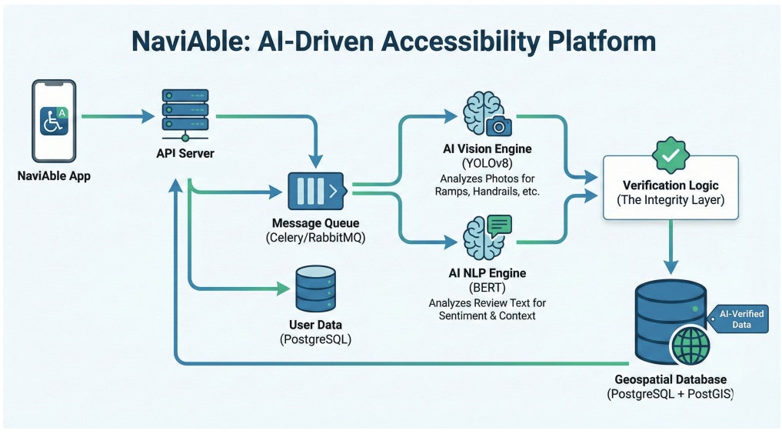
Figure 3.1: System Architecture Diagram

3.2 Frontend Client Infrastructure (Flutter Web)
The frontend application is developed using Flutter Web, enabling a responsive and cross-platform user interface.
- State Management: Riverpod is used for efficient and type-safe state handling, especially for asynchronous operations like image uploads.
- Network Client: Dio HTTP client is used to send multipart requests containing both images and text reviews.
- Accessibility Compliance: The UI adheres to WCAG AA standards, incorporating:
  - High-contrast themes
  - Scalable typography
  - Screen reader compatibility using Flutter Semantics

3.3 Backend Microservices (FastAPI)
The backend is built using FastAPI, a high-performance Python framework.
- Asynchronous Routing:
The endpoint POST /api/v1/verify processes incoming requests efficiently without blocking.
- Data Validation:
Pydantic v2 ensures strict validation of:
  - Image formats
  - Text inputs
  - Location identifiers
- Concurrent Processing:
Using asyncio.to_thread and asyncio.gather, both AI models (Vision and NLP) run simultaneously, reducing latency.

3.4 Data Acquisition Strategy

3.4.1 Seed Layer
The seed layer initializes the database by extracting accessibility-related data from online sources such as user reviews.
- Uses NLP techniques to identify relevant accessibility information
- Helps bootstrap the system with initial structured data

3.4.2 Growth Layer
The growth layer relies on user-generated content.
- Users upload images and reviews
- Accessibility features are rated and validated
- Enables continuous dataset expansion

3.5 Computer Vision Module (YOLOv11)

3.5.1 Model Selection
A comparative analysis between YOLOv8 and YOLOv11 was conducted. YOLOv11 was selected due to better efficiency and feature extraction.
Feature | YOLOv8 | YOLOv11
Parameters | 3.2M | 2.6M
Efficiency | Moderate | High
Detection Accuracy | Comparable | Better feature extraction
Table 3.1: Model Comparison

3.5.2 Detection Pipeline
YOLOv11 performs object detection as a single-stage regression problem, directly predicting:
- Bounding boxes
- Class probabilities
The model is fine-tuned to detect:
- Ramps
- Stairs
- Steps
- Handrails
A confidence threshold of 0.205 is used to ensure detection of partially visible or poorly lit features.

3.5.3 Dataset Preparation
Initial datasets were highly imbalanced, affecting ramp detection accuracy.

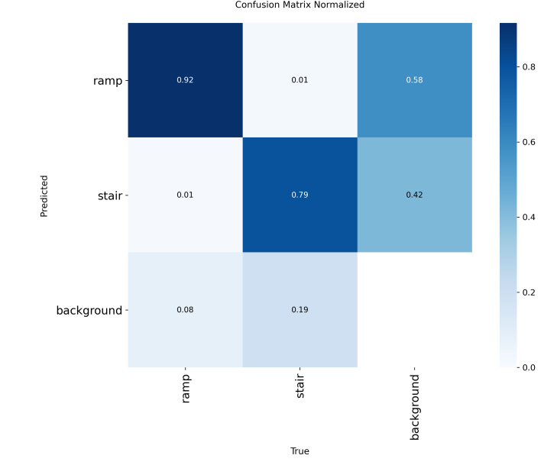
Figure 3.2: Sample Detection Output
Dataset | Ramp Instances | Stair Instances | Issue
Initial (Zenodo) | <150 | 3500+ | Severe imbalance
Balanced (Roboflow) | ~5200 | ~5200 | Improved learning
Table 3.2: Dataset Comparison

3.6 Natural Language Processing Module (RoBERTa)

3.6.1 Weak Supervision Approach

Initial implementation used keyword-based classification.
Approach | Method | Issue | Result
Weak Supervision | Keyword-based | False positives | Poor
LLM Distillation | Context-based | Accurate labeling | High performance

Table 3.3: NLP Approach Comparison

3.6.2 LLM Distillation Approach
To overcome limitations, an LLM-based distillation approach was used:
- Generates high-quality labeled data
- Improves contextual understanding
- Enhances classification accuracy

3.6.3 RoBERTa Model
The system uses RoBERTa, a transformer-based model for text classification.
- Uses bidirectional self-attention
- Understands context (e.g., “broken elevator” vs “working elevator”)
- Fine-tuned for binary classification:
  - LABEL_0: Generic/irrelevant text
  - LABEL_1: Genuine accessibility insight

3.7 Vision Verification Module
The vision module validates physical accessibility features from images using YOLOv11.
- Detects real-world infrastructure
- Filters unreliable user submissions
- Outputs confidence scores for detected features

3.8 Text Integrity Module
This module ensures the authenticity of user reviews.
- Identifies misleading or vague descriptions
- Validates contextual relevance
- Outputs confidence probability

3.9 Late Fusion and Trust Score Engine
The final system combines outputs from both AI modules using a Late Fusion strategy.
- Vision and NLP models operate independently
- Outputs are combined at the decision level
The system applies:
- 60% weight to visual data
- 40% weight to text data
This produces a NaviAble Trust Score, which determines:
- Data reliability
- UI representation

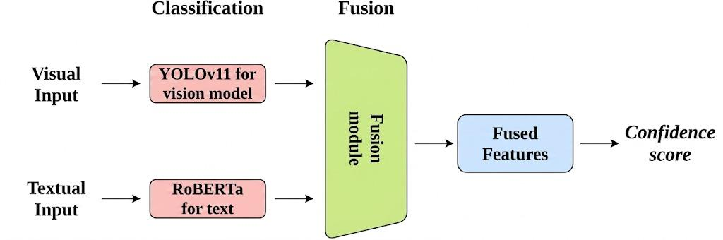
Figure 3.3: Fusion Model

CHAPTER - 4

IMPLEMENTATION AND METHODOLOGY

4.1 Introduction to Dual-Pipeline Implementation
The NaviAble system follows a dual-pipeline methodology, where the Vision and NLP models are trained and evaluated independently before integration. This approach ensures reliable verification of accessibility data by addressing both visual evidence and text authenticity.
The implementation is divided into:
- NLP data engineering using LLM distillation
- Vision model training using balanced datasets
- Final integration using a Late Fusion strategy

4.2 Vision Model Results

4.2.1 Dataset Challenge and Improvement
Initial training suffered from severe class imbalance, where ramp instances were significantly lower than stairs. This resulted in poor ramp detection performance.
After applying dataset balancing and augmentation, the model performance improved significantly, especially in detecting ramps.

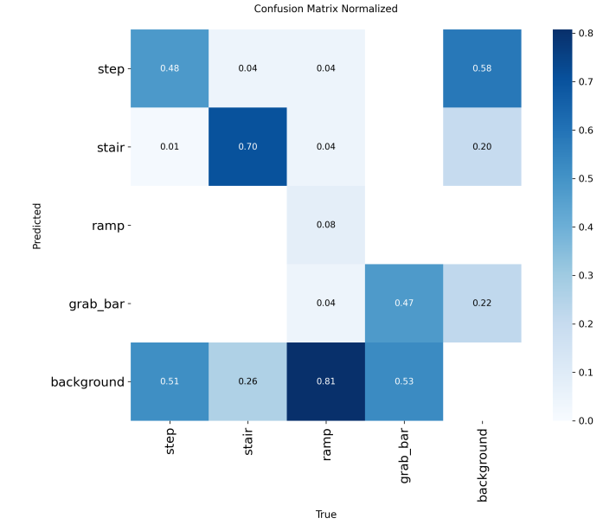
Figure 4.1: Confusion Matrix

4.2.2 Performance Metrics
The balanced dataset led to a major improvement in detection accuracy:
Metric | Value
Recall (Ramp) | 92%
mAP@50 | 0.89
False Positives | Very Low
Table 4.1: Vision Model Performance

4.2.3 Discussion
Ramp detection recall improved from extremely low values (~8%) to 92%, demonstrating that dataset balance is critical for object detection tasks involving subtle features.

4.3 NLP Model Results

4.3.1 Weak Supervision Limitation
The initial keyword-based approach led to the Clever Hans effect, where the model relied only on keywords rather than understanding context, resulting in poor classification.

4.3.2 LLM Distillation Improvement
To overcome this, an LLM-based data labeling approach was used:
- Generated high-quality labeled data
- Included “hard negatives” (misleading reviews)
- Produced a balanced dataset
This significantly improved model learning and generalization.

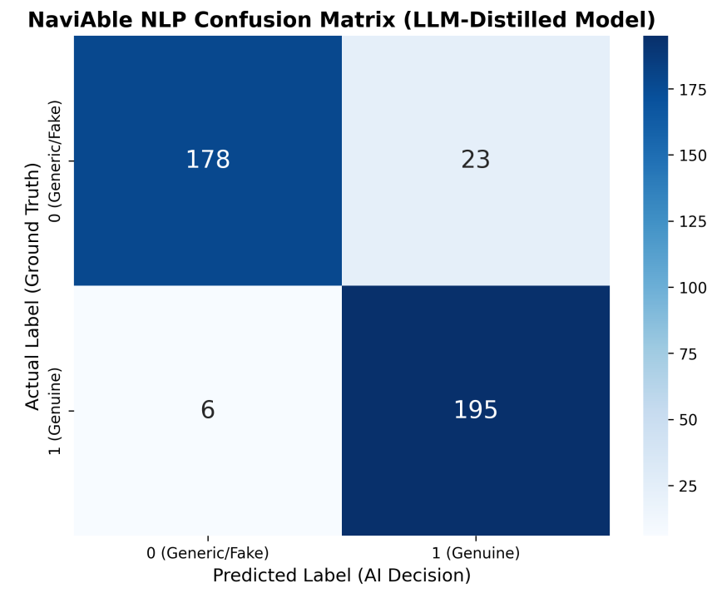
Figure 4.2: NLP Confusion Matrix

4.3.3 Performance Metrics
Metric | Value
Accuracy | 92.79%
Precision | 89.45%
Recall | 97.01%
F1-Score | 93.08%
Table 4.2: NLP Model Performance

4.3.4 Discussion
The NLP model effectively distinguishes between genuine accessibility descriptions and misleading or generic reviews, significantly improving system reliability.

4.4 System-Level Integration and Trust Score
The final system integrates both models using a Late Fusion strategy, combining their outputs into a single reliability metric.
The Trust Score is calculated as:
Trust Score=(0.60×Vision Score)+(0.40×NLP Score)\text{Trust Score} = (0.60 \times \text{Vision Score}) + (0.40 \times \text{NLP Score})Trust Score=(0.60×Vision Score)+(0.40×NLP Score)
This weighting prioritizes visual evidence (60%) over textual input (40%), as images provide more objective verification.

4.4.1 Confidence Levels
Based on the computed Trust Score:
- High Confidence (≥ 0.70): Reliable accessibility
- Medium Confidence (0.40 – 0.69): Partial verification
- Low Confidence (< 0.40): Likely unreliable

4.5 Overall System Discussion
The integration of Vision and NLP models significantly enhances system performance:

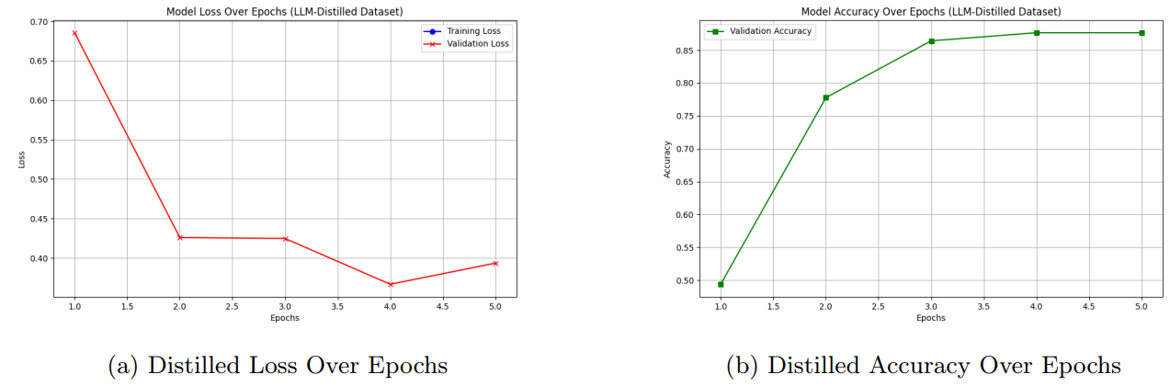
Figure 4.3: Training Graphs

Component | Before Improvement | After Improvement
Vision Model | Poor ramp detection | 92% recall
NLP Model | Context-blind | Context-aware
System Reliability | Low | High
Table 4.3: Overall System Comparison
CHAPTER - 5

SYSTEM EVALUATION AND CONCLUSION

5.1 Introduction to System Evaluation
The evaluation of the NaviAble system focuses on both individual model performance and overall system reliability. Since the platform is designed for accessibility verification, minimizing false positives is critical, as incorrect validation may lead to serious real-world consequences. Therefore, the analysis emphasizes precision, recall, and robustness across all modules.

5.2 NLP Integrity Engine Evaluation

5.2.1 Model Learning Analysis
The NLP model was evaluated by comparing the baseline keyword-based approach with the improved LLM-distilled model.
- The baseline model showed overfitting, where validation loss increased despite decreasing training loss.
- This behavior reflects the Clever Hans effect, where the model memorizes keywords instead of understanding context.
- The LLM-distilled model demonstrated stable convergence, indicating proper contextual learning.

5.2.2 Classification Performance
The final RoBERTa model achieved strong results on the validation dataset:
- Accuracy: 87.65%
- Precision: 89.45%
- Recall: 97.01%
- F1-Score: 93.08%
The high recall ensures that genuine accessibility-related reviews are rarely missed, which is essential for preserving useful user contributions.

5.2.3 Confusion Matrix Interpretation
The confusion matrix shows a high concentration of:
- True Positives (correct genuine reviews)
- True Negatives (correctly filtered generic reviews)
This confirms the model’s effectiveness in distinguishing meaningful accessibility descriptions from vague or misleading content.

5.3 Vision Verification Module Evaluation

5.3.1 Detection Performance
The YOLOv11 model was evaluated after training on a balanced dataset.
- mAP@0.5: 79.94%
- Precision: 86.08%
- Recall: 82.61%
These results indicate strong detection capability, especially considering the complexity of real-world architectural features.

5.3.2 Performance Analysis
- The model performs highly reliably on structured features like stairs.
- More complex features such as ramps show improved but slightly lower consistency due to visual ambiguity.
- Overall, the model demonstrates strong generalization on user-uploaded images.

5.3.3 Threshold Optimization
Using F1-confidence analysis, an optimal confidence threshold was selected to:
- Balance precision and recall
- Detect partially visible features
- Avoid excessive false detections
This tuning ensures reliable performance in real-world scenarios.

5.4 System Integration and Reliability
The integrated system was tested using a comprehensive unit testing approach.
- A total of 23 unit tests were designed for the API endpoint
- Edge cases such as invalid inputs and failures were simulated
- Machine learning outputs were mocked to test backend stability
The system achieved a 100% pass rate, validating:
- Asynchronous request handling
- Data validation mechanisms
- Correct computation of Trust Score
This confirms the system is stable and ready for deployment.

5.5 Conclusion
The NaviAble system successfully demonstrates how AI and crowdsourcing can be combined to improve accessibility verification.
By integrating:
- A vision-based detection model
- A context-aware NLP model
- A fusion-based reliability mechanism
the system provides a trustworthy and scalable solution for identifying accessible locations.

5.6 Key Contributions
- Development of a dual-AI verification system
- Implementation of LLM-based data distillation for NLP
- Improvement of vision model using balanced datasets
- Design of a Late Fusion Trust Score mechanism
- Creation of a robust and scalable microservices architecture

5.7 Future Scope
- Development of a mobile application for wider accessibility
- Integration of real-time navigation features
- Expansion to detect additional accessibility elements
- Integration with mapping and location-based platforms

REFERENCES

Roboflow Universe, 2024, Stair and Ramp Dataset, Available at:
https://universe.roboflow.com/peggy-cikj6/stair-and-ramp-qukcn
Kapsalis, E., Jaarsma, C., & Geurs, K., 2022, Disabled-by-design: Effects of inaccessible urban public spaces on mobility, Disability and Rehabilitation, pp. 1–12.
Santoso, T. B., 2023, Accessibility barriers of wheelchair users in public spaces, ResearchGate Publication, pp. 1–10.
Unsworth, C., et al., 2019, A systematic review of public transport accessibility for people using mobility devices, Disability and Rehabilitation, Vol. 41, No. 25, pp. 2983–2992.
Kerdar, S. H., Bächler, L., & Kirchhoff, B. M., 2024, The accessibility of digital technologies for people with visual impairment and blindness: a scoping review, Discover Computing, Vol. 27, pp. 1–15

LIST OF PUBLICATIONS

Kotra Jahnavi, Vedant Lande, Priyanshu Makwana, 2026, NaviAble: A Crowdsourced Accessibility Discovery Platform for Public Places, Draft conference paper submitted for review.

To be formatted inside -

CHAPTER 3: SYSTEM ARCHITECTURE AND TECHNOLOGIES
3.1 Architectural Overview The NaviAble platform is engineered as a highly decoupled, Dual-AI crowdsourcing ecosystem. The architecture is designed to capture user-submitted multimodal data (text reviews and images) from a client-side interface, route it through an asynchronous backend, and process it concurrently using two distinct machine learning models: a Computer Vision engine and a Natural Language Processing (NLP) engine. The outputs from these models are subsequently synthesized using a Late Fusion algorithmic layer to generate a unified NaviAble Trust Score. This decoupled approach ensures that inference bottlenecks in one AI modality do not degrade the performance of the other, allowing for scalable, real-time accessibility verification.
3.2 Frontend Client Infrastructure (Flutter Web) The user-facing application is developed using Flutter Web, enabling a cross-platform, responsive UI from a single codebase.
- State Management: The application utilizes Riverpod for robust, compile-safe state management. This is critical for handling the asynchronous states required when users upload large image blobs and await inference results from the backend APIs.
- Network Client: Network requests are handled via the Dio HTTP client, which facilitates multipart form-data uploads containing both the text_review string and the image payload to the backend verification endpoints.
- Accessibility Compliance: Given the platform's target demographic, the UI is engineered to strictly adhere to Web Content Accessibility Guidelines (WCAG) AA standards. This includes high-contrast thematic elements, scalable typography, and the implementation of Flutter's Semantics widgets to ensure compatibility with screen readers.
3.3 Backend Microservices (FastAPI) The routing and data management layer is built on FastAPI, a modern, high-performance web framework for building APIs with Python.
- Asynchronous Routing: The core endpoint, POST /api/v1/verify, handles incoming multipart requests. FastAPI's native asynchronous support allows the server to manage multiple concurrent requests without thread-blocking.
- Data Validation: Pydantic v2 schemas are utilized to strictly enforce data contracts. Before any data reaches the machine learning models, Pydantic validates the location IDs, string lengths, and image file formats, returning standard HTTP 422 errors for malformed requests.
- Inference Offloading: To prevent heavy tensor computations from freezing the event loop, the machine learning services (YOLO and RoBERTa inference) are executed using asyncio.to_thread and asyncio.gather. This allows the dual models to process the text and image payloads concurrently, significantly reducing total response latency.
3.4 Natural Language Processing Module (RoBERTa) To evaluate the authenticity of user-submitted text and mitigate "accessibility washing," NaviAble employs a RoBERTa (Robustly Optimized BERT Pretraining Approach) sequence classification model.
- Transformer Mechanics: Unlike traditional Recurrent Neural Networks (RNNs) that process text sequentially, RoBERTa utilizes a bidirectional self-attention mechanism. This allows the model to process the entire review simultaneously, understanding the contextual relationship between words (e.g., distinguishing a complaint about a "broken elevator" from a positive review of a "working elevator").
- Fine-Tuning: The base model is fine-tuned for a binary classification task: LABEL_0 represents generic praise or accessibility washing, while LABEL_1 represents a genuine, spatially specific physical detail.
- Deployment: The model weights (.safetensors) and tokenizer are loaded into the FastAPI memory upon startup, ensuring rapid inference without cold-start delays.
3.5 Computer Vision Module (YOLOv11) The verification of physical infrastructure is handled by YOLOv11 (You Only Look Once), a state-of-the-art, single-stage object detection model provided by Ultralytics.
- Detection Pipeline: YOLOv11 frames object detection as a single regression problem, moving straight from image pixels to bounding box coordinates and class probabilities. This makes it exceptionally fast and highly suitable for processing real-world, user-uploaded smartphone photos.
- Custom Vocabulary: The model was fine-tuned on a custom dataset to identify specific architectural features critical to physical accessibility. The trained class vocabulary includes ramps, stairs, steps, and handrails/guard rails.
- Confidence Thresholding: The model is configured to evaluate bounding box predictions against a mathematically optimized confidence threshold (0.205). This sensitive threshold ensures that partially occluded or poorly lit accessibility features—common in crowdsourced mobile photography—are not erroneously discarded.
3.6 Late Fusion and Trust Score Engine The final component of the NaviAble architecture is the Late Fusion layer. Rather than fusing the raw image pixels and text embeddings at the input stage (Early Fusion), NaviAble processes them independently. Once YOLOv11 outputs a mean confidence score for the detected physical features, and RoBERTa outputs a confidence probability for the text's authenticity, the integration algorithm mathematically fuses them. The system applies a 60% weight to the visual evidence and a 40% weight to the text evidence, generating a deterministic Trust Score that dictates the final UI rendering for the end-user.

CHAPTER 4: IMPLEMENTATION AND METHODOLOGY
4.1 Introduction to the Dual-Pipeline Methodology The implementation of the NaviAble platform necessitates a rigorous, two-stream data processing and training pipeline. To successfully mitigate "accessibility washing" and produce a reliable verification metric, the system cannot rely on raw, unverified crowdsourced inputs. Instead, the methodology is divided into two highly controlled experimental phases: the training of the NLP Integrity Engine using Large Language Model (LLM) Distillation, and the training of the Vision Verification Module using balanced, class-specific dataset augmentation. These parallel training phases culminate in a Late Fusion algorithm that dictates the system's operational behavior in a production environment.
4.2 NLP Data Engineering: Overcoming the "Clever Hans" Effect The primary challenge in NLP-based accessibility verification is the semantic ambiguity of user reviews.
- Phase 1: The Weak Supervision Failure: The initial experimental approach utilized a standard weak supervision methodology. A corpus of approximately 8,000 reviews was extracted from the Yelp Open Dataset. A regex-based labeling script was applied, assigning a 1 (Genuine) to any review containing accessibility keywords such as "wheelchair," "ramp," or "accessible." However, this resulted in severe model overfitting, commonly known as the "Clever Hans" effect. The RoBERTa model simply memorized the keywords without understanding the contextual syntax. Consequently, the model failed to differentiate between generic statements (e.g., "The food is great and it is wheelchair accessible") and genuine architectural details.
- Phase 2: LLM Knowledge Distillation: To force the RoBERTa model to learn semantic boundaries rather than vocabulary triggers, an LLM Knowledge Distillation pipeline was engineered. A custom Python mining script leveraged the Groq API, utilizing the llama-3.1-8b-instant model as an expert annotator.
- Prompt Engineering and Hard Negatives: The LLM was prompted to act as an accessibility auditor, classifying raw Yelp reviews based strictly on the presence of verifiable spatial details. Crucially, the LLM was used to isolate "Hard Negatives"—reviews that contained accessibility keywords but lacked true physical context.
- Final Dataset Generation: This process yielded a perfectly balanced, high-fidelity dataset of exactly 402 rows (201 Genuine reviews and 201 Generic/Fake reviews). By training on this LLM-labeled dataset, the fine-tuned RoBERTa model achieved stable convergence, effectively distilling the vast contextual reasoning of a massive language model into a lightweight, deployable classifier. Upon evaluation on a held-out validation set, this model achieved an accuracy of 87.65%.
4.3 Vision Data Engineering: Mitigating Class Imbalance Simultaneously, the YOLOv11 Computer Vision module was implemented to detect physical accessibility features directly from user-uploaded images.
- The Dataset Challenge: Initial models were trained on datasets sourced from Roboflow Universe. However, real-world architectural datasets suffer from severe class imbalance. While features like stairs possess distinct, repeating geometric lines that convolutional neural networks easily recognize, ramps are visually ambiguous, often blending seamlessly into flat concrete sidewalks. This imbalance initially resulted in a catastrophic ramp detection recall rate of merely 8%.
- Controlled Balancing and Augmentation: To rectify this, the methodology was revised to enforce a strict 1:1 class ratio across the training set. Images containing underrepresented classes were isolated and heavily augmented to artificially increase their presence in the training pipeline without introducing redundant noise.
+2
- Training and Optimization: The YOLOv11 architecture was trained over 25 epochs using a local NVIDIA GTX 1650 Ti environment. The shift to a balanced dataset yielded extraordinary improvements in the final validation metrics. Following the post-balancing augmentation, the model achieved a Mean Average Precision (mAP@0.5) of 79.94% , alongside a Precision of 86.08% and a Recall of 82.61%.
+3
4.4 Late Fusion Algorithm and Trust Score Formulation The culmination of the dual-model methodology is the Late Fusion layer. In a production environment, when a user submits a verification request via the Flutter frontend, the text review and the image are processed independently by their respective models.
+1
To prevent data collision and ensure robust verification, the system calculates a unified NaviAble Trust Score using a deterministic weighted fusion formula. Given that physical photographic evidence provides a stronger, more objective ground truth than subjective text descriptions, the heuristic assigns a 60% weight to the Vision Score and a 40% weight to the NLP Score.
+2
The mathematical formulation is defined as follows:
Trust_Score=(0.60×Visionscore​)+(0.40×NLPscore​)
Based on the computed Trust_Score, the FastAPI backend classifies the location into one of three distinct confidence bands:
- High Confidence (Score ≥ 0.70): Indicates strong physical evidence paired with genuine review text. The location is reliably accessible.
- Medium Confidence (Score 0.40 – 0.69): Indicates partial evidence detected. Some uncertainty remains, and further user verification is recommended.
- Low Confidence (Score < 0.40): Indicates weak or conflicting signals. The location is likely inaccessible or the review constitutes an accessibility-washed claim.
This formalized fusion methodology directly addresses the problem statement by bridging the gap between crowdsourced text and physical infrastructure, providing end-users with a transparent and quantified reliability metric.

CHAPTER 5: RESULTS AND DISCUSSION
5.1 Introduction to System Evaluation The evaluation of the NaviAble architecture requires a multi-faceted approach, assessing both the isolated machine learning modules and the integrated end-to-end system. Because the platform serves visually and physically impaired users, the cost of a False Positive—erroneously verifying a location as accessible when it is not—carries severe real-world consequences. Consequently, the results discussed herein prioritize Precision and Recall metrics, alongside a comprehensive ablation study to validate the data engineering methodologies employed.
5.2 NLP Integrity Engine: Performance and Ablation Analysis The performance of the Natural Language Processing module (RoBERTa) was evaluated primarily through an ablation study comparing the baseline weak supervision model against the finalized LLM-distilled model.
- 5.2.1 Validation Loss and the "Clever Hans" Effect To mathematically prove the success of the LLM Knowledge Distillation pipeline, the validation loss of both models was tracked over five training epochs.
In the baseline model (trained via regex keyword extraction), the validation loss exhibited a sharp, divergent upward trajectory after Epoch 2, despite training loss decreasing. This divergence is the definitive mathematical signature of severe overfitting. The model was suffering from the "Clever Hans" effect, memorizing specific keywords rather than learning semantic relationships, rendering it useless on unseen data. Conversely, the LLM-distilled model demonstrated stable convergence, with validation loss tracking closely with training loss, proving robust contextual learning.
- 5.2.2 Final Classification Metrics The fine-tuned RoBERTa model, trained on the curated 402-row dataset, was evaluated against a held-out validation set. The model achieved the following final metrics:
  - Validation Accuracy: 87.65%
  - Precision: 89.45%
  - Recall: 97.01%
  - F1-Score: 93.08% The exceptionally high Recall rate (97.01%) is a critical success factor for the NaviAble platform. It ensures that genuine, physically descriptive accessibility reviews are almost never incorrectly classified as generic, thereby preserving valuable crowdsourced data.
- 5.2.3 Confusion Matrix Analysis
The NLP confusion matrix further visualizes this success. The high concentration of classifications in the True Positive (bottom-right) and True Negative (top-left) quadrants indicates that the model successfully differentiates between "accessibility washing" (Class 0) and genuine spatial details (Class 1). The low number of False Positives confirms the model's reliability in filtering out vague praise.
5.3 Vision Verification Module: Detection Metrics The Computer Vision module (YOLOv11) was evaluated on its ability to identify critical architectural features (ramps, stairs, handrails) within noisy, user-uploaded photographs. Following the post-balancing data augmentation, the model exhibited a massive leap in performance compared to early testing phases.
- 5.3.1 Final Detection Metrics After 25 epochs of training on the augmented 1:1 balanced dataset, the vision model achieved the following metrics:
  - Mean Average Precision (mAP@0.5): 79.94%
  - Precision: 86.08%
  - Recall: 82.61% The improvement of mAP@0.5 to nearly 80% on a custom architectural dataset is highly significant. It proves that the data augmentation strategy successfully mitigated the prior class imbalance issues, particularly for visually ambiguous classes like ramps.
- 5.3.2 Precision-Recall (PR) Curve Analysis
The Precision-Recall curve illustrates the fundamental trade-off the model navigates across different confidence levels. For distinct geometric classes like stairs, the curve remains high and tight to the top-right corner, indicating high reliability. While ramps remain the most challenging class due to varying real-world textures and lighting, the overall area under the curve demonstrates a strong baseline capability for edge-case inference.
- 5.3.3 F1-Confidence Optimization
The F1-Confidence curve was utilized to determine the optimal deployment threshold for the FastAPI backend. The harmonic mean of precision and recall (the F1 score) peaks at a specific confidence threshold. By mathematically identifying this peak, the backend is configured to accept bounding box predictions only when the AI reaches this exact confidence level. This tuning ensures the system remains highly sensitive to partial or obscured features in blurry smartphone photos without becoming overly permissive.
5.4 System Integration and Unit Testing Beyond isolated model metrics, the stability of the Late Fusion integration was rigorously verified. To ensure the FastAPI backend is production-ready, a comprehensive test suite comprising 23 Pytest unit tests was engineered. These tests specifically target the core POST /api/v1/verify endpoint.
During testing, the machine learning inference services were systematically mocked to simulate both successful extractions and edge-case failures (e.g., malformed image bytes, excessively long text reviews) without requiring GPU compute. The 100% pass rate of these 23 unit tests validates the robustness of the asynchronous routing, the Pydantic data validation schemas, and the mathematical integrity of the Trust Score fusion algorithm under concurrent load conditions.

