Experiment 8

Design Analysis Report
Topics: Modularization, Coupling and Cohesion Analysis, Function-Oriented vs. Object-Oriented Design, Top-Down and Bottom-Up Design
Project Name: Smart Tax Calculator
Student Name: Pulkit Verma
Roll Number: 202401100200247

1. Introduction
Selected system: The Smart Tax Calculator (Version 1.0) is a web-based application that estimates the income-tax liability of an individual taxpayer in India from the income, deduction and exemption details entered by the user, and compares that liability under the Old and the New Tax Regimes. It is developed for the Software Engineering & Design Principles Lab (Semester V, Section D, KIET Group of Institutions) using HTML/CSS/JavaScript for the front end, Java Spring Boot for the REST back end and MySQL for the database, in a three-tier client–server architecture.
Purpose: The system reduces the manual effort and arithmetic errors of self-assessment, makes the structure of the tax computation transparent to a non-expert, and helps the user identify the more suitable regime. It is an informational and educational tool; it does not file returns, does not connect to any government portal and is not a substitute for professional tax advice.
Target users: Individual Taxpayers (occasional, non-expert users), Salaried Employees (frequent users around investment-declaration and filing periods), Self-Employed Users (business or professional income) and the Project Administrator/Developer, who maintains slab and deduction reference data.
Major functionalities:
- Income and financial details entry, with validation (salary, house property, business/profession and other income).
- Deduction and exemption management, applying a statutory ceiling to each category and enabling categories according to the selected regime.
- Tax regime selection (Old, New, or comparison of both) for a chosen financial year.
- Tax computation with a slab-wise breakdown, including rebate, surcharge, and health and education cess.
- Old versus New regime comparison, identifying the lower liability and the monetary difference.
- Itemised, plain-language tax summary with a print-friendly view and a mandatory estimate disclaimer.
- Administration of slab and deduction reference data, so that Finance Act changes need no recompilation.
Scope of this report: the analysis below is based on the design recorded in the Software Requirements Specification (SRS v1.0, including the use case diagram and the class/DFD models listed in its Appendix B). It evaluates the design of the system; it is not a review of finished source code.

2. System Architecture and Modularization
The system follows a three-tier architecture (presentation, application and data tiers) communicating through JSON over REST. Within these tiers the SRS requirements and the use cases (Register/Login, Enter Income Details, Enter Deductions, Select Tax Regime, Calculate Tax, View Tax Breakdown, Compare Tax Regimes, Download Tax Report, Manage Tax Slabs, Update Tax Rules) were grouped into nine modules, each with one clearly stated responsibility. The modules and their responsibilities are listed in the table below, and Figure 1 shows the module decomposition (structure chart).
Module Name | Responsibility
M1 User Interface Module | Renders the Home, Income Details, Deductions, Regime Selection, Results and Comparison screens; collects input, shows the running gross-income total, the Next/Back/Calculate/Reset/Print controls, Indian-format currency and the estimate disclaimer.
M2 Input Validation Module | Rejects non-numeric and negative values, treats an empty field as zero, requires at least one income value above zero, sanitises every input on the server side and produces plain-language error messages (REQ-2, 3, 5).
M3 REST Controller Module | Exposes the REST endpoints; maps the JSON request to a calculation request object, invokes validation and the services, returns the JSON response and converts internal errors into non-technical messages.
M4 Income & Deduction Module | Computes gross total income, applies the statutory ceiling to each deduction category and reports any capping, enables or disables categories by regime, and derives taxable income (never negative) (REQ-4, 7–12).
M5 Tax Computation Engine | Applies slab rates progressively, then rebate, surcharge and cess (on tax after rebate), rounds the final liability to the nearest rupee and reports nil liability below the basic exemption limit (REQ-18 to 25).
M6 Regime Comparison Module | Runs the engine under both regimes on one set of inputs, computes the effective tax rate of each, and identifies the lower-liability regime and the difference (REQ-26 to 30).
M7 Summary Report Module | Builds the itemised, plain-language summary (income, deductions, taxable income, tax before cess, rebate, cess, total), financial year, regime, effective rate, disclaimer and print-friendly rendering (REQ-31 to 36).
M8 Reference Data Access Module | Provides repositories for slabs, deduction categories and ceilings, rebate limits, surcharge thresholds and cess per financial year and regime, and for optionally saved calculation records, using parameterised/ORM access only.
M9 Admin & Authentication Module | Authenticates administrators and lets them create, modify or delete slab, rebate and deduction reference data (Manage Tax Slabs, Update Tax Rules); ordinary users have read-only access through the calculation.
How modularization improves maintainability and reusability
Maintainability. Each change has a small, predictable home. A change in the Finance Act touches only the reference data held through M8/M9, with no recompilation of the engine (SRS constraint 2.5-3). A change of screen layout touches only M1. A new deduction rule is confined to M4. Because the calculation engine (M5) is independent of the user interface and the database, it can be unit-tested directly, which is the Testability requirement of SRS 5.4, and defects can be located module by module. Four team members can also work in parallel on separate modules once their interfaces are fixed.
Reusability. The engine is designed as an independent service layer (SRS 6.4), so a future mobile client or public API can reuse it unchanged. M5 is reused by M6, which simply calls it once per regime instead of duplicating the slab logic. The validation routines (M2) are shared utilities used by every screen, and the reference-data repositories (M8) serve both the engine and the administrator functions.
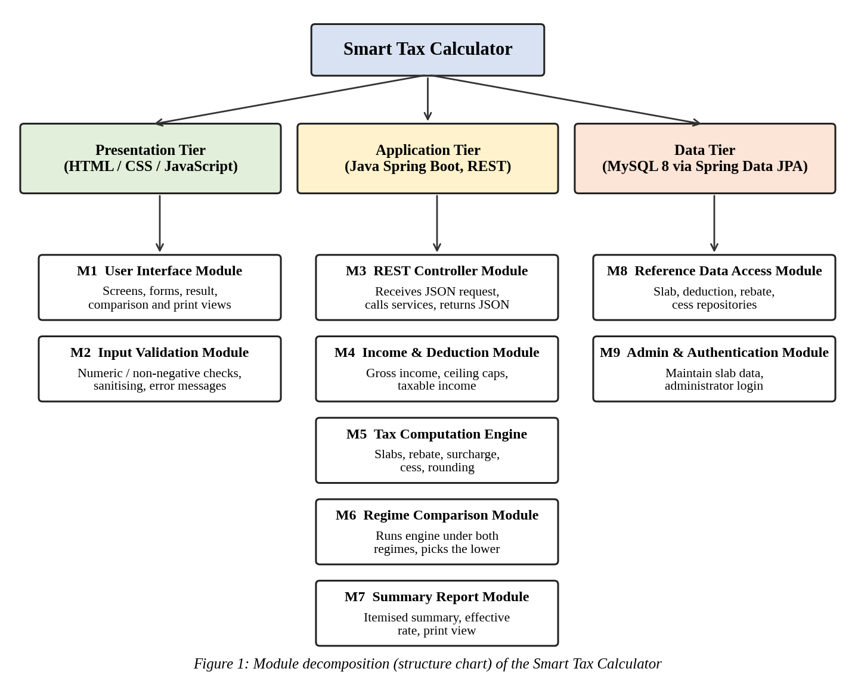

3. Coupling and Cohesion Analysis
Coupling Analysis
Module Pair | Nature of Dependency | Coupling Level | Justification
M1 – M3 | The UI sends a JSON request (income, deductions, regime, financial year) and receives a JSON result over REST. | Data coupling (low) | Only simple fields cross an agreed JSON contract; neither side sees the other’s internals, so the UI can be replaced without changing the back end.
M3 – M2 | The controller hands the request object to the validator and receives a list of validation errors. | Stamp coupling (low–moderate) | A whole request object is passed although each rule uses only some fields; a change to the request structure affects both modules.
M3 – M5 | The controller calls the calculation service with the request and receives a tax-result object. | Stamp coupling (low–moderate) | Composite objects are exchanged as the service contract; no control flags are passed and the controller knows nothing of slab logic.
M5 – M4 | The engine receives the taxable income derived by M4. | Data coupling (low) | Only numeric (fixed-point decimal) values are exchanged; M4 knows nothing of slab rates and M5 nothing of deduction ceilings.
M5 – M8 | The engine asks the repositories for slabs, rebate limit, surcharge and cess for a given financial year and regime. | Data coupling through an interface (low) | Only the year and regime identifiers go in, and rule objects come back; the engine has no SQL knowledge and no rule value is hard-coded.
M6 – M5 | The comparison module invokes the engine twice, once per regime, on the same inputs. | Data coupling (borderline control) | The regime is passed as a parameter that selects which rule data is loaded; it does not change M5’s internal flow, so this is not true control coupling.
M7 – M5 / M6 | The summary builder reads the result objects of the computation and the comparison. | Stamp coupling (low–moderate) | It receives whole result objects and uses most of their fields; the dependency is one-directional (M7 depends on M5/M6, not the reverse).
M9 – M8 (and M5) | The administrator updates the same reference tables that the engine reads for every calculation. | Common (shared data store) coupling – the weakest point | Both rely on the same tables, so a schema change affects both. It is limited because all access goes through the repository layer (M8) and only M9 writes.
Cohesion Analysis
Module Name | Responsibilities | Type of Cohesion | Justification
M1 User Interface | Screens, input forms, result and comparison views, print view. | Communicational | All parts operate on the same request/result data; it is not functional because it spans several screens.
M2 Input Validation | Numeric, non-negative, mandatory-field checks, sanitising, error messages. | Functional | Every element contributes to one task: deciding whether the input is acceptable.
M3 REST Controller | Map request, call validation, call services, map response, translate errors. | Sequential | The steps run in a fixed order and the output of each feeds the next.
M4 Income & Deduction | Sum income, cap deductions, apply regime admissibility, derive taxable income. | Sequential | Gross income feeds the capped deductions, which feed the taxable income.
M5 Tax Computation Engine | Slab tax, rebate, surcharge, cess, rounding, nil-liability case. | Functional (internally sequential) | All parts serve one purpose: computing the liability from taxable income.
M6 Regime Comparison | Run two computations, compute effective rates, pick the lower, state the difference. | Functional | A single purpose: comparing the two regimes.
M7 Summary Report | Itemised summary, effective rate, disclaimer, print-friendly rendering. | Communicational | All parts present the same result object; the print rendering could be separated.
M8 Reference Data Access | Slab, deduction, rebate/cess repositories; saved records. | Communicational | All operations act on one data store and contain no business logic.
M9 Admin & Authentication | Administrator login plus create/modify/delete of reference data. | Logical (weak) | Two loosely related activities are grouped only because both are “admin”; this is the least cohesive module.

Does the system follow low coupling and high cohesion?
Largely yes. Coupling between modules is mostly data coupling (M1–M3, M5–M4, M5–M8) or stamp coupling (M3–M2, M3–M5, M7–M5/M6). No module uses content coupling, and no module passes control flags that dictate another module’s internal flow, which are the harmful forms. Dependencies run one way down the layers (UI → controller → services → repositories), and the tax rules are held as configurable reference data rather than being embedded in code. This keeps the calculation engine independent of both the interface and the database.
Cohesion is also generally high: of the nine modules, M2, M5 and M6 are functionally cohesive, M3 and M4 are sequentially cohesive, and M1, M7 and M8 are communicationally cohesive. All of these are acceptable levels. The two weaker areas are (i) M9, which has logical cohesion because it combines authentication with reference-data maintenance, and (ii) the common coupling between M9 and M5 through the shared reference tables. Both are addressed in the recommendations in Section 7.

4. Function-Oriented vs. Object-Oriented Design
Criterion | Function-Oriented Design | Object-Oriented Design
Basic design unit | The function or procedure (for example validateIncome(), applyCeiling(), computeSlabTax()). | The class and object (for example TaxCalculationService, RegimeRuleSet, SlabRate, DeductionPolicy, TaxSummary).
Data and operations | Data and the functions that process it are kept apart; data travels as parameters or shared structures between functions. | Data and its operations are encapsulated together; a SlabRate holds its bounds and rate and knows how to compute the tax in its band, while its state is hidden.
Modularity | Modules are processing steps taken from the DFD (validate input, compute taxable income, apply slab rates, compare regimes, generate summary). | Modules are classes and layers grouped by responsibility (controller, service, repository, entity), the same grouping used in the SRS class model.
Reusability | Reuse is at function or library level and depends on callers using the same data structures, so reuse is limited. | Reuse through classes, interfaces and composition; the engine can serve a future mobile client, and a new financial year is added as data, not code.
Maintainability | A change to a shared data structure ripples through every function that uses it; supporting a new regime tends to add if/else branches across functions. | Changes are localised; a new regime or financial year is another RegimeRuleSet configuration, and polymorphism removes most conditionals.
Suitability for the system | Suits the calculation pipeline (a clear input → process → output flow) and is useful at analysis time, as in the Level-1 DFD. | Better suited overall: a layered Spring Boot application with entities, JPA repositories and REST services, with rules that change annually. This is the style the project adopts for implementation.
Conclusion: the project uses a hybrid. Function-oriented thinking (data flow diagrams, step-by-step computation) is used during analysis, while the implementation is object-oriented. Object-oriented design is the better fit because the main source of change, the annual revision of slabs, rebates and deduction ceilings, can be absorbed by adding or editing objects and data without changing the rest of the system.

5. Top-Down and Bottom-Up Design
5.1 Top-Down Design
Top-down design starts from the complete system and repeatedly breaks it into smaller parts. Level 0 is the Smart Tax Calculator as a whole. Level 1 splits it into four subsystems that correspond to the Level-1 DFD and the major use cases: Input & Validation, Tax Computation, Regime Comparison, and Reporting & Administration. Level 2 divides each subsystem into eight activities (income entry, deduction entry, taxable-income derivation, slab/rebate/cess calculation, running both regimes, picking the lower regime, summary generation and slab-data maintenance). Level 3 shows the functions that implement them. Figure 2 shows this decomposition.
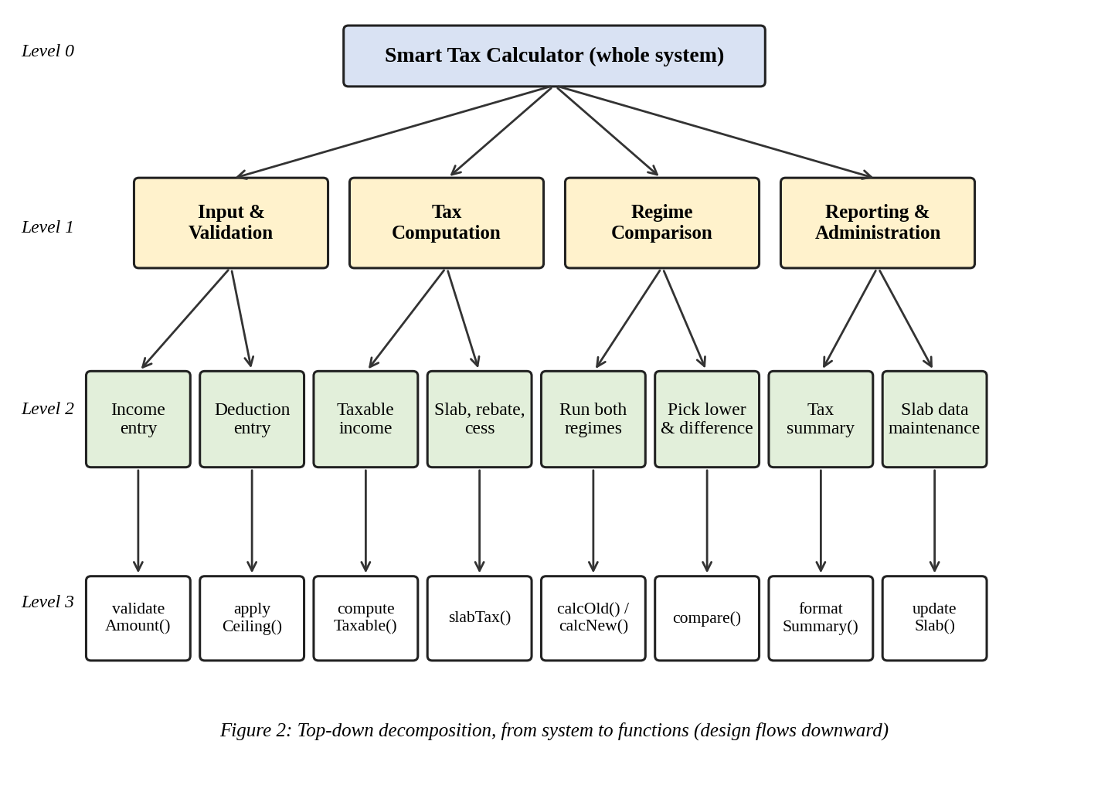
Advantages
- Gives the whole picture first, so the structure follows the SRS and DFDs and every requirement can be traced to a module.
- Interfaces between subsystems are fixed early, so team members can work in parallel and use stubs for modules not yet written.
- Errors in the overall structure are found early, before detailed coding effort is spent.
Limitations
- Reusable low-level pieces (money arithmetic, rounding, validation) are noticed late and may be written more than once.
- It depends on the top-level understanding being right; if the tax rules were misread, the error spreads downwards through all levels.
- Testing the upper levels has to wait for, or work with, stubs for the lower modules.
5.2 Bottom-Up Design
Bottom-up design begins with the small, well-understood components that many parts of the system will need. Here these are: a money utility based on fixed-point decimal arithmetic (SRS constraint 2.5-5), DeductionCategory and SlabRate entities, the JPA repositories, shared input validators, an Indian-style currency formatter and rounding/percentage helpers. These combine into larger units: DeductionPolicy (categories, ceilings and regime admissibility), RegimeRuleSet (slabs, rebate, surcharge and cess for a year and regime) and the TaxSummary builder. TaxCalculationService then combines DeductionPolicy and RegimeRuleSet to compute a single-regime liability; ComparisonService reuses it for both regimes; and finally the REST controllers and web UI sit on top to form the complete system. Figure 3 shows this composition.
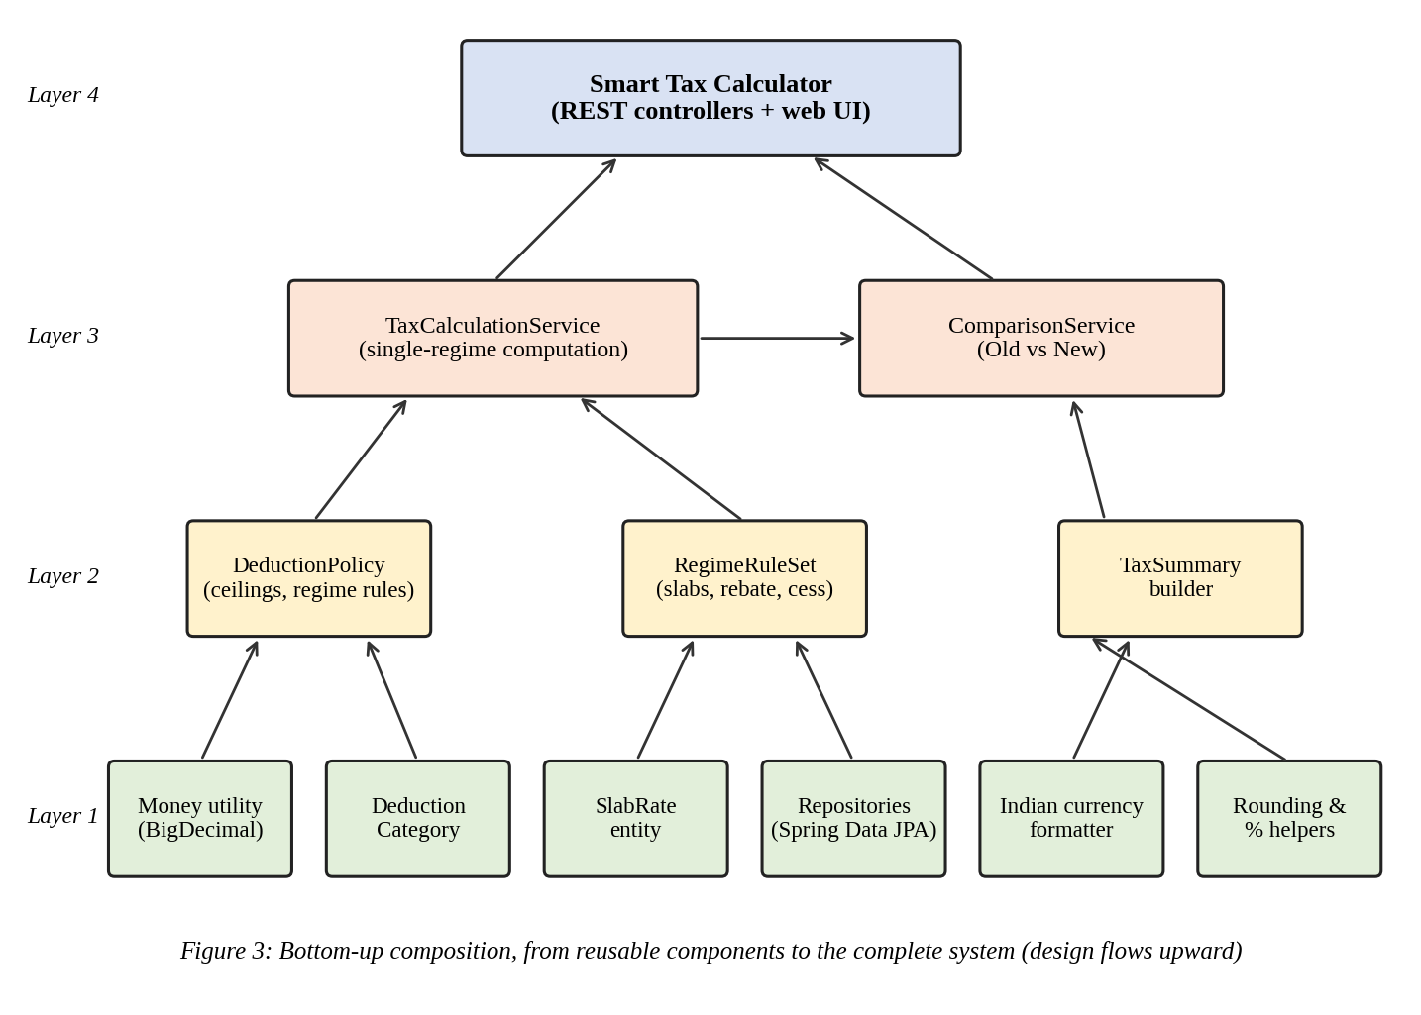
Advantages
- Produces well-tested, reusable building blocks; the money and slab logic can be unit-tested before any screen exists.
- Reduces duplication, because common routines are written once and used by every module that needs them.
- Early, concrete progress: working components exist from the first iteration.
Limitations
- Without the overall design in view, components may not fit the final system and need rework.
- Integration is deferred until the upper layers are built, so interface mismatches appear late.
- The global structure and user-visible behaviour are only visible at the end.
5.3 Comparison
Criterion | Top-Down Design | Bottom-Up Design
Starting point | The complete system and its requirements (SRS, use cases and DFDs). | Small, low-level components such as money arithmetic, SlabRate and the repositories.
Development approach | Decompose into subsystems, modules and functions; define interfaces first and fill in the detail later. | Build and test the primitives first, then combine them into services and finally the application.
Reusability | Reuse is found late; there is a risk of duplicate helper code. | High; reuse is planned from the start and shared utilities are written once.
Testing considerations | Needs stubs and drivers for unfinished lower modules; integration testing follows the top-level structure. | Unit tests come first and are easy; integration problems appear later when the pieces are joined.
Suitability | Good for setting the architecture and module boundaries from the SRS. | Good for the calculation core and shared utilities (money, slabs, validation).
For this project the two approaches complement each other. Top-down design fixes the architecture, the nine modules and their interfaces from the SRS, while bottom-up design is best for the shared utilities and the calculation core, where reuse and early unit testing matter most.

6. Overall Design Evaluation
Design Aspect | Strengths | Weaknesses | Suggested Improvements
Modularization | Three tiers and nine modules, each traceable to SRS features; the engine is independent of the UI and database; tax rules are kept as configurable data. | M9 mixes authentication with data maintenance; there is no dedicated place for cross-cutting concerns such as error handling and logging; M7 combines summary building and print rendering. | Split M9 into Authentication and Reference-Data Administration; add a global exception handler and logging component; separate print rendering from summary building if it grows.
Coupling and cohesion | Mainly data and stamp coupling; no content coupling or control flags; most modules are functional, sequential or communicational. | Large request and result objects cause stamp coupling; M9 and M5 share reference tables (common coupling); M9 has logical cohesion. | Pass narrower, purpose-specific objects; give the engine a read-only rule-provider interface instead of direct table access; split M9.
Design approach | A sensible hybrid: top-down for architecture and traceability, bottom-up for reusable utilities; object-oriented implementation. | Bottom-up utilities may be built late and duplicated if not planned; interface mismatches may appear at integration. | Build the shared utility package first and fix module interfaces early, using stubs and continuous integration.
System decomposition | Subsystems match the Level-1 DFD and use cases; decomposition is by responsibility rather than by screen. | Reporting and Administration share one Level-1 subsystem although they are unrelated; open items (capital-gains income, PDF export) have no defined place yet. | Separate Reporting and Administration; define extension points (an income-type strategy and an exporter interface) for the open SRS items.

7. Recommendations
The following improvements are recommended to strengthen the design:
- Split M9 into two modules. Create separate Authentication and Reference-Data Administration modules. This raises cohesion from logical to functional and lets the open decision on the authentication mechanism (SRS TBD-3) be settled without touching data maintenance.
- Introduce a read-only RuleProvider interface between M5 and M8. The engine would obtain slabs, rebates and cess through this interface, with caching. This removes direct dependence on the shared tables, reduces the common coupling with M9, lets unit tests use in-memory rules, and gives one place to refuse computation when reference data is missing.
- Replace large shared objects with narrower ones. Use separate IncomeDetails, DeductionDetails and RegimeSelection objects, and separate TaxResult and ComparisonResult objects, so each module receives only what it uses. This reduces stamp coupling and limits the effect of a field change.
- Apply a strategy pattern to regimes. Define a RegimeRuleSet interface with Old and New implementations (and later years or income types such as capital gains, TBD-5). New rules are then added without modifying the engine, following the open/closed principle.
- Centralise cross-cutting concerns and rule duplication. Add a global exception handler and logging, and let the server publish the field limits and ceilings that the JavaScript front end reads, so validation rules live in one place instead of being duplicated in the browser and the server.

8. Conclusion
This report analysed the Smart Tax Calculator against four design principles. The system is divided into nine modules across a three-tier architecture, each with a single stated responsibility. Coupling is low, being mainly data and stamp coupling with no content coupling or control flags, and cohesion is mostly functional, sequential or communicational. The weakest points are the logical cohesion of the Admin & Authentication module and the shared reference tables between it and the calculation engine. An object-oriented implementation is the better fit for rules that change every year, and the combination of top-down structuring with bottom-up reusable components gives both a clear architecture and a dependable calculation core.
Applying these principles improves maintainability, because a change in rates, ceilings, screens or deduction rules stays inside one module or one data table; reusability, because the engine, validators and repositories can serve a mobile client or a public API; and overall software quality, because independent modules with low coupling can be tested separately and the computed tax can be checked against manual calculation. Carrying out the five recommendations in Section 7 would further improve the design before implementation proceeds.

