Name: Priyanshu Vyas

Reg No. 20BCE1685

Course: CSE3002 Internet and web programming

Title: Lab Activity – 28 Sept 2022

1. Assume that you are sending a 4-digit ATM PIN to your friend through email. For security purpose, PIN gets encrypted based on the following points:

(a). Reverse the 4-digit PIN. [If pin is 4567, then reversed pin is 7654]

(b). In the reversed PIN, add 7 to each digit. [14,13,12,11]

(c). Replace each digit with remainder value after dividing by 10. [4321]

(d). Swap the first digit with the third digit. [2341]

(e). Swap the second digit with the fourth. Then print the encrypted integer. [2143]

Actual PIN: 4567, then the Encrypted PIN: 2143

Develop a PHP program using while loop to decrypt the pin, that is if 2143 is given as an input, then it should print 4567 as an output.

<?php

$pin = 4567;

//$pin = (int)readline('Enter a Pin: ');

echo "\n\nPin $pin\n\n";

$arr = array();

//reverse, +7, %10

while ($pin > 1)

{

    array_push($arr,((($pin % 10 )+ 7)%10));

    $pin = ($pin / 10);

}

// Alternate swapping

for($i=0;$i<sizeof($arr)/2;$i++)

{

    $temp=$arr[$i];

    $arr[$i]=$arr[$i+2];

    $arr[$i+2]=$temp;

}

echo "Encrypted Code ";

print_r($arr);

for($i=0;$i<sizeof($arr)/2;$i++)

{

    $temp=$arr[$i]+3;

    $arr[$i]=$arr[$i+2]+3;

    $arr[$i+2]=$temp;

}

$arr = array_reverse($arr);

echo "Decrypted Code ";

print_r($arr);

?>

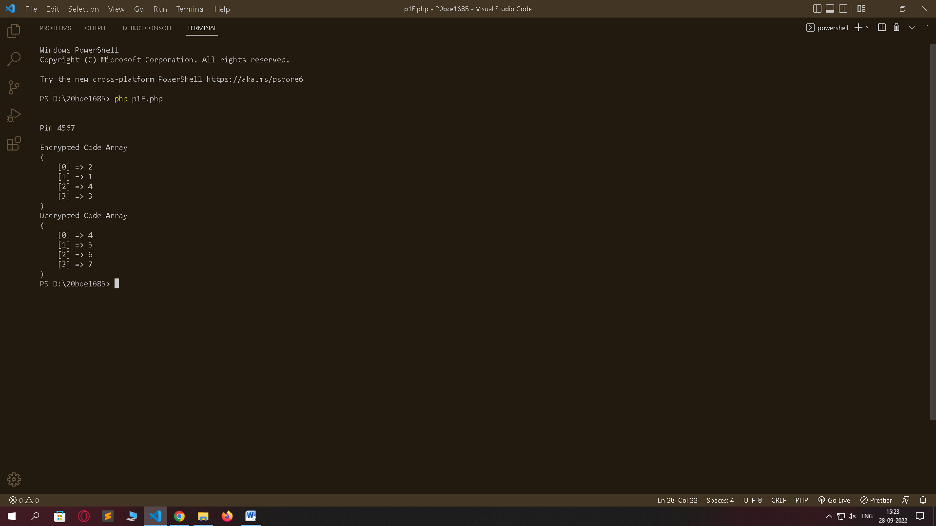

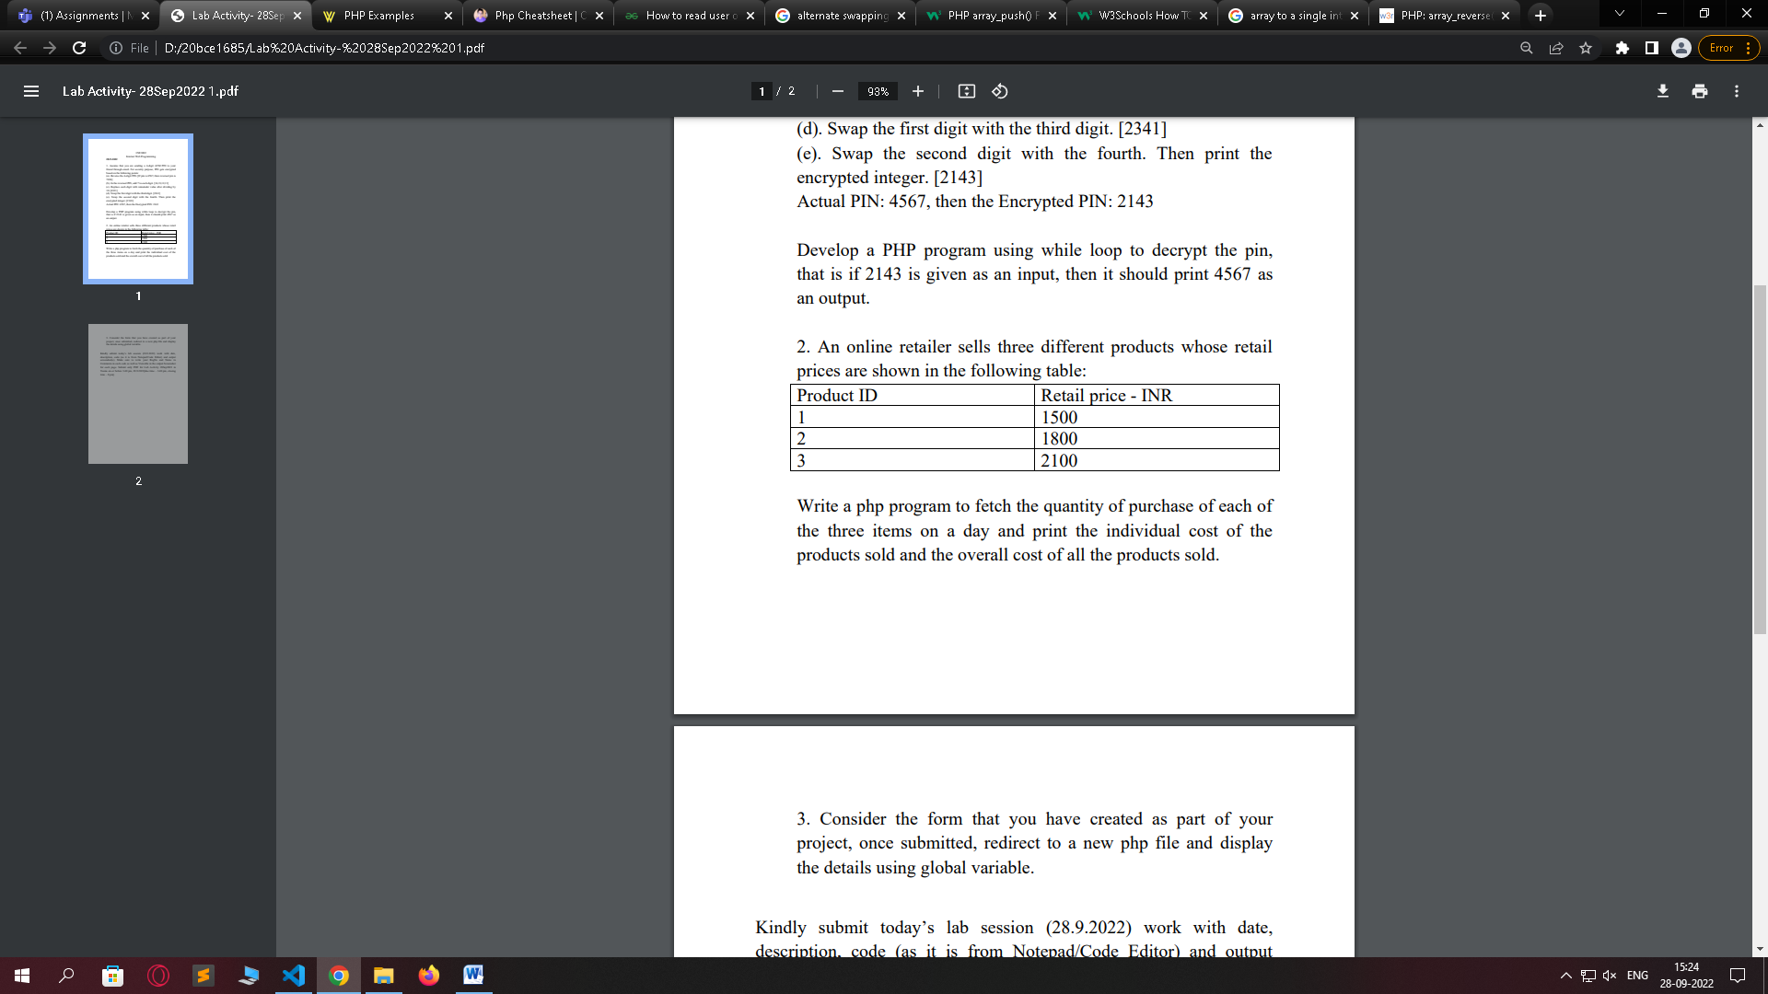

<?php

$q1 = (int)readline("Quantity(1) : ");

$q2 = (int)readline("Quantity(2) : ");

$q3 = (int)readline("Quantity(3) : ");

$r1 = 1500;

$r2 = 1800;

$r3 = 2100;

$p1 = $q1*$r1;

$p2 = $q2*$r2;

$p3 = $q3*$r3;

echo "Cost(1) : $p1 \n";

echo "Cost(2) : $p2 \n";

echo "Cost(3) : $p3 \n";

echo "Cost(Total) : ".$p1+$p2+$p3;

?>

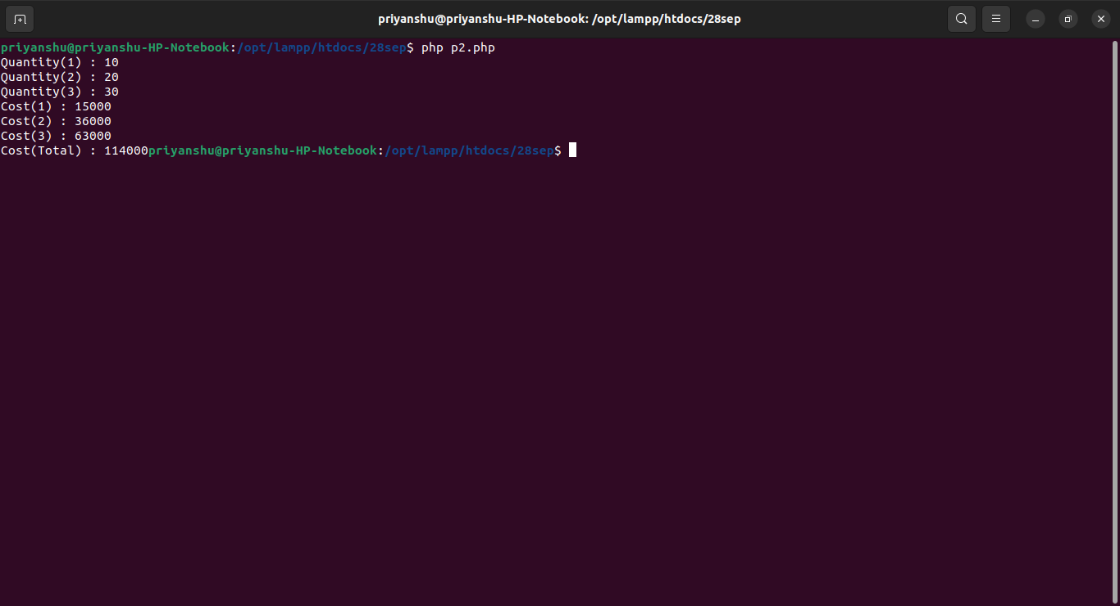



<?php

$name=$_POST['name'];

$email=$_POST['email'];

$mobile=$_POST['no'];

$topic=$_POST['topic'];

$msg=$_POST['msg'];

echo "NAME: $name <br> <br> EMAIL: $email <br> <br> MOBILE: $mobile <br> <br> TOPIC: $topic <br> <br> MESSAGE: $msg <br> <br> ";

?>

