# Lab 4:

Reg No. 20BCE1685 Name: PRIYANSHU VYAS

**CSE3002 10-08-2022**

Step-4:10.8.2022

Use JavaScript to validate the form created in “Step 2”. Also use box model and animation in your page.

**Index.html**

<!DOCTYPE html>

<!--PRIYANSHU VYAS 20BCE1685-->

<html>

<head>

  <title>CONTACT US</title>

  <link rel="stylesheet" href="styles.css">

  <link rel="script" href="script.js">

  <style>

    a::selection {

      color: skyblue;

      background-color: darkcyan;

    }

    div:hover {

      background-color: black;

    }

  </style>

</head>

<body align="center" bgcolor="black">

  <header id="header">

    <h1><a class="a" href="form.html" style="color: black;">CONTACT US</a></h1>

  </header>

  <div class="iframe">

    <iframe src="form.html" height="400" width="100%"> </iframe>

  </div>

  <footer name="footer">

    <marquee>DEVELOPED BY PRIYANSHU VYAS - 20BCE1685</marquee>

  </footer>

</body>

</html>

**form.html**

<!DOCTYPE html>

<html>

<head>

    <title>Form</title>

    <link rel="stylesheet" href="styles.css">

    <script src="script.js"></script>

</head>

<body>

    <div class="form">

        <p>LEAVE US A MESSAGE</p>

        <hr>

        <form name="MyForm" onsubmit="return validateForm()">

            <table align="center">

                <tr>

                    <td>Your Name</td>

                    <td><input type="text" name="name"></td>

                </tr>

                <tr>

                    <td>Your Email</td>

                    <td><input type="email" name="email"></td>

                </tr>

                <tr>

                    <td>Your Mobile Number</td>

                    <td><input type="tel" name="no"></td>

                </tr>

                <tr>

                    <td>Topic</td>

                    <td><select id="topic">

                            <option value="none">------- Please Select -------</option>

                            <option value="feedback">Feedback</option>

                            <option value="question">Question</option>

                            <option value="quotation">Quotation</option>

                            <option value="Others">Others</option>

                        </select></td>

                </tr>

                <tr>

                    <td>Your Message</td>

                    <td><textarea placeholder="Your Message" name="msg"></textarea></td>

                </tr>

                <tr>

                    <td>Enter the code in the box</td>

                    <td><input type="text" name="cap">

                        <img src="https://upload.wikimedia.org/wikipedia/commons/thumb/a/ad/RecaptchaLogo.svg/1200px-RecaptchaLogo.svg.png"

                            width=50 height=50 />

                    </td>

                </tr>

                <tr align="center">

                    <td colspan="2"><input type="submit"></td>

                </tr>

            </table>

        </form>

    </div>

</body>

</html>

**styles.css**

.form {

    background-color: white;

    padding: 3%;

}

#header {

    background-color: skyblue;

    margin: 5%;

    padding: 1%;

    margin-bottom: 0;

    border: solid darkcyan 10px;

    border-radius: 10px;

}

#header h1 {

    overflow: hidden;

    border-right: .15em solid black;

    white-space: nowrap;

    margin: 0 auto;

    letter-spacing: .15em;

    animation:

      typing 5s steps(40,end),

      blink-caret .75s step-end infinite;

}

@keyframes typing {

    from { width: 0 }

    to { width: 40% }

  }

@keyframes blink-caret {

    from, to { border-color: transparent }

    50% { border-color: skyblue; }

  }

.iframe {

    background-color: grey;

    margin: 5%;

    margin-top: 0;

    padding: 2%;

    border: solid white 10px;

    border-radius: 10px;

}

footer {

    color: aliceblue;

    position: fixed;

    bottom: 0;

    width: 100%;

    margin-bottom: 2%;

}

**script.js**

function validateForm() {

    var x = document.forms["MyForm"]["name"].value;

    if (x == "") {

      alert("Name must be filled out");

      return false;

    }

    var y = document.forms["MyForm"]["email"].value;

    if (y == "") {

      alert("Email cannot be Empty!!");

      return false;

    }

    var z = document.forms["MyForm"]["no"].value;

    if (z == "") {

      alert("Number must be filled out");

      return false;

    }

    var m = document.forms["MyForm"]["msg"].value;

    if (m == "") {

      alert("Message must be filled out, Please Specify the purpose!!");

      return false;

    }

    var select = document.getElementById('topic');

    var v = select.options[select.selectedIndex].value;

    if(v=="none") {

        alert("Please select a valid Topic");

        return false;

    }

    var c = document.forms["MyForm"]["cap"].value;

    if (c == "") {

      alert("Enter the captcha code..");

      return false;

    }

  }

**Output ScreenShot’s:**

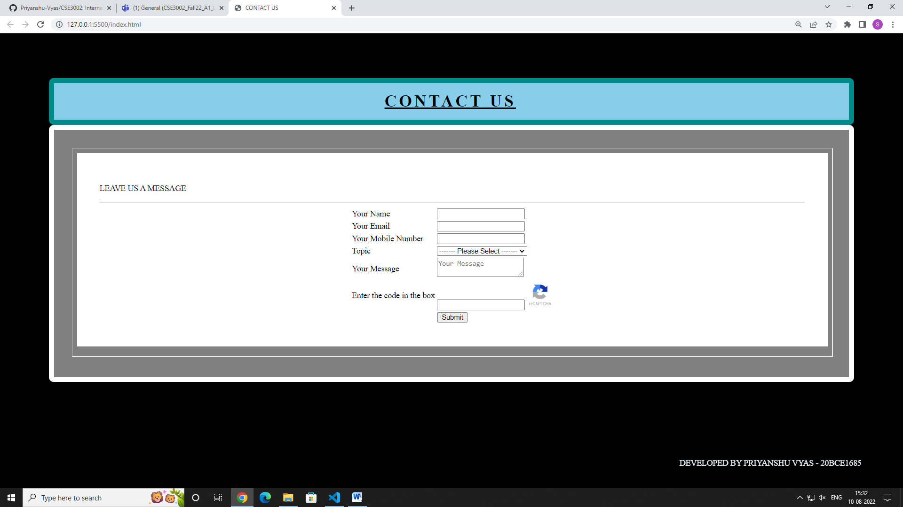

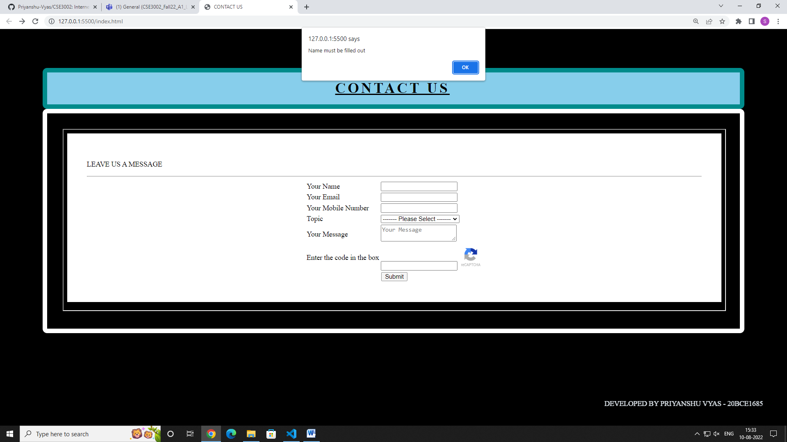

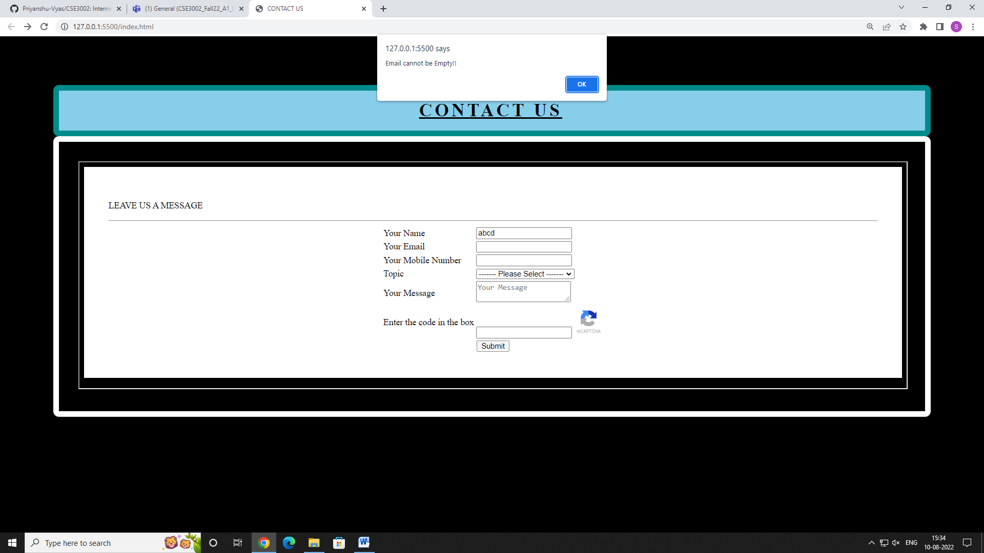

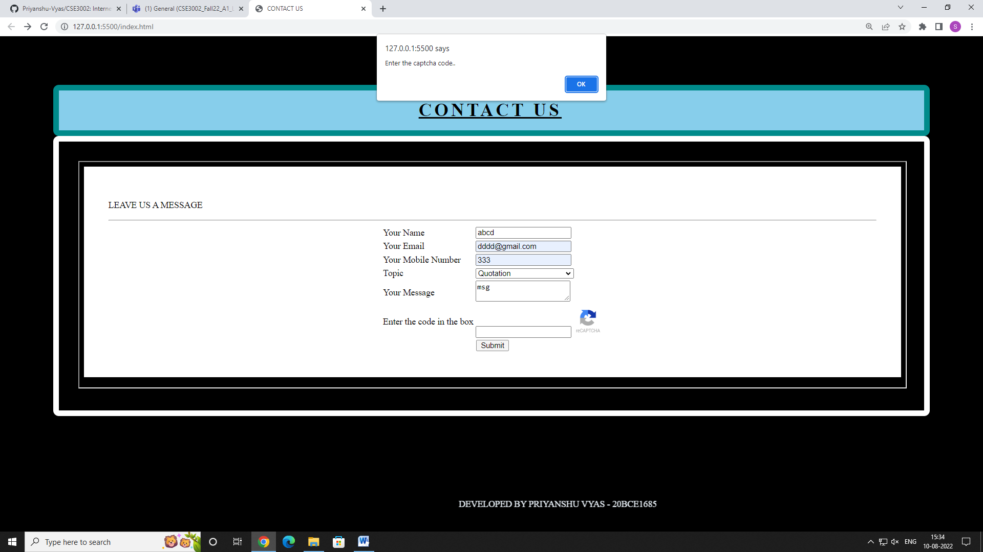

# Lab 5:

Reg No. 20BCE1685 Name: Priyanshu Vyas

CSE3002 - Internet Web Programming - 17-8-2022

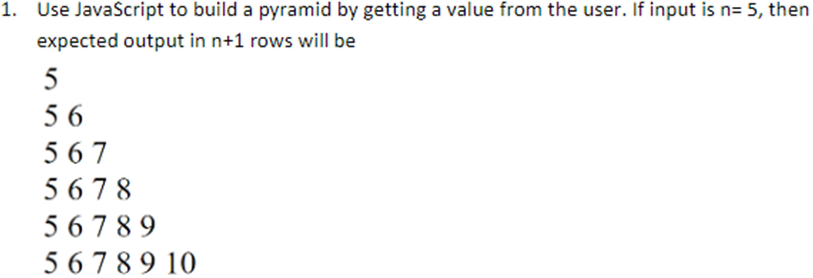

<!DOCTYPE html>

<!-- PRIYANSHU VYAS 20BCE1685 -->

<html>

<head>

<title>Lab Activity</title>

</head>

<body>

<h1>Pyramid Pattern</h1>

<br>

<script>

var a = prompt("Enter a Number: ",5); let n=Number(a);

for(var i=0;i<=n;i++)

{

for(var j=0;j<=i;j++)

{

document.write(j+n+"&nbsp;");

}

document.write("<br>");

}

</script>

</body>

</html>

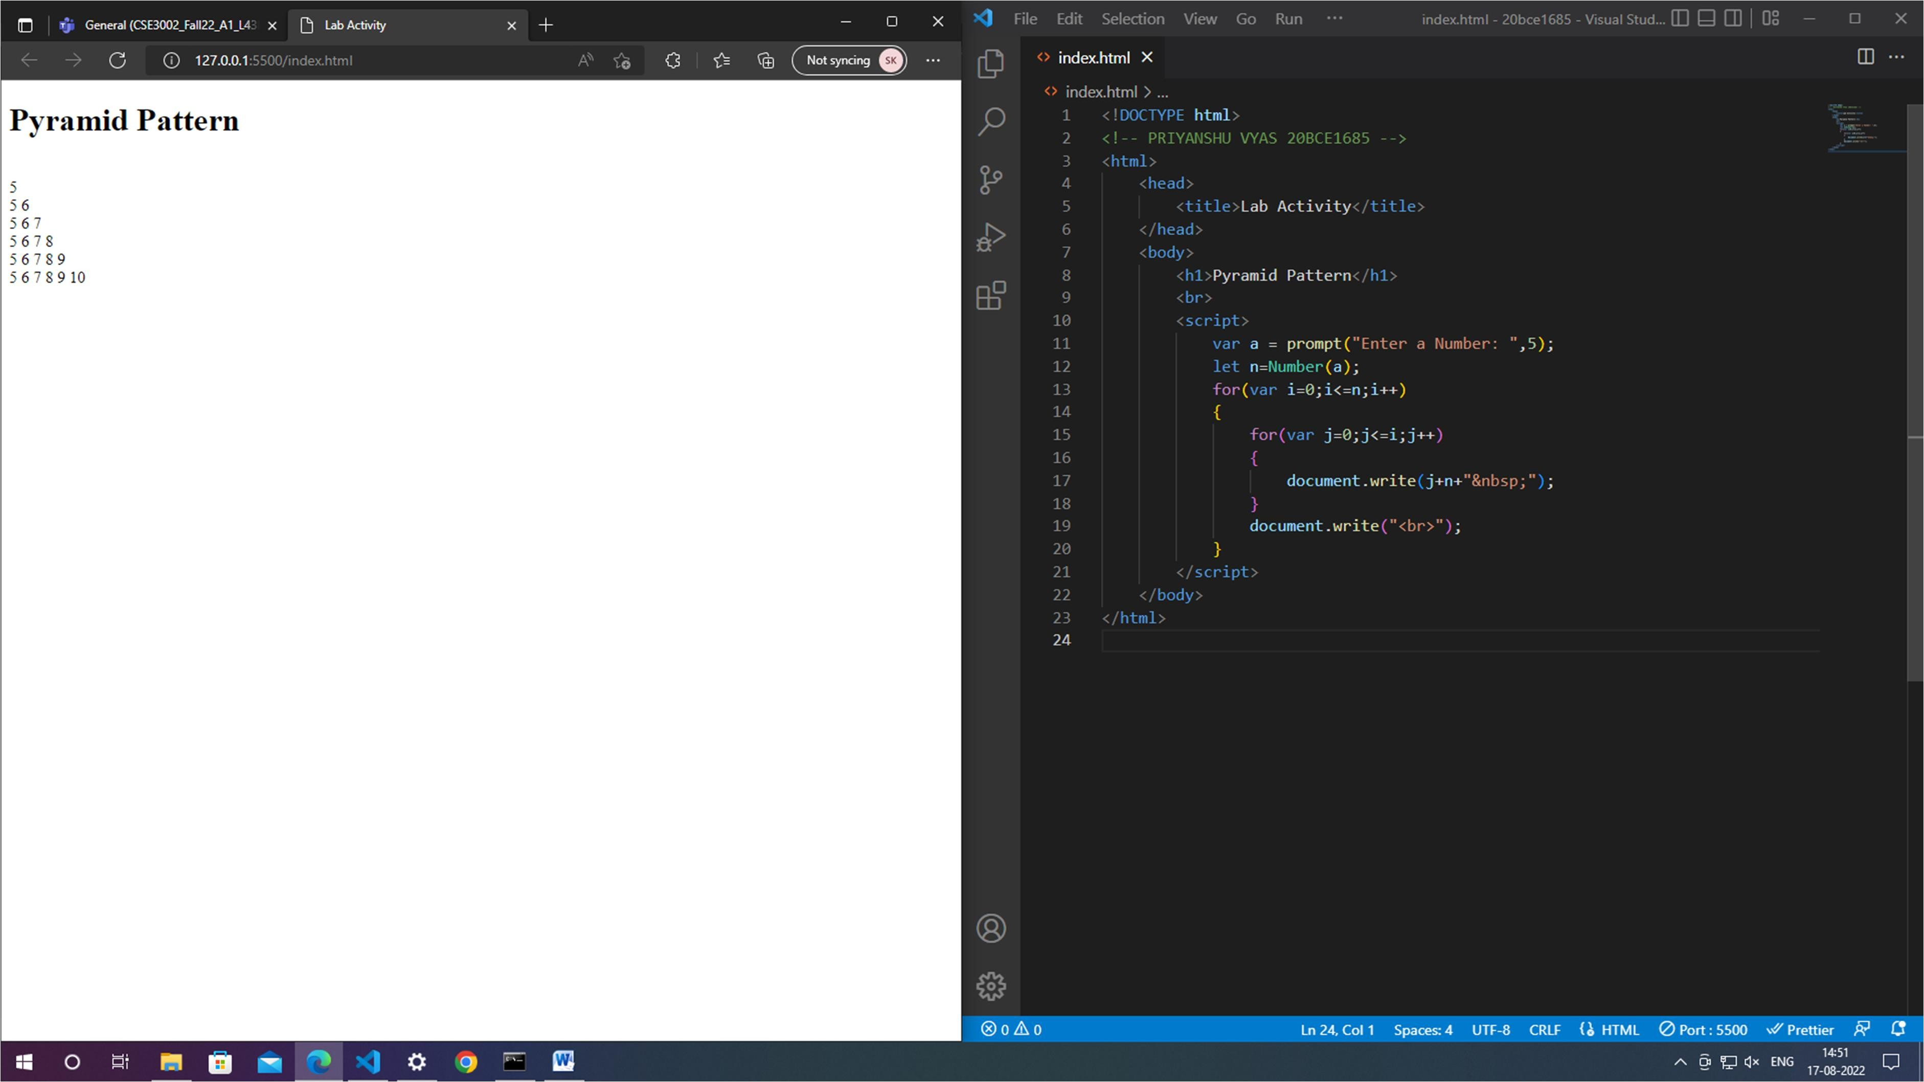

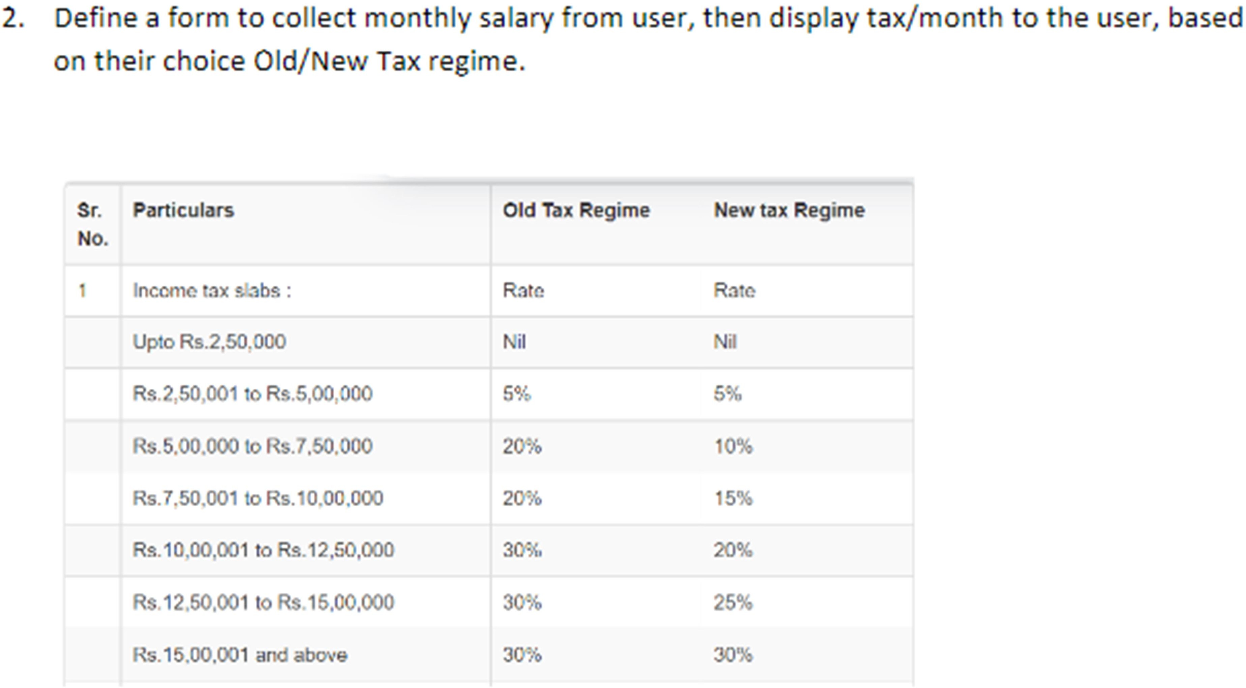

<!DOCTYPE html>

<html>

<head>

<title>Lab Activity 2</title>

</head>

<body>

<form>

<label>Monthly_salary: </label>

<input id="monthly_salary" type="text"><br><br>

<label>Tax_Regime: </label>

<select id="tax_regime">

<option value="old">Old</option>

<option value="new">New</option>

</select><br><br>

<input type="submit" onclick="f1()">

</form>

<script>

function f1() {

var S=Number(document.getElementById("monthly_salary").value); var T=document.getElementById("tax_regime").value;

var output; if(S<=250000) {

output=S;

}

else if(250001<=S && S<=500000) {

if(T=="old") { output=S*(5/100);

}

else {

output=S*(5/100);

}

}

else if(500000<=S && S<=750000) {

if(T=="old") { output=S*(20/100);

}

else {

output=S*(10/100);

}

}

else if(750001<=S && S<=1000000) {

if(T=="old") { output=S*(20/100);

}

else {

output=S*(15/100);

}

}

else if(1000001<=S && S<=1250000) {

if(T=="old") { output=S*(30/100);

}

else {

output=S*(20/100);

}

}

else if(1250001<=S && S<=1500000) {

if(T=="old") {

output=S*(30/100);

}

else {

output=S*(25/100);

}

}

else if(1500001<=S) { if(T=="old") {

output=S*(30/100);

}

else {

output=S*(30/100);

}

}

document.write("Tax/Month = " + output);

}

</script>

</body>

</html>

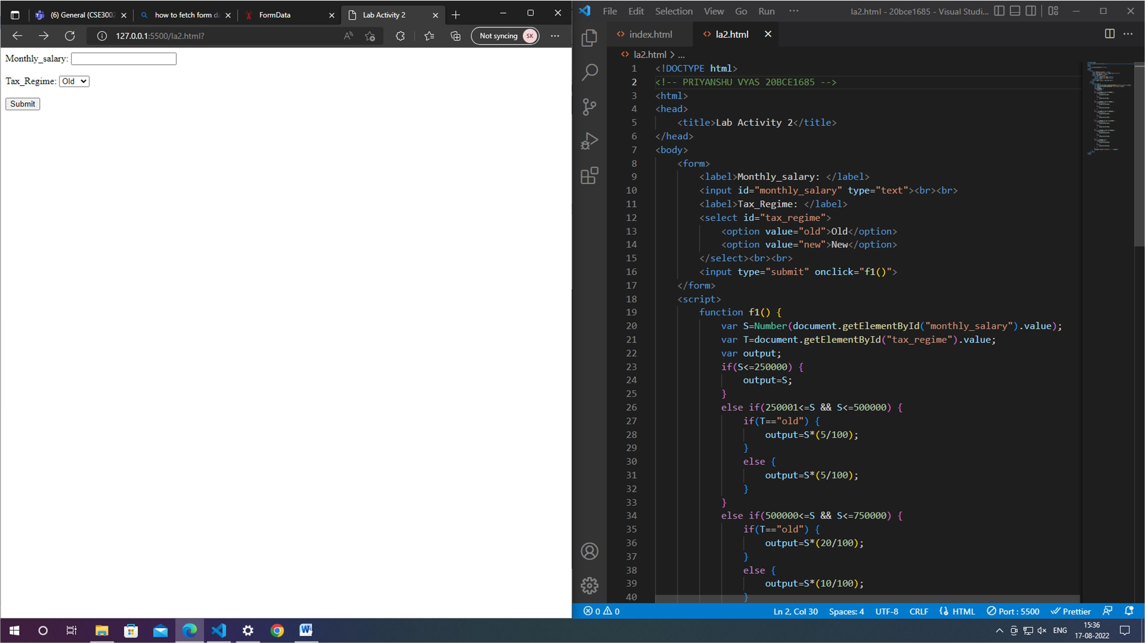

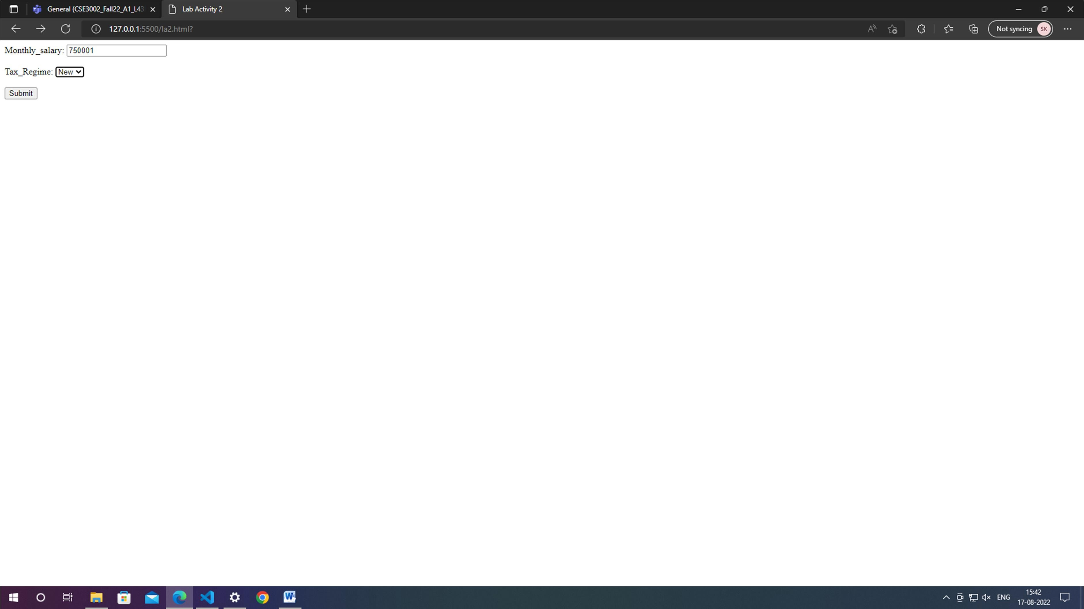

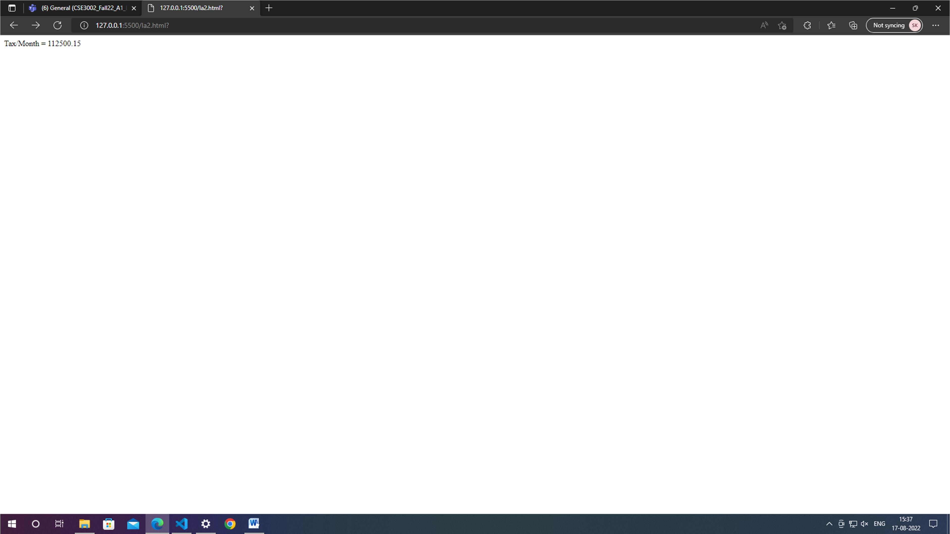

# Lab 6:

Reg No. 20BCE1685 Name: Priyanshu vyas

CSE3002 Internet Web Programming 24-8-2022

Design a page for VIT faculty to deal with various projects of IWP course, J component. Create the page with VIT logo on the middle and link the page to other pages like Review I, Review II and Review III. In home page, provide a form to collect Project name, Number of team members, Registration number, name and phone number of each member. Display a warning message below the form that maximum team size is 3. Display few information-like tentative dates, time and format for each review in the respective Review pages. Use map and area tags to identify middle part of the logo, on clicking it, redirect to VIT home page. Consolidate today’s lab session(24.8.2022)work with date, description, code (as it is from Notepad/Code Editor) and output screenshot(s)along with last two lab submission(10.8.2022 and 17.8.2022). Make sure to write your RegNo and Name in Comments in each code as well as Viewable in the output Screenshot for each page. Submit only PDF for Lab Activity 24Aug2022 in Teams on or before8 pm, 24.8.2022.

home.html

<!DOCTYPE *html*>

*<!-- PRIYANSHU VYAS 20BCE1685 -->*

<html>

  <head>

    <title>IWP</title>

  </head>

  <body align="center" bgcolor="skyblue">

    <h1>IWP Course - J Component</h1>

    <br />

    <br />

    <img

*style*="background-color: #272829"

*src*="https://vit.ac.in/vit-rank/assets/img/VIT-logo.png"

*alt*="VIT-logo"

*width*="10%"

*usemap*="#logomap"

    />

    <map *name*="logomap">

      <area *shape*="rect" *coords*="49,26,83,46" *alt*="VIT-logo" *href*="https://vit.ac.in/" />

    </map>

    <br />

    <br />

    <form>

      <table align="center" border="solid">

        <tr>

          <td>Project Name:</td>

          <td><input *type*="text" *required*/></td>

        </tr>

        <tr>

          <td>Number of team members:</td>

          <td><input *type*="number" *required*/></td>

        </tr>

        <tr>

          <td>Registration No.:</td>

          <td><input *type*="text" *required*/></td>

        </tr>

        <tr>

          <td>Name:</td>

          <td><input *type*="text" *required*/></td>

        </tr>

        <tr>

          <td>Phone No.:</td>

          <td><input *type*="tel" *required*/></td>

        </tr>

        <tr>

          <td *colspan*="2"><input *type*="submit" /></td>

        </tr>

      </table>

    </form>

    <br />

    <br />

    <code>Note: Team members must be less than or equal to 3.</code>

    <br />

    <br />

    <div *style*="display: flex; justify-content: center">

      <ul *style*="font-size: larger; list-style-type: square">

        <li><a *href*="review1.html">Review 1</a></li>

        <br />

        <li><a *href*="review2.html">Review 2</a></li>

        <br />

        <li><a *href*="review3.html">Review 3</a></li>

      </ul>

    </div>

    <br>

    <br>

    <footer>

      DEVELOPED BY - PRIYANSHU VYAS 20BCE1685

    </footer>

  </body>

</html>

Review 1

<!DOCTYPE *html*>

<html>

<head>

    <title>Review 1</title>

</head>

<body *style*="margin: 15%" align="center" bgcolor="skyblue">

    <h3><u>Tentative Dates</u></h3>

    <p>28 August 2022</p>

    <h3><u>Time</u></h3>

    <p>11:00:00 AM</p>

    <h3><u>Format</u></h3>

    <div *style*="display: flex; justify-content: center; font-size: larger;"><ol>

        <li>Project Title</li>

        <li>Introduction</li>

        <li>Motivation</li>

    </ol></div>

</body>

</html>

Review 2

<!DOCTYPE *html*>

<html>

<head>

    <title>Review 2</title>

</head>

<body *style*="margin: 15%" align="center" bgcolor="skyblue">

    <h3><u>Tentative Dates</u></h3>

    <p>12 September 2022</p>

    <h3><u>Time</u></h3>

    <p>01:00:00 PM</p>

    <h3><u>Format</u></h3>

    <div *style*="display: flex; justify-content: center; font-size: larger;"><ol>

        <li>Tools Required</li>

        <li>Project Details</li>

        <li>Sample code</li>

    </ol></div>

</body>

</html>

Review 3

<!DOCTYPE *html*>

<html>

<head>

    <title>Review 3</title>

</head>

<body *style*="margin: 15%" align="center" bgcolor="skyblue">

    <h3><u>Tentative Dates</u></h3>

    <p>10 October 2022</p>

    <h3><u>Time</u></h3>

    <p>02:00:00 PM</p>

    <h3><u>Format</u></h3>

    <div *style*="display: flex; justify-content: center; font-size: larger;"><ol>

        <li>Input Screenshots</li>

        <li>Output Screenshots</li>

        <li>References</li>

    </ol></div>

</body>

</html>

