**Name: Priyanshu Vyas**

**Reg No. 20BCE1685**

**Course: CSE3002 Internet Web Programming**

**Title: Lab-9 [21-09-2022]**

Question:

Create a page to display your Project information like title of your project, Team members’ details...Use text file for “Description” of your project and display the same using Ajax, while clicking on “Description”. Individual team members[Name, Regno, Hobby, Phno, cgpa]info has to be appended using JQuery in the portal, while clicking on any team member’s Regno. Add new class while hovering over the members and add few CSS properties.

Code:

<!DOCTYPE html>

<!-- PRIYANSHU VYAS 20BCE1685 -->

<!-- Project information -->

<html>

<head>

<title>Ajax with JQuery</title>

<style>

#container {

opacity: 0.8;

background-color: #ccc;

position: fixed;

width: 100%;

height: 100%;

top: 0px;

left: 0px;

z-index: 1000;

background: lightblue;

text-align: center;

}

.table td a {

color: black;

}

#details {

display: flex;

justify-content: center;

column-gap: 7%;

}

</style>

</head>

<body>

<div id="container">

<h1>Project Title: Computer Accessories</h1>

<br />

<button id="des">Click here to see project Description</button>

<br />

<p id="desc"></p>

<br />

<br />

<div id="details">

<table border class="table">

<th>Team Members</th>

<th>Reg No.</th>

<tr>

<td>Priyanshu Vyas</td>

<td><button id="20bce1685">20BCE1685</button></td>

</tr>

<tr>

<td>Aditya Bhardwaj</td>

<td><button id="20bce1216">20BCE1216</button></td>

</tr>

<tr>

<td>Himanshu baid</td>

<td><button id="20bce1259">20BCE1159</button></td>

</tr>

</table>

<div id="20BCE1685"></div>

<div id="20BCE1216"></div>

<div id="20BCE1259"></div>

</div>

</div>

<script src="https://ajax.googleapis.com/ajax/libs/jquery/3.6.1/jquery.min.js"></script>

<script>

$(function () {

$("#des").click(function () {

const xhttp = new XMLHttpRequest();

xhttp.onload = function () {

$("#desc").html(this.responseText);

};

xhttp.open("GET", "desc.txt", true);

xhttp.send();

});

$("#20bce1685").click(function () {

const xhttp = new XMLHttpRequest();

xhttp.onload = function () {

$("#20BCE1685").html(this.responseText);

};

xhttp.open("GET", "20BCE1685.txt", true);

xhttp.send();

});

$("#20bce1216").click(function () {

const xhttp = new XMLHttpRequest();

xhttp.onload = function () {

$("#20BCE1216").html(this.responseText);

};

xhttp.open("GET", "20BCE1216.txt", true);

xhttp.send();

});

$("#20bce1259").click(function () {

const xhttp = new XMLHttpRequest();

xhttp.onload = function () {

$("#20BCE1259").html(this.responseText);

};

xhttp.open("GET", "20BCE1259.txt", true);

xhttp.send();

});

});

</script>

</body>

</html>

text-files:

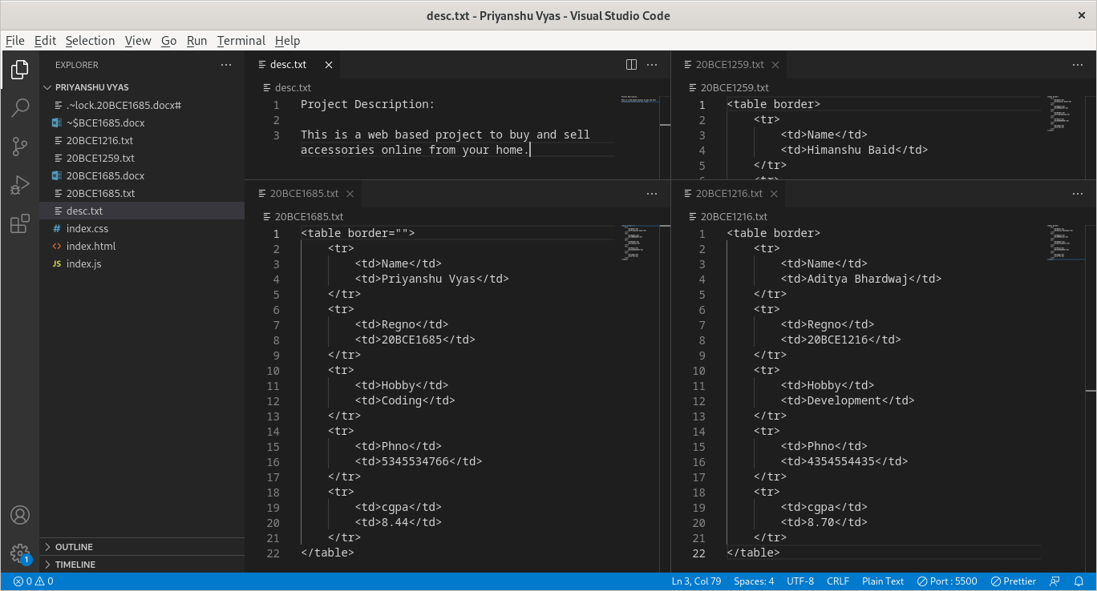

Output:

