Reg No. 20BCE1685 Name: Priyanshu Vyas

Week 6 - Lab Program Submission
Ques:
Write and implement Openmp program:

1. Matrix multiplication:

Algorithm:
(i) Intialise two matrices mat1 and mat2 of size r1*c1 and r2*c2.
(ii) if c1 is not equal to r2 return with exit message as “matrix multiplication not possible”.
(iii) traverse row wise in mat1 and column wise in mat2 and multiply the elements.
(iv) store the sum of matrix multiplication of step (iii) in new matrix res of size r1*c2.
(v) Resultant Matrix multiplication is stored in matrix res.

Code:
#include<stdio.h>
#include<omp.h>
#include<time.h>
#include<stdlib.h>
int main(int argc,char *argv[])
{
omp_set_num_threads(atoi(argv[1]));
int r1,c1;
printf("Enter no of rows and columns of matrix 1:");
scanf("%d%d",&r1,&c1);
int mat1[r1][c1];
printf("Enter Matrix 1:\n");
for(int i=0;i<r1;i++)
{
for(int j=0;j<c1;j++)
{
scanf("%d",&mat1[i][j]);
}
}
int r2,c2;
printf("Enter no of rows and columns of matrix 2:");
scanf("%d%d",&r2,&c2);
int mat2[r2][c2];
printf("Enter Matrix 2:\n");
for(int i=0;i<r2;i++)
{
for(int j=0;j<c2;j++)
{
scanf("%d",&mat2[i][j]);
}
}

if(c1!=r2)
{
printf("Matrix Multiplication Not Possible!!");
return 0;
}
int res[r1][c2];
for(int i=0;i<r1;i++)
{
for(int j=0;j<c2;j++)
{
res[i][j]=0;
}
}
clock_t t;
t=clock();
#pragma omp parallel for collapse(3)
for(int i=0;i<r1;i++)
{
for(int j=0;j<c2;j++)
{
for(int k=0;k<c1;k++)
{
res[i][j]+=mat1[i][k]*mat2[k][j];
}
}
}
t=clock()-t;
printf("Resultant Matrix:\n");
for(int i=0;i<r1;i++)
{
for(int j=0;j<c2;j++)
{
printf("%d ",res[i][j]);
}
printf("\n");
}

printf("Execution time is %lf ms.\n",(double)t/CLOCKS_PER_SEC);
}

Ouput:
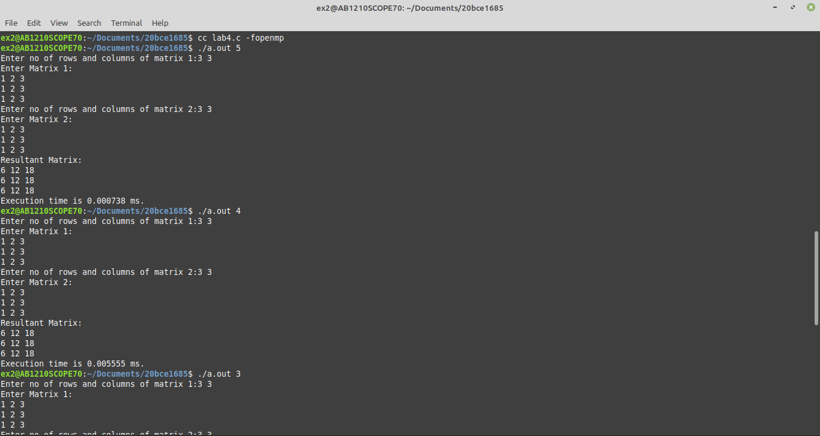
Graph:

2. Travelling Salesman Problem:

Algorithm:
(i) Consider city 1 as the starting and ending point.
(ii) Generate all (n-1)! Permutations of cities.
(iii) Calculate the cost of every permutation and keep track of the minimum cost permutation.
(iv) Return the permutation with minimum cost.

Code:

Output:

Graph:

