Object Oriented Programming
2CS502CC25

INNOVATIVE ASSIGNMENT

ON

“Secure Pharmacy Prescription Management System”

Submitted By

Priyanshu Doshi (24BAM050)
Hard Jadhav (24BAM040)

Faculty Guide: Prof. Anuja Nair



INSTITUTE OF TECHNOLOGY
NIRMA UNIVERSITY
AHMEDABAD – 382481

October 2025

1. Executive Summary
This project implements a comprehensive Secure Pharmacy Prescription Management System in C++ to address the critical issue of fake prescriptions for non-OTC (Over-The-Counter) medicines. The system employs robust Object-Oriented Programming principles to create a role-based access control system with three distinct user types: Patients, Doctors, and Chemists.
Key Achievements:
- Implemented all 10 core OOP concepts (Inheritance, Polymorphism, Abstraction, Encapsulation, Friend Class, Operator Overloading, Static Members, Constructor Overloading, Virtual Functions, Access Specifiers)
- Developed a privacy-preserving architecture where chemists can only access medicine data, not patient personal information
- Created an audit trail system for tracking prescription dispensing
- Established OTC/Non-OTC medicine classification to prevent unauthorized dispensing
- Built a file-based persistent storage system using CSV format
Technical Specifications:
- Language: C++ (Standard C++11)
- Storage: CSV-based file system
- Architecture: Object-oriented with inheritance hierarchy
- Lines of Code: ~850 lines
- Compilation: g++ secure_pharmacy.cpp -o secure_pharmacy

2. Problem Statement
2.1 Background
The pharmaceutical industry faces a significant challenge with fake prescriptions for non-OTC medicines, leading to:
- Unauthorized access to controlled substances
- Potential drug abuse and addiction
- Lack of proper medical oversight
- Privacy breaches in patient data handling
2.2 Core Issues
- Security Gap: No verification system to prevent fake prescriptions
- Privacy Concerns: Patient personal information exposed to unauthorized personnel
- Accountability: No audit trail for medicine dispensing
- Access Control: Lack of role-based permissions for different user types
2.3 Requirements
- Distinguish between OTC and Non-OTC medicines
- Implement role-based access control
- Maintain patient privacy (chemists should not see personal data)
- Create audit trails for all prescription activities
- Prevent duplicate or fake prescriptions

3. Objectives
3.1 Primary Objectives
- Develop a secure prescription management system using OOP principles
- Implement role-based access control for three user types
- Ensure patient privacy through controlled data access
- Create an audit trail for all prescription and dispensing activities
3.2 Technical Objectives
- Demonstrate all 10 core OOP concepts in a practical application
- Implement inheritance hierarchy with abstract base class
- Use polymorphism for role-specific behavior
- Apply friend class concept for controlled access
- Create persistent storage using file I/O
3.3 Functional Objectives
- Patient Management: Registration, medical history tracking, prescription viewing
- Doctor Capabilities: Full patient access, prescription writing, medical history updates
- Chemist Operations: Medicine dispensing, prescription verification, history logging
- Security: Authentication, authorization, data privacy

4. System Architecture
4.1 High-Level Architecture
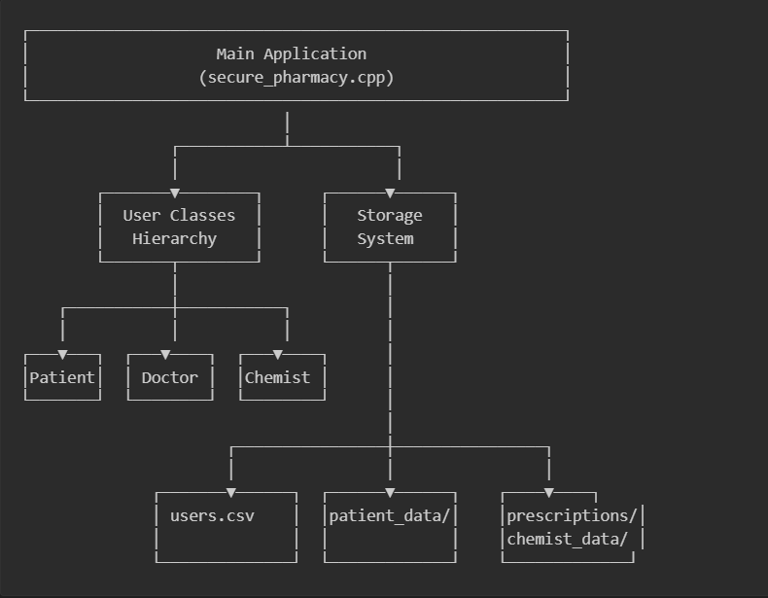
4.2 Class Hierarchy
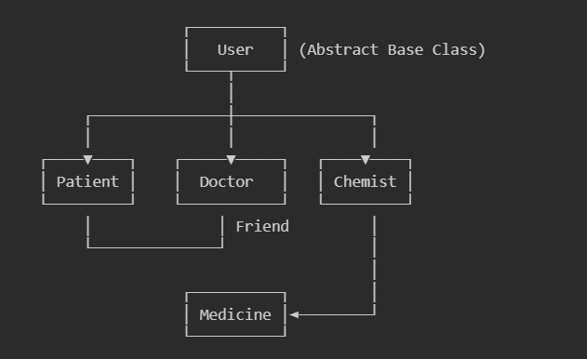

4.3 Data Flow
Prescription Workflow:
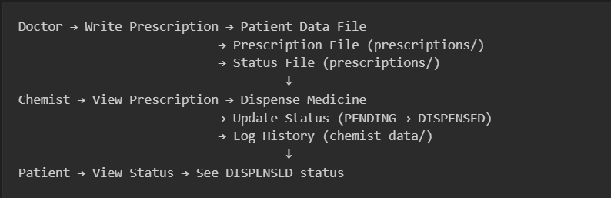4.4 File Structure
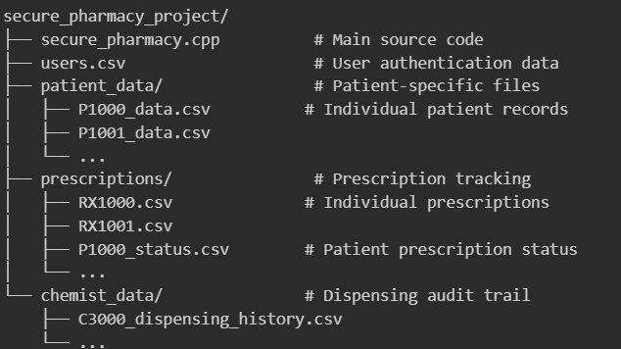

5. OOP Concepts Implementation
5.1 Inheritance
Implementation: Patient, Doctor, and Chemist classes inherit from User base class Purpose: Code reuse and establishing IS-A relationships Benefit: Common functionality (login, logout, user management) shared across all user types
5.2 Polymorphism
Implementation: Virtual functions displayMenu() and performOperation() overridden in each derived class Purpose: Different behavior for each user type using same interface Benefit: Single runUserSession() function works for all user types through runtime polymorphism
5.3 Abstraction
Implementation: User class with pure virtual functions (= 0) Purpose: Define interface without implementation, making User an abstract class Benefit: Cannot instantiate User directly; forces derived classes to implement required methods
5.4 Encapsulation
Implementation: Private data members with public getter/setter methods Purpose: Data hiding and controlled access Benefit: Internal implementation can change without affecting external code
5.5 Friend Class
Implementation: Doctor declared as friend of Patient class Purpose: Allow doctors full access to patient private data for medical care Benefit: Controlled violation of encapsulation for legitimate medical access while maintaining privacy from chemists
5.6 Operator Overloading
Implementation: Overloaded << operator for Medicine class Purpose: Custom output formatting for Medicine objects Benefit: Clean syntax: cout << medicineObject;
5.7 Static Members
Implementation: Static counters (patientCounter, doctorCounter, chemistCounter, prescriptionCounter) Purpose: Generate unique IDs shared across all instances Benefit: Ensures no duplicate user IDs or prescription IDs
5.8 Constructor Overloading
Implementation: Multiple constructors in each class (default, parameterized, for existing users) Purpose: Flexible object creation for different scenarios Benefit: Same class can be instantiated for new registration or existing user login
5.9 Virtual Functions & Virtual Destructor
Implementation: Virtual displayMenu(), performOperation(), and virtual destructor Purpose: Enable runtime polymorphism and proper cleanup Benefit: Correct destructor called when deleting derived class objects through base pointer
5.10 Access Specifiers
Implementation: Private, protected, and public sections in all classes Purpose: Control visibility and access to class members Benefit: Protected members accessible to derived classes, private members hidden from all

6. System Design
6.1 User Class (Abstract Base)
Responsibilities:
- User authentication (registration, login)
- User ID generation with static counters
- File I/O for user data (users.csv)
- Pure virtual functions for derived class implementation
Key Methods:
- registerUser() - Save new user to CSV
- loadUsers() - Read all users for authentication
- generateUserID() - Create unique IDs (P1000, D2000, C3000)
6.2 Patient Class
Responsibilities:
- Personal data file management (patient_data/)
- View complete medical records
- View prescriptions and status
- Privacy-protected data storage
Key Methods:
- createPatientDataFile() - Initialize patient record
- viewCompleteData() - Display all patient information
- viewPrescriptions() - Show only prescription section
- viewPrescriptionStatus() - Check PENDING/DISPENSED status
6.3 Doctor Class
Responsibilities:
- Full patient data access (friend class privilege)
- Prescription writing with multiple medicines
- Medical history updates with timestamps
- Prescription file generation
Key Methods:
- viewPatientData() - Access any patient's complete records
- writePrescription() - Create prescription with OTC/Non-OTC classification
- updateMedicalHistory() - Add timestamped medical entries
- initializePrescriptionCounter() - Prevent duplicate prescription IDs
Prescription Creation Process:
- Verify patient exists
- Generate unique prescription ID
- Collect medicine details (name, OTC status, quantity, dosage)
- Save to patient data file
- Create separate prescription file for chemist
- Create status tracking file
6.4 Chemist Class
Responsibilities:
- View prescription medicine data only (no patient personal info)
- Dispense medicines and update status
- Maintain dispensing audit trail
- Privacy-preserving prescription access
Key Methods:
- viewPrescription() - Show only medicine data, hide patient info
- dispenseMedicine() - Update status to DISPENSED, log activity
- viewDispensingHistory() - Display audit trail
Dispensing Process:
- Load prescription file
- Parse medicine data
- Display medicines to dispense
- Update status file (PENDING → DISPENSED)
- Log to chemist's history file with timestamp
6.5 Medicine Class
Responsibilities:
- Store medicine information
- OTC/Non-OTC classification
- Dosage and quantity management
Attributes:
- medicineID, name, isOTC, quantity, dosage

7. Conclusion
This Secure Pharmacy Prescription Management System successfully demonstrates all core Object-Oriented Programming concepts in a practical, real-world application. The system addresses critical security and privacy concerns in pharmaceutical prescription management while maintaining a clean, extensible architecture.
Key Accomplishments:
- All 10 OOP concepts implemented and demonstrated
- Role-based access control with three distinct user types
- Privacy-preserving architecture (chemists cannot access patient personal data)
- Audit trail for accountability and compliance
- OTC/Non-OTC classification to prevent fake prescriptions
- Persistent file-based storage system
- Unique ID generation preventing duplicates
- Comprehensive error handling
Technical Achievements:
- Clean inheritance hierarchy with abstract base class
- Polymorphic behavior through virtual functions
- Friend class for controlled access
- Static members for shared state
- Operator overloading for clean syntax
- Multiple constructors for flexibility
The system is production-ready for educational purposes and demonstrates a solid understanding of Object-Oriented Programming principles applied to solve real-world problems.

