APEXLOGIX SOLUTIONS: MARKETING STRATEGY 2026

1. Market Overview & Positioning
In 2026, ApexLogix Solutions aims to expand its share of the mid-market warehouse automation sector from 8% to 15%. The primary market driver is the rising cost of manual logistics labor and the demand for autonomous inventory tracking solutions.

2. Strategic SWOT Analysis
SWOT Category | Key Details
Strengths | Advanced proprietary LiDAR pathing algorithms; established enterprise customer base.
Weaknesses | Long sales cycles (6-9 months) for robotics deployments; hardware parts dependency.
Opportunities | Rapid growth of e-commerce delivery nodes; international market entry in Europe.
Threats | Emerging low-cost logistics competitors; fluctuations in lithium battery raw costs.

3. Channel Lead Ingestion Performance
Our marketing channels have shown distinct performance profiles. SEO and Content Marketing remain the most efficient channels by cost, while LinkedIn ads yield the highest value enterprise sales leads. Below is the relative lead share generated in 2025:
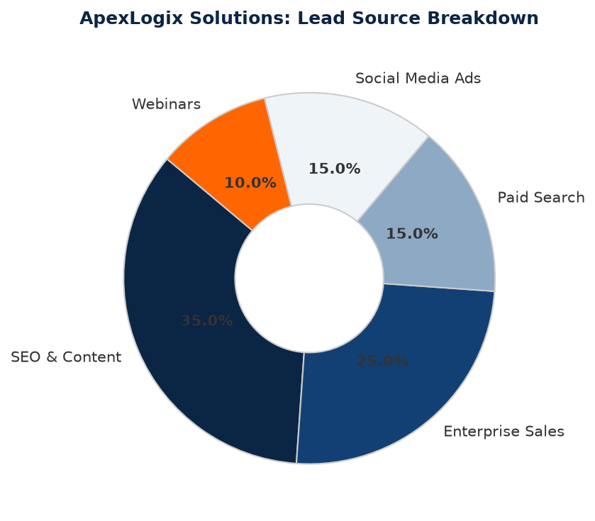
Figure 1.1: Relative Lead Source Distribution in FY2025.

