APEXLOGIX SOLUTIONS: WAREHOUSE ROBOTICS DEPLOYMENT SOP

1. Purpose and Scope
This Standard Operating Procedure (SOP) defines the operational guidelines for commissioning and testing the ApexLogix AR-200 Autonomous Mobile Robot (AMR) fleet in client fulfillment facilities. This covers physical setup, sensor calibrations, and automated pick pathing.

2. Pre-Deployment Configuration Checklist
Before activating robots on the warehouse floor, field engineers must complete the physical inspection checklist below:
Step Number | Check Procedure | Validation Action Required | Domain
Step 1 | Hardware Mounting Check | Verify LiDAR sensors (RL-101) and Mecanum wheels are securely attached. | Mechanical
Step 2 | Battery Voltage Verify | Confirm Lithium battery packs (RL-505) are fully charged to 54.2V. | Electrical
Step 3 | Firmware Upload & Boot | Flash embedded Controller Board (RL-404) with firmware version 4.8.1. | Compute
Step 4 | Local Telemetry Sync | Verify MQTT connection status via the local facility broker endpoint. | Network

3. Robot Performance Trends
Fulfillment center efficiency is tracked using the average items picked per hour per robot. The chart below shows performance growth across our three primary active customer sites during 2025 following the implementation of this SOP:
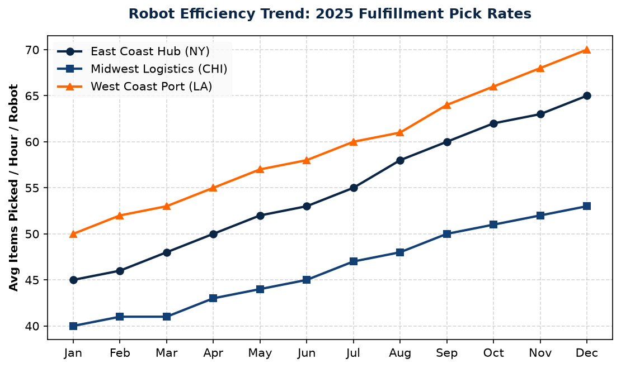
Figure 2.1: Monthly Average Pick Rates by Logistics Center (2025).

