APEXLOGIX SOLUTIONS: SYSTEM ARCHITECTURE DESIGN

1. Architecture Overview
The ApexLogix platform utilizes a highly modular microservices design to scale telemetry ingestion and robot path routing. The layout consists of an API Gateway reverse proxy routing incoming traffic to specialized domain services. PostgreSQL is used for relational transactional storage, while TimescaleDB captures the high-frequency robot telemetry metrics.
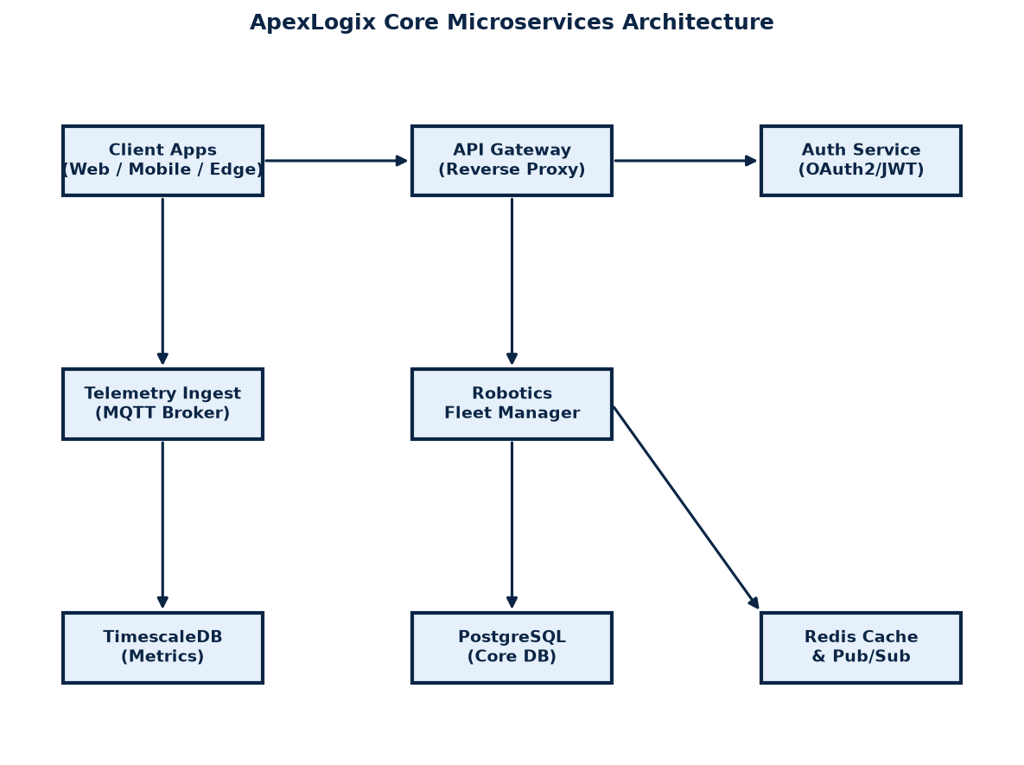
Figure 3.1: Microservices and Storage Layer Layout Diagram.

2. Robot Telemetry Table Schema
Telemetry reports are streamed via MQTT every 500ms from active robots. The metrics are ingested and stored in the relational timeseries table structured as follows:
Column Name | Data Type | Constraint & Description
id | BIGINT | PRIMARY KEY, auto-incrementing unique identifier.
robot_id | VARCHAR(36) | UUID referencing the unique active robot registration.
timestamp | TIMESTAMPTZ | UTC time coordinates of packet transmission.
battery_level | NUMERIC(4,2) | Percentage value indicating battery power (0.00% to 100.00%).
x_coord / y_coord | REAL | Position coordinates relative to the warehouse grid coordinates.
status_code | INTEGER | Status enum value: 0=Idle, 1=Routing, 2=Charging, 3=Fault.
error_log | TEXT | Optional field containing error codes or system traceback dump.

