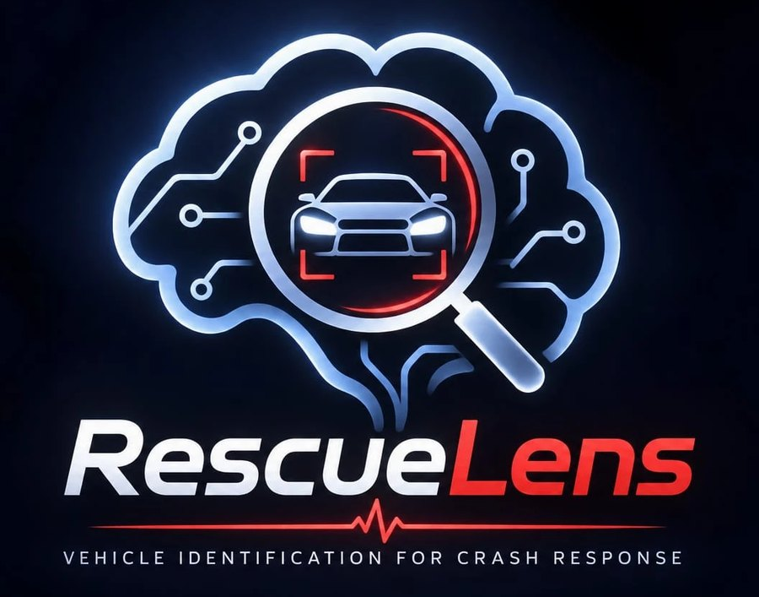

Hackathon Technical Solution Report
Field | Details
Problem ID | P5
Problem Title | Intelligent Fine-Grained Vehicle Recognition and Analysis System
Team Name | T50 "Clover"
Team Members | Priyanshu Kumar Senapati (1RUA24CSE0337), Saatwik Kumar Yadav (1RUA24CSE0390), Rachana Bhaskar Gowda (1RUA24CSE0348), R Muni Disnitha (1RUA24CSE0345)
GitHub Repository | https://github.com/Priyanshu-senapati/Rescuelens (commit eb587b6, the code and results this report describes)
Live Demo / Deployment | https://priyanshu-senapati--rescuelens-web.us-east.modal.run

Work Division
Member | Owns
Priyanshu Kumar Senapati | Classifier training, calibration, safety metrics, deployment
Saatwik Kumar Yadav | Product and UI: live camera, crash handling, browser tests, CI
Rachana Bhaskar Gowda | Safety content and real-world validation
R Muni Disnitha | Evidence, documentation and demo

AI Assistance Declaration
Tool | Used by | Used for
Claude Code (Anthropic) | Priyanshu Kumar Senapati | Classifier training, calibration, safety metrics and deployment
Claude Code (Anthropic) | Saatwik Kumar Yadav | Live camera, rescue-sheet drawing, stress sweep, crash screen, offline mode, browser tests and CI; finding and reading the manufacturer guides and statistics; README, viva sheets and charts; drafting this report

Most of the text in this report was drafted with Claude Code from our code and evaluation results.

1. Problem Understanding & Solution Strategy
- Core Technical Challenge: Stanford Cars asks for one label out of 196, and many of those labels are nearly the same car. An Audi S5 and an Audi A5 differ mainly in the grille, bumpers and badges, and that pair was our most frequent test error (15 photos). A Hyundai Sonata and a Sonata Hybrid share a body. Real photos then add darkness, smoke, blur, low resolution, occlusion and awkward angles.
We built this for crash response, where a wrong answer has a real cost. Rescuers need to know the model before cutting, because hybrids and EVs carry high-voltage batteries and cables that can't be seen from outside, and at a crash the plate or VIN may be crushed or hidden. So we had two failures to design against: missing a hybrid, and confidently naming a car the model has never seen, which is likely because the dataset stops at 2012 and covers US-market cars. Our constraints were a public web app usable from a phone, an answer well inside the 10 seconds the rubric allows, and a CPU-only host with 2 cores and 2 GB of memory.
- Proposed Methodology: A fine-tuned YOLO11s finds the vehicle, classical computer vision measures whether the photo can be trusted, and a ConvNeXt-Small classifies the crop. A safety layer then turns calibrated probabilities into one of three answers (identified, not certain, not recognised) and warns about high voltage whenever the 9 hybrid and EV classes together reach 5%. We went with this instead of a static baseline because classical features alone reached 13.72% top-1, the network on the whole photo reached 91.66%, and trusting only the top answer missed 4.32% of hybrids and EVs against 1.15% with the summed rule.
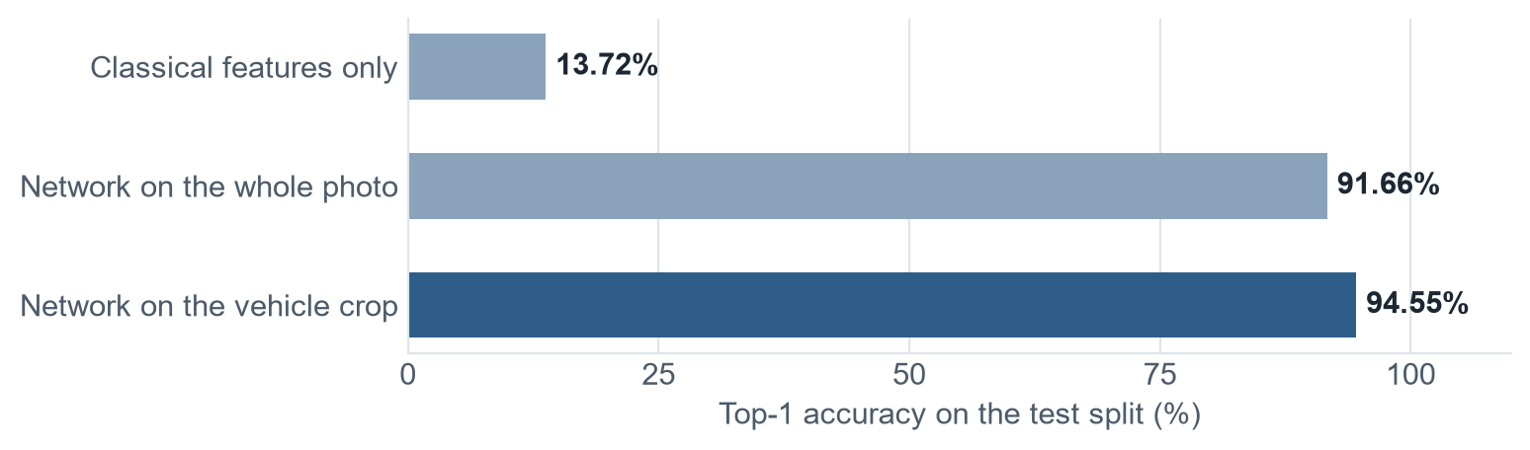

2. Technical Architecture & Implementation
The code is split by job: backend/app/classical.py (classical CV), models.py (ONNX models), safety.py (decision rules), pipeline.py (orchestration) and main.py (API and input validation). Training lives in training/ and the React interface in frontend/. docs/design.md has the full reasoning.
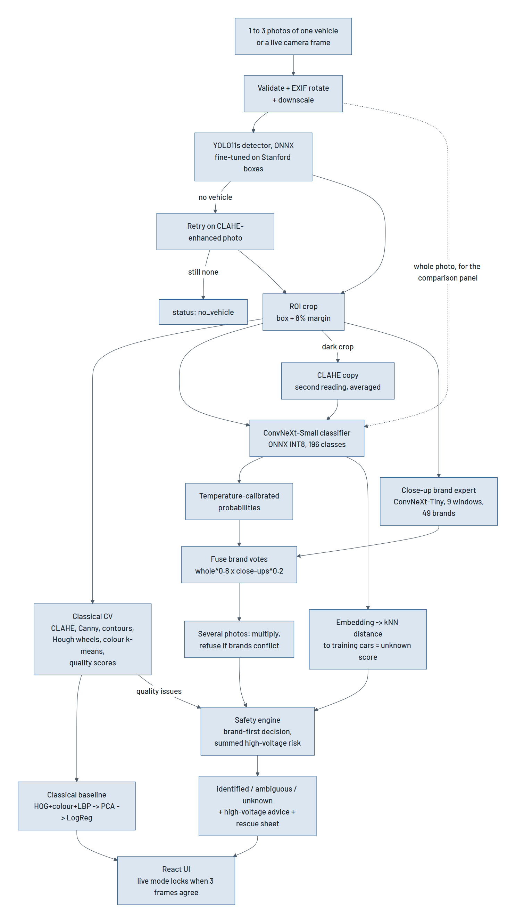

2.1 Classical Algorithmic Baseline
- Algorithms Utilized:
P5 requirement | What we used
Preprocessing and normalization | EXIF rotation, downscaling to 1600 px, CLAHE on the LAB lightness channel, ImageNet normalization
Edges and contours | Bilateral filter, Canny, morphological closing, largest outer contour as the body outline
Colour and texture | HSV histogram, k-means dominant colours on the central 70% of the crop, 8-neighbour LBP histogram
Region of interest | Detector box plus an 8% margin, the same rule used in training
Geometry | Aspect ratio, contour extent and solidity, Hough circles for wheels and a wheelbase ratio

For the required comparison we also trained a classical-only classifier: HOG, HSV colour, LBP and aspect ratio, reduced with PCA and passed to logistic regression. It reached 13.72% top-1 and 34.03% top-5.
- Adaptive Selection Logic: Canny thresholds come from the photo itself, at 0.66 and 1.33 times the median grey level. The Hough search is scaled to the car: it looks only in the lower 60% of the crop, for radii between 8% and 30% of the crop height. CLAHE settings are fixed (clip limit 2.0, 8x8 grid), but when CLAHE runs depends on the input. It retries detection if the first pass finds nothing, and it gives the classifier a second reading when the crop's brightness falls below 30 out of 100. Checks on brightness, contrast, Laplacian sharpness, resolution and cut-off produce plain reasons such as "Low light" or "Blurry", shown beside the answer.

2.2 Deep Learning Pipeline
- Model Architecture:
Model | Role | Why
ConvNeXt-Small, 384 px, 49.6 M parameters | 196-class classifier | ImageNet-22k weights transfer well to fine-grained work. We trained ConvNeXt-Tiny first, then moved up: validation top-1 rose from 93.74% to 94.23%, and unseen cars caught rose from 88.3% to 96.7%
YOLO11s, 640 px | Vehicle detector | Started from COCO weights, then fine-tuned for 20 epochs on the Stanford train boxes as one class. Mean IoU rose from 0.886 to 0.954
ConvNeXt-Tiny, 224 px windows | Close-up brand expert | Badges are a few pixels wide in a 384 px view of a whole car, so this model votes on 49 brands over 9 zoomed windows

- Loss Functions & Training: The classifier uses cross-entropy with label smoothing of 0.1 and AdamW (learning rate 2e-4, weight decay 0.05), with a one-epoch warm-up, cosine decay, mixed precision and stochastic depth of 0.1. Augmentation covers random resized crops, flips, colour jitter, random darkening to mimic night, and random erasing to mimic occlusion. The dataset is Stanford Cars: we split the official training images 90/10 with stratification and seed 42, kept the best validation epoch, and used the 8,041 test images only for final numbers. The brand expert uses the same loss with AdamW, and the detector uses the default Ultralytics losses. Temperature scaling on validation (T = 0.768) brought calibration error (ECE) from 0.098 to 0.011. For deployment we export to ONNX and apply dynamic INT8 quantization to the MatMul and Gemm layers, since ConvNeXt's heavy layers are linear and ONNX Runtime's CPU provider lacks ConvInteger support for int8.

2.3 Hybrid Integration & Adaptive Mechanism
- Fusion Strategy: The classical and deep parts connect in a few places. Detection decides the crop the classifier sees. CLAHE gives detection a second try in dark scenes and gives the classifier a second reading on dark crops, averaged with the first. Quality measurements explain low confidence to the user. We also tried late fusion of classical and deep probabilities, and the best weight on validation came out as 0, so the classical model wasn't adding anything the network didn't already have, and we left it out of classification. The brand expert is fused with the whole-car brand totals by a product rule (whole^0.8 x close-ups^0.2), chosen on validation. A user can also add up to 3 photos of one vehicle: their probabilities are multiplied, and photos that confidently name different brands are never merged.
- Decision Logic: The template's example is about balancing amplification against noise. For us the equivalent question is how much to conclude from uncertain evidence:
1. The brand with the most summed probability wins, then the strongest family inside it, then the likeliest model, so a lone top guess can't overrule the combined evidence for another brand.
2. The answer stops at the deepest level it is sure of: a model at 0.6 or above, then a family at 0.6 or above, and otherwise the brand alone.
3. A car is called unknown when its brand probability is below 0.5, or when its embedding is far from the training cars. That distance is 1 minus the mean cosine similarity to the 5 nearest training embeddings, with the threshold at the 95th percentile of validation scores (0.369).
4. The high-voltage warning uses summed probability with a threshold of 0.05, the lowest we tested, because a missed high-voltage car can kill and a false alarm only costs time. Unknown cars are treated as possibly high voltage. When a hybrid or EV is likely, the app shows where its battery and cables are, taken from the manufacturer's guide for all 9 models (docs/hazard-sources.md).
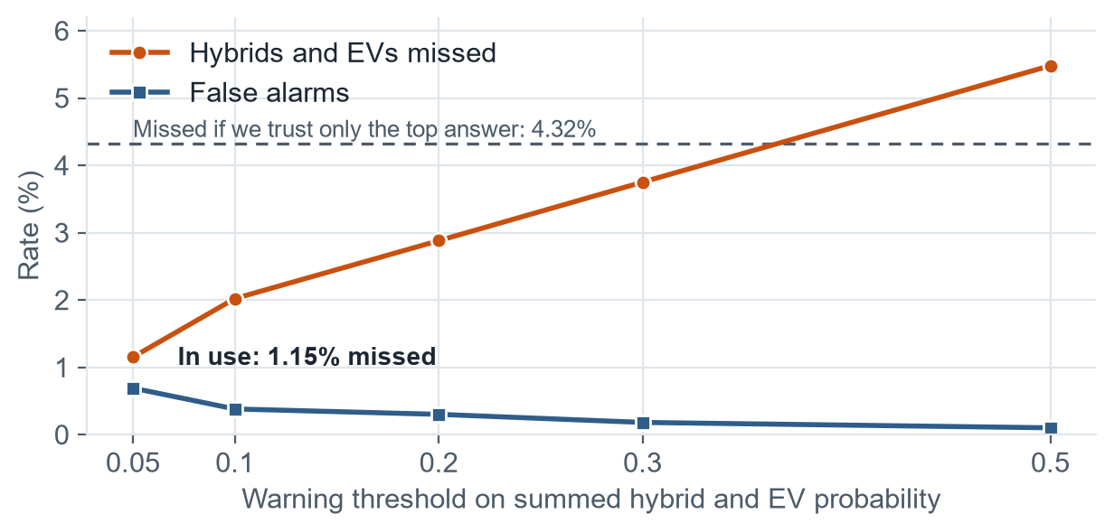

3. Experimental Benchmarks & Evaluation

3.1 Quantitative Benchmarks
The template's PSNR, SSIM and LPIPS columns measure image enhancement and don't apply to P5, so we report the metrics P5 asks for. All numbers come from eval_P5_T50.md unless stated otherwise. The scripts in training/ and tools/ produce them, and the README lists the steps. The dataset, model files and the test photos for the unseen-car and crash rows aren't stored in git, so they have to be supplied to rerun those tests.
Approach / Model Variant | Top-1 ↑ | Top-5 ↑ | Mean IoU ↑ | Latency
Classical Baseline | 13.72% | 34.03% | 0.639 (edge contours) | Not timed separately
Deep Learning Only (whole photo) | 91.66% | Not measured | No localization | 302 ms (classifier, 2 CPU threads)
Proposed Hybrid System | 94.55% | 99.27% | 0.954 | About 1 to 2 s (full answer, live site)

P5 metric | Result
Classification | Top-1 94.55%, top-5 99.27%, 94.70% with flip TTA
Object localization | Mean IoU 0.954, with 99.85% of boxes at IoU 0.5 or above (COCO weights: 0.886 and 92.81%)
Object detection | mAP@0.5 0.999, mAP@0.5:0.95 0.941 (COCO weights: 0.892 and 0.825)
Model efficiency | Classifier 189.4 MB to 54.3 MB, 739 ms to 302 ms on 2 CPU threads, accuracy unchanged at 93.67% on a 300-image check
Confidence | ECE 0.098 to 0.011. Most confident 90% of photos: 97.58% accurate
Missed hybrids and EVs (347 photos) | 1.15% with the summed rule, 4.32% trusting the top answer, 0.69% false alarms
Cars outside the 196 classes (60 photos, 30 models) | 96.67% answered unknown, while 8.33% of known cars were wrongly flagged
Brand accuracy, 49 brands | 98.61% on clean photos, 92.05% with 30% of the vehicle hidden
Real crash photos (48) | 44 declined. Of 3 confident answers, 1 was wrong

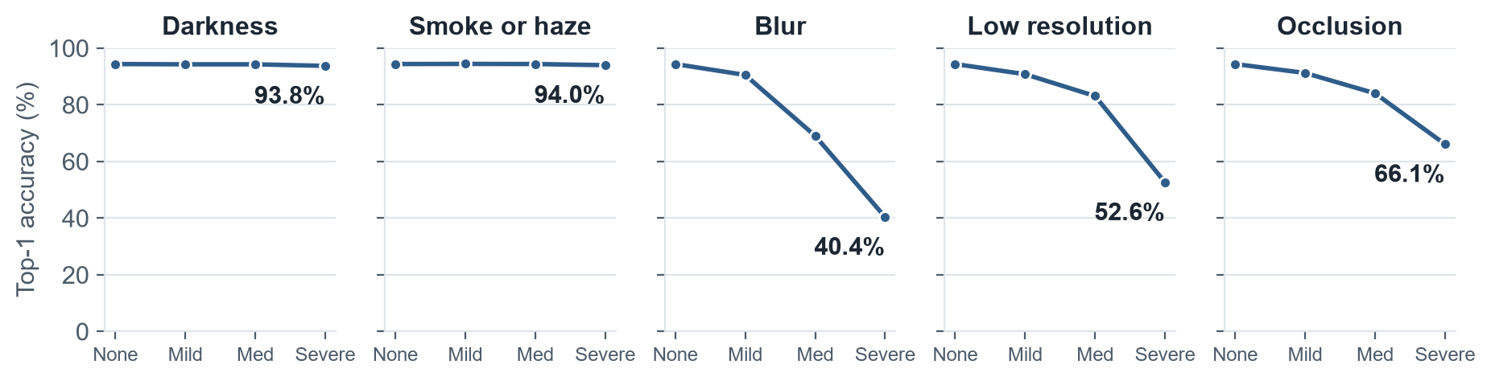
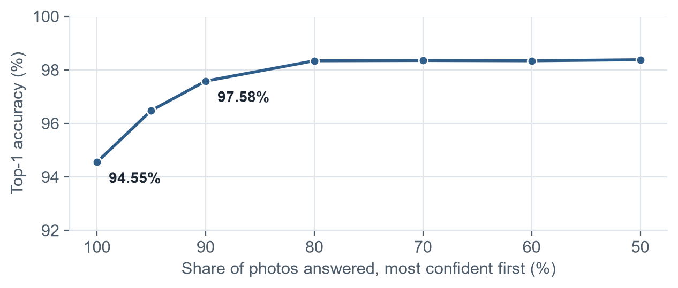
- Analysis: The crop helped accuracy the most. Quantization helped speed the most, and we measured no accuracy loss from it on our 300-image check. Darkness and haze barely hurt because training already darkens images, while blur and low resolution remove the fine detail this task depends on. The summed rule trades a small rise in false alarms for far fewer missed hybrids. With all the models running, a full answer on the live site takes about 1 to 2 s, well inside the 10-second limit.
The 94.55% figure was measured on crops from the dataset's annotated boxes, with the classifier alone. It doesn't include errors from our detector, or the brand expert and night reading, which we tested separately. With 99.85% of detector boxes at IoU 0.5 or above we'd expect the full pipeline to be close, but we haven't measured that number. The robustness and high-voltage figures have the same limit.

3.2 Visual Outputs & Intermediate Representations
1. Extreme low-light: In the top row of the figure below, step 1 is a dark photo and step 2 is the CLAHE-enhanced version. The live model still identifies this car as an Audi S4 Sedan 2012 at about 91%.
2. Non-uniform / backlit scenes: We didn't test backlit scenes as a separate condition. CLAHE works on local tiles, which limits overexposure of bright regions. The closest thing we have is partial occlusion: in the stress sweep below, a BMW holds "Identified" up to 75% on the occlusion slider, then turns to "Not recognised" with the warning on.
3. Intermediate states: Every classical step is returned as an image and shown in the app: original with box, contrast boost, edges, contours, vehicle region, wheels and colour.
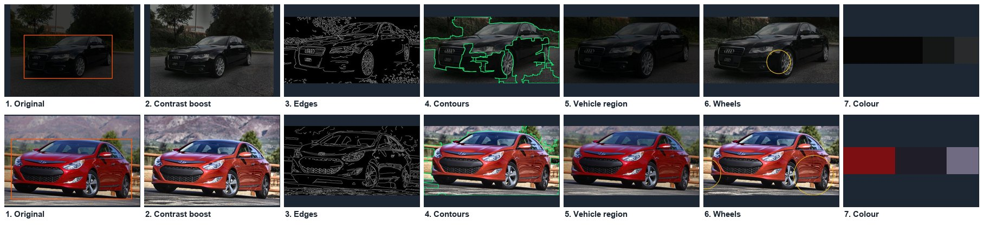
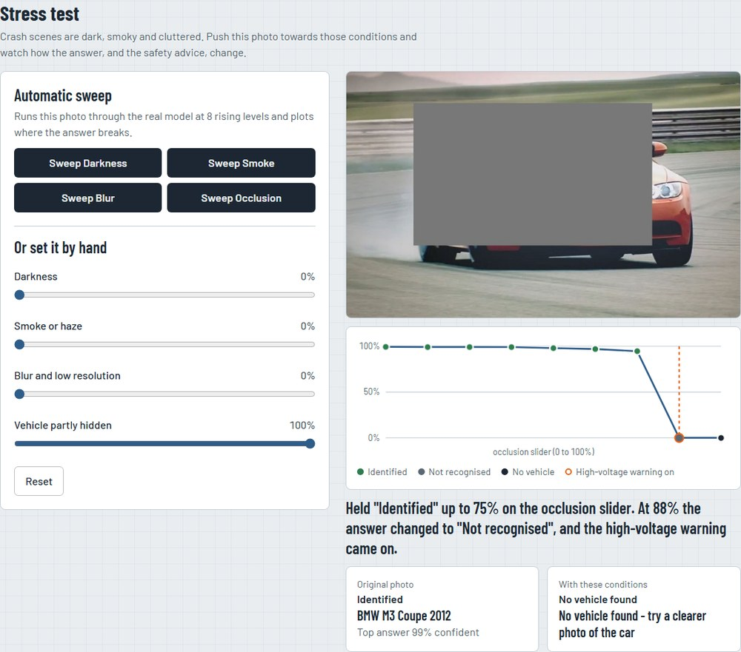
The three answers from the real model: a Tesla Model S identified with its battery location, a Chevrolet Silverado with its rear hidden answered as "not certain", and a Tata Nexon, which isn't in the dataset, answered as "not recognised".
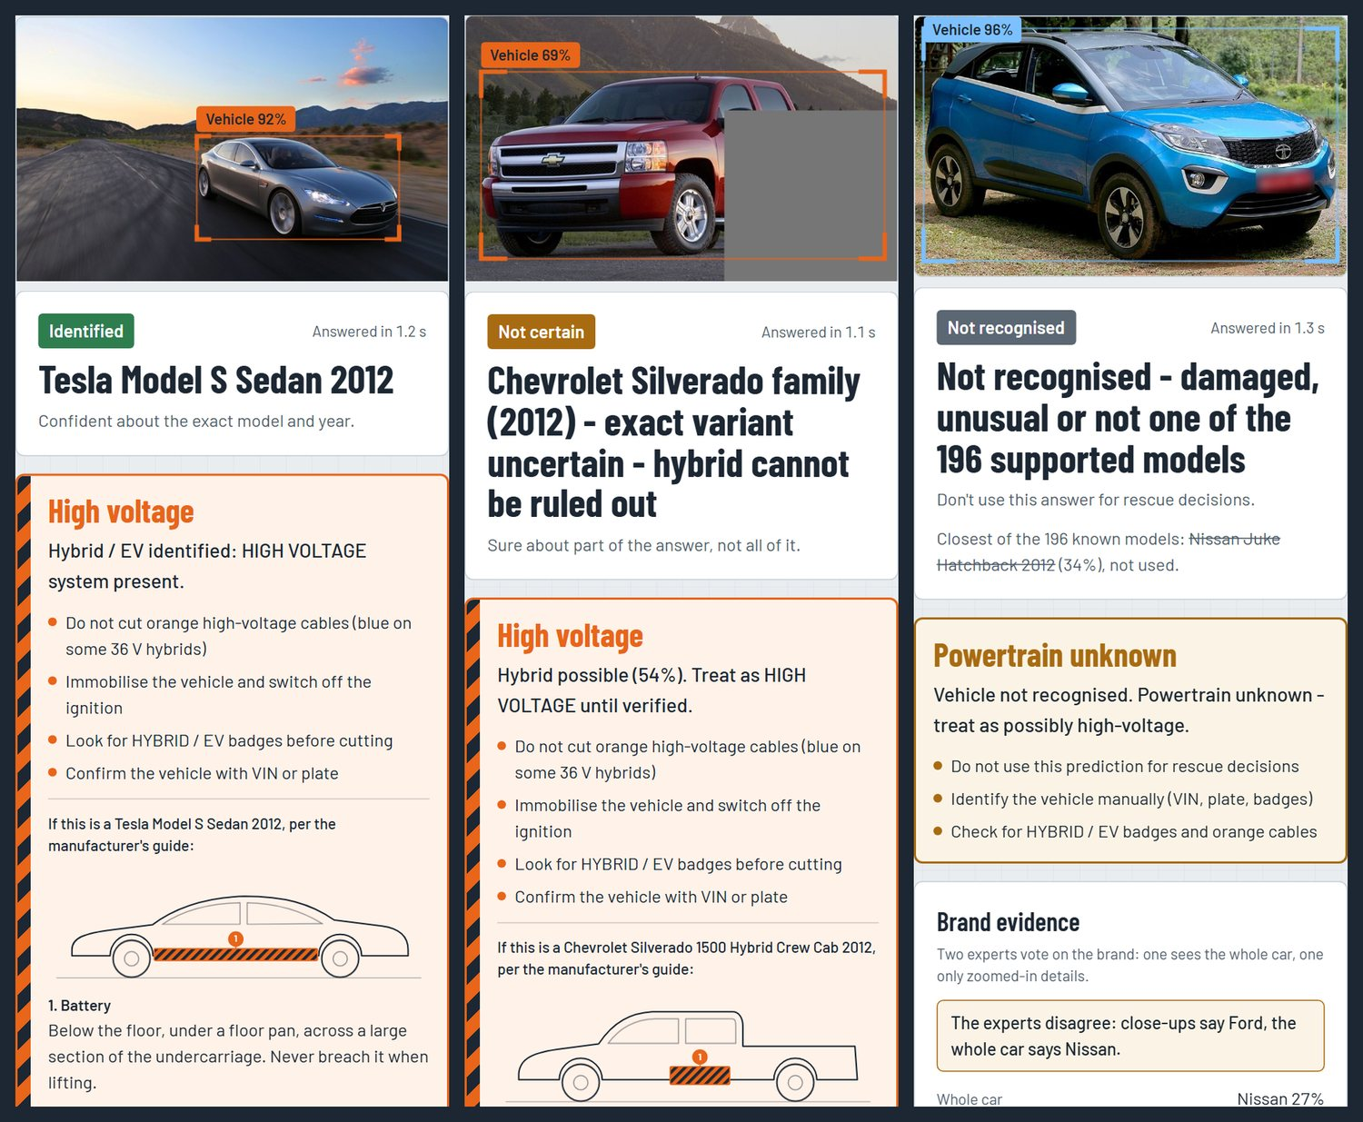

3.3 Ablation Study
Variant | Top-1 | What it shows
Full system | 94.55% | Reference
Without classical fusion | 94.55% | No change. The fusion weight was 0 on validation
Without the crop (whole photo) | 91.66% | The crop adds 2.89 points, the biggest single gain
With flip TTA | 94.70% | Adds 0.15 points for double the inference time, so we left it out
FP32 instead of INT8 (300 images) | 93.67% vs 93.67% | Quantization lost nothing on this subset
CLAHE before the classifier, severe darkness | 93.75% to 93.90% | Very little, because training already darkens images

Some gains don't show up in top-1. Fine-tuning the detector raised mean IoU from 0.886 to 0.954, and the brand expert raised brand accuracy from 98.30% to 98.61% on clean photos and from 90.75% to 92.05% with 30% hidden. The night reading was neutral to +0.5 points on artificially darkened photos.

4. Failure Modes & Limitations
- Observed Failure Case: Our most serious failure is the Mahindra Thar. On 8 new photos on the live model, 5 came back "Identified: Jeep Wrangler" at 65 to 99% with no high-voltage warning, and the other 3 were answered unknown. Other failures: an Audi S5 taken for an A5 (15 test photos), a Tahoe Hybrid with its upper rear hidden taken for an Avalanche at 98% with no warning, top-1 falling to 40.40% under severe blur, and the brand being right only 22.92% of the time on 48 real crash photos, where it declined 44 but made 1 confident wrong call (a wrecked Ford called a Chevrolet).
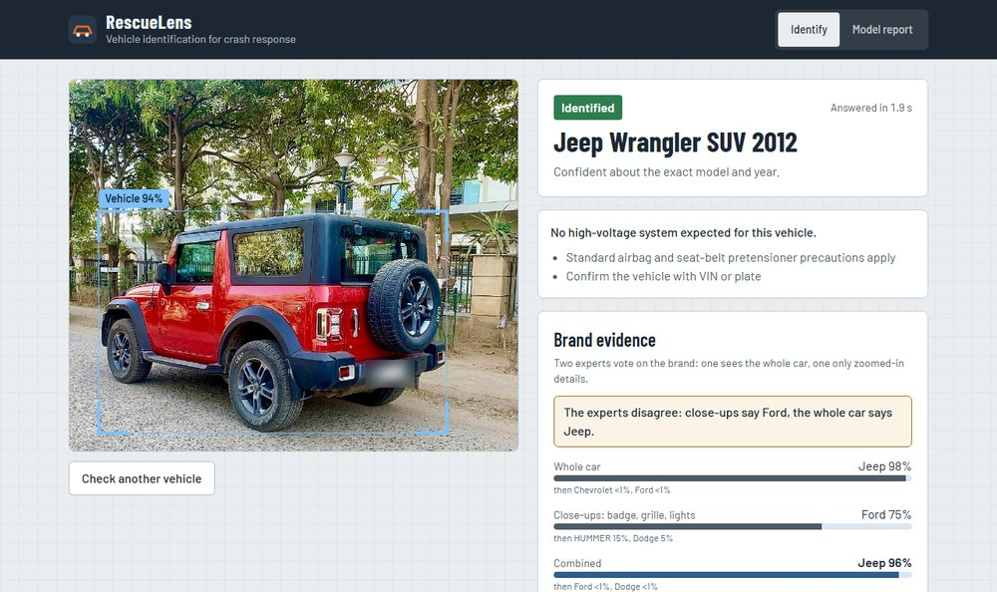
Photo: Mahindra Thar SUV in "Red Rage" colour, by Ank Kumar, CC BY-SA 4.0, Wikimedia Commons. Plate blurred.
- Root Cause & Mitigation:
Failure | Root cause | Mitigation
Thar taken for Wrangler | The Thar is styled like the Wrangler, so its embedding sits close to a known class and passes the distance check | The app always says to confirm with VIN or plate. Next: lower the answer when the brand experts disagree (they did on the photo we inspected), and add look-alikes to a held-out set when tuning the threshold
S5 taken for A5 | Trims and facelifts change only grilles, bumpers and badges, which are tiny at 384 px | Family-level answers, plus the close-up brand expert
Tahoe taken for Avalanche | The two share a front end, and the detector's box stops at the occluder | The multi-photo option lets a rescuer add another side
Severe blur | Blur removes the high-frequency detail that separates similar cars | The "Blurry" check gives a reason for the low confidence
Real crash photos | Wrecks and unseen models are far from the training data | Collect labelled damaged vehicles, which Stanford Cars doesn't have

Other limits: The training data is US-market cars up to 2012, so most cars on Indian roads today should be answered "unknown". Robustness tests use simulated degradation. Offline mode has only run with stand-in models, so it's switched off on the live site. Seven of the nine guide links are copies hosted by fire services, a rescue-training site or a rescue-software vendor. No responder has reviewed the safety text yet. This is a decision-support prototype, uploads aren't kept, and we left out plate reading and tracking to keep the scope to rescue.

5. Deployment & Quickstart Guide

Quickstart Commands
# 1. Clone the repository and install dependencies
git clone https://github.com/Priyanshu-senapati/Rescuelens
cd Rescuelens
pip install -r backend/requirements.txt
# 2. Run inference on a sample directory (needs the model files in ./models)
python tools/check_samples.py --samples ./frontend/public/samples --models ./models
# Or run the whole app in Docker (MODEL_BASE_URL is a folder holding the model files)
docker build -t rescuelens --build-arg MODEL_BASE_URL=<folder-with-the-model-files> .
docker run -p 7860:7860 rescuelens # open http://localhost:7860
Model weights aren't in git because of GitHub's file size limit. Without them the app still runs but serves sample answers and says so on screen, so real answers need the live URL or the model files.

Deployment Format
- One container runs the React interface, a FastAPI service and ONNX Runtime. It's deployed on Modal with one warm container (2 CPUs, 2 GB) from modal_app.py, and a Dockerfile runs the same app elsewhere. GitHub Actions runs the back-end tests, type check, build and browser tests on every push.

Student Submission Checklist
☑ Working GitHub repository link included with an updated README.md.
☑ No raw code pasted into this report.
☑ All table metrics match test runs reproducible via the repository.
☑ All team member details accurately recorded.

