First Test Case: Login Test Success:

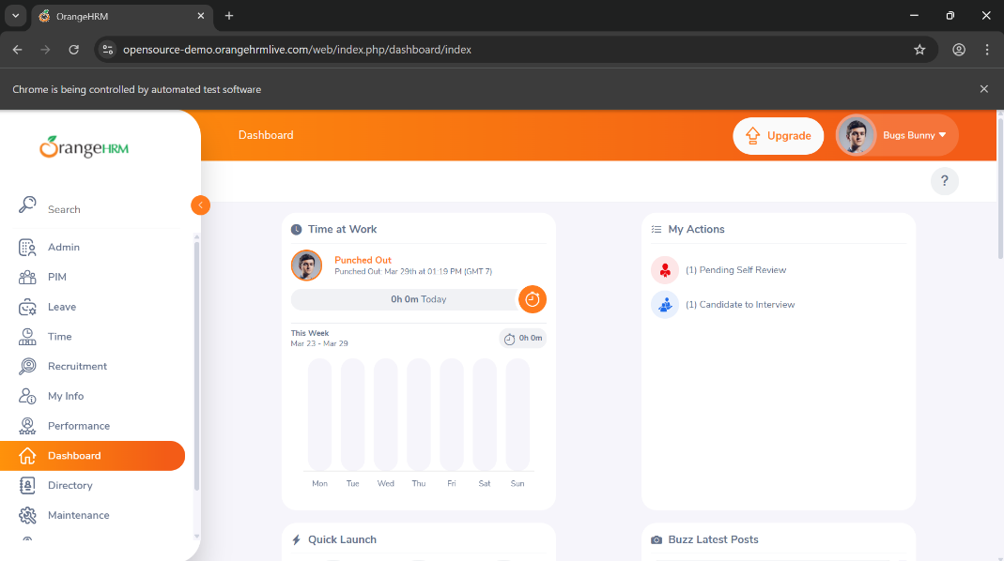
Test Case 2: login failed

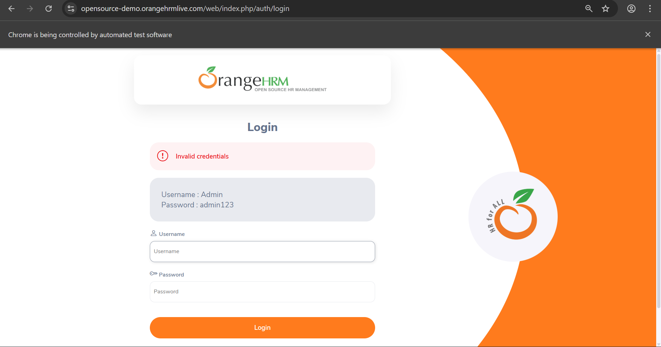

Test Case 3 : Admin Test

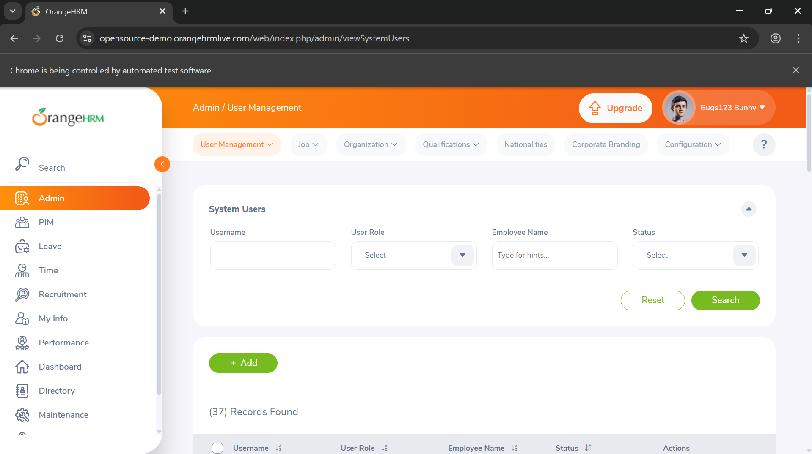
Test Case 4 : Add User
.sendKeys("Test@1234");
driver.findElement(By.xpath("//button[normalize-space()='Save']")).click();
Thread.sleep(3000);
System.out.println("User Added Successfully ");
}
}
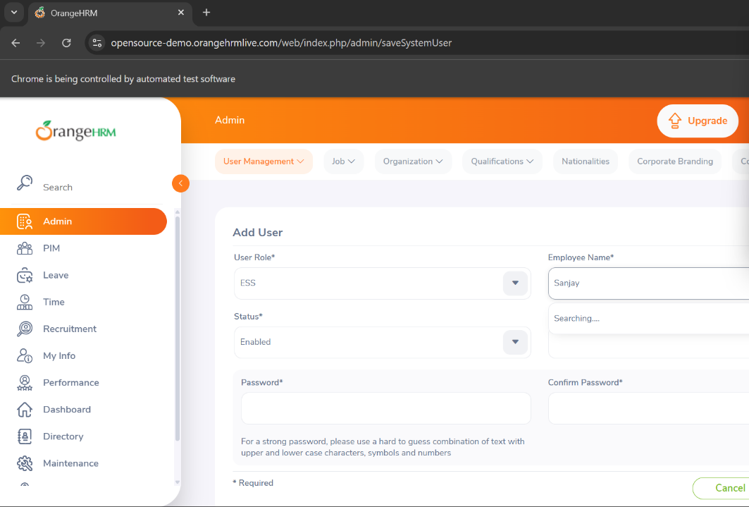

Test Case 5: PIMTest

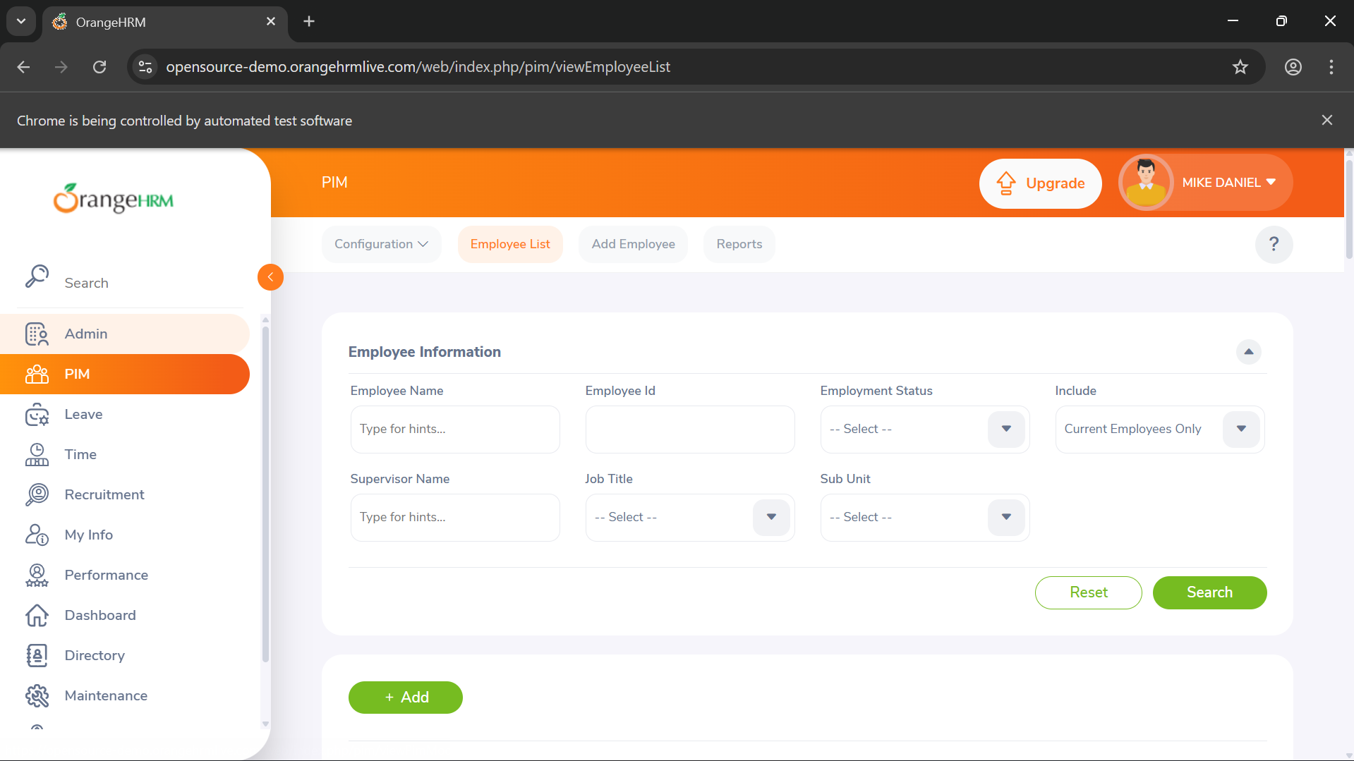

Test Case 6: TestTime:
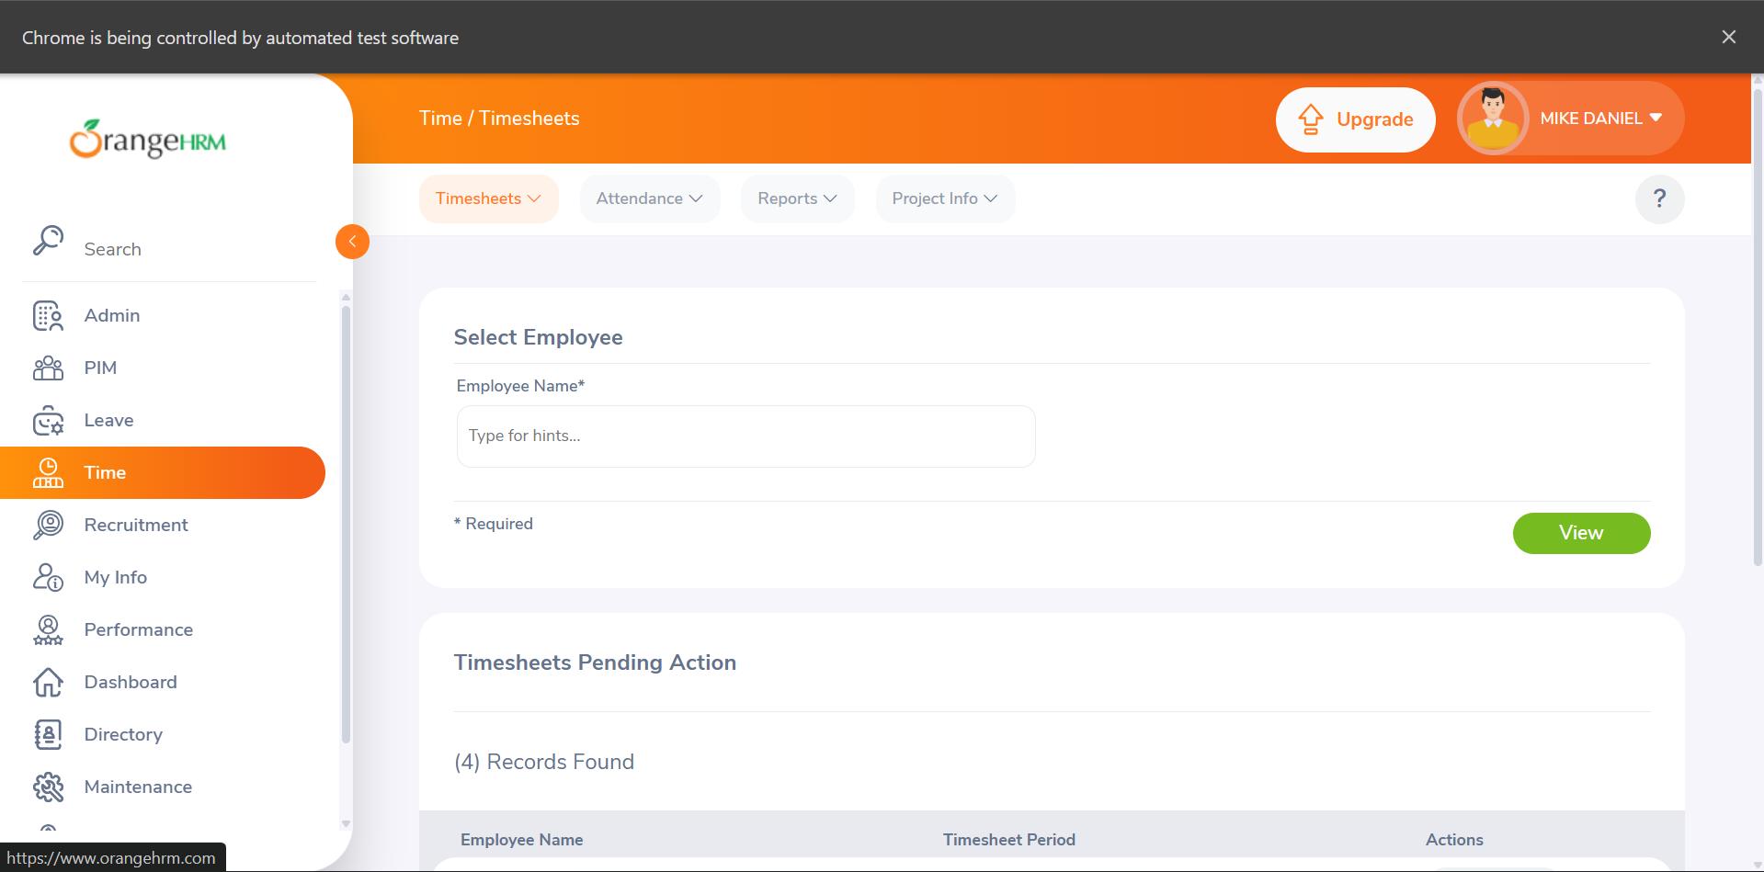

Test Case 7: Leave Test

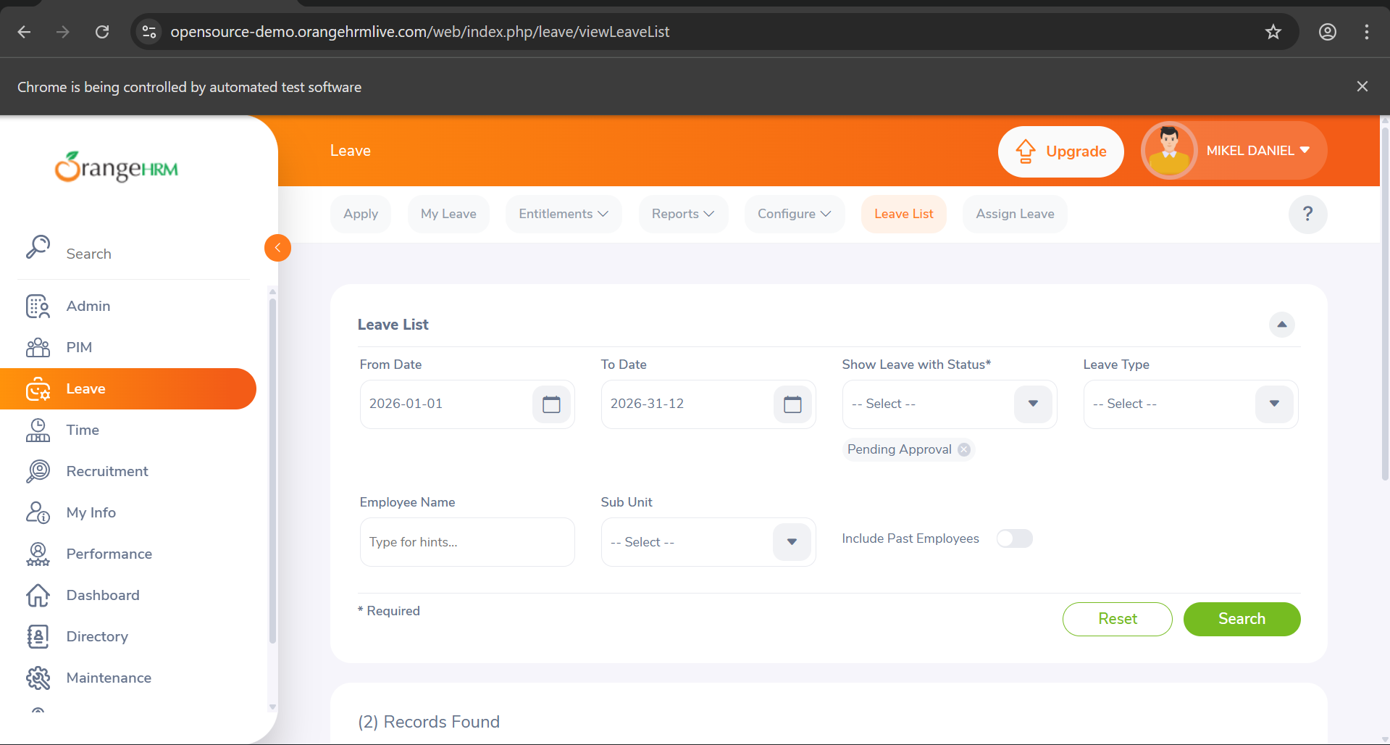
Test Case 8:RecruitementTest

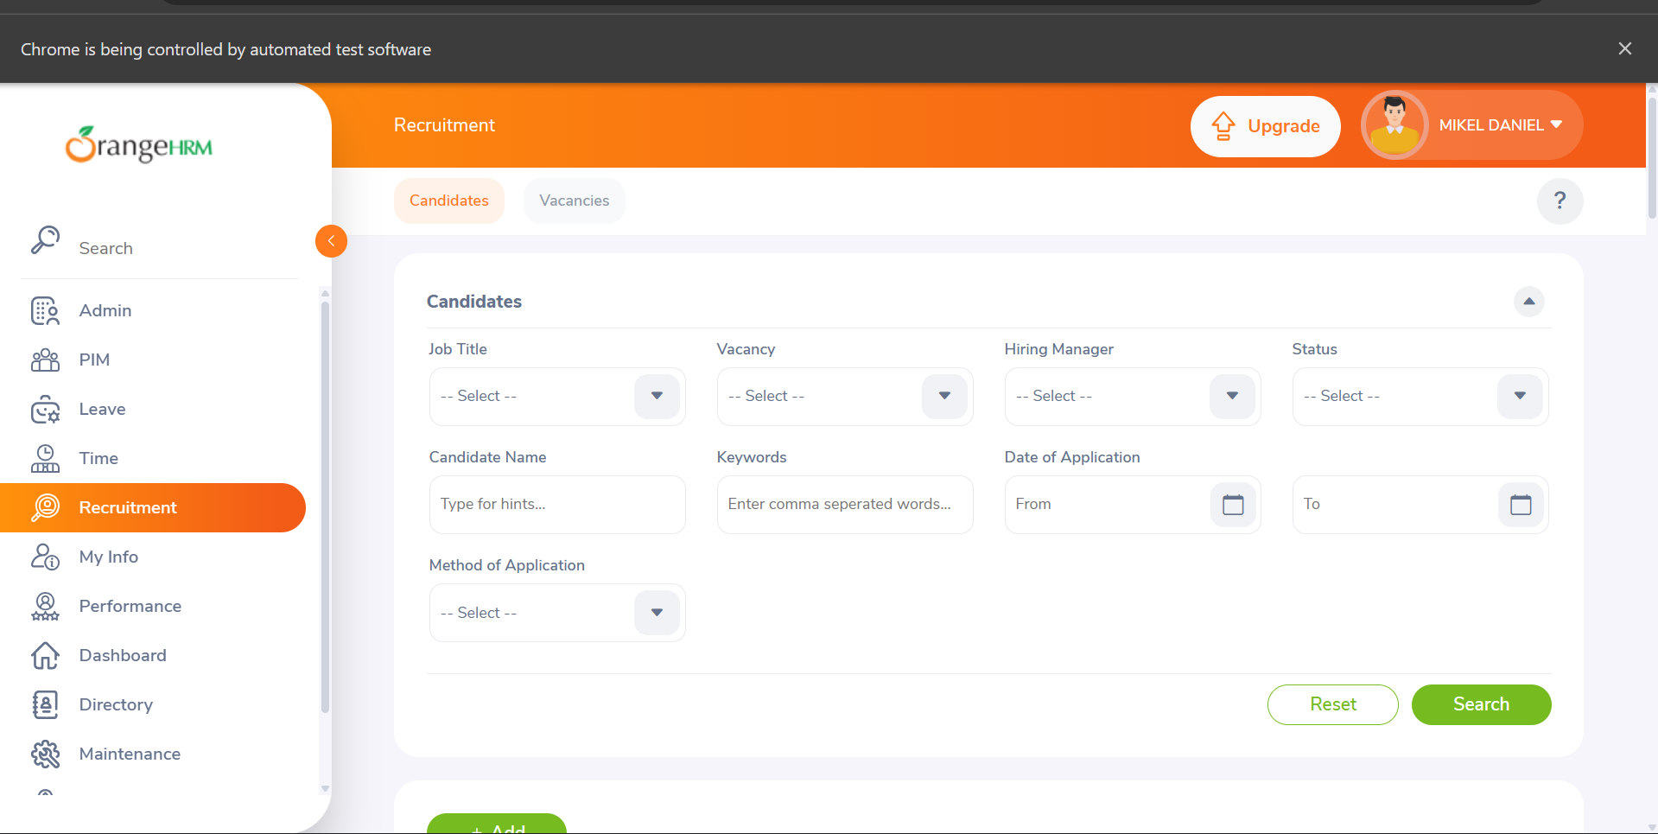

Test Case 9: My Info
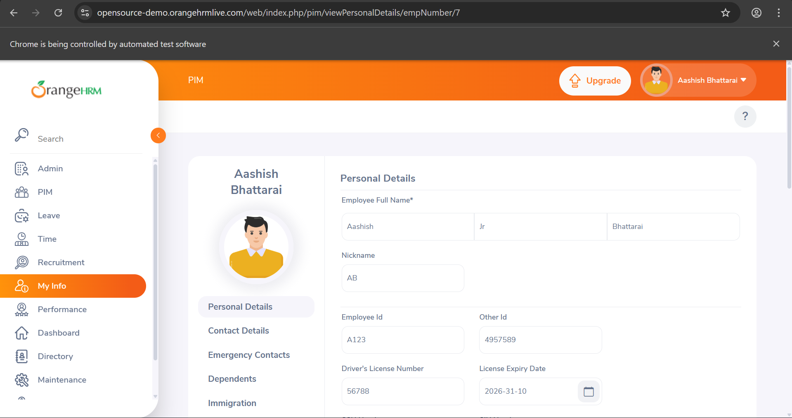
Test Case 10: Performance

