ATLANTIC RECORDING CORPORATION
Executive Summary — for Government & Regulatory Stakeholders
Content Compliance in the France Top 50 Streaming Chart
A plain-language summary of Atlantic's content sensitivity, compliance and format analysis of the French streaming market

Purpose of This Summary
Atlantic Recording Corporation monitors the daily France Top 50 streaming playlist to understand how explicit content, release formats and song structure relate to audience acceptance in the French market. This summary presents the findings in non-technical terms for government, regulatory and public-policy stakeholders with an interest in cultural content standards and the music streaming industry. It is a companion to a detailed technical research paper and an interactive analytics dashboard, both available on request.

What Was Studied
Atlantic reviewed 555 days of publicly charted playlist data (18 May 2024 to 27 November 2025), covering 27,780 individual song appearances on the France Top 50. For each song, the analysis recorded whether it was flagged as containing explicit content, whether it was released as a standalone single or as part of a larger album, its duration, and how popular it was with listeners.

Key Findings

1. Explicit content is common, but not dominant in listener acceptance
56% of songs on the France Top 50 during the study period carried an explicit content flag. However, clean (non-explicit) songs were consistently more popular with listeners on average than explicit songs — by a margin of roughly 8 points on a 100-point popularity scale. This gap was most pronounced outside the very top of the chart.
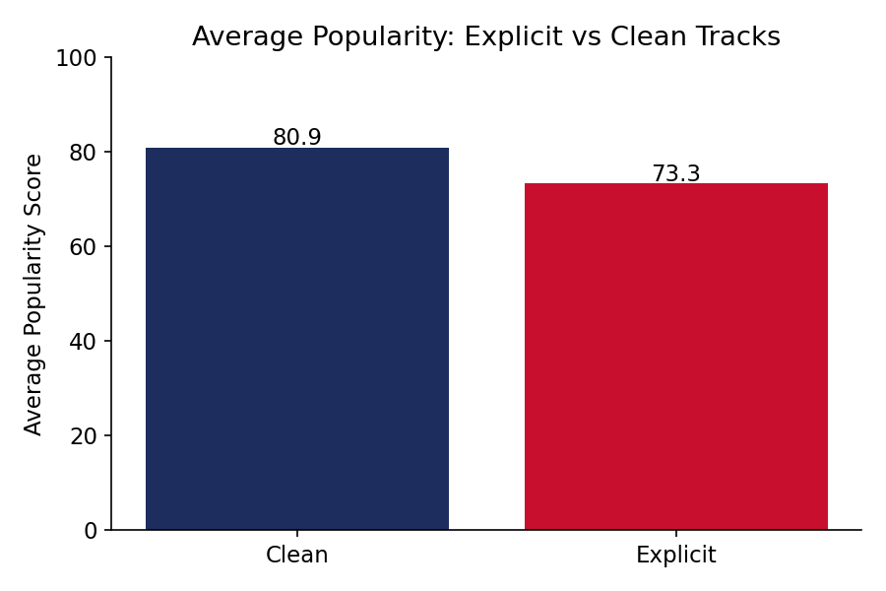
Clean content outperforms explicit content on average listener popularity.

2. France favors structured, catalog-style releases over rapid single releases
Songs released as part of an album made up the majority (57%) of entries once the full Top 50 is considered, confirming the market's structural preference for album-based catalogs over single-driven release strategies. At the same time, individual singles tend to achieve a higher average popularity score per song than individual album tracks.

3. Very large albums show diminishing returns per song
As albums grow larger (more tracks), the average popularity of any individual song on that album tends to decrease. Songs from large or deluxe albums (17 or more tracks) scored, on average, about 11 points lower in popularity than standalone singles — evidence of listener attention being divided across a larger catalog.
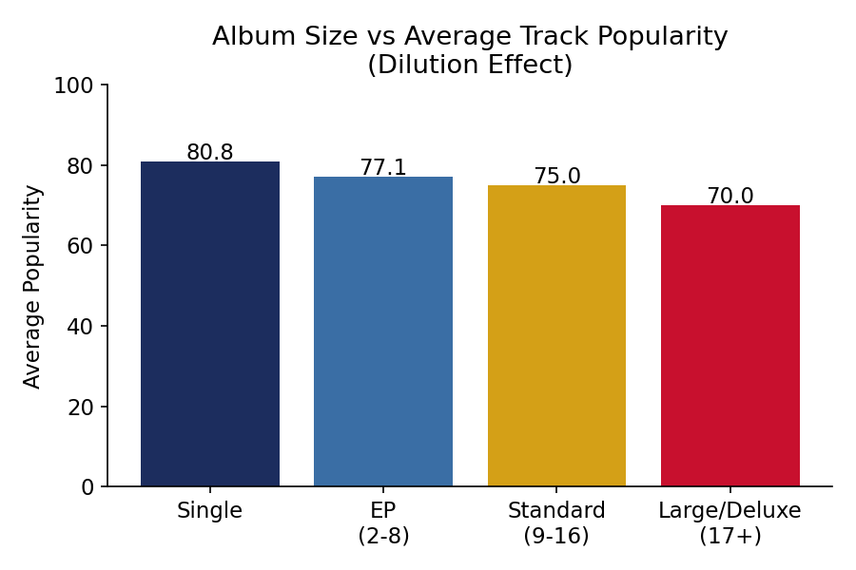
Average song popularity declines as album size increases.

4. Song length is not a significant factor in listener acceptance
The typical song on the France Top 50 is about 3 minutes long, and this has remained the market norm throughout the study period. Unlike explicit content and album size, song duration showed almost no relationship with listener popularity — France's audience does not systematically favor either shorter or longer songs within a normal range.

Summary Indicators
Indicator | Value
Explicit content share of chart entries | 56.3%
Average popularity — clean vs. explicit songs | 80.9 vs. 73.3 (of 100)
Share of chart entries from albums (Top 50) | 56.7%
Average song duration | 3.09 minutes
Popularity gap, single vs. large/deluxe album track | ≈ 11 points

What This Means for Cultural and Regulatory Context
These findings are consistent with independent, publicly documented characteristics of the French music market — namely, a degree of audience and cultural sensitivity toward explicit lyrical content, and an enduring preference for structured album formats over rapid single-driven release cycles. The data shows this sensitivity expressed through listener behavior (clean content is consistently more popular) rather than through the complete absence of explicit content from the chart, which continues to reflect a mixed but majority-explicit landscape.
Atlantic uses these findings internally to guide voluntary content practices, such as offering clean or radio-edit versions of tracks intended for broad playlist and family-context distribution in France, without limiting artists' creative expression on flagship releases.

Availability of Further Detail
A full technical research paper — including complete methodology, statistical detail and format-specific recommendations — and an interactive Streamlit analytics dashboard are available to stakeholders on request from Atlantic Recording Corporation's content strategy team.
Prepared September 2026 · Unified Mentor project deliverable for Atlantic Recording Corporation

