ATLANTIC RECORDING CORPORATION
in partnership with Unified Mentor
Audience Sensitivity, Content Compliance
& Format Preference Analysis
France Top 50 Playlist — Research Paper
Prepared for Content Strategy, Compliance & International Release Planning
Dataset window: 18 May 2024 – 27 Nov 2025 | 27,780 validated chart-entry snapshots | 555 daily observations
September 2026

Table of Contents

1. Executive Overview
The French streaming market rewards cultural fit, lyrical appropriateness and durable catalog engagement more than raw release velocity. This paper analyzes 555 daily snapshots of the France Top 50 playlist (18 May 2024 – 27 November 2025), covering 27,780 validated chart-position records, to give Atlantic Recording Corporation an evidence base for content compliance, format strategy and localization decisions in France.
Four questions anchor the analysis: how explicit content performs relative to clean tracks; whether the French chart favors singles or album tracks; how song duration aligns with listener acceptance; and whether larger albums dilute or strengthen individual track performance. Each is examined at the level of rank tiers (Top 10 / Top 25 / Top 50) so that findings can be applied differently to flagship singles versus catalog-depth strategy.
Headline finding: explicit content is common on the chart (56.3% of entries) but is not the top performer — clean tracks carry a materially higher average popularity score (80.9 vs 73.3) and this gap widens toward the top of the chart. Singles modestly outperform album tracks in popularity, and album size shows a measurable dilution effect: the largest albums (17+ tracks) underperform singles by roughly 11 popularity points on average. Song duration has only a weak relationship with popularity, indicating France's playlist audience is comparatively duration-agnostic within the observed 0.7–9.1 minute range.

2. Background and Problem Statement
The French music market carries distinct characteristics relevant to Atlantic's release strategy:
- A strong cultural emphasis on lyrical appropriateness and sensitivity
- Greater scrutiny of explicit content than in some other major markets
- A structural preference for album formats over rapid single-release cycles
- Historically longer listener engagement with artist catalogs
Despite daily access to France Top 50 playlist data, Atlantic has lacked a consolidated, quantified view of how these characteristics manifest in actual chart behavior. This gap creates risk across four decision areas: release format selection, explicit-content risk management, playlist pitching strategy, and localization of global releases for the French audience. This research paper, together with the accompanying Streamlit dashboard and executive summary, closes that gap.

3. Analytical Methodology

3.1 Data Validation and Preparation
The raw dataset supplied by Atlantic contained 27,800 daily chart-position records across 10 fields (date, position, song, artist, popularity, duration_ms, album_type, total_tracks, is_explicit, album_cover_url). The following validation and preparation steps were applied before analysis:
- Removed 20 exact duplicate rows (one snapshot date, 01-03-2025, had been logged twice in full)
- Removed 1 record with a missing song title
- Parsed and standardized the date field; validated that 553 of 555 remaining days carry the expected 50 positions (2 partial-coverage days were retained for their valid rows rather than dropped outright)
- Converted duration_ms to duration in minutes for readability
- Standardized album_type labels to lowercase (single / album / compilation); compilation entries are a negligible 0.03% of the dataset
- Validated is_explicit as a strict boolean flag
- Derived rank tiers (Top 10 / Top 25 / Top 50), duration buckets (Short <2.5 min, Medium 2.5–3.5 min, Long >3.5 min) and album-size buckets (Single, EP 2–8, Standard 9–16, Large/Deluxe 17+) for tiered comparison
The cleaned working dataset used throughout this paper and the companion dashboard contains 27,780 records spanning 2024-05-18 to 2025-11-27.

3.2 Analytical Dimensions
Five analytical dimensions structure the remainder of this paper, mirroring Atlantic's brief: Explicit Content Sensitivity, Release Format Preference, Album Structure Impact, Song Duration Preference, and Content Attribute Concentration across rank tiers. A final KPI summary consolidates results into the indicators specified in the project brief.

4. Explicit Content Sensitivity Analysis
Explicit content is flagged for 56.3% of all France Top 50 chart entries in the observation window, versus 43.7% clean. While explicit content is not rare, it is not the strongest performer: clean tracks average a popularity score of 80.9 versus 73.3 for explicit tracks — a gap of 7.6 points, equivalent to clean tracks scoring roughly 10% higher on average.
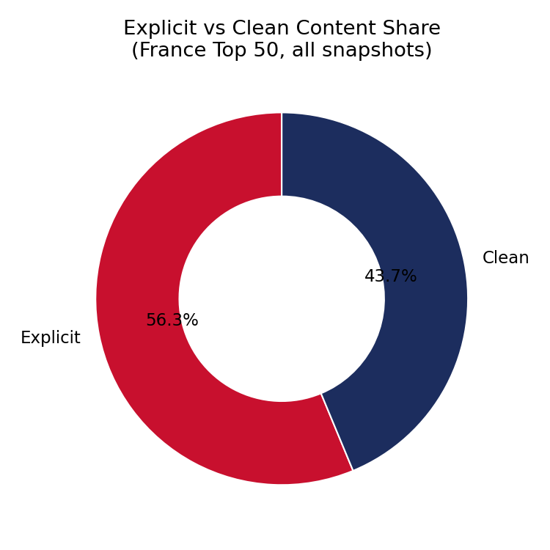
Figure 1. Explicit vs. clean content share across all chart entries.
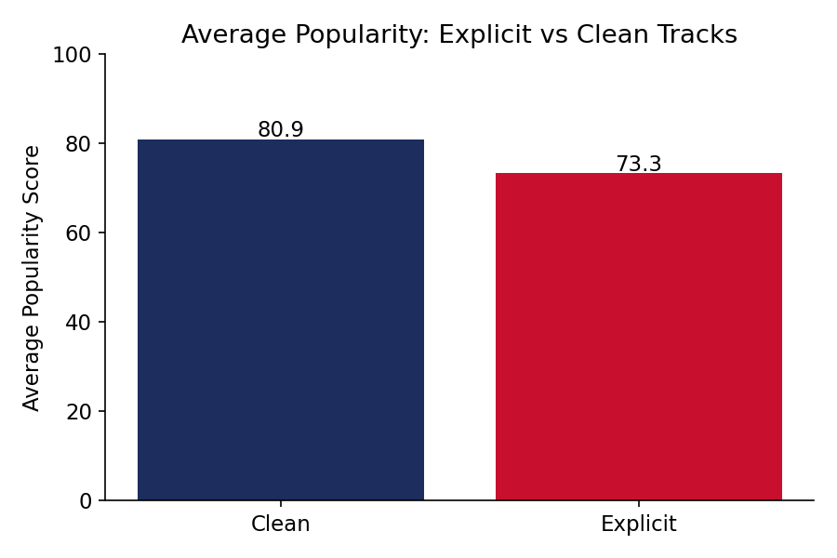
Figure 2. Average popularity score, explicit vs. clean tracks.
The clean-content advantage is not uniform across the chart: explicit content is more concentrated at the very top of the chart than further down it.
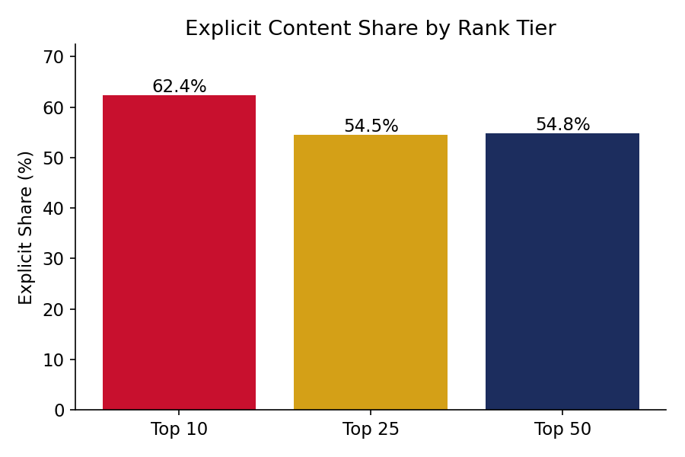
Figure 3. Explicit content share by rank tier (Top 10 / 25 / 50).
Explicit share falls from 62.4% in the Top 10 to 54.8% across the full Top 50 — meaning the highest-profile chart positions in France skew slightly more explicit than the tail of the chart, even though clean tracks retain the higher average popularity score overall. This is consistent with a small number of high-profile explicit hits pulling up the top of the chart while a broader, more risk-averse base of clean catalog tracks fills out positions 26–50.
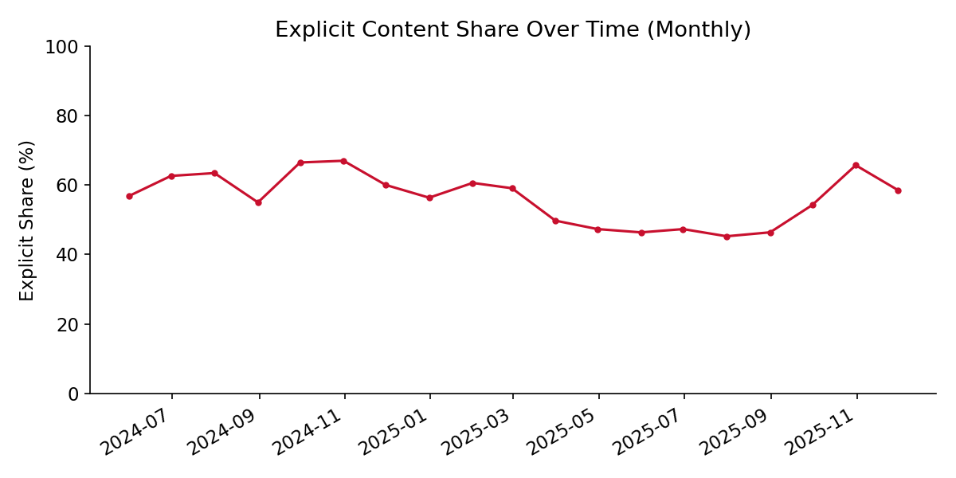
Figure 4. Monthly trend in explicit content share, May 2024 – November 2025.

4.1 Key Metrics
KPI | Value | Interpretation
Explicit Content Share | 56.26% | Majority of chart entries carry an explicit flag
Clean Content Dominance Ratio | 0.78× | Clean entries are 0.78× as numerous as explicit entries — explicit entries are still the majority by count, but clean entries carry the higher average popularity
Avg. Popularity — Clean | 80.9 / 100 | Higher than explicit average
Avg. Popularity — Explicit | 73.3 / 100 | 7.6 points below clean average
Content Acceptance Score — Clean | 0.81 | Popularity-normalized acceptance indicator
Content Acceptance Score — Explicit | 0.73 | Popularity-normalized acceptance indicator

4.2 Interpretation
For a market with documented cultural sensitivity to explicit lyrical content, the data shows a nuanced picture: explicit material is commercially present and even slightly concentrated at the top of the chart, but it does not outperform clean content on average popularity at any rank tier. This supports a compliance posture that permits explicit lead singles where the creative case is strong, while prioritizing clean or radio-edit versions for sustained catalog and playlist-pitching purposes, where the popularity advantage of clean content compounds over time.

5. Release Format Preference Analysis
Album-sourced tracks represent 52.9% of chart entries versus 47.1% for singles (compilations are negligible at 0.03%), so albums supply a slightly larger share of chart real estate. However, on a per-track basis, singles convert better: singles average 80.8 popularity versus 73.0 for album tracks — a gap of nearly 8 points.
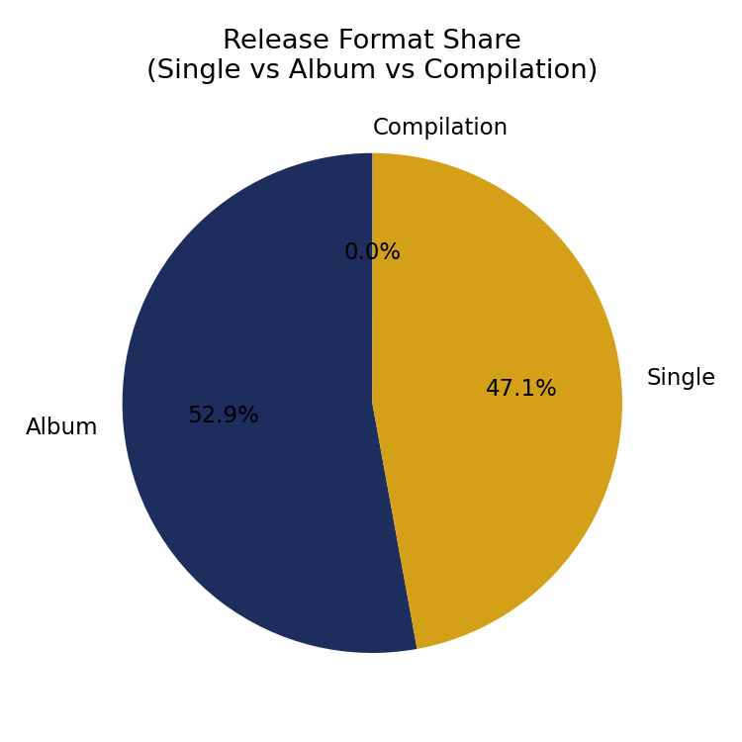
Figure 5. Release format share (single / album / compilation).
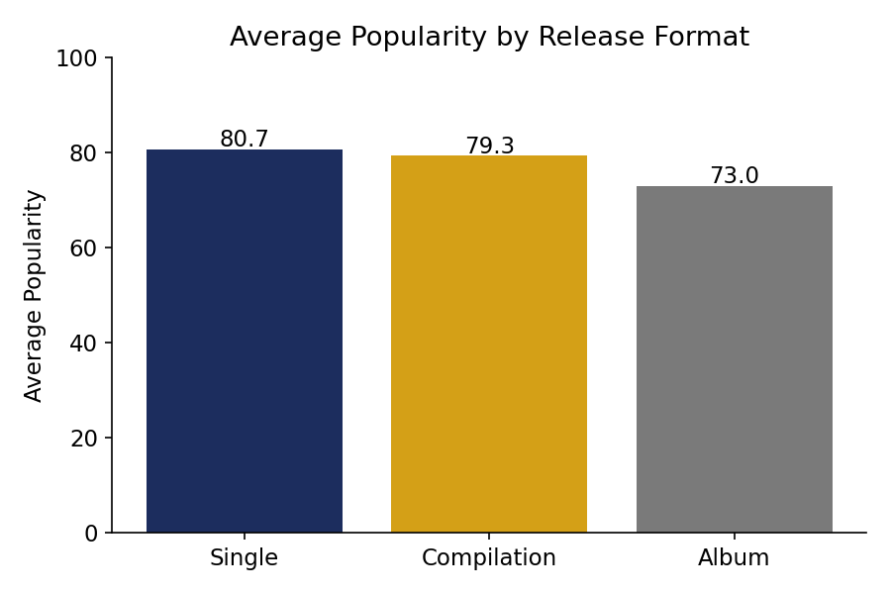
Figure 6. Average popularity by release format.
Format mix also shifts by rank tier: singles make up just over half of the Top 10 and Top 25 (50.7% and 51.1% respectively) but album tracks become the majority in the full Top 50 (56.7%), reflecting how album catalogs contribute long-tail chart presence even when few individual album tracks reach the very top.
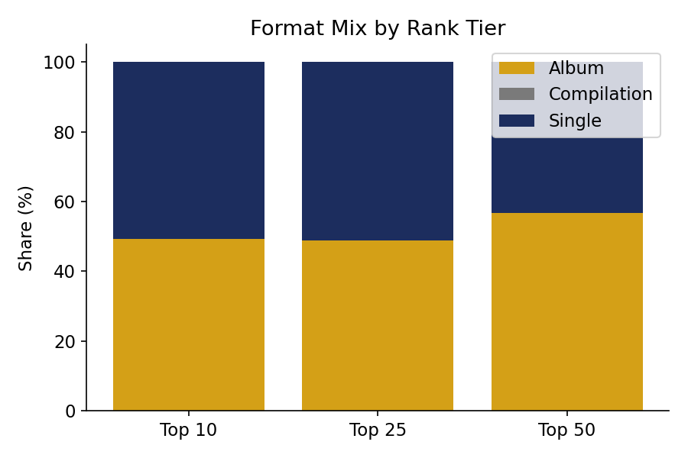
Figure 7. Format mix by rank tier.

5.1 Key Metrics
KPI | Value | Interpretation
Single vs Album Track Ratio | 0.89× | Near parity in entry count; singles slightly fewer than album tracks overall
Avg. Popularity — Single | 80.75 / 100 | Highest-performing format
Avg. Popularity — Album | 72.99 / 100 | Below single average
Single Share, Top 10 | 50.7% | Singles and albums roughly split at the very top
Album Share, Top 50 | 56.7% | Albums dominate chart depth beyond Top 25

5.2 Interpretation
The French market's documented preference for structured album formats is visible in chart depth (albums supply the majority of Top 50 entries) rather than in peak performance (singles achieve materially higher average popularity per track). This is consistent with albums driving sustained catalog presence — several tracks holding chart positions simultaneously — while singles remain the more efficient vehicle for a single high-impact chart push. A hybrid strategy — lead with a single for peak popularity, follow with an album for chart depth and duration of presence — is best supported by the data.

6. Album Structure Impact Analysis
Album size (total_tracks) ranges from 1 to 119 tracks, with a median of 10 and mean of 9.0. Popularity declines as album size increases: the correlation between total_tracks and popularity across all chart entries is −0.343, a moderate negative relationship, and average popularity by album-size bucket confirms a clear dilution pattern.
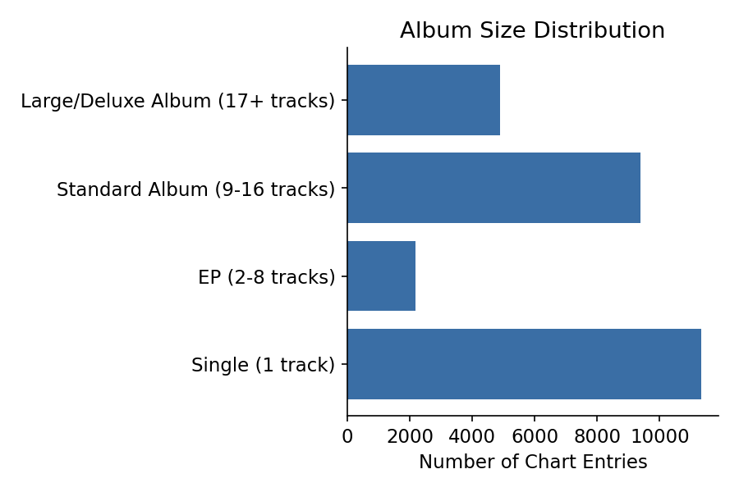
Figure 8. Distribution of chart entries by album size bucket.
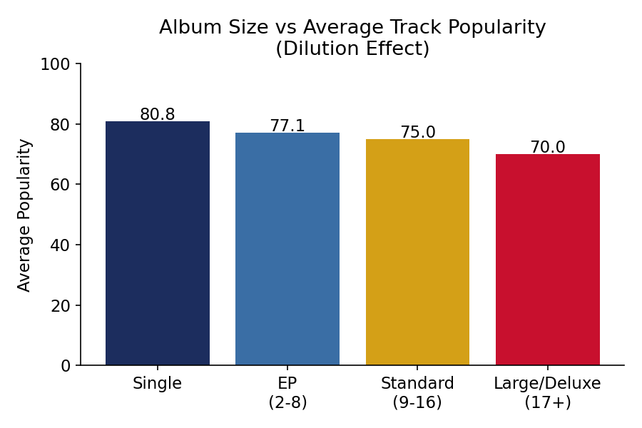
Figure 9. Average track popularity by album size bucket — the dilution effect.

6.1 Key Metrics
KPI | Value | Interpretation
Album Size Impact Index (correlation) | −0.343 | Dilution effect: larger albums associate with lower average track popularity
Avg. Popularity — Single (1 track) | 80.83 | Highest-performing group
Avg. Popularity — EP (2–8 tracks) | 77.06 | Second-highest
Avg. Popularity — Standard Album (9–16 tracks) | 74.96 | Below EP average
Avg. Popularity — Large/Deluxe (17+ tracks) | 69.99 | Lowest-performing group, ~11 points below singles

6.2 Interpretation
The data supports a genuine dilution effect: as albums grow larger, the average popularity of any individual track on the France chart declines by roughly 11 points from single-track releases to large/deluxe albums (17+ tracks). This does not mean large albums fail to chart — many entries in the dataset come from sizeable albums — but rather that streaming attention and playlist favor spread thinner across more tracks, softening any one track's individual performance. For France specifically, where structured album formats are culturally favored, Atlantic should weigh the reach benefit of a large tracklist against the popularity cost to any single track when selecting which cuts to pitch for playlist placement.

7. Song Duration Preference Analysis
Track duration in the dataset ranges from 0.7 to 9.1 minutes, with a mean of 3.09 minutes and a tight interquartile range (2.76–3.46 minutes), confirming that the 2.5–3.5 minute 'radio length' remains the dominant format: 63.6% of all chart entries fall in this medium bucket, versus 23.5% long (>3.5 min) and 12.9% short (<2.5 min).
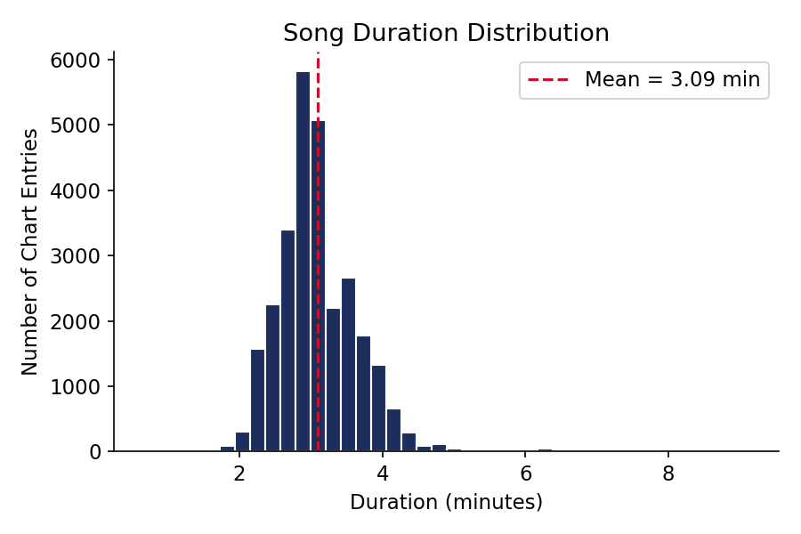
Figure 10. Song duration distribution across the France Top 50.
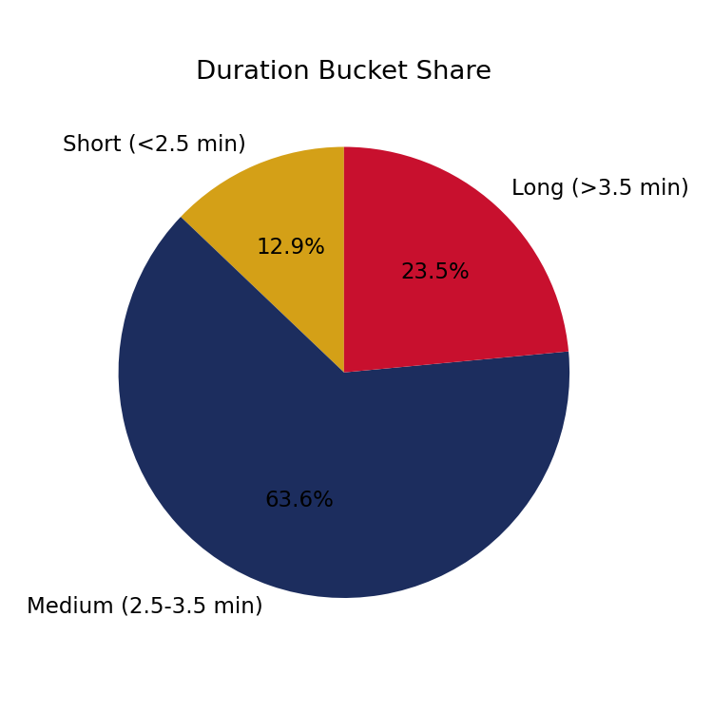
Figure 11. Share of chart entries by duration bucket.
Unlike album size, duration shows only a very weak relationship with popularity (correlation +0.055) and average rank position is essentially flat across duration buckets (25.4–26.1 average position). Long tracks (>3.5 min) have a marginally higher average popularity (78.8) than medium (75.8) or short (76.9) tracks, but the effect size is small relative to the explicit-content and album-size findings.
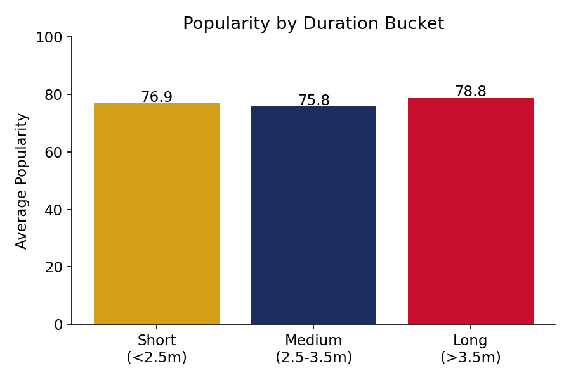
Figure 12. Average popularity by duration bucket.

7.1 Key Metrics
KPI | Value | Interpretation
Average Song Duration | 3.09 minutes | Structural norm for the France chart
Duration–Popularity Correlation | +0.055 | Negligible; duration is not a meaningful driver of popularity
Medium-Length Share (2.5–3.5 min) | 63.6% | Dominant duration bucket
Avg. Popularity — Long Tracks (>3.5 min) | 78.8 | Marginally highest, but not a strong effect

7.2 Interpretation
France's chart audience is largely duration-agnostic within a conventional 2.5–4.5 minute range: neither unusually short nor unusually long tracks are systematically penalized or rewarded. This suggests duration should be treated as a creative rather than a compliance or strategic lever — Atlantic does not need to enforce a strict runtime ceiling for the French market specifically, though staying near the prevailing 3-minute norm remains a safe default that matches listener expectations without constraining artistic choices.

8. Content Attribute Concentration Analysis
Comparing content attribute density across Top 10, Top 25 and Top 50 reveals how the 'preferred content profile' shifts with chart depth.
Attribute | Top 10 | Top 25 | Top 50
Explicit share | 62.4% | 57.7% | 56.3%
Single share | 50.7% | 51.0% | 47.1%
Album share | 49.3% | 49.0% | 52.9%
Avg. duration (min) | 3.09 | 3.08 | 3.09
Avg. album size (tracks) | 8.04 | 8.24 | 9.00
Avg. popularity | 78.29 | 77.97 | 76.65

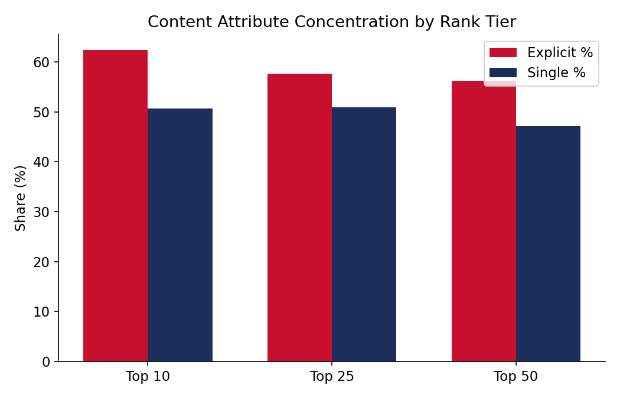
Figure 13. Explicit % and single % concentration across rank tiers.

8.1 Preferred Content Profile for France
Synthesizing all five analytical dimensions, the content profile most associated with strong France Top 50 performance is:
- Clean or radio-edit lead version (clean tracks average ~8 popularity points above explicit)
- Released as a single or from a small-to-medium tracklist, not a large deluxe album (17+ tracks cost ~11 popularity points versus singles)
- Duration close to the 3-minute market norm, though this is a weak constraint rather than a strict requirement
- Understanding that explicit, high-profile tracks can still reach the very top of the chart (Top 10 skews more explicit than the tail), so explicit content is a viable choice for a flagship lead single even though it is not the average-case top performer

9. KPI Summary
KPI | Value | Interpretation
Explicit Content Share | 56.3% | Audience sensitivity indicator — majority explicit by volume
Clean Content Dominance Ratio | 0.78× by count / +7.6 pts popularity | Clean content is fewer in number but higher performing
Single vs Album Track Ratio | 0.89× | Near parity; albums supply more chart depth, singles higher peak popularity
Average Song Duration | 3.09 minutes | Structural norm; weak link to popularity
Album Size Impact Index | −0.343 correlation | Moderate dilution effect as album size grows
Content Acceptance Score (Clean / Explicit) | 0.81 / 0.73 | Rank-aligned preference indicator, clean favored

10. Insights and Strategic Recommendations

10.1 Release Format Decisions
- Lead international releases into France with a single for maximum per-track popularity, then follow with an album to build sustained chart depth — the data shows singles outperform on popularity while albums contribute more total Top 50 entries.
- For deluxe or expanded editions, expect a popularity cost per track (~11 points versus a standalone single); reserve the largest tracklists for artists with strong existing France fanbases who can sustain broader catalog attention.

10.2 Explicit-Content Risk Management
- Treat explicit content as viable for flagship lead singles — it is not penalized at the very top of the chart — but prioritize clean or radio-edit versions for playlist pitching and sustained catalog positioning, where clean content's popularity advantage compounds.
- Maintain France-specific clean-edit production as standard practice for any track intended for broad daytime or family-context playlist placement, consistent with the market's documented sensitivity to explicit content.

10.3 Playlist Pitching Strategy
- Pitch clean versions preferentially for algorithmic and editorial playlists beyond the Top 25, where clean content's relative share and popularity advantage are most pronounced.
- For Top 10 pushes, an explicit flagship single remains a defensible choice given its overrepresentation at the top of the chart, provided a clean alternate mix is available in parallel for broader placement.

10.4 Localization of Global Releases
- No strict duration adjustment is needed for France; global standard-length masters (approximately 3 minutes) already match local listening norms.
- When localizing an album release, consider a trimmed France-specific edition or a curated 'highlights' single/EP release alongside the full album, to capture both the chart-depth benefit of the album and the higher per-track popularity typical of smaller releases.

11. Conclusion
This analysis of 555 days of France Top 50 playlist data gives Atlantic Recording Corporation a quantified, tier-aware view of content compliance and format preference in the French market. The findings are consistent with — and sharpen — the qualitative market characteristics in Atlantic's brief: France does show measurable, if moderate, audience sensitivity to explicit content, a structural (though nuanced) preference for album-format catalog depth, and a comparatively duration-agnostic listening pattern. Applying these findings through the accompanying Streamlit dashboard will allow Atlantic's release, compliance and playlist-pitching teams to make France-specific, data-grounded decisions rather than relying on general market assumptions.
A companion executive summary distills these findings for non-technical government and policy stakeholders, and a live Streamlit dashboard is provided for ongoing, self-service exploration of the underlying data as new daily snapshots are added.

