eSign
Electronic Signature Document Management System
Database Design Documentation
MySQL 8.0 • InnoDB • utf8mb4
Prepared by Priyanshu

Table of Contents
1. Overview 3
1.1 Purpose of this Document 3
1.2 Technology Summary 3
2. Entity-Relationship Diagram 4
2.1 Relationship Summary 4
3. Table Reference 5
admin 5
users 5
documents 6
signer_roles6
document_signature_fields7
4. Keys, Indexes & Constraints 8
4.1 Primary Keys 8
4.2 Unique Constraints 8
4.3 Foreign Keys 8
4.4 Secondary Indexes 8
5. Design Notes & Observations 9

1. Overview
This document describes the MySQL database schema that powers the eSign Electronic Signature Document Management System. The schema supports document upload and lifecycle tracking, role-based signer assignment, precise placement of signature fields on document pages, and separate authentication stores for platform administrators and end users.
The database consists of five tables: admin, users, documents, signer_roles, and document_signature_fields. All tables use the InnoDB storage engine with utf8mb4 character encoding and auto-incrementing integer primary keys.

1.1 Purpose of this Document
- Provide a complete field-level reference for every table in the schema.
- Document primary keys, foreign keys, unique constraints, and default values.
- Visualize entity relationships through an Entity-Relationship (ER) diagram.
- Serve as a reference for backend development, code review, and onboarding.

1.2 Technology Summary
Property | Value
Database Engine | MySQL 8.0
Storage Engine | InnoDB
Character Set / Collation | utf8mb4 / utf8mb4_0900_ai_ci
Total Tables | 5
Primary Key Strategy | INT, AUTO_INCREMENT (surrogate keys)

2. Entity-Relationship Diagram
The diagram below shows all five tables, their key fields, and the foreign key relationships that connect them. Crow's-foot notation is used on the "many" side of each relationship.
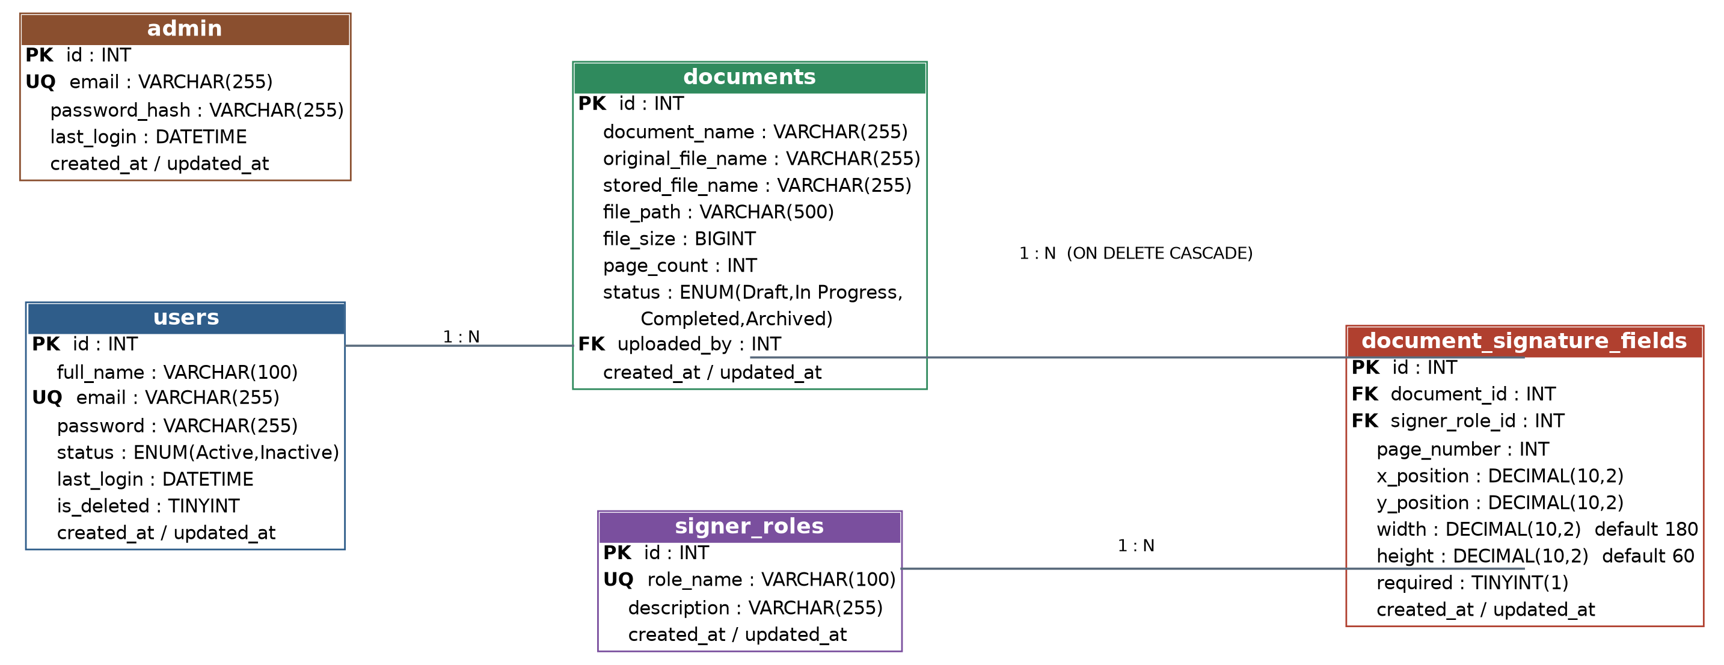

2.1 Relationship Summary
Parent Table | Card. | Child Table | On Delete / Notes
users | 1 : N | documents | documents.uploaded_by → users.id (RESTRICT, default)
documents | 1 : N | document_signature_fields | document_signature_fields.document_id → documents.id (ON DELETE CASCADE)
signer_roles | 1 : N | document_signature_fields | document_signature_fields.signer_role_id → signer_roles.id (RESTRICT, default)
Note: the admin table has no foreign key relationships to the other tables — it is a standalone authentication store, functionally separate from the users table.

3. Table Reference
admin
Stores login credentials for platform administrators, separate from regular application users.
Column | Data Type | Key | Nullable | Default | Description
id | INT | PK | No | AUTO_INCREMENT | Surrogate primary key.
email | VARCHAR(255) | UQ | No | — | Administrator login email; must be unique.
password_hash | VARCHAR(255) | — | No | — | Hashed password credential.
last_login | DATETIME | — | Yes | NULL | Timestamp of the admin's most recent login.
created_at | TIMESTAMP | — | Yes | CURRENT_TIMESTAMP | Record creation time.
updated_at | TIMESTAMP | — | Yes | CURRENT_TIMESTAMP (on update) | Auto-updates on every row change.
users
Stores end users of the eSign platform — the people who upload documents and are tracked as document owners.
Column | Data Type | Key | Nullable | Default | Description
id | INT | PK | No | AUTO_INCREMENT | Surrogate primary key.
full_name | VARCHAR(100) | — | No | — | User's display name.
email | VARCHAR(255) | UQ | No | — | Login email; must be unique.
password | VARCHAR(255) | — | No | — | Hashed password credential.
status | ENUM('Active','Inactive') | — | Yes | 'Active' | Account status flag.
last_login | DATETIME | — | Yes | NULL | Timestamp of the user's most recent login.
is_deleted | TINYINT | — | Yes | 0 | Soft-delete flag (1 = deleted).
created_at | TIMESTAMP | — | Yes | CURRENT_TIMESTAMP | Record creation time.
updated_at | TIMESTAMP | — | Yes | CURRENT_TIMESTAMP (on update) | Auto-updates on every row change.
documents
Central table tracking every uploaded document — its file metadata, page count, and processing status.
Column | Data Type | Key | Nullable | Default | Description
id | INT | PK | No | AUTO_INCREMENT | Surrogate primary key.
document_name | VARCHAR(255) | — | No | — | Human-readable document title.
original_file_name | VARCHAR(255) | — | No | — | Original filename as uploaded by the user.
stored_file_name | VARCHAR(255) | — | No | — | Filename used for storage on disk / object store.
file_path | VARCHAR(500) | — | No | — | Path or URI where the file is stored.
file_size | BIGINT | — | No | — | File size in bytes.
page_count | INT | — | No | — | Number of pages in the document (used to place signature fields).
status | ENUM('Draft','In Progress','Completed','Archived') | — | Yes | 'Draft' | Current lifecycle state of the document.
uploaded_by | INT | FK | No | — | References users.id — the uploading user.
created_at | TIMESTAMP | — | Yes | CURRENT_TIMESTAMP | Record creation time.
updated_at | TIMESTAMP | — | Yes | CURRENT_TIMESTAMP (on update) | Auto-updates on every row change.
signer_roles
Lookup table defining the reusable signer roles (e.g. Signer, Approver, Witness) that can be assigned to signature fields.
Column | Data Type | Key | Nullable | Default | Description
id | INT | PK | No | AUTO_INCREMENT | Surrogate primary key.
role_name | VARCHAR(100) | UQ | No | — | Unique name of the role.
description | VARCHAR(255) | — | Yes | NULL | Optional description of the role's purpose.
created_at | TIMESTAMP | — | Yes | CURRENT_TIMESTAMP | Record creation time.
updated_at | TIMESTAMP | — | Yes | CURRENT_TIMESTAMP (on update) | Auto-updates on every row change.
document_signature_fields
Defines every placeholder signature field placed on a document — its page, coordinates, size, and which signer role must complete it.
Column | Data Type | Key | Nullable | Default | Description
id | INT | PK | No | AUTO_INCREMENT | Surrogate primary key.
document_id | INT | FK | No | — | References documents.id — the parent document. Cascades on delete.
signer_role_id | INT | FK | No | — | References signer_roles.id — role required to complete this field.
page_number | INT | — | No | — | Page of the document this field appears on.
x_position | DECIMAL(10,2) | — | No | — | Horizontal coordinate of the field on the page.
y_position | DECIMAL(10,2) | — | No | — | Vertical coordinate of the field on the page.
width | DECIMAL(10,2) | — | Yes | 180.00 | Field width.
height | DECIMAL(10,2) | — | Yes | 60.00 | Field height.
required | TINYINT(1) | — | Yes | 1 | Whether this field must be completed (1 = required).
created_at | TIMESTAMP | — | Yes | CURRENT_TIMESTAMP | Record creation time.
updated_at | TIMESTAMP | — | Yes | CURRENT_TIMESTAMP (on update) | Auto-updates on every row change.

4. Keys, Indexes & Constraints

4.1 Primary Keys
- Every table uses a single-column surrogate primary key: id (INT, AUTO_INCREMENT).

4.2 Unique Constraints
- admin.email — one login per email address.
- users.email — one account per email address.
- signer_roles.role_name — role names cannot be duplicated.

4.3 Foreign Keys
Constraint | Column → References | On Delete | On Update
documents_ibfk_1 | documents.uploaded_by → users.id | RESTRICT | RESTRICT
document_signature_fields_ibfk_1 | document_signature_fields.document_id → documents.id | CASCADE | RESTRICT
document_signature_fields_ibfk_2 | document_signature_fields.signer_role_id → signer_roles.id | RESTRICT | RESTRICT

4.4 Secondary Indexes
- documents(uploaded_by) — supports fast lookup of documents by owner.
- document_signature_fields(document_id) — supports fast lookup of all fields on a document.
- document_signature_fields(signer_role_id) — supports fast lookup of fields by role.

5. Design Notes & Observations
- Separation of admin and users: platform administrators are authenticated independently of application end users, keeping privileged access isolated in its own table.
- Cascade delete on document_signature_fields: deleting a document automatically removes all of its associated signature fields, preventing orphaned field records.
- Soft delete on users: the is_deleted flag allows a user record to be retained for referential integrity (e.g. documents they uploaded) rather than being hard-deleted.
- Lifecycle tracking via documents.status: the ENUM ('Draft', 'In Progress', 'Completed', 'Archived') models the document's signature workflow state directly in the schema.
- Reusable roles: signer_roles is a lookup table, allowing the same role (e.g. "Signer", "Witness") to be reused across many documents and fields rather than duplicated as free text.
- Auditability: every table carries created_at and updated_at timestamps, with updated_at auto-maintained by MySQL ON UPDATE CURRENT_TIMESTAMP.

