# CCC Exam -

**1. What is CCC?**

**Course on Computer Concepts** — basic computer knowledge sikhaane wala course.

**2. Who conducts it ?**

NIELIT (**National Institute of Electronics & Information Technology**), Govt. of India.

**. Benefits:**

* Computer ki basic skills milti hain.
* Jobs aur online forms mein help karta hai.
* Digital India me participate karne ka mauka.

**4. Exam Details:**

* 100 questions, 90 minutes.
* Online exam.
* Passing marks: 50%.

**📚 (Full Syllabus Coverage (REVISION)): 🡪 (CCC)**

Course on Computer Concepts

**1. Introduction to Computers**

* What is Computer?
* Characteristics & limitations
* Types of computers (Analog, Digital, Hybrid)
* Applications of computers

**2. Introduction to Operating Systems**

* Windows, Linux, and their features
* Desktop, Icons, Taskbar, Files/Folders ka use

**3. Word Processing (MS Word / LibreOffice Writer)**

* File create, open, save
* Formatting text, inserting tables/images
* Page setup, header/footer
* Spell check, Print preview

**4. Spreadsheet (MS Excel / LibreOffice Calc)**

* Create/edit spreadsheets
* Use of formulas & functions (SUM, AVERAGE, IF, etc.)
* Cell formatting, charts, sort/filter

**5. Presentation (MS PowerPoint / LibreOffice Impress)**

* Slides banana, format karna
* Insert images/videos
* Slide transitions & animations

**6. Internet & WWW & Network & Email**

* Browsers (Chrome, Firefox)
* Search engines (Google, Bing)
* Download/upload
* Email use (Gmail, attachments)

**7. Digital Financial Tools**

* UPI, BHIM, AEPS
* Internet banking, Mobile wallets
* Cyber security basics (phishing, OTP safety)

**8. Social Networking & E-Governance & Service Provider**

* Facebook, WhatsApp, etc. ke basics
* Online services: Aadhar, PAN, Voter ID
* Online forms bharna

**9. Cyber Security**

* Virus, malware, antivirus
* Password safety
* Safe browsing practices

**10. Most Repeated Full Forms**

## 📘 **1. Introduction to Computers – Mixed Language Notes (CCC)**

### 🔹 ****1.1 What is a Computer ?****

**Definition**:  
A computer is an electronic device that accepts data as input, processes it, and gives output as meaningful information.

**Samjhaav**:

Computer ek **electronic machine** hai jo humse data leta hai (input), us par kaam karta hai (process), aur phir result deta hai (output).  
Jaise calculator add karta hai, waise hi computer kai kaam karta hai.

## 💻 **Full Form of COMPUTER**

**C** – Common  
**O** – Operating  
**M** – Machine  
**P** – Particularly  
**U** – Used for  
**T** – Technical  
**E** – Education and  
**R** – Research

**Example**:  
 Mobile, Laptop, ATM, Desktop Computer

🧠 **IPO Cycle**:  
**Input → Process → Output**

### 🔹 ****1.2 Characteristics of Computer****

|  |  |
| --- | --- |
| **🔹 Feature** | **🔹 Meaning (Samjhaav)** |
| **Speed** | Computer bohot tezi se kaam karta hai – ek second mein lakhon calculation kar sakta hai. |
| **Accuracy** | Ye sahi result deta hai. Agar mistake ho to program mein hoti hai, computer mein nahi. |
| **Automation** | Ek baar instruction mil jaaye to bina rukhe kaam karta hai. |
| **Storage** | Bahut saari files, videos, documents ko store karke rakh sakta hai. |
| **Diligence** | Na thakta hai, na bore hota hai – lagataar kaam kar sakta hai. |
| **Versatility** | Har field mein use ho sakta hai – education, hospital, bank, etc. |

### 🔹 ****1.3 Limitations of Computer****

| **❌ Limitation** | **❌ Samjhaav** |
| --- | --- |
| **No IQ** | Computer khud se soch nahi sakta. Usse batana padta hai kya karna hai. |
| **No Emotions** | Isme feelings nahi hoti – na khushi, na gussa. |
| **Dependent on Instructions-** | Jab tak command nahi doge, tab tak kuch nahi karega. |

### 🔹 ****1.4 Types of Computers****

| **🖥️ Type** | **📌 Description** | **🧾 Example** |
| --- | --- | --- |
| **Analog** | Continuous signal par kaam karta hai | Thermometer, Speedometer |
| **Digital** | Binary number (0 & 1) par kaam karta hai | Laptop, Desktop |
| **Hybrid** | Analog + Digital dono ka combination | ECG Machine, CT Scanner |

📝 Samjhaav:

* **Analog**: Aise computer jo physical signals par kaam karte hain (jaise speed).
* **Digital**: Jo binary (0 & 1) par kaam karte hain – jaise aapka laptop.
* **Hybrid**: Dono ka mix – mostly medical machines mein use hote hain.

### 🟠 ****1. Analog Computer****

**Definition (English)**:  
Analog computers work with **continuous physical quantities** like temperature, speed, pressure, voltage, etc.

**Samjhaav (Hindi + English)**:  
Analog computer wo hote hain jo **physical signals** ko read karke unka result dete hain.  
Ye computers **real-world signals** (jo continuously change hote hain) ko measure karte hain.

**Example**:

* Thermometer (temperature measure karta hai)
* Speedometer (vehicle ki speed show karta hai)
* Analog Clock

🧠 **Important Point**:  
Analog computers aaj ke time mein zyada use nahi hote, but measurement tools mein ab bhi milte hain.

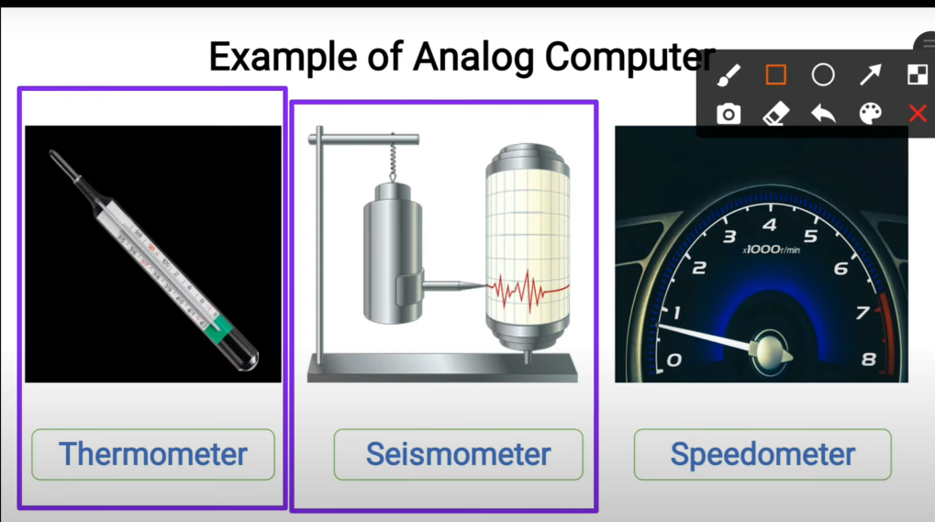

### 🔵 ****2. Digital Computer****

**Definition (English)**:  
Digital computers work with **discrete data** in the form of binary numbers – 0s and 1s.

**Samjhaav (Hindi + English)**:

Digital computers wahi hote hain jo **binary number system** (0 aur 1) ka use karte hain.  
Ye aapka har roz ka laptop, mobile, desktop computer hote hain.

**Example**:

* Laptop
* Desktop PC
* Calculator
* Smartphone

🧠 **Important Point**:  
Digital computers har jagah use hote hain — office, school, ghar, bank, etc.

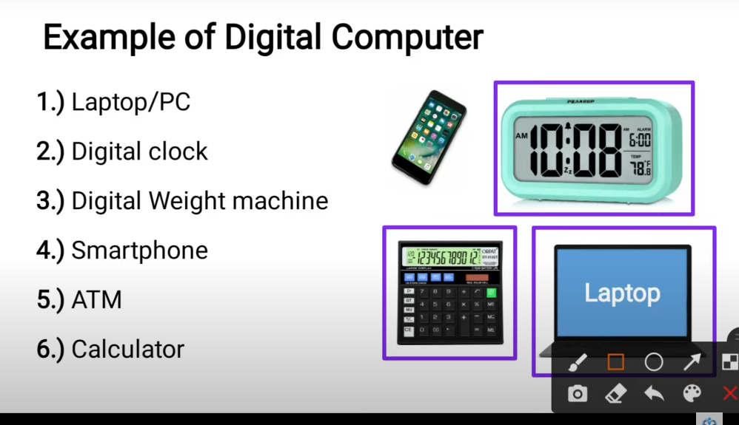

### 🟣 ****3. Hybrid Computer****

**Definition (English)**:

Hybrid computers are a combination of **analog and digital computers**, used where both types of data are needed.

**Samjhaav (Hindi + English)**:

Hybrid computers dono analog aur digital signals par kaam karte hain.  
Jaise **medical field** mein kuch machines pehle patient ka **heart rate** (analog) measure karti hain, phir uska **digital report** banati hain.

**Example**:

* ECG (Electrocardiogram) Machine
* CT Scanner
* ICU Monitoring Devices

🧠 **Important Point**:

Hybrid computers **special-purpose** devices hote hain – mostly scientific, industrial ya medical uses ke liye.

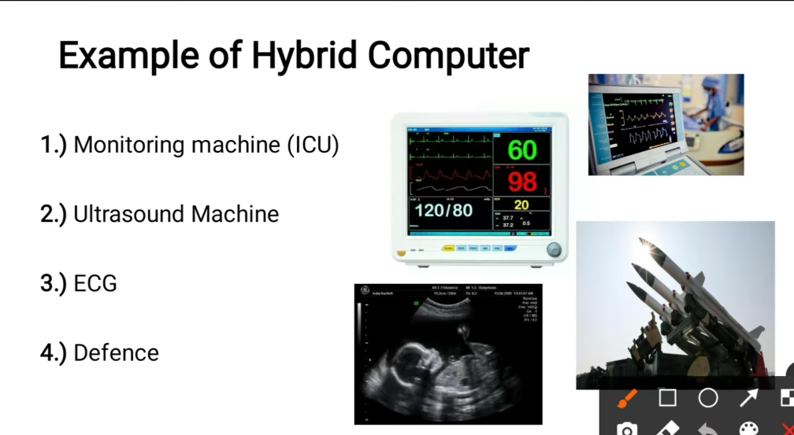

### 🔹 ****1.5 Applications of Computers****

| **🔧 Field** | **📌 Use** |
| --- | --- |
| **Education** | Online class, e-book, smart board |
| **Banking** | ATM, online banking, passbook print |
| **Healthcare** | Patient report, machine operation |
| **Business** | Billing, email, file management |
| **Entertainment** | Games, Movies, Music |
| **Government** | Online services: Aadhar, PAN, voting |
| **Transport** | Online ticket booking, GPS |

### 🔹 ****1.6 Memory in Computer****

**Samjhaav**:  
  
Memory matlab wahi jagah jahan computer ka data store hota hai — temporary ya permanent.

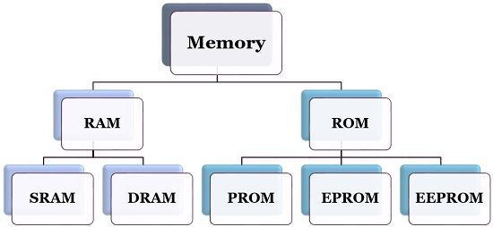

| **📦 Type** | **📝 Full Form** |
| --- | --- |
| **RAM** | Random Access Memory |
| **SRAM** | Static Random Access Memory |
| **DRAM** | Dynamic Random Access Memory |
| **ROM** | Read Only Memory |
| **PROM** | Programmable Read Only Memory |
| **EPROM** | Erasable Programmable Read Only Memory |
| **EEPROM** | Electrically Erasable Programmable Read Only Memory |

#### 📌 A. RAM (Random Access Memory)

**Definition**:  
RAM is a volatile memory used to store data temporarily while the computer is running.

🧠 Samjhaav:

* Jab aap computer chalu karte ho, to RAM mein program load hota hai.
* Jaise MS Word open karna — RAM use hoti hai.
* **Power off hone pe data chala jata hai.**

| **🔸 Type** | **📌 Meaning** |
| --- | --- |
| **DRAM** | Dynamic RAM – slow, cheap |
| **SRAM** | Static RAM – fast, costly, cache mein use hoti hai |
| **DDR** | DDR1 to DDR5 – naye version fast aur energy-efficient hote hain |

#### 📌 B. ROM (Read Only Memory)

**Definition**:  
ROM is a non-volatile memory that stores permanent instructions like BIOS.

Basic I/O;

🧠 Samjhaav:

* ROM mein wahi data hota hai jo computer start hone par chahiye hota hai.
* Ye kabhi delete nahi hota (unless updated).
* **Power off hone par bhi data safe rehta hai.**

| **🔸 Type** | **📌 Use** |
| --- | --- |
| **PROM** | Ek baar hi program kiya ja sakta hai |
| **EPROM** | UV light se erase karke dobara program kiya ja sakta hai |
| **EEPROM** | Electrically erase/update kar sakte ho – BIOS yahi hota hai |

### 🔹 ****1.7 Input / Output Devices****

#### ✅ Input Devices (Data dene wale):

* Keyboard
* Mouse
* Scanner
* Microphone
* Webcam

#### ✅ Output Devices (Data dikhane/sunane wale):

* Monitor
* Printer
* Speaker
* Projector

### 🔹 ****1.8 Block Diagram of Computer****

[Input Device] → [CPU (CU + ALU)] ↔ [Memory] → [Output Device]

* **CPU**: Computer ka brain hota hai
  + **CU (Control Unit)**: Har kaam ko control karta hai
  + **ALU (Arithmetic Logic Unit)**: Calculation aur logical comparison karta hai

### 📋 Quick Revision (1 Line Summary)

| **🔸 Topic** | **✅ One Line** |
| --- | --- |
| Computer | Data ko process karke useful information deta hai |
| RAM | Temporary memory – fast but volatile |
| ROM | Permanent memory – non-volatile |
| CPU | Brain of computer (CU + ALU) |
| Input Device | * + Jo computer ko data dete hain |
| Output Device | * + Jo result dikhate hain |

### 🔹 ****What is an Operating System (OS)?****

**Definition (English)**:  
An Operating System is a software that acts as an interface between the user and the computer hardware.

**Samjhaav (Hindi + English)**:

Operating System ek **software** hai jo **user aur computer hardware ke beech ka bridge** ka kaam karta hai.

**Bina OS ke computer chalana possible nahi hai.**

🧠 **Examples**: Windows, Linux, Android, macOS

### 🔸 ****Main Functions of OS****:

1. **User Interface** dena (GUI ya CLI)
2. **File Management** (copy, delete, rename files)
3. **Memory Management**
4. **Task Management** (multiple programs at once)
5. **Hardware Control** (printer, keyboard, etc.)

| **Type** | **Full Form** | **Description** |
| --- | --- | --- |
| **GUI** | Graphical User Interface | Mouse, icons, windows (easy) |
| **CLI** | Command Line Interface | Keyboard commands (technical) |
|  |  |  |

## **🖥️ Basic Parts of Windows Desktop**

| **Component** | **Explanation (Hindi + English)** |
| --- | --- |

### 🔸 ****1. Desktop****

* Computer ka home screen hota hai
* Background image + icons yahin hote hain

### 🔸 ****2. Icons****

* Small pictures that represent programs or files
* Jaise: My Computer, Recycle Bin, This PC

### 🔸 ****3. Taskbar****

* Screen ke neeche hota hai
* Start button, time, background apps yahin dikhte hain

### 🔸 ****4. Start Menu****

* Left corner mein hota hai
* All Programs, Settings, Shutdown yahin milta hai

### 🔸 ****5. Files & Folders****

* File = Ek data ka unit (document, image, etc.)
* Folder = File ko group mein rakhne ke liye  
  Example: Folder “Photos” mein 50 image files ho sakti hain

| **Task** | **Shortcut / Use** |
| --- | --- |
| * Open File/Folder | * Double-click |
| * Rename | * Right-click → Rename |
| * Copy | * Ctrl + C |
| * Paste | * Ctrl + V |
| * Delete | * Delete key |
| * Undo | * Ctrl + Z |

## **📝 3. Word Processing – (MS Word / LibreOffice Writer)**

## **MS Office vs LibreOffice (Comparison Table)**

|  |  |  |
| --- | --- | --- |
| Feature | MS Office | LibreOffice |
| Price | Paid (License ke saath) | Free (Open Source) |
| User Interface | Modern, user-friendly, polished | Simple, thoda basic |
| Features | Advanced, professional tools | Basic to moderate features |
| Compatibility | Best compatibility with MS formats | Supports MS formats, but kabhi thoda different hota hai |
|  |  |  |
| System Requirements | Thoda zyada powerful computer chahiye | Kam powerful computers pe bhi chal jaata hai |
| Support & Updates | Paid support, regular updates | Community-driven, free updates |
| Usage | Offices, professionals, businesses | Students, small offices, budget users |

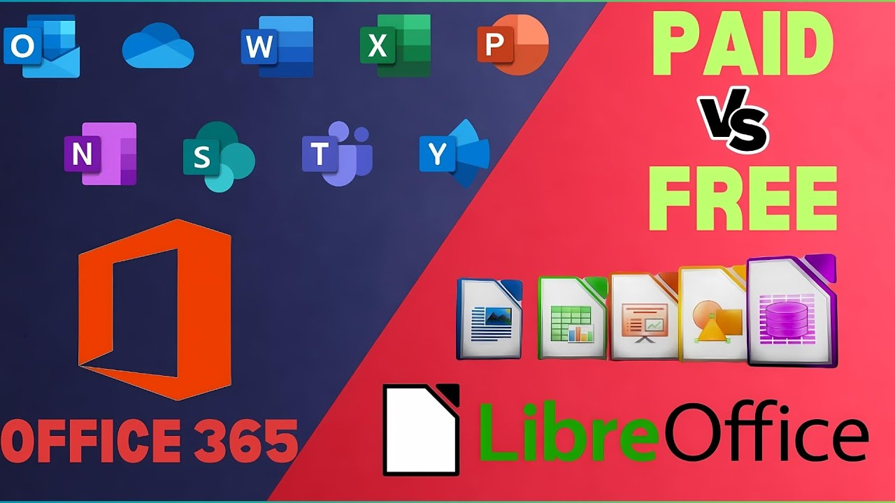

* Word processor ek aisa software hota hai jisme hum **text type, edit aur format** kar sakte hain.

**MS Word, LibreOffice Writer**

### 🔹 ****File Create, Open, Save****

* **Create (Naya Document):**  
  File → New ya Ctrl + N
* **Open (Purana Document kholna):**  
  File → Open ya Ctrl + O
* **Save (File ko store karna):**  
  File → Save ya Ctrl + S
* **Save As:**  
  File ko naye naam ya naye format mein save karna

### 🔹 ****Text Formatting & Insert Table/Image****

* **Formatting:**  
  Font style, size, bold (Ctrl+B), italic (Ctrl+I), underline (Ctrl+U),
* color, alignment change karna
* **Insert Table:**
* Insert → Table → Rows & Columns select karo
* **Insert Image:**
* Insert → Picture → From File → Image select karo

### 🔹 ****Page Setup, Header/Footer****

* **Page Setup:**  
  Page size (A4), orientation (Portrait/Landscape), margins set karna (Page Layout tab mein hota hai)
* **Header/Footer:**  
  Page ke top (header) ya bottom (footer) mein date, page number, file name add karna  
  Insert → Header/Footer

### 🔹 ****Spell Check & Print Preview****

* **Spell Check:**  
  Galat spellings ko check karta hai  
  Shortcut: **F7**
* **Print Preview:**  
  Document ko print se pehle dekhna  
  File → Print Preview  
  Shortcut: **Ctrl + P** (Print option bhi open karta hai)

## 📊 **4. Spreadsheet (MS Excel / LibreOffice Calc)**

**Spreadsheet** ek aisa software hota hai jisme **data rows aur columns** me hota hai.  
Aap usme **calculation, analysis, chart, sorting, filtering** kar sakte ho.

✅ Examples: **MS Excel**, **LibreOffice Calc**

|  |  |
| --- | --- |
| **Task** | **Real Option / Shortcut** |
| **Naya Sheet Banana** | File → New → Spreadsheet |
| **Open Sheet** | File → Open / Ctrl + O |
| **Save Sheet** | File → Save / Ctrl + S |
| **Edit Cell** | Cell select karo, type karo |
| **Navigate Cells** | Arrow keys ya mouse se |

|  |  |
| --- | --- |
| Feature | Shortcut / Tab / Menu |
| New Spreadsheet | Ctrl + N / File → New |
| Sum Function | =SUM(A1:A5) |
| Average Function | =AVERAGE(range) |
| IF Condition | =IF(condition, true, false) |
| Insert Chart | Insert → Chart |
| Cell Formatting | Home tab → Font / Number group |
| Sort / Filter | Data tab → Sort / Filter |

### 📌 ****Presentation Software kya hota hai?****

Presentation software ek aisa program hai jiska use **slide shows banane ke liye** kiya jata hai.

Isme hum **text, images, videos, charts, animations** ka use karke **information visually present** karte hain.

✅ Examples:

* **MS PowerPoint** (Microsoft ka)
* **LibreOffice Impress** (Free & open-source)

### 📚 ****Presentation Software ke Uses (Kaha Use Aata Hai)****

1. **School / College:** Project & topics explain karne ke liye
2. **Office / Business:** Reports, product info, training dikhane ke liye
3. **Government:** Awareness & training programs
4. **Online Meetings:** Zoom, Google Meet mein content present karne ke liye
5. **Public Events:** Guest intro, schedule display karne ke liye

## 🌐 **6. Internet, WWW, Network & Email – Theory Notes**

### 🔹 ****Network kya hota hai?****

* Jab 2 ya zyada computers ek doosre se **connected hote hain** (wired ya wireless), toh usse **network** kehte hain.

| **Type of Network** | **Full Form** | **Range** |
| --- | --- | --- |
| **LAN** | Local Area Network | Same building/office |
| **MAN** | Metropolitan Area Network | City level |
| **WAN** | Wide Area Network | Country/worldwide level |
|  |  |  |

|  |  |  |
| --- | --- | --- |
| **Network Type** | **Full Form** | **Definition & Example** |
| **LAN** | Local Area Network | Ek chhota network jo ek building, office ya ghar ke andar hota hai. |
| **Example:** School ka computer lab. |  |  |
| **MAN** | Metropolitan Area Network | Shehar (city) ke andar computers ya offices ko jodne wala network. |
| **Example:** City ke sarkari offices ka network. |  |  |
| **WAN** | Wide Area Network | Bade area me alag-alag cities, states ya countries ko jodne wala network. |
| **Example:** Internet. |  |  |
| **PAN** | Personal Area Network | Ek aadmi ke personal devices ko jodne wala chhota network. |
|  |  |  |
| **Example:** Mobile phone aur wireless earphones Bluetooth se connected hain. |  |  |
| **CAN** | Campus Area Network | University ya large campus ke andar multiple LANs ko jodne wala network. |
| **Example:** University campus ka computer network. |  |  |
| **VPN** | Virtual Private Network | Secure network connection jo internet ke through private network jaisa kaam karta hai. |
| **Example:** Work from home karte waqt office ke servers se secure connection. |  |  |

### 🔹 ****Internet kya hai?****

### **Definition:**

### The Internet is a global network of connected computers that communicate and share information worldwide.

**Internet** (International Network) duniya ka sabse bada network hai jo hazaaron computers ko **worldwide connect** karta hai.

Iske through hum **websites, email, files, videos, information** access kar sakte hain.

### 🔹 ****WWW (World Wide Web)****

### **Definition: 🡺**

### The World Wide Web is a service on the Internet that allows users to access and view web pages through browsers.

* **WWW** ek service hai jo internet ke upar kaam karti hai.
* Hum **web pages** access karte hain using **web browsers**.
* Web pages ke address ko **URL** (Uniform Resource Locator) kehte hain.

🧠 Example: https://www.google.com — ek URL hai.

### 🧭 4. ****Web Browser****

**Definition (English):**  
A web browser is a software application used to access and view websites on the Internet.

**Hindi Explanation:**  
Browser ek software hota hai jaise Chrome, Firefox, jisse hum websites open karte hain.

### 🔍 5. ****Search Engine****

**Definition (English):**  
A search engine is a tool that helps users find information on the internet by typing keywords.

**Hindi Explanation:**  
Search engine (jaise Google, Bing) wo jagah hai jahan aap kuch bhi search karte ho aur internet se uska result milta hai.

### 📥 6. ****Download****

**Definition (English):**  
Downloading is the process of receiving data from the internet to your device.

**Hindi Explanation:**  
Internet se file ya image apne phone/computer me lana download kehlata hai.

**📤 7. Upload**

**Definition (English):**  
Uploading means sending a file or data from your device to the internet.

**Hindi Explanation:**  
Jab aap apne phone/computer se internet pe koi file bhejte ho, use upload kehte hain.

**📧 8. Email (Electronic Mail)**

**Definition (English):**  
Email is a method of exchanging digital messages over the internet.

**Hindi Explanation:**  
Email ek online tareeka hai message aur file bhejne ka, jaise Gmail use karna.

### 📎 9. ****Email Attachment****

**Definition (English):**  
An attachment is a file (like photo, PDF) sent along with an email.

**Hindi Explanation:**  
Email ke sath jo file bhejte hain (jaise photo, document), use attachment kehte hain

|  |  |  |
| --- | --- | --- |
| Topic | Definition (English) | Explanation (Hindi) |
| Internet | Global network of computers | Duniya bhar ke computers ka connected system |
| WWW | Interlinked web pages system | Websites ka network, browser se access hota hai |
| Network | Connected computers for sharing data | Devices aapas me jude hote hain |
| Browser | Tool to view websites | Chrome, Firefox se sites dekhte hain |
| Search Engine | Tool to search info on internet | Google jahan hum kuch bhi search karte hain |
| Download | Get file from internet | File net se apne device me lana |
| Upload | Send file to internet | Apni file net pe bhejna |
| Email | Sending messages via internet | Online message bhejna (Gmail, etc.) |
| Attachment | File sent with email | Email ke sath file bhejna (image, PDF, etc.) |

**7. Digital Financial Tools**

### 1. ✅ ****UPI (Unified Payments Interface)****

**Definition (English):**

UPI is a real-time payment system that allows users to transfer money instantly using mobile apps.

**Hindi Explanation:**

UPI ek digital system hai jisme aap mobile se bina IFSC ya account number ke turant paise transfer kar sakte ho.

**Example:** Google Pay, PhonePe, Paytm.

### 📱 2. ****BHIM – Bharat Interface for Money****

**Definition (English):**  
BHIM is a government mobile app based on UPI for safe and quick payments.

**Hindi Explanation:**

Ye ek sarkari UPI app hai jisme aap QR code scan karke ya mobile number se paisa bhej sakte ho.

🔹 **Example:** BHIM app (launched by NPCI)

### 👆 3. ****AEPS – Aadhaar Enabled Payment System****

**Definition (English):**

AEPS allows banking services using Aadhaar number and fingerprint authentication.

**Hindi Explanation:**

Fingerprint aur Aadhaar number ke zariye paisa nikala ja sakta hai — mostly rural areas me use hota hai.

🔹 **Example:** CSC center pe finger lagake paisa lena

### 💻 4. ****Internet Banking****

**Definition (English):**

Internet banking is using the bank’s website to access your account and do transactions online.

**Hindi Explanation:**

Bank ki website se aap paisa transfer kar sakte ho, bills bhar sakte ho, balance check kar sakte ho.

🔹 **Example:** SBI Net Banking, HDFC NetBanking

### 📲 5. ****Mobile Wallets (E-Wallets)****

**Definition (English):**

Mobile wallets are digital apps where you can store money and make payments.

**Hindi Explanation:**

Apps jisme aap pehle paise bharte ho aur fir use karte ho.

🔹 **Example:** Paytm Wallet, Amazon Pay, Mobikwik

## **🔐 Cyber Security Basics** (** important)

### ⚠️ 6. ****Phishing****

**Definition (English):**

Phishing is an online fraud where fake emails/websites are used to steal your personal or bank details.

**Hindi Explanation:**

Fraud log bank ke naam se fake message ya link bhejte hain jisse aapka password/OTP le lete hain.

🔹 **Example:** "Click here to unblock your account..."

### 🔑 7. ****OTP Safety (One Time Password)****

**Definition (English):**

OTP is a one-time code sent to your mobile for verifying transactions.

**Hindi Explanation:**

Har transaction me ek naya code aata hai, jise( **kabhi bhi kisi ke sath share nahi karna chahiye**.)

✅ **Rule:**

**OTP = Secret** → Kisi bhi caller, agent, app se share mat karna!

| **Topic** | **Use / Explanation** | **Example** |
| --- | --- | --- |
| **UPI** | Instant mobile-based fund transfer | Google Pay, PhonePe |
| **BHIM** | Govt UPI app for secure payment | BHIM App |
| **AEPS** | Aadhaar + fingerprint based banking | CSC pe finger lagake paisa |
| **Internet Banking** | Online banking via website | SBI Netbanking |
| **Mobile Wallets** | Prepaid apps for payment | Paytm Wallet, Amazon Pay |
| **Phishing** | Online fraud through fake links | Fake email/SMS |
| **OTP Safety** | One-time code for transaction – keep secret | Never share OTP |

### 📌 ****Full Form of IFSC:****

**I**ndian **F**inancial **S**ystem **C**ode

• NEFT (National Electronic Funds Transfer)

• RTGS (Real Time Gross Settlement)

• IMPS (Immediate Payment Service)

• Online fund transfers via net/mobile banking

### ****Important Tips (CCC Level):****

* IFSC code sirf **India me use hota hai**
* Har bank branch ka **alag-alag IFSC code** hota hai
* Without correct IFSC, online transaction nahi hoga

8. Social Networking & E-Governance & Service Provider

### ****1. Social Networking Basics****

#### ✅ Definition:

Social Networking refers to using websites or applications to connect and communicate with friends, family, and communities online.

#### ✅ Examples:

* **Facebook** – Share photos, updates, chat, join groups.
* **WhatsApp** – Send messages, make calls, share media.
* **Instagram** – Post photos/videos, stories, follow friends.
* **X (Twitter)** – Share short messages (tweets), news, trends.

#### ✅ Real World Use:

* Staying in touch with family and friends.
* Sharing news, personal updates.
* Marketing products or services.

### ****2. E-Governance (Electronic Governance)****

#### ✅ Definition:

E-Governance means using digital technology (internet, websites, apps) to provide government services and information to citizens efficiently.

#### ✅ Examples:

* **Aadhar** – Digital ID system for every citizen.
* **PAN Card** – Used for tax and financial transactions.
* **Voter ID** – Identity proof for voting in elections.
* **DigiLocker** – Store digital documents securely.
* **UMANG App** – Access various government services on mobile.

### ****3. Online Forms Bharna (Filling Online Forms)****

#### ✅ Definition:

Filling online forms means entering your details into a digital form on a website or app for various services (government or private).

#### ✅ Examples:

* **Aadhar Update Form** – To correct/update your details.
* **PAN Card Application** – Apply for a new PAN.
* **Voter ID Registration** – Register as a new voter.
* **Job Application Forms** – For govt or private jobs.
* **College Admission Forms** – For online education applications.

|  |  |  |
| --- | --- | --- |
| **Topic** | **Real World Example** | **Use** |
| Facebook | Sharing photos, messaging | Social communication |
| WhatsApp | Group chats, voice/video call | Instant communication |
| Aadhar | Unique ID for every citizen | Identity proof for services |
| PAN Card | Tax filing, bank account | Financial identity |
| Online Forms | Job, admission, ID card forms | Apply from home |

# 📘 **Chapter 9: Cyber Security**

### 🔹 ****1. Virus, Malware, and Antivirus****

#### ✅ ****Definition:****

A **virus** is a harmful program that can enter a computer and damage files or slow down the system.

**Malware** means all types of bad software like virus, spyware, ransomware etc.  
**Antivirus** is a software that protects the computer from viruses and malware.

#### 💡 ****Samjhaav:****

Virus ek aisi kharaab software hoti hai jo computer mein chupke se ghus jaati hai aur file delete ya system slow kar deti hai.

Malware matlab saari dangerous software – jaise jo password churaye ya computer lock kar de.

Antivirus ek suraksha guard jaisa hota hai jo in sabse humein bachata hai.

### 🔹 ****2. Password Safety****

#### ✅ ****Definition:****

Password safety means creating and using strong passwords that are hard to guess, so that online accounts remain secure.

#### 💡 ****Samjhaav:****

Password safety ka matlab hai aise strong password banana jo dusre log guess na kar sakein.  
Jaise "123456" ya "name123" weak hai, lekin "S@m123#2025" strong hai.  
Hamesha alag-alag websites ke liye alag password rakho, aur kisi ko apna password mat batao.

### 🔹 ****3. Safe Browsing Practices****

#### ✅ ****Definition:****

Safe browsing means using the internet in a careful way to avoid fake websites, scams, and online viruses.

#### 💡 ****Samjhaav:****

Internet chalate waqt humesha soch samajh kar link ya website kholo.  
Sirf **https://** wali websites par visit karo – kyunki yeh secure hoti hai.  
Kisi unknown link, pop-up ad ya free download wale site se door raho.  
Public computer pe password kabhi mat dalna, aur browser update rakhna

|  |  |  |
| --- | --- | --- |
| **Topic** | **Definition (English)** | **Samjhaav (Hindi)** |
| Virus | Harmful program that damages computer | Computer ko bimaar kar deta hai |
| Malware | All dangerous software types | Virus, spyware, ransomware – sabko malware kehte hain |
| Antivirus | Software that removes virus and malware | Security guard jaise hota hai |
| Password Safety | Using strong, unguessable passwords | Majboot password banao, dusron ko na do |
| Safe Browsing | Carefully using internet to stay protected | Soch samajh ke site kholo, galat link se bacho |

* + TOP ((** Important ))

🡪 **Top 20 Most Repeated Full Forms for CCC Exam**

|  |  |  |
| --- | --- | --- |
| **No.** | **Full Form** | **Abbreviation** |
| 1. | Central Processing Unit | **CPU** |
| 2. | Random Access Memory | **RAM** |
| 3. | Read Only Memory | **ROM** |
| 4. | HyperText Markup Language | **HTML** |
| 5. | Uniform Resource Locator | **URL** |
| 6. | Universal Serial Bus | **USB** |
| 7. | HyperText Transfer Protocol | **HTTP** |
| 8. | Internet Protocol | **IP** |
| 9. | Local Area Network | **LAN** |
| 10. | Portable Document Format | **PDF** |
| 11. | Basic Input Output System | **BIOS** |
| 12. | Internet Service Provider | **ISP** |
| 13. | Graphical User Interface | **GUI** |
| 14. | Operating System | **OS** |
| 15. | Wide Area Network | **WAN** |
| 16. | Domain Name System | **DNS** |
| 17. | Compact Disc Read Only Memory | **CD-ROM** |
| 18. | American Standard Code for Information Interchange | **ASCII** |
| 19. | Simple Mail Transfer Protocol | **SMTP** |
| 20. | File Transfer Protocol | **FTP** |

50 **most commonly repeated MCQs**

CCC (Course on Computer Concepts)

## **50 Frequently Asked CCC MCQs**

### ****1–10: Computer Basics & Memory****

1. **What is the full form of CPU?**
   * Central Processing Unit ([Uiit](https://uiit.in/ccc-question-and-answers-top-50/?utm_source=chatgpt.com" \o "Top 50 CCC Questions and Answers 2025 - UIIT- Online), [Nielit Note](https://nielitnote.blogspot.com/2023/05/100-ccc-mcqs.html?utm_source=chatgpt.com))
2. **What is the part of computer known as the “brain”?**
   * CPU ([Uiit](https://uiit.in/ccc-question-and-answers-top-50/?utm_source=chatgpt.com" \o "Top 50 CCC Questions and Answers 2025 - UIIT- Online))
3. **What is the function of an ALU?**
   * Performs arithmetic and logic operations ([Uiit](https://uiit.in/ccc-question-and-answers-top-50/?utm_source=chatgpt.com" \o "Top 50 CCC Questions and Answers 2025 - UIIT- Online))
4. **What is the full form of RAM?**
   * Random Access Memory ([Uiit](https://uiit.in/ccc-question-and-answers-top-50/?utm_source=chatgpt.com" \o "Top 50 CCC Questions and Answers 2025 - UIIT- Online), [Nielit Note](https://nielitnote.blogspot.com/2023/05/100-ccc-mcqs.html?utm_source=chatgpt.com))
5. **Which memory is non-volatile: RAM or ROM?**
   * ROM ([Uiit](https://uiit.in/ccc-question-and-answers-top-50/?utm_source=chatgpt.com" \o "Top 50 CCC Questions and Answers 2025 - UIIT- Online))
6. **What does GUI stand for?**
   * Graphical User Interface ([Uiit](https://uiit.in/ccc-question-and-answers-top-50/?utm_source=chatgpt.com" \o "Top 50 CCC Questions and Answers 2025 - UIIT- Online), [Nielit Note](https://nielitnote.blogspot.com/2023/05/100-ccc-mcqs.html?utm_source=chatgpt.com))
7. **What is an input device? Give an example.**
   * Device to enter data; e.g., Keyboard ([Uiit](https://uiit.in/ccc-question-and-answers-top-50/?utm_source=chatgpt.com" \o "Top 50 CCC Questions and Answers 2025 - UIIT- Online))
8. **Function of a printer?**
   * Produces hard copy of digital data ([Uiit](https://uiit.in/ccc-question-and-answers-top-50/?utm_source=chatgpt.com" \o "Top 50 CCC Questions and Answers 2025 - UIIT- Online))
9. **Define software.**
   * Set of instructions that tells hardware what to do ([Uiit](https://uiit.in/ccc-question-and-answers-top-50/?utm_source=chatgpt.com" \o "Top 50 CCC Questions and Answers 2025 - UIIT- Online))
10. **Use of an operating system?**
    * Manages hardware and software resources ([Uiit](https://uiit.in/ccc-question-and-answers-top-50/?utm_source=chatgpt.com" \o "Top 50 CCC Questions and Answers 2025 - UIIT- Online))

### ****11–20: MS Office Basics****

1. **Default extension of a Word document?**
   * .docx ([Uiit](https://uiit.in/ccc-question-and-answers-top-50/?utm_source=chatgpt.com" \o "Top 50 CCC Questions and Answers 2025 - UIIT- Online))
2. **Key combo to copy text in Word?**
   * Ctrl + C ([Uiit](https://uiit.in/ccc-question-and-answers-top-50/?utm_source=chatgpt.com" \o "Top 50 CCC Questions and Answers 2025 - UIIT- Online))
3. **In Excel, what does the SUM function do?**
   * Adds values in selected cells ([Uiit](https://uiit.in/ccc-question-and-answers-top-50/?utm_source=chatgpt.com" \o "Top 50 CCC Questions and Answers 2025 - UIIT- Online))
4. **How to insert a chart in Excel?**
   * Select data → Insert tab → Choose chart type ([Uiit](https://uiit.in/ccc-question-and-answers-top-50/?utm_source=chatgpt.com" \o "Top 50 CCC Questions and Answers 2025 - UIIT- Online))
5. **What is a cell in Excel?**
   * Intersection of a row and a column ([Uiit](https://uiit.in/ccc-question-and-answers-top-50/?utm_source=chatgpt.com" \o "Top 50 CCC Questions and Answers 2025 - UIIT- Online))
6. **Application for creating presentations?**
   * Microsoft PowerPoint ([Uiit](https://uiit.in/ccc-question-and-answers-top-50/?utm_source=chatgpt.com" \o "Top 50 CCC Questions and Answers 2025 - UIIT- Online))
7. **Shortcut for new slide in PowerPoint?**
   * Ctrl + M ([Uiit](https://uiit.in/ccc-question-and-answers-top-50/?utm_source=chatgpt.com" \o "Top 50 CCC Questions and Answers 2025 - UIIT- Online))
8. **What is a placeholder in PowerPoint?**
   * Box to hold text or images ([Uiit](https://uiit.in/ccc-question-and-answers-top-50/?utm_source=chatgpt.com" \o "Top 50 CCC Questions and Answers 2025 - UIIT- Online))
9. **File extension of PowerPoint presentations?**
   * .pptx ([Uiit](https://uiit.in/ccc-question-and-answers-top-50/?utm_source=chatgpt.com" \o "Top 50 CCC Questions and Answers 2025 - UIIT- Online))
10. **What does Ctrl + B do in Word?**
    * Makes selected text bold ([Uiit](https://uiit.in/ccc-question-and-answers-top-50/?utm_source=chatgpt.com" \o "Top 50 CCC Questions and Answers 2025 - UIIT- Online))

### ****21–30: Internet & Web****

1. **What is a web browser?**
   * Software to access websites; e.g., Chrome, Firefox ([Uiit](https://uiit.in/ccc-question-and-answers-top-50/?utm_source=chatgpt.com" \o "Top 50 CCC Questions and Answers 2025 - UIIT- Online))
2. **Full form of URL?**
   * Uniform Resource Locator ([Uiit](https://uiit.in/ccc-question-and-answers-top-50/?utm_source=chatgpt.com" \o "Top 50 CCC Questions and Answers 2025 - UIIT- Online), [Education Nest](https://blog.educationnest.com/ccc-online-test-50-questions-with-answers/?utm_source=chatgpt.com))
3. **Full form of HTTP?**
   * HyperText Transfer Protocol ([Uiit](https://uiit.in/ccc-question-and-answers-top-50/?utm_source=chatgpt.com" \o "Top 50 CCC Questions and Answers 2025 - UIIT- Online), [Education Nest](https://blog.educationnest.com/ccc-online-test-50-questions-with-answers/?utm_source=chatgpt.com))
4. **Protocol used to send emails?**
   * SMTP ([Uiit](https://uiit.in/ccc-question-and-answers-top-50/?utm_source=chatgpt.com" \o "Top 50 CCC Questions and Answers 2025 - UIIT- Online), [Nielit Note](https://nielitnote.blogspot.com/2023/05/100-ccc-mcqs.html?utm_source=chatgpt.com))
5. **What is a search engine?**
   * Tool to search info; e.g., Google ([Uiit](https://uiit.in/ccc-question-and-answers-top-50/?utm_source=chatgpt.com" \o "Top 50 CCC Questions and Answers 2025 - UIIT- Online))
6. **Email ID example?**
   * [yourname@example.com](mailto:yourname@example.com) ([Uiit](https://uiit.in/ccc-question-and-answers-top-50/?utm_source=chatgpt.com" \o "Top 50 CCC Questions and Answers 2025 - UIIT- Online))
7. **What is cyber security?**
   * Protection of computer systems from digital attacks ([Uiit](https://uiit.in/ccc-question-and-answers-top-50/?utm_source=chatgpt.com" \o "Top 50 CCC Questions and Answers 2025 - UIIT- Online))
8. **What is phishing?**
   * Fraudulent attempt to obtain sensitive info ([Uiit](https://uiit.in/ccc-question-and-answers-top-50/?utm_source=chatgpt.com" \o "Top 50 CCC Questions and Answers 2025 - UIIT- Online))
9. **What is cloud storage?**
   * Online storage of data; e.g., Google Drive ([Uiit](https://uiit.in/ccc-question-and-answers-top-50/?utm_source=chatgpt.com" \o "Top 50 CCC Questions and Answers 2025 - UIIT- Online))
10. **Function of a modem?**
    * Converts digital signals to analog for internet access ([Uiit](https://uiit.in/ccc-question-and-answers-top-50/?utm_source=chatgpt.com" \o "Top 50 CCC Questions and Answers 2025 - UIIT- Online))

### ****31–40: General Shortcuts & Terms****

1. **What does “CPU” stand for?**
   * Central Processing Unit (repeat for reinforcement) ([Education Nest](https://blog.educationnest.com/ccc-online-test-50-questions-with-answers/?utm_source=chatgpt.com))
2. **Type of software helps browse the internet?**
   * Web browser ([Education Nest](https://blog.educationnest.com/ccc-online-test-50-questions-with-answers/?utm_source=chatgpt.com))
3. **Full form of HTML?**
   * HyperText Markup Language ([Education Nest](https://blog.educationnest.com/ccc-online-test-50-questions-with-answers/?utm_source=chatgpt.com))
4. **Small pictures/symbols used in texts are called?**
   * Emojis ([Education Nest](https://blog.educationnest.com/ccc-online-test-50-questions-with-answers/?utm_source=chatgpt.com))
5. **Key used to capitalize a single letter?**
   * Shift key ([Education Nest](https://blog.educationnest.com/ccc-online-test-50-questions-with-answers/?utm_source=chatgpt.com))
6. **Main purpose of spreadsheet software?**
   * Organizing and analyzing data ([Education Nest](https://blog.educationnest.com/ccc-online-test-50-questions-with-answers/?utm_source=chatgpt.com))
7. **Non-volatile memory retains data even when powered off?**
   * ROM or HDD ([Education Nest](https://blog.educationnest.com/ccc-online-test-50-questions-with-answers/?utm_source=chatgpt.com))
8. **What does WIFI stand for?**
   * Wireless Fidelity ([Education Nest](https://blog.educationnest.com/ccc-online-test-50-questions-with-answers/?utm_source=chatgpt.com))
9. **Purpose of “Ctrl + S” shortcut?**
   * Save the current document ([Education Nest](https://blog.educationnest.com/ccc-online-test-50-questions-with-answers/?utm_source=chatgpt.com))
10. **Used for browsing the internet?**
    * Google Chrome ([Education Nest](https://blog.educationnest.com/ccc-online-test-50-questions-with-answers/?utm_source=chatgpt.com))

### ****41–50: Networking, File, and General Usage****

1. **What is SSD?**
   * Solid State Drive ([Online Computer Study](https://onlinecomputerstudy.com/ccc-online-test/?utm_source=chatgpt.com))
2. **Shortcut to refresh webpage?**
   * F5 ([Online Computer Study](https://onlinecomputerstudy.com/ccc-online-test/?utm_source=chatgpt.com))
3. **Purpose of Paste Special in MS Word?**
   * Paste as plain text or with options ([Online Computer Study](https://onlinecomputerstudy.com/ccc-online-test/?utm_source=chatgpt.com))
4. **AES, DES, RSA are encryption standards. True / False?**
   * True ([Online Computer Study](https://onlinecomputerstudy.com/ccc-online-test/?utm_source=chatgpt.com))
5. **Which is a programming language?**
   * Python ([Online Computer Study](https://onlinecomputerstudy.com/ccc-online-test/?utm_source=chatgpt.com))
6. **What is AEPS?**
   * Aadhaar Enabled Payment System ([Online Computer Study](https://onlinecomputerstudy.com/ccc-online-test/?utm_source=chatgpt.com))
7. **Use of scanner?**
   * Converts paper to digital format ([Online Computer Study](https://onlinecomputerstudy.com/ccc-online-test/?utm_source=chatgpt.com))
8. **Key combo to copy text?**
   * Ctrl + C (repeat) ([Online Computer Study](https://onlinecomputerstudy.com/ccc-online-test/?utm_source=chatgpt.com))
9. **Function of antivirus software?**
   * Protects computer from malware and viruses ([Education Nest](https://blog.educationnest.com/ccc-online-test-50-questions-with-answers/?utm_source=chatgpt.com))
10. **Purpose of a folder on a computer?**
    * To organize and store files/documents ([Education Nest](https://blog.educationnest.com/ccc-online-test-50-questions-with-answers/?utm_source=chatgpt.com))

**Approximate Number of Questions (Out of 100)**  🡪

To clarify with numbers:

| **Topic** | **Approximate Number of Questions (Out of 100)** |
| --- | --- |
| **Word Processing** | 15–18 |
| **Spreadsheets (Excel)** | 15–18 |
| **Presentations (PowerPoint)** | 8–12 |
| **Internet & WWW** | 12–15 |
| **Digital Financial Tools** | 8–10 |
| **Cyber Security** | 7–10 |
| **Operating Systems** | 5–7 |
| **Computer Basics** | 6–8 |
| **Social Networking & E-Governance** | 5–7 |
| **Full Forms & Shortcuts** | 5–10 (spread across topics, often in Word/Internet sections) |

**Pervious Year Paper Set**

1. [Click me](https://sscstudy.com/ccc-question-paper-pdf/)