## 💡 **Java me Variable Kitne Type ke Hote hain?**

Java me mainly **3 types ke variables** hote hain:

| **Type** | **Kahan Use Hota Hai** | **Memory Lifetime** |
| --- | --- | --- |
| 1. Local Variable | Method ke andar | Method khatam to memory free |
| 2. Instance Variable | Class ke andar, lekin method ke bahar | Object ke saath survive karta hai |
| 3. Static Variable | Class ke andar, static keyword ke saath | Class ke saath ek hi baar banta hai |

### ✅ 1. **Local Variable**

📌 Ye sirf method/function ke andar hi kaam karta hai.  
🔒 Iska scope sirf us block/method tak hota hai.

**class Test {**

**void show() {**

**int x = 10; // local variable**

**System.out.println("x = " + x);**

**}**

**}**

### ✅ 2. **Instance Variable**

📌 Ye variable class ke andar hota hai (lekin kisi method ke bahar).  
🔗 Har object ka apna alag instance hota hai.

**class Student {**

**String name; // instance variable**

**int age; // instance variable**

**void show() {**

**System.out.println("Name: " + name + ", Age: " + age);**

**}**

**}**

### ✅ 3. **Static Variable**

📌 static keyword ke saath use hota hai.  
🌐 Ek hi copy poori class ke liye hoti hai (common for all objects).

class Student {

String name;

int age;

static String college = "ABC College"; // static variable

void show() {

System.out.println(name + " | " + age + " | " + college);

}

}

**🔧 Situation: pass 100 students data hai**

**🔴 1. Bina Constructor ke kaise karega? (Manually har baar set karega)**

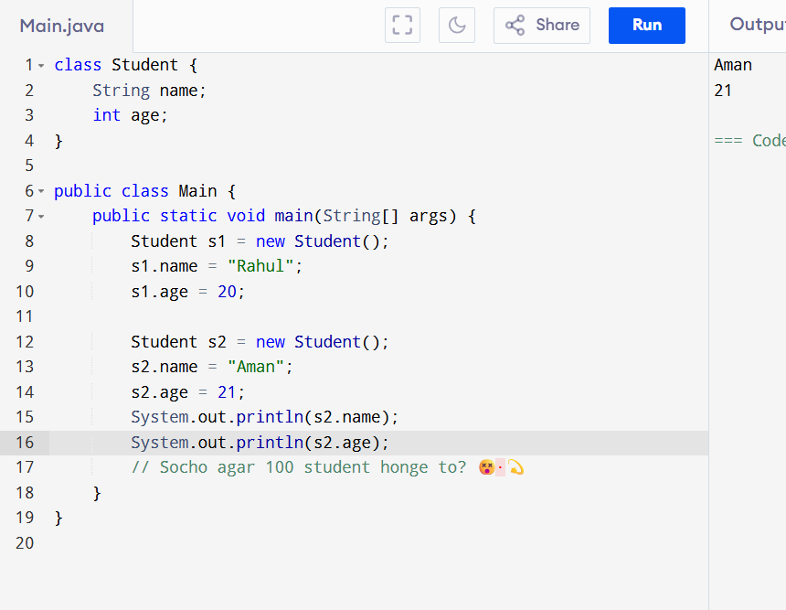

**🡪Constructor**

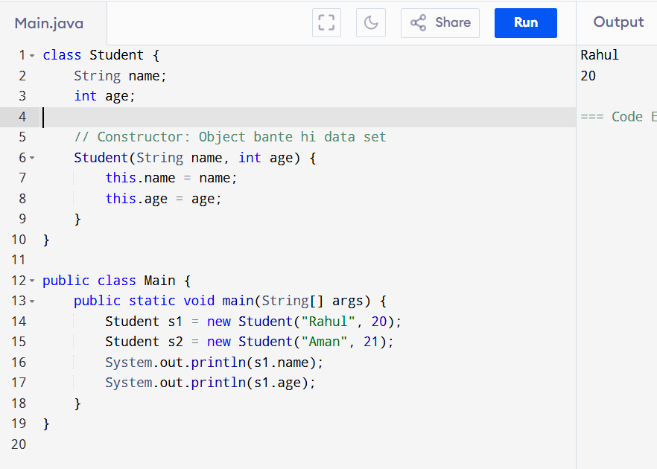

**Bina constructor:** Object banta hai… phir Ham manually data dete hai .  
**Constructor ke saath:** Object bante hi data bhi set ho jaata hai ✅ .

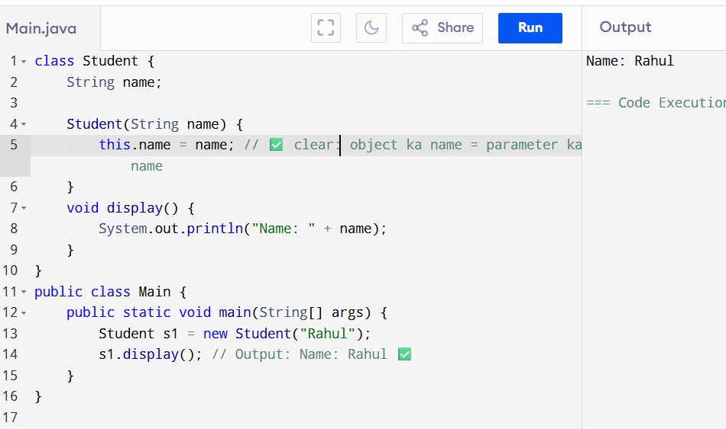

**Defination :🡪**A constructor is a special method in Java that is used to initialize objects.  
It has the same name as the class and does **not have any return type.  
  
:::: 🡪**constructor ek special function hota hai jo object banate hi automatic chal jaata hai, aur wo object ke variables ko set (initialize) karta hai. Iska naam class ke naam jaisa hota hai aur koi return type nahi hoti.

**Toh Constructor Ki Zarurat Kyu Padti Hai?**

**1. Automatic Initialization — Object banate hi variables set karne ke liye**

**2. Code Saaf aur Maintain Karna Aasan Hotaa Hai**

Jab tum bahut saare objects banao (jaise 100 students), toh har baar manually properties set karna boring aur error-prone ho sakta hai.

Constructor se:

Student s1 = new Student("Rahul");

Student s2 = new Student("Aman");

Student s3 = new Student("Priya");

Direct, fast, aur simple!

: initial Object   
  
Without initialization: 🡪  
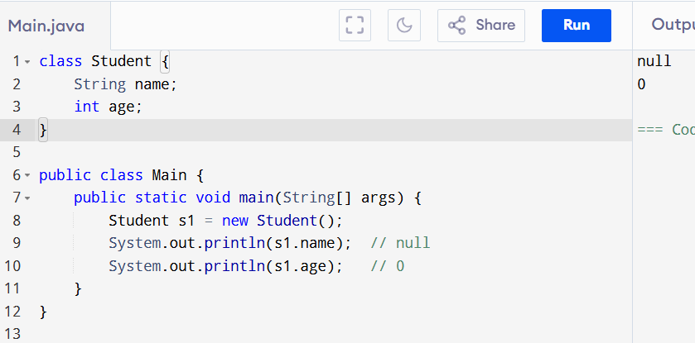  
With Constructor (Initialization):

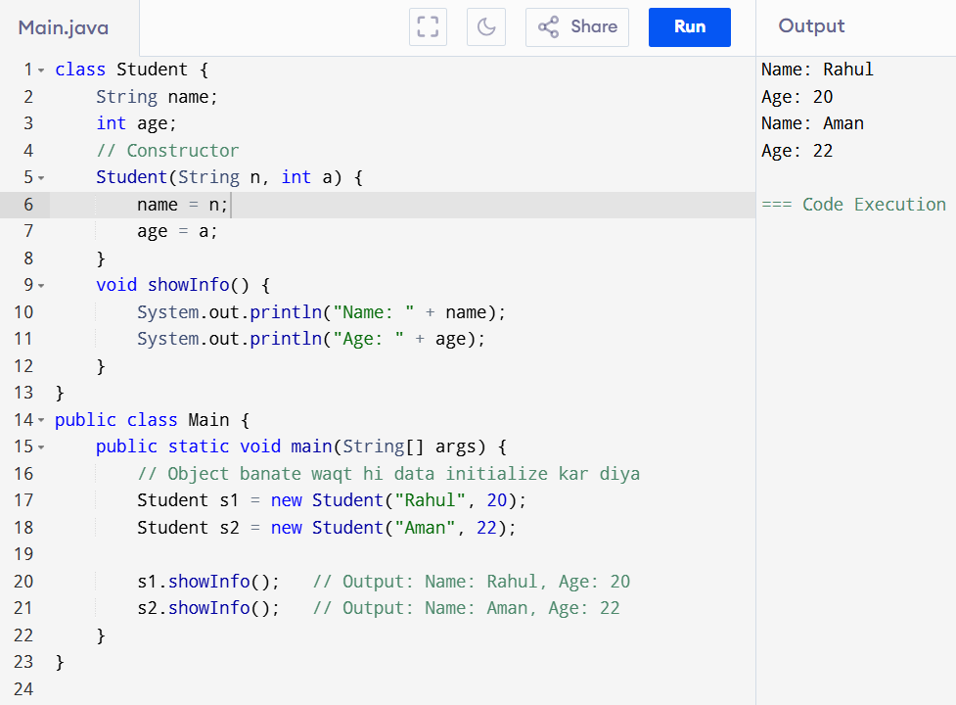

🡪##

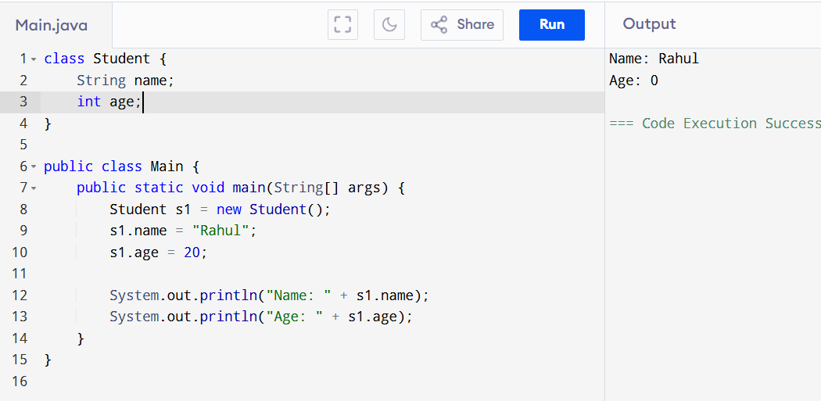

**❌ Problem:**

* Agar s1.name set karna bhool gaye to object **incomplete** rahega.
* Har object ke liye alag se .name aur .age set karna padta hai.

✅ 2. **Constructor ke saath:**

