1. Pehle **table create karen**
2. Fir **data insert karen**
3. Uske baad **column add/delete/update/rename** ke operations dikhayein
4. Aur har step ka output bhi ho

**📘 MySQL Notes: Column Operations (Step by Step)**

**🧾 Step 1: Create Table (Sheet)**

CREATE TABLE students (

id INT PRIMARY KEY,

name VARCHAR(50),

age INT

);

**✅ Output Table (Initially Blank)**

| **id** | **name** | **age** |
| --- | --- | --- |
|  |  |  |

**🧾 Step 2: Insert Data into Table**

INSERT INTO students (id, name, age)

VALUES (1, 'Aman', 18),

(2, 'Priya', 19),

(3, 'Ravi', 20);

**✅ Output Table After Insert:**

| **id** | **name** | **age** |
| --- | --- | --- |
| 1 | Aman | 18 |
| 2 | Priya | 19 |
| 3 | Ravi | 20 |

**🧾 Step 3: Add a New Column**

ALTER TABLE students ADD city VARCHAR(30);

**✅ Output Table After Adding Column:**

| **id** | **name** | **age** | **city** |
| --- | --- | --- | --- |
| 1 | Aman | 18 | NULL |
| 2 | Priya | 19 | NULL |
| 3 | Ravi | 20 | NULL |

**🧾 Step 4: Update New Column Data**

UPDATE students SET city = 'Delhi' WHERE id = 1;

UPDATE students SET city = 'Mumbai' WHERE id = 2;

UPDATE students SET city = 'Pune' WHERE id = 3;

**✅ Output Table After Updating city:**

| **id** | **name** | **age** | **city** |
| --- | --- | --- | --- |
| 1 | Aman | 18 | Delhi |
| 2 | Priya | 19 | Mumbai |
| 3 | Ravi | 20 | Pune |

**🧾 Step 5: Delete a Column (age)**

ALTER TABLE students DROP COLUMN age;

**✅ Output Table After Deleting age:**

| **id** | **name** | **city** |
| --- | --- | --- |
| 1 | Aman | Delhi |
| 2 | Priya | Mumbai |
| 3 | Ravi | Pune |

**🧾 Step 6: Rename Column name to full_name**

ALTER TABLE students RENAME COLUMN name TO full_name;

**✅ Output Table After Renaming Column:**

| **id** | **full_name** | **city** |
| --- | --- | --- |
| 1 | Aman | Delhi |
| 2 | Priya | Mumbai |
| 3 | Ravi | Pune |

**🧾 Step 7: View Table Structure (Optional)**

DESC students;

**✅ Output:**

+------------+-------------+------+-----+---------+-------+

| Field | Type | Null | Key | Default | Extra |

+------------+-------------+------+-----+---------+-------+

| id | int | NO | PRI | NULL | |

| full_name | varchar(50) | YES | | NULL | |

| city | varchar(30) | YES | | NULL | |

+------------+-------------+------+-----+---------+-------+

**🧾 Summary Table (Cheat Sheet)**

| **Task** | **Query Example** |
| --- | --- |
| Add column | ALTER TABLE students ADD city VARCHAR(30); |
| Delete column | ALTER TABLE students DROP COLUMN age; |
| Rename column | ALTER TABLE students RENAME COLUMN name TO full_name; |
| Update column values | UPDATE students SET city = 'Pune' WHERE id = 1; |
| View table columns | DESC students; |

🡺  
  
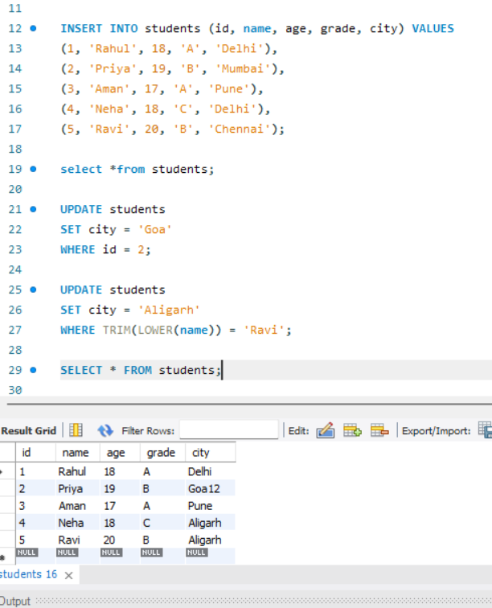

🡺Add F.NAME Coloum  
  
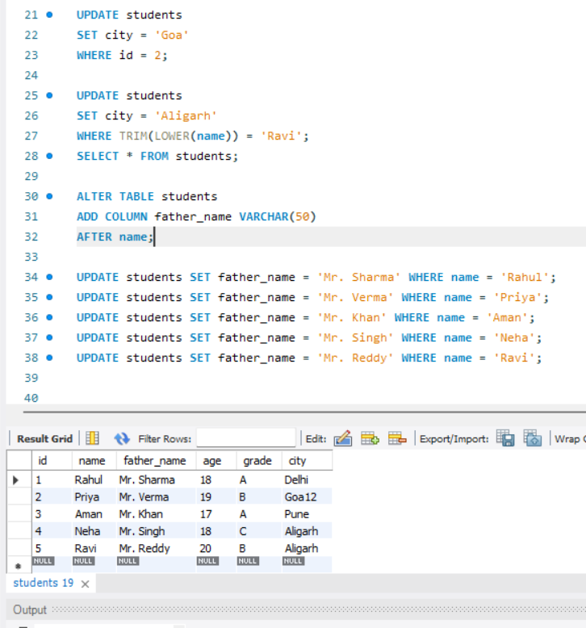

🡺MARKSHEET TASK

