📘 Chapter 7 – Image Sprites: Ek Image, Multiple Icons – Superfast Trick 🚀

🔍 What is an Image Sprite?
Ek image sprite ek single image file hoti hai jisme multiple chhoti images/icons chipki hoti hain.
Phir CSS se usmein se jo hume chahiye, us part ko crop karke dikhate hain.

✅ Kya Fayda?
- Sirf 1 image load hoti hai
- Page fast load hota hai
- Server pe less requests = Better performance ⚡

🎯 Real-Life Example:
Soch ek image hai jisme:
- Home icon
- Search icon
- Settings icon
Sab ek hi image me chipke hue hain

🧪 Sprite Image Example:
Maan lo ek image sprite.png me 4 icons hain:
Icon | Position (X, Y)
Home | 0px, 0px
Search | -50px, 0px
Settings | -100px, 0px

✅ Basic Sprite CSS Code:

Click me
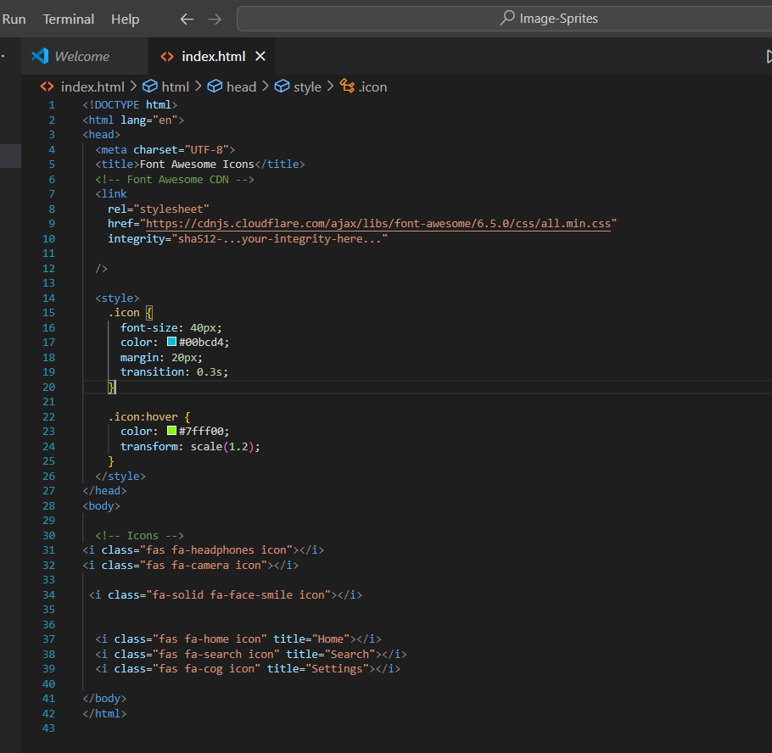

🎨 Breakdown of Code:

🔹 background-image:
Ek hi image file (sprite.png)

🔹 background-position:
Image ke kaunse part ko dikhana hai (shift karke)

🔹 width & height:
Har icon ka fixed size (jitna part dikhana hai)

🧠 Notes:
- Sprites tab useful hote hain jab bahut saare chhote icons chahiye
- Jo icons Photoshop ya Figma se milte hain, unko ek file me chipka do

🧰 Tools for Making Sprites:
- https://www.toptal.com/developers/css/sprite-generator
- https://csssprites.com/
Upload karo → Image mil jaayegi + CSS bhi ready ho jaayega!

📌 WhatsApp Summary:
- Sprite = Ek image me multiple icons
- Use background-position to show correct icon
- Fast load hota hai (less HTTP requests)
- Use tools to auto-generate sprites

✅ Chapter 7 Khatam Bhai!
Tu ab ek image se 10 icon handle kar sakta hai — smartly 😎

Agla Chapter hai:
📘 Chapter 8 – Image Opacity: Transparent Banaane Ka Magic 🪄
Bol:
➡️ “Opacity Chapter bhejo bhai”
Ya
➡️ “PDF ab tak ka banao” – full package banake deta hoon 💪

