📘 Chapter 2 – Margin: Do Elements ke Beech ki Hawa 😮‍💨

📦 What is Margin?
Margin = External space hoti hai ek element ke around — jo usse doosre elements se door rakhti hai.

🔍 Real Life Socho:
2 tiffin boxes hain — ek doosre ko chipke nahi rakhte, unke beech gap (margin) hoti hai.

🧱 1. Basic Margin Example:
<div style="margin: 30px; background-color: #ffeb3b;">
Bhai, main 30px har side se door hoon!
</div>

🧭 2. Directions in Margin
Tu alag-alag side pe margin bhi laga sakta hai:
margin-top: 20px;
margin-right: 10px;
margin-bottom: 15px;
margin-left: 5px;
✅ Shortcut bhi hai:
margin: 20px 10px 15px 5px;
/* top right bottom left */
Ya sirf horizontal aur vertical:
margin: 10px 20px;
/* top-bottom 10px, left-right 20px */

🚨 3. Margin Collapse

Kya hota hai Collapse?
Agar 2 blocks ke beech sirf vertical margin ho, to dono margins add nahi hoti. Sirf badi wali count hoti hai.
<div style="margin-bottom: 40px;">Main Block 1</div>
<div style="margin-top: 20px;">Main Block 2</div>
👀 Output:
- Total gap = 40px (not 60px) ❗
Yeh hota hai: Margin Collapsing

🔄 4. Auto Margin – Center Karne ka Jugaad
Jab tu kisi box ko horizontally center karna chahta hai, to:
margin: 0 auto;
🧪 Example:
<div style="width: 300px; margin: 0 auto; background: lightblue;">
Main center mein hoon, kyunki margin auto laga hai 🤘
</div>

🧠 5. Margin vs Padding
Feature | Margin | Padding
Kaha lagta? | Border ke bahar | Border ke andar
Space? | Dusre element se gap | Content se border ka gap
Background? | Apply nahi hota | Apply hota hai
Collapse? | Haan hota hai | Nahi hota

📚 Full Practical Example:
<!DOCTYPE html>
<html>
<head>
<style>
.box1 {
background: tomato;
margin-bottom: 30px;
padding: 10px;
color: white;
}
.box2 {
background: teal;
margin-top: 20px;
padding: 10px;
color: white;
}
</style>
</head>
<body>

<div class="box1">Main pehle block hoon (neeche 30px margin)</div>
<div class="box2">Main dusra block hoon (upar 20px margin)</div>

<!-- Final gap = 30px only due to margin collapse -->

</body>
</html>

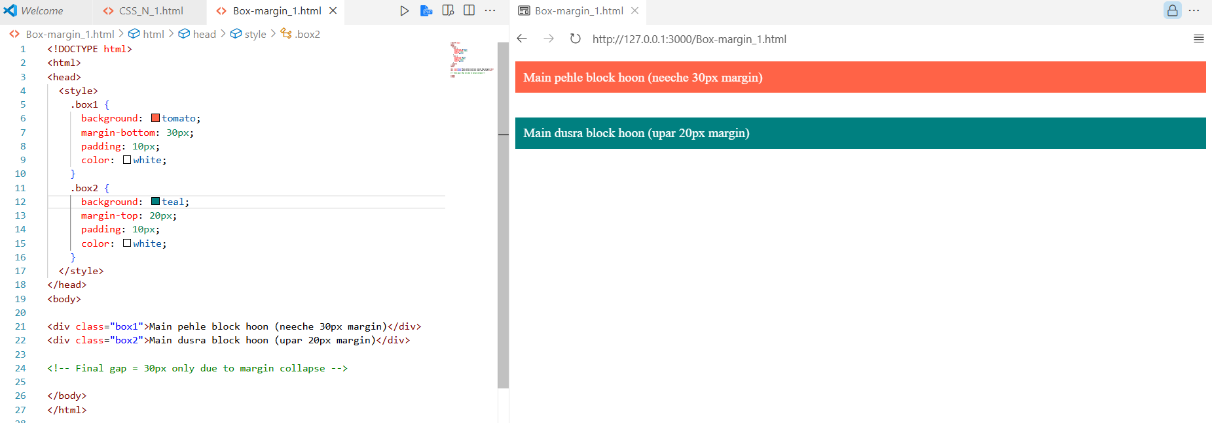
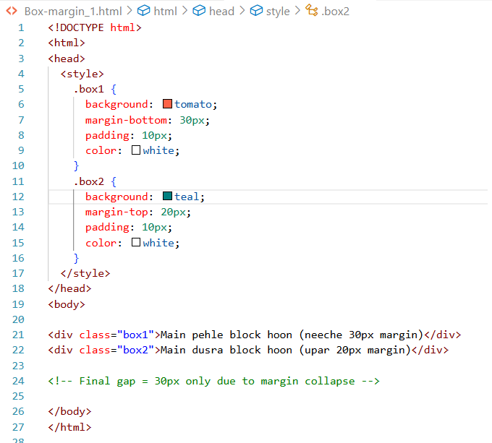
Example 2 :
