JS Async
JS Callbacks
JS Asynchronous
JS Promises
JS Async/Await

🔥 Part 1: JavaScript Asynchronous ka matlab kya hota hai ?

🔹 JavaScript normal kaise kaam karta hai?
- JavaScript ek line-by-line chalne wali language hai.
- Pehle ek kaam hoga, phir doosra. Jab tak pehla complete nahi hota, doosra start nahi hota.
🟩 Isse bolte hain Synchronous.
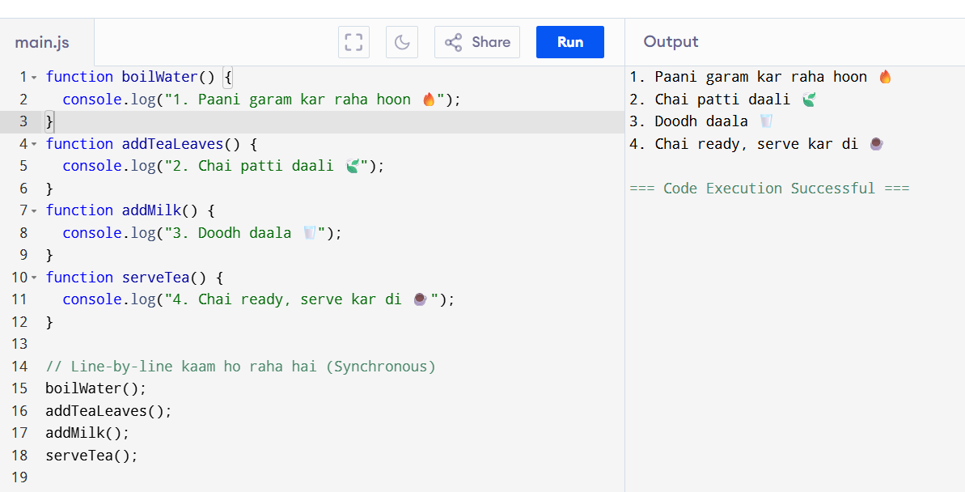
Code ->Click me

🔥 Part 2: Asynchronous ka matlab ?
- Kuch kaam aise hote hain jo turant nahi hote (like: API se data lana, 5 sec wait karna).
- Ye kaam background mein chal jaate hain, aur JavaScript aage badh jaata hai.
🟨 Isse bolte hain Asynchronous.
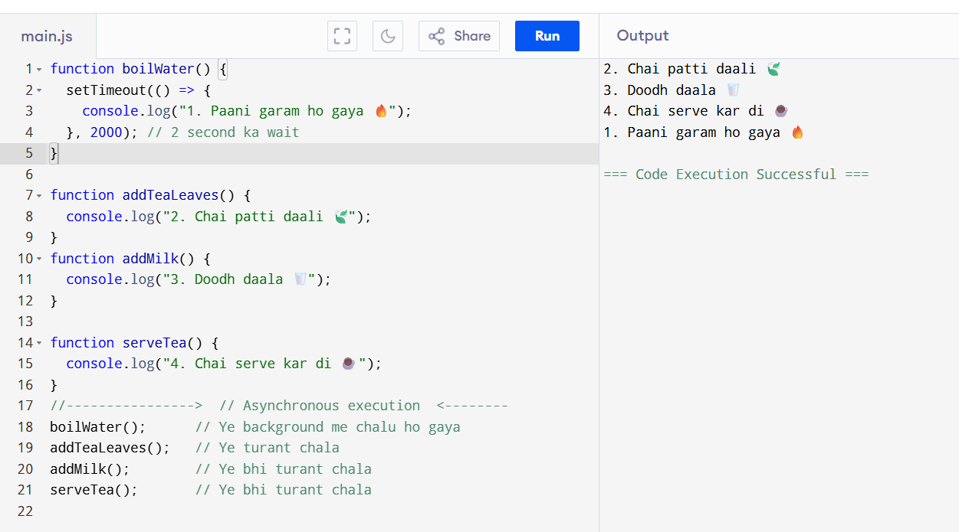
Code Click me

🔥 Part 3: Callback – ek chhota helper function

🟢 Callback kya hota hai?
Jab hum kisi function ko bolte hain:
“Tu kaam khatam hone ke baad ye function chala dena”
Us function ko callback kehte hain.
Code Click me
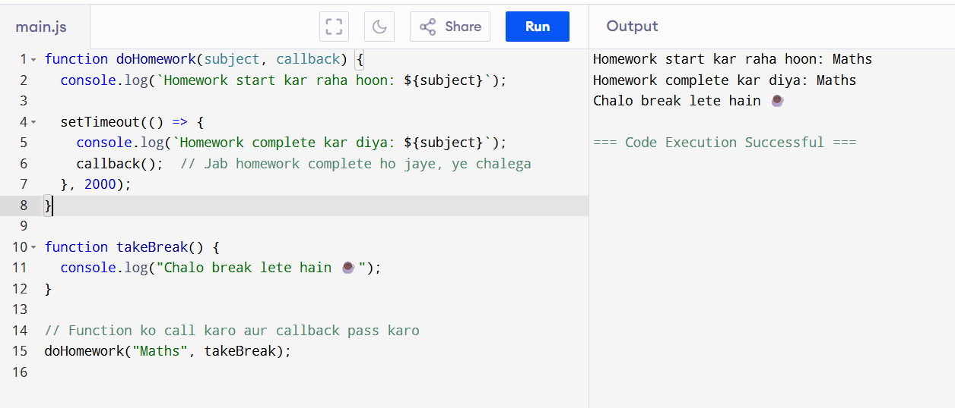
Ex-2
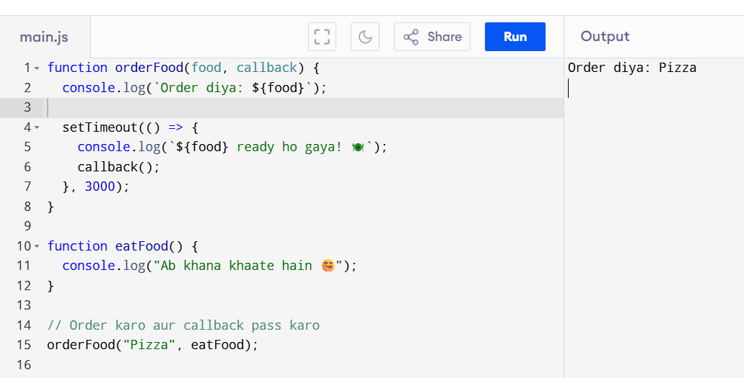
After 2 Sec
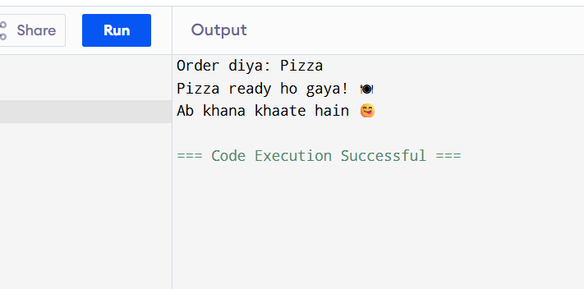

🔥 Part 4: Promises – Future ka promise

🟢 Promise kya hai?
JavaScript bolta hai:
“Main tumko ek promise deta hoon. Agar kaam sahi se ho gaya, to success (resolve) bolunga. Nahi hua to error (reject)”

🔥 Part 5: async / await – Easy tarika Promises ka
Yeh ek naya aur simple style hai Promise use karne ka.
Code dekhne me normal synchronous jaisa lagta hai, lekin andar se async hota hai.

