CSS transform property ke kaafi types hote hain, jo element ko alag-alag tarah se change karte hain — jaise size badalna, ghumana, move karna, ya tilt karna.
Type | Kya karta hai? | Example
scale() | Size ko badhata ya chhota karta hai | transform: scale(1.2);
translate() | Element ko move karta hai (left, right, up, down) | transform: translate(50px, 20px);
rotate() | Element ko ghumata hai degree me | transform: rotate(45deg);
skew() | Element ko tilt karta hai | transform: skew(20deg, 10deg);
matrix() | Complex transform (scale, rotate, skew, translate ek saath) | transform: matrix(1, 0, 0, 1, 50, 50);

1. Scale()

🔍 transform: scale() – Easy Breakdown
📏 Size ke hisaab se samjho:
- ✅ scale(1.0) → 🎯 Normal size (100%)
👉 Box jaisa hai, waisa hi dikhega
- 🔍 scale(1.2) → 🔎 Bada size (120%)
👉 Box 20% bada ho jayega
Jaise zoom kar diya ho
- 🔽 scale(0.8) → 🔻 Chhota size (80%)
👉 Box 20% chhota ho jayega
Jaise shrink ho gaya ho
Situation | Use scale() like
Button hover | scale(1.1) for pop effect ✨
Image enlarge | scale(1.2) on hover 🖼️
Shrink on click | scale(0.9) for press feel 👆

- 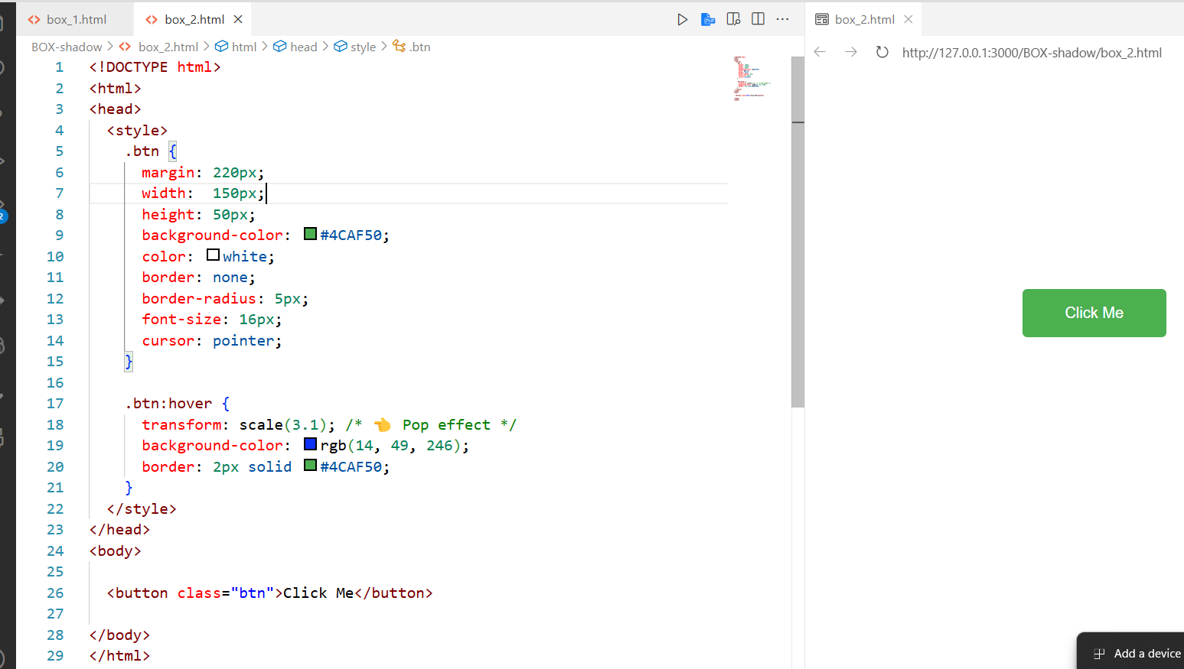
After hover :
o/p
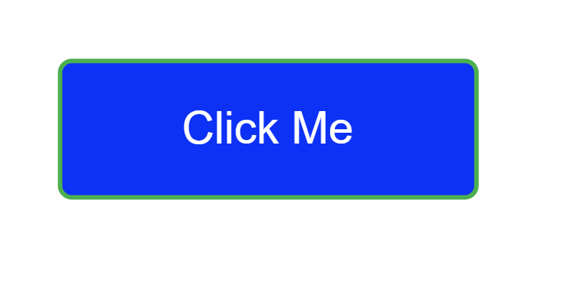
Example 2
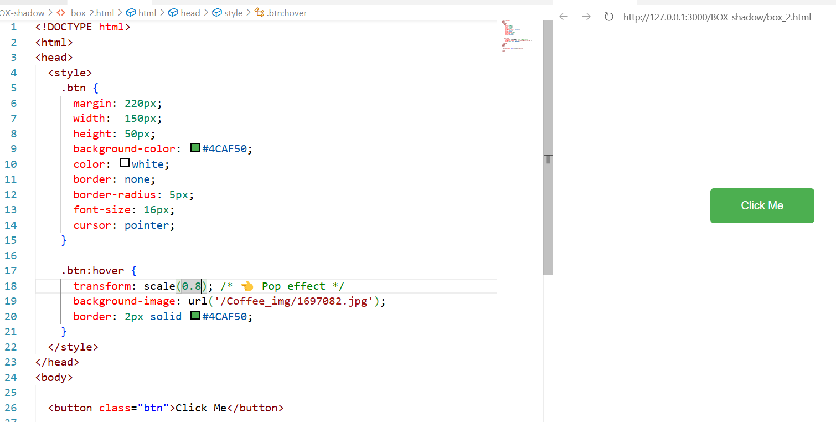
After hover


translate() | Element ko move karta hai (left, right, up, down) | transform: translate(50px, 20px);

📏 Breakdown:
- translate(50px, 20px)
➡️ 50px right, ⬇️ 20px down
- translate(-50px, -20px)
⬅️ 50px left, ⬆️ 20px up
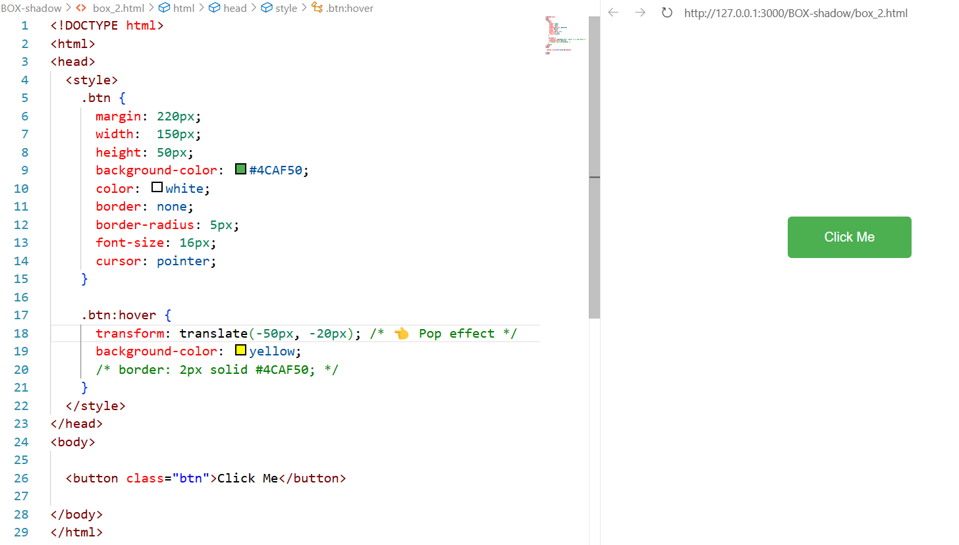
After hover :


Property | Kya karta hai
translate(50px, 20px) | 50px right, 20px down
translate(-30px, 0) | 30px left
translate(0, -40px) | 40px up
translateX(100px) | Sirf right
translateY(100px) | Sirf down

Try your Self :

rotate() | Element ko ghumata hai degree me | transform: rotate(45deg);

🔧 Kya karta hai?
👉 Ye element ko ghumata (rotate) hai, degree mein — jaise clock ke needle ghoomte hain 🕰️
transform: rotate(angle);
angle = kitne degree ghumana hai (positive ya negative)

Code | Meaning
rotate(45deg) | 🔁 45° clockwise (right side)
rotate(-45deg) | 🔁 45° anti-clockwise (left side)
rotate(90deg) | 🔁 Quarter turn (right angle)
rotate(180deg) | 🔁 Upside down

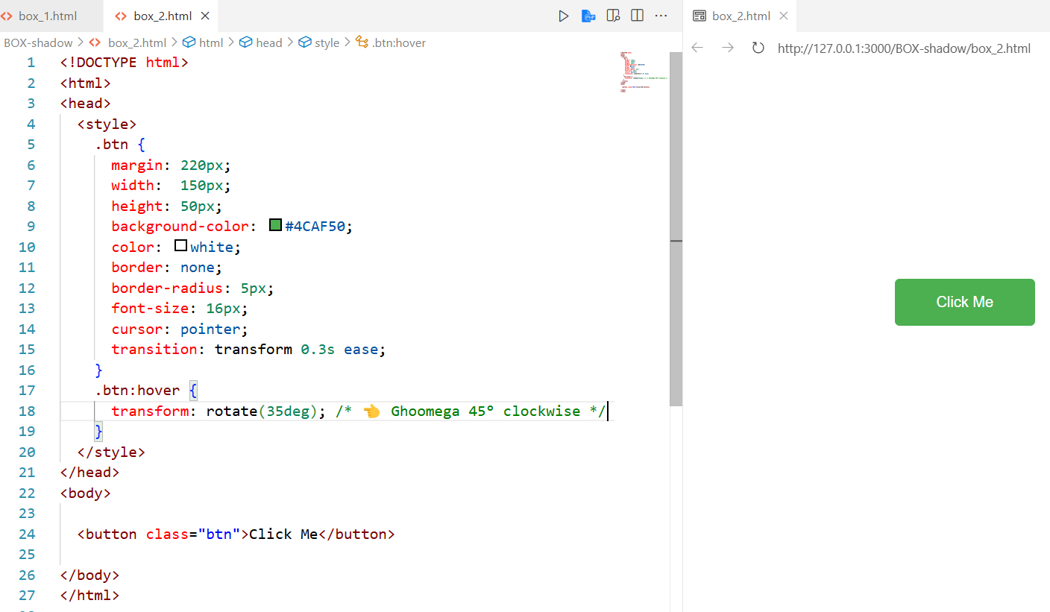
After hover :

Example 2
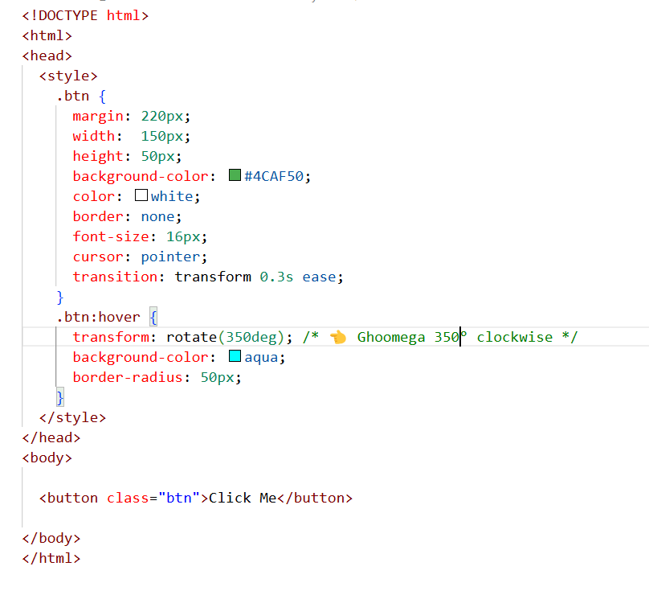
o/p =>

skew() | Element ko tilt karta hai | transform: skew(20deg, 10deg);

🎭 transform: skew() — Asaan Samjhaav

🔧 Kya karta hai?
👉 skew() element ko tilt karta hai — jaise image ya box tedha ho gaya ho 🪞
Socho: Jaise kisi box ko pakad ke thoda sa ek taraf kheench diya ho 🎨
transform: skew(X, Y);
Value | Meaning
X | Horizontal tilt ↔️ (left/right)
Y | Vertical tilt ↕️ (top/bottom)

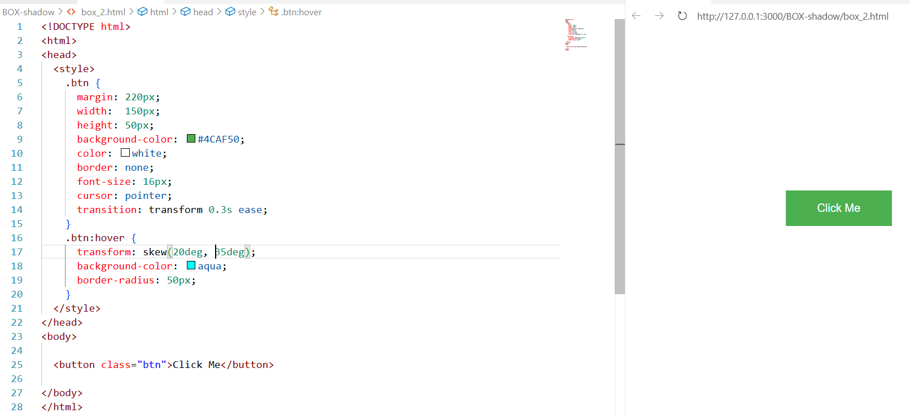
o/p ==>


example 2 =>

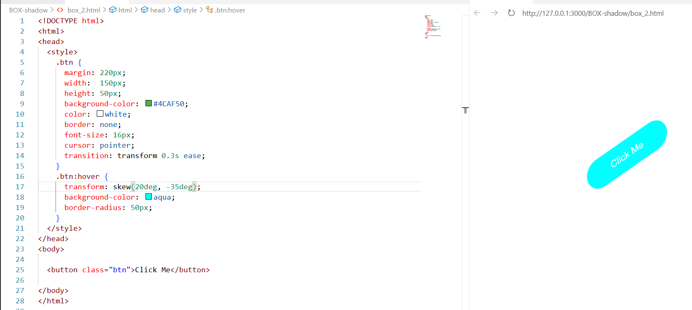

matrix() | Complex transform (scale, rotate, skew, translate ek saath) | transform: matrix(1, 0, 0, 1, 50, 50);

