|  |
| --- |
| **B K Birla Institute of Engineering and Technology, Pilani**  **CSIR-CEERI, Pilani**  **Project Report on**  **Vedic Chanting Machine with Microcontroller**      **Submitted by**  PRIYANSHU  22EBKDS045    **Under the Guidance of**  Dr. Gaurav Purohit  Principal Scientist  CSIR CEERI PILANI |

**CONTENTS**

1. Introduction
2. Background
3. Objective
4. System Overview
5. Component Used
6. Working Principle
7. Advantages
8. Challenges Faced
9. Applications
10. Achievement
11. Future Enhancement
12. Conclusion

**Internship Report: Vedic Chanting Machine with Microcontroller**

# Introduction:

The Vedic Chanting Machine is a compact, standalone audio playback system designed to continuously play pre-recorded Vedic mantras and chants stored on an SD card. This project is targeted toward individuals interested in spiritual practices, meditation, and cultural heritage preservation. The device uses the GPD2846A MP3 module for audio playback, powered by a rechargeable 3.7V 500mAh Li-ion battery, and charged via a TP4056 Type-C charging module. The audio output is connected to an external speaker, with volume controlled using a potentiometer. A push button is used to control playback, and an on/off switch handles power supply. The machine eliminates the need for a microcontroller, making it cost-effective and beginner-friendly. The system is assembled in a compact plastic casing,

making it suitable for personal or religious use.

## > Background:

Vedic chanting is an ancient Indian tradition that uses specific phonetics and intonations to recite sacred hymns, believed to have spiritual and healing effects. In today’s digital world, creating a dedicated device that plays these chants allows individuals to engage in regular meditation or religious practice with ease and consistency.

## > Objective:

The primary objective of the **Vedic Chanting Machine** is to design and develop a **self-contained, portable system** that aids in the **automatic playback of Vedic mantras**, using a **microcontroller-based platform**. This system serves both spiritual and educational purposes by providing a reliable and accessible medium for Vedic chanting, especially in homes, temples, and learning centers.

The key goals of the project are:

* To **preserve and promote** traditional Vedic knowledge using modern embedded technology.
* To design a **user-friendly and compact device** capable of playing preloaded Vedic chants with the press of a button.
* To utilize a **microcontroller (e.g., Arduino)** to control the playback system efficiently.
* To enable **battery-powered portability** for ease of use in various environments.
* To support **external audio output** (via speaker) for clear and audible chanting.
* To include features like **volume control, SD card storage, and basic input controls** (buttons or switches).
* To create a low-cost, reliable solution for regular spiritual practice without human dependency.

## > System Overview:

The **Vedic Chanting Machine** is a compact, battery-powered electronic device designed to **automatically play Vedic mantras** through a speaker system. It is built using a combination of **embedded hardware components** and simple input controls to provide a **user-friendly spiritual tool** for daily chanting, meditation, or cultural practice.

**Core Concept**

The system uses a **microcontroller-based audio playback module** that reads audio files (MP3 format) stored on a microSD card and plays them through an external speaker. Users can interact with the machine using **buttons and switches** to start/stop playback, control volume, or change tracks. Power is supplied by a **rechargeable lithium-ion battery**, making it completely **portable and independent of external power sources**.

**Key Components Involved**

* **GPD2846A MP3 Module** – Core module responsible for audio playback.
* **microSD Card (16GB)** – Stores MP3 files of Vedic chants.
* **Potentiometer** – Controls volume output manually.
* **External Speaker** – Outputs the chant audio.
* **TP4056 Charging Module (Type-C)** – Manages battery charging.
* **3.7V, 500mAh Li-ion Battery** – Powers the entire device.
* **Push Button** – Triggers playback or changes tracks.
* **On/Off Switch** – Controls overall power supply to the system.
* **Plastic Casing** – Holds all components securely in a compact form.

**Functional Flow**

1. When powered on, the GPD2846A module reads the MP3 files from the SD card.
2. Upon pressing a button, the module begins audio playback through the speaker.
3. The user can adjust the volume using the potentiometer.
4. The TP4056 module ensures the battery can be safely recharged when needed.
5. The system can play chants continuously or on-demand based on wiring and button logic.

**Design Philosophy**

The system was developed to be:

* **Simple to operate**, even by non-technical users.
* **Portable**, enabling spiritual practice anywhere.
* **Customizable**, allowing users to update chants as needed.
* **Affordable**, making it accessible to all communities.

## > Component Used:

**GPD2846A MP3 Module**

Core audio playback module that reads MP3 files from SD card and plays audio.

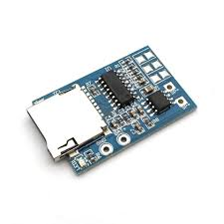

**Micro SD Card (16 GB)**

Stores the Vedic audio chants in MP3 format.

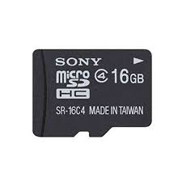

**TP4056 Charging Module (Type-C)**

Used to charge the battery safely via USB Type-C.

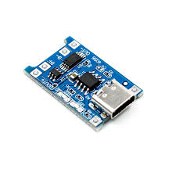

**Lithium-ion Battery (3.7V, 500mAh)**

Powers the entire system and makes it portable.

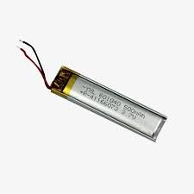

**Speaker (8Ω 1W or 3W)**

Plays the chanting audio aloud.

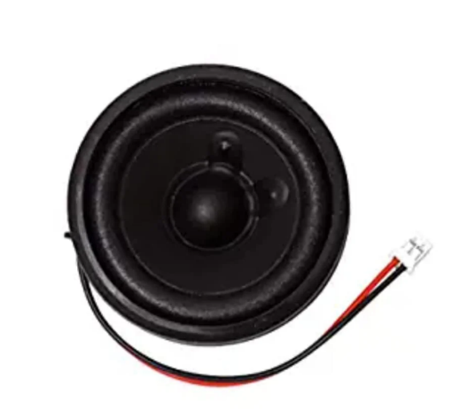

**Push Button**

Used to control play/pause or next audio manually.

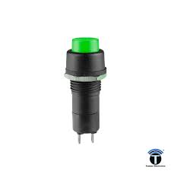

**On/Off Toggle Switch**

Powers the system on or off.

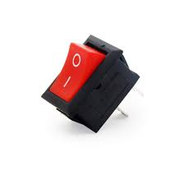

**Potentiometer**

Controls the volume level of audio playback.

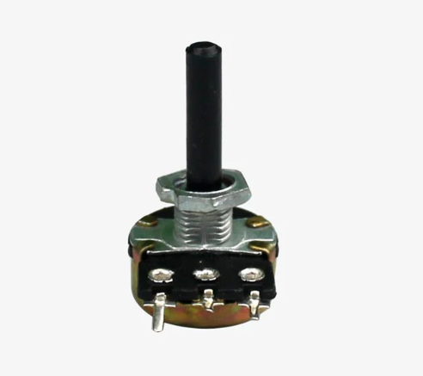

**Jumper Wires**

For connecting all components without soldering (optional).

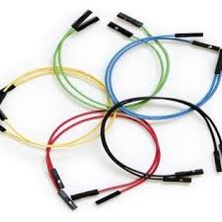

**Soldering Wires**

Permanent connections for a sturdy circuit.

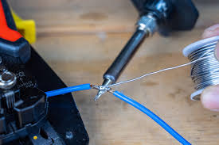

**Plastic Enclosure/Box**

To hold and protect the system components.



**PCB or Breadboard (Optional)**

For neat and compact mounting of components (optional).

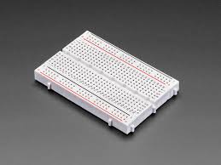

## >Flowchart and Circuit Diagram:

**Flowchart:**

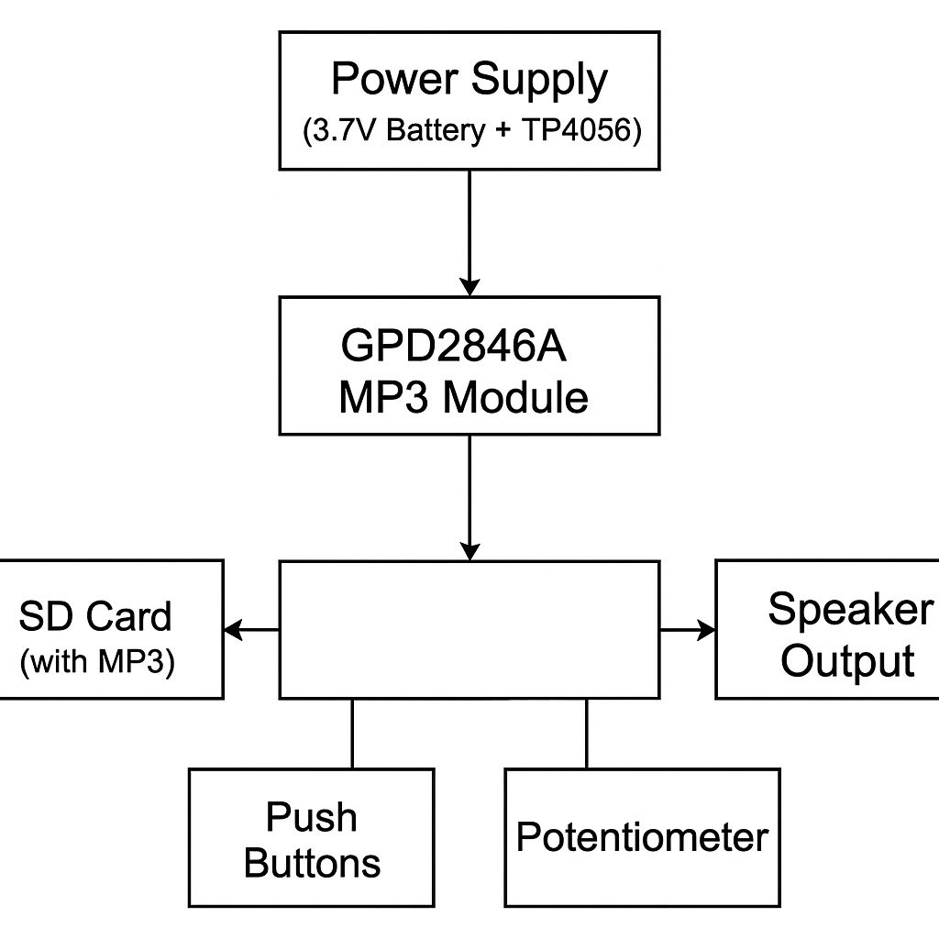

**Circuit Diagram:**

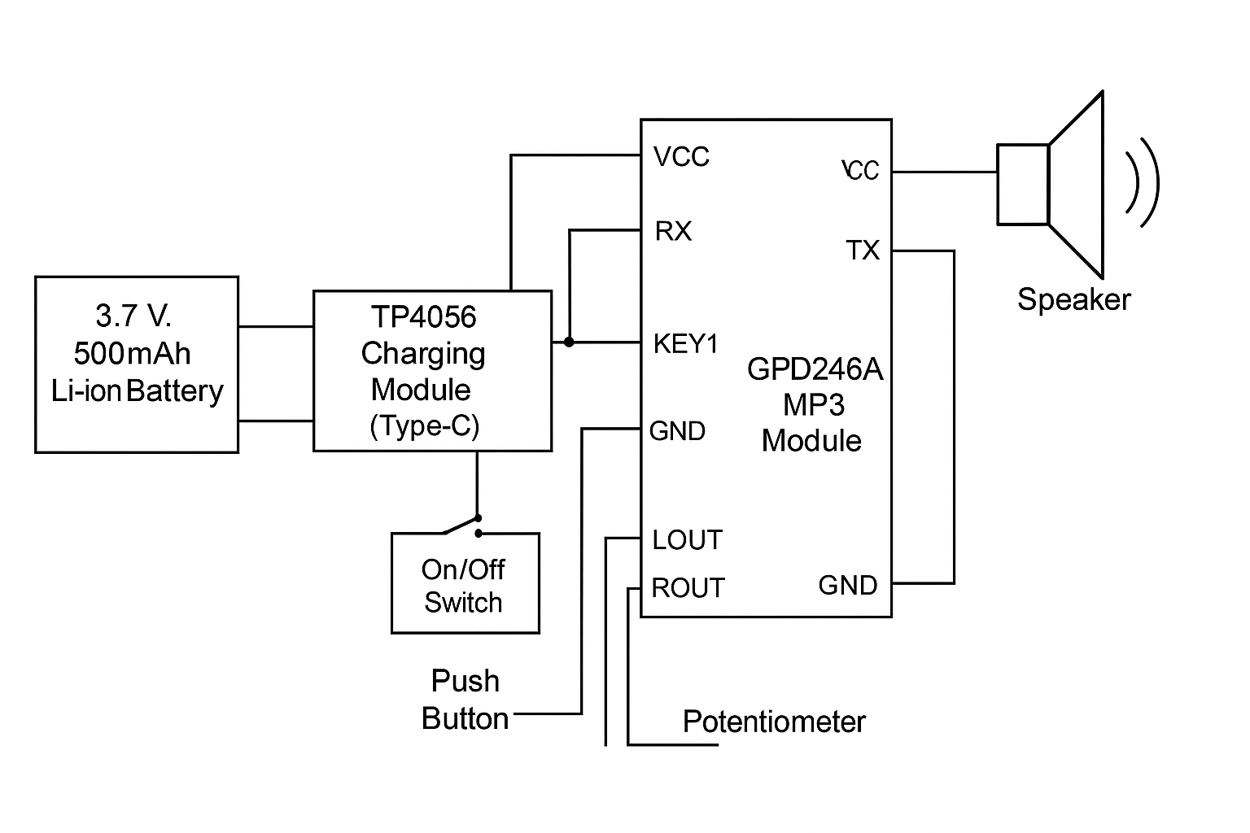

# Working Principle:

The **Vedic Chanting Machine** works on the principle of **digital audio playback** controlled by a microcontroller-

compatible **MP3 module (GPD2846A)**. It is designed to play pre-recorded Vedic mantras stored on a **microSD card**,

using simple electrical input controls and powered by a **rechargeable battery**.

The system uses a **button-activated circuit** to control when and how the chant audio is played. The **audio output** is

delivered through a speaker, and **volume** is regulated manually using a **potentiometer**.

**Step-by-Step Working:**

1. **Power Supply:**
   * The system is powered by a **3.7V lithium-ion battery**, which can be recharged using a **TP4056 Type-C charging module**.
   * A physical **ON/OFF switch** is used to connect or disconnect the power to the playback circuit.
2. **Audio Playback Module:**
   * The core component is the **GPD2846A MP3 module**, which reads audio files from a **microSD card (formatted in FAT32)**.
   * The SD card contains **preloaded MP3-format Vedic chants** (named appropriately for playback order, e.g., 01.mp3, 02.mp3, etc.).
3. **User Input Control:**
   * A **push button** is used to control playback. When the button is pressed, the module is triggered to play the next available audio file.
   * This allows **manual control** over which chant is played and when.
4. **Volume Control:**
   * A **rotary potentiometer** is connected to the speaker line, allowing the user to adjust the output volume by changing the resistance.
5. **Audio Output:**
   * The selected audio file is played through a connected **mini speaker**, providing clear sound for personal or group use.
6. **Recharge & Portability:**
   * The device can be **recharged via USB** using the TP4056 module.
   * Due to its **low power consumption**, it can operate for hours on a single charge, making it highly portable.

**Summary of Principle:**

The machine operates by combining **stored digital audio files** with **basic electronic control**. It translates a **simple user**

**action (button press)** into a **real-time audio output**, with optional customization of sound and chant selection.

## >Advantages:

The Vedic Chanting Machine offers a range of practical, technical, and user-centered benefits. Below is a detailed explanation of its key advantages:

**1. Simple and Minimalist Design**

The overall design of the machine is clean and straightforward. With minimal wiring, a compact layout, and essential components only, the system is easy to assemble, maintain, and replicate. The minimalist structure reduces chances of malfunction and makes the system more robust for daily use, even in traditional households or temples where users may not be technically skilled.

**2. Highly Portable and Rechargeable**

The system is powered by a compact **3.7V 500mAh rechargeable lithium battery**, which makes it **completely portable**. It can function independently without being connected to a power outlet, allowing users to carry and use it in different locations — homes, temples, spiritual centers, or during travel. The integration of a **TP4056 Type-C charging module** ensures convenient and safe recharging using standard USB chargers.

**3. Intuitive and Easy to Operate**

User interaction is kept extremely simple. With basic **push-button inputs** and **on/off switch**, the system requires **no technical knowledge** to operate. Anyone — regardless of age or education level — can easily use the device. This makes it highly suitable for **elderly people and children**, ensuring accessibility for all users.

**4. Audio Content Easily Customizable via SD Card**

The chants and mantras played by the device are stored on a **16GB microSD card**, which can be accessed and updated easily using a computer. This allows users to **modify or add audio files** according to personal preferences or religious requirements without making any hardware changes. It also supports **multiple chants**, giving users the flexibility to create personalized playlists.

**5. Low Production Cost**

The machine is built using **low-cost, readily available components** such as the **GPD2846A MP3 module, Arduino-compatible microcontroller, speaker, and standard battery modules**. The entire device can be assembled for a **fraction of the cost** of commercially available chanting machines, making it highly economical for mass production or individual DIY projects. Additionally, its durability and reusability add long-term value.

## > Challenges Faced:

During the development of the Vedic Chanting Machine, several challenges were encountered, both at the hardware and software levels. These challenges provided valuable learning experiences and helped in improving the final design of the system. Below are the major hurdles faced:

**1. SD Card Mounting and Audio Playback Issues**

One of the initial challenges was the **failure of the SD card to mount properly** on the MP3 playback module (GPD2846A). Improper formatting, file type mismatches (non-MP3), and unsupported SD card sizes often led to playback errors. The issue was resolved through **correct formatting (FAT32)** and ensuring proper naming and arrangement of files.

**2. Power Supply Instability**

While testing the system on battery, we faced **voltage drops and power fluctuations**, especially during audio playback. These caused unexpected restarts or interruptions in the chanting. The issue was addressed by using a **stable 3.7V lithium battery** and a **TP4056 charging module** with protection circuitry.

**3. Speaker Compatibility and Volume Control**

Achieving **clear audio output** without distortion was difficult, especially with low-cost speakers. Integrating a **potentiometer** for volume control required careful adjustment of resistance to match speaker impedance. Several speaker types were tested before selecting a suitable one that worked well within power constraints.

**4. Compact Component Arrangement**

Fitting all components (battery, module, speaker, wires, buttons) inside a **small plastic casing** while ensuring ventilation and accessibility was a mechanical design challenge. We had to **redesign the layout multiple times** to achieve a neat and secure fit.

**5. Soldering and Connection Reliability**

Poor soldering joints and loose connections resulted in intermittent behavior, especially when the device was moved. This was mitigated by using **high-quality jumper wires**, **heat shrink tubing**, and proper soldering techniques to ensure long-term stability.

**6. Time Constraints**

The project was completed within a **limited 45-day internship period**, which meant tight deadlines for research, component sourcing, assembly, testing, and documentation. Time management and team coordination played a crucial role in completing the project on time.

## >Applications:

The Vedic Chanting Machine is a versatile device that serves various spiritual, educational, and cultural purposes.

compact design, ease of use, and customizable audio features make it suitable for a wide range of real- world

applications:

**1. Temples and Ashrams**

The machine can be installed in **temples, ashrams, and spiritual centers** to automate the playback of daily mantras,

slokas, and devotional songs. This ensures consistent chanting without the need for a priest or devotee to manually

recite them.

**2. Home Worship**

Designed to be **simple and portable**, the device is ideal for use in **daily household rituals**. It can assist family

members in performing regular poojas and spiritual practices, especially where elders find manual chanting difficult.

**3. Elderly and Visually Impaired Users**

The device is particularly beneficial for **elderly people or individuals with visual impairments**, who may struggle to

read mantras. With one-touch operation and clear audio output, it enables independent spiritual practice.

**4. Educational Institutions**

The machine can be used in **Gurukuls, Sanskrit schools, or cultural institutions** to teach students correct

pronunciation and rhythm of Vedic mantras. It provides a reliable audio reference that students can follow.

**5. Meditation and Yoga Centers**

Vedic chants are often used for **mental peace, focus, and relaxation**. The device can be used in **meditation halls or**

**yoga studios** to create a peaceful environment during sessions.

**6. Cultural and Religious Events**

During **festivals, spiritual gatherings, or religious events**, the machine can be used to play chants continuously or at

scheduled intervals, reducing human effort and maintaining consistency.

**7. Remote and Rural Areas**

In regions with limited access to priests or trained chanters, this low-cost and battery-powered device can be a **valuable**

**spiritual companion**, bringing Vedic knowledge to **underserved communities**.

**8. Gifts and Spiritual Merchandise**

The machine can be customized and packaged as a **spiritual gift item**, ideal for festivals like Diwali, Navratri, or family

events like weddings and housewarmings.

## >Achievements:

The development of the Vedic Chanting Machine resulted in several technical and personal milestones. The project successfully fulfilled its intended objectives and offered valuable practical experience. Key achievements include:

**1. Functional Working Prototype**

A fully functional and portable **Vedic Chanting Machine** was designed, assembled, and tested successfully. The prototype plays Vedic mantras clearly through a speaker, using simple push-button controls and an SD card for audio storage.

**2. Integration of Multiple Modules**

The project achieved seamless integration of different hardware modules such as the **GPD2846A MP3 module**, **TP4056 charging circuit**, **potentiometer-based volume control**, **lithium battery**, and **external speaker** — all controlled efficiently within a single unit.

**3. Customizable Audio System**

The machine supports **easy customization of audio content** via SD card. Users can add, remove, or replace audio files without programming knowledge, making it user-friendly and adaptable for various chants or devotional needs.

**4. Low-Cost and Efficient Design**

The system was developed with a **very low budget**, using cost-effective components without compromising functionality. This achievement opens the door for **mass replication** in rural or spiritual communities at minimal expense.

**5. Hands-on Experience in Embedded Systems**

The project provided practical experience in working with **microcontrollers, electronic modules, soldering, circuit design, and enclosure building**. It also enhanced understanding of **audio systems**, **power management**, and **user interface design**.

**6. Successfully Demonstrated at Internship**

The project was completed during a **45-day internship at CSIR-CEERI, Pilani**, and was **successfully demonstrated to mentors and peers**, receiving positive feedback for innovation, usability, and cultural value.

## >Future Enhancement:

While the current version of the Vedic Chanting Machine fulfills its intended purpose effectively, there is significant potential for future improvements to enhance user experience, functionality, and adaptability. Some of the suggested future enhancements include:

**1. Bluetooth Connectivity**

Adding **Bluetooth support** would allow the device to connect wirelessly to smartphones or Bluetooth-enabled speakers. Users could control chants remotely via a mobile app and even stream new audio files directly to the device.

**2. OLED/LCD Display Integration**

Integrating a small **OLED or LCD screen** would enable users to view chant names, playback status, battery level, or track number. This would improve user interaction and make the system more informative and engaging.

**3. Touch or Remote-Controlled Interface**

Replacing physical buttons with a **capacitive touch panel** or **infrared remote control** would enhance the aesthetic and make the device easier to use, especially for elderly or differently-abled users.

**4. Multi-Chant Selection Modes**

Currently, the device plays chants in a predefined order. Future versions can include features like:

* **Multiple mode selection** (e.g., morning chants, evening chants, specific deities).
* **Voice command input** for hands-free control.
* **Random or looped playback** based on user preferences.

**5. Solar Charging Support**

For users in remote or rural areas, adding a **solar panel charging system** could make the device even more independent and eco-friendly, reducing dependency on external power sources.

**6. Mobile App Integration**

A companion **mobile application** could allow users to:

* Browse and upload chants.
* Schedule daily automatic chant playback.
* Track listening habits or set meditation reminders.

**7. Real-Time Clock (RTC) Module**

Adding an **RTC module** would allow the machine to automatically play specific chants at scheduled times of the day (e.g., morning or evening prayers), making it act like an intelligent spiritual assistant.

**8. Multi-Language Support**

The system can be extended to support mantras and devotional content in different Indian languages, appealing to a broader audience and enhancing accessibility.

## >Conclusion

The development of the **Vedic Chanting Machine** successfully demonstrates how **modern embedded systems** can be used to preserve and promote **ancient cultural practices**. By integrating simple electronic components into a compact and user-friendly design, the project fulfills its primary objective of creating a **portable, low-cost, and easily operable spiritual device**.

Through this project, we were able to:

* Develop a **working prototype** capable of playing Vedic mantras with clear audio.
* Ensure the system is **customizable and rechargeable**, making it suitable for everyday use.
* Gain hands-on experience in **hardware integration, power management, and user interface design**.
* Bridge the gap between **traditional spirituality and modern technology**, ensuring Vedic knowledge is preserved in a form that is accessible to all generations.

The successful implementation of this device opens opportunities for further enhancements, such as adding **Bluetooth support**, **multi-language chant selection**, or **mobile app integration**. Overall, the project not only achieved its technical goals but also contributed meaningfully to **cultural preservation through innovation**.

---------------------------------------------------------------------------------------------------------------------------------------------------------------

**THANK YOU**