Design and Development of an Updated Vedic Chanting Machine

# 1. Abstract

The Vedic Chanting Machine is a compact, standalone audio playback system designed to continuously play pre-recorded Vedic mantras and chants stored on an SD card. This project is targeted toward individuals interested in spiritual practices, meditation, and cultural heritage preservation. The device uses the GPD2846A MP3 module for audio playback, powered by a rechargeable 3.7V 500mAh Li-ion battery, and charged via a TP4056 Type-C charging module. The audio output is connected to an external speaker, with volume controlled using a potentiometer. A push button is used to control playback, and an on/off switch handles power supply. The machine eliminates the need for a microcontroller, making it cost-effective and beginner-friendly. The system is assembled in a compact plastic casing, making it suitable for personal or religious use.

# 2. Introduction

## 2.1 Background

Vedic chanting is an ancient Indian tradition that uses specific phonetics and intonations to recite sacred hymns, believed to have spiritual and healing effects. In today’s digital world, creating a dedicated device that plays these chants allows individuals to engage in regular meditation or religious practice with ease and consistency.

## 2.2 Objective

The main objective of this project is to design a portable electronic device that can play Vedic chants without needing any app or internet connectivity. The system should be simple to operate, low cost, power-efficient, and able to be recharged via USB.

# 3. System Overview

The system is based on the GPD2846A audio decoding module. It reads MP3 files from a microSD card and plays them through an external speaker. The user can control the system using a push button and a rotary potentiometer for volume adjustment.

# 4. Components Used

|  |  |  |  |
| --- | --- | --- | --- |
| S. No | Component | Description | Quantity |
| 1 | GPD2846A MP3 Module | Audio decoder & player with TF card slot | 1 |
| 2 | TP4056 Charging Module | Li-ion battery charging with Type-C port | 1 |
| 3 | Li-ion Battery | 3.7V, 500mAh rechargeable | 1 |
| 4 | Potentiometer | 10kΩ variable resistor for volume control | 1 |
| 5 | Push Button | Used for playback control | 1 |
| 6 | On/Off Switch | Toggle power supply | 1 |
| 7 | Speaker | 3W, 4Ω or 8Ω external speaker | 1 |
| 8 | SD Card | 16 GB, FAT32 format | 1 |
| 9 | Jumper Wires | Male-female for interconnections | As needed |
| 10 | Plastic Enclosure | Box to house all components | 1 |
| 11 | Soldering Materials | Wires, iron, flux | As needed |

# 5. Circuit Design

The power supply is provided by a 3.7V Li-ion battery through a TP4056 module. The GPD2846A reads MP3 files from an SD card and outputs audio to a speaker. A potentiometer controls the volume. A push button allows the user to skip tracks. A simple on/off switch is included for power control.

# 6. Working Principle

Insert an SD card with MP3 chants. Turn on the device using the power switch. The module automatically plays the files. The push button skips tracks and the potentiometer controls the volume. Audio is played through the speaker.

# 7. Advantages

- Simple design  
- Portable and Rechargeable  
- Easy to operate  
- Customizable audio  
- Low cost

# 8. Limitations

- No display  
- No remote control  
- Limited interactivity

# 9. Applications

- Personal meditation  
- Gifts  
- Temples  
- Schools or cultural centers

# 10. Future Enhancements

- OLED display  
- Bluetooth/app control  
- Multi-language chants  
- Arduino for advanced control  
- Battery level indicator

# 11. Conclusion

The Vedic Chanting Machine offers a simple and efficient solution to deliver spiritual content. With its compact design and easy operation, it is ideal for users across age groups and can be enhanced in the future with more interactive features.

# 12. Images of Components and Final Project

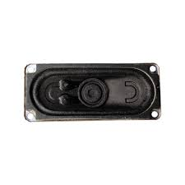

Rectangular Speaker

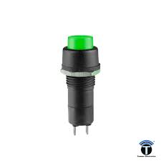

Push Button

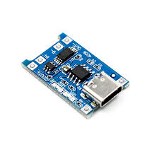

TP4056 Type-C Charging Module

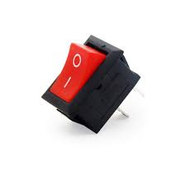

ON/OFF Switch

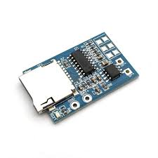

GPD2846A MP3 Module

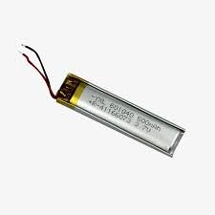

3.7V 500mAh Li-ion Battery

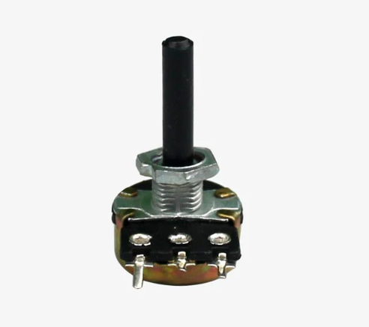

10k Potentiometer

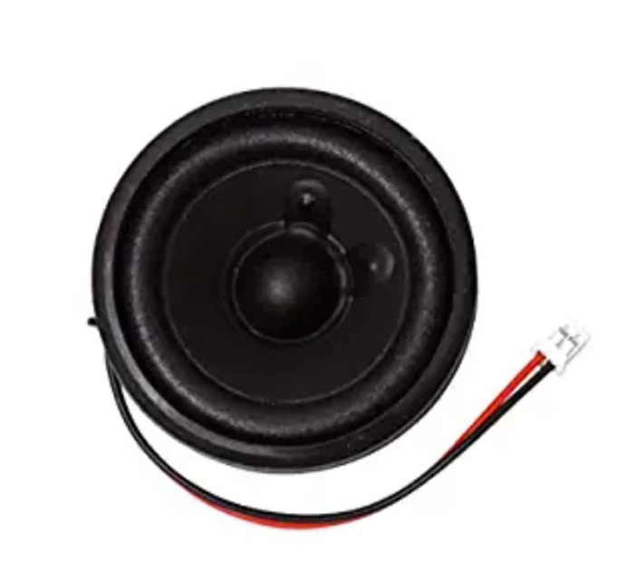

Round External Speaker

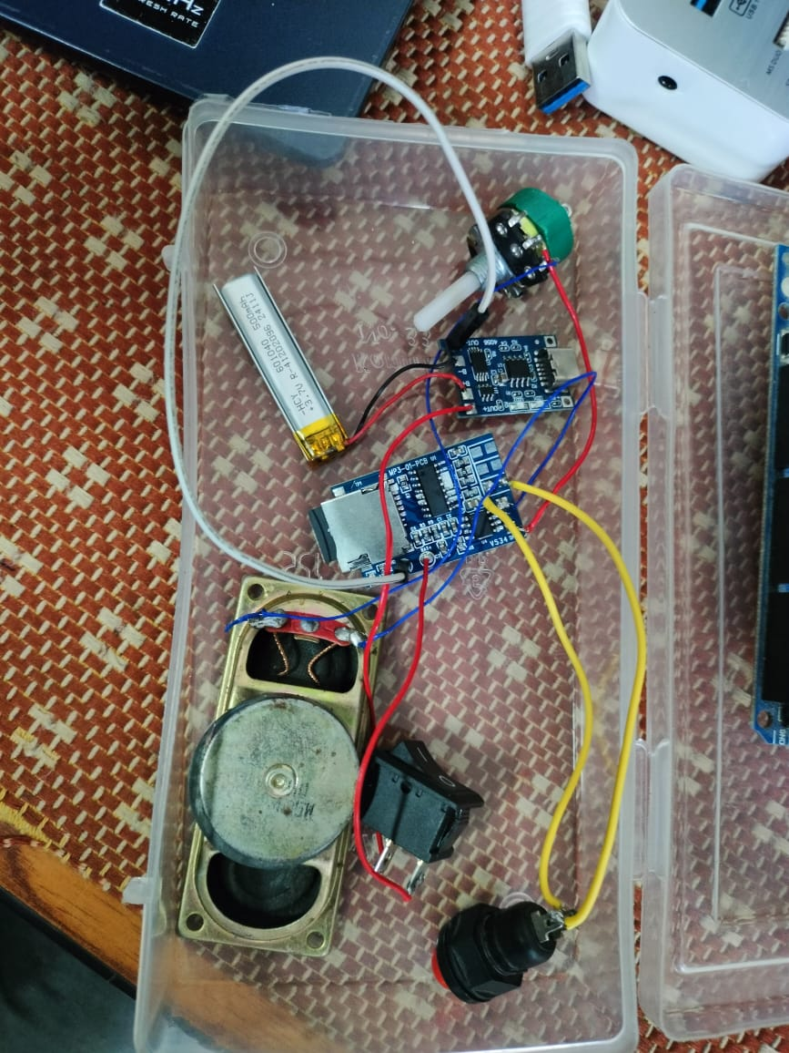

Final Assembled Vedic Chanting Machine