**Case Study**

# We Care Everyone: A Comprehensive Hospital Management System

Healthcare IT Department  
 2024

**Name:** Priyanshu Patel

**Course:** Data concepts

**Enrollment No**: 000972819



**Table of Contents:-**

1. Introduction

2. Objectives

3. Data Model

4. System Overview

4.1. Department Management

4.2. Employee Management

4.3. Patient Management

4.4. Appointment Scheduling

4.5. Billing System

5. Database Structure

6. SQL Queries and Views

7. Database Relationships

8. Conclusion

9. Team Contributions

10. Feedback and Improvements

**Introduction:-**

The 'We Care Everyone' hospital management system aims to streamline hospital operations by implementing a structured database system. This system provides efficient patient care management, staff scheduling, inventory tracking, and a transparent billing system. The use of relational databases enhances data organization and ensures seamless operations.

**Mission**:

Hospital goal is to build a simple and effective database system that helps manage patient care, schedule appointments, and support staff. It will keep track of medical records, billing, inventory, and emergencies while providing useful reports to improve hospital operations.

**Objective:**

1. Efficient Patient Management
2. Streamlined Employee Management
3. Patient Appointment Scheduling
4. Effective Inventory & Equipment
5. Accurate & Transparent Billing
6. Optimized Department Management

**4. Database Design**

**List of Tables:**

1. Department_Info
2. Employee_Details:
3. Patient_Details:
4. **Patient_Appointments:**
5. **Service_Table:**
6. Stock_Details:
7. Invoice_Details:
8. **Tables and Fields**
9. **Department_info Table:**

|  |  |  |
| --- | --- | --- |
| **Field Name** | **Datatype** | **Description** |
| **DepartmentID** | **INT** | **Unique id for each department** |
| **Department_Name** | **VARCHAR** | **Different department has different names** |

1. **Employee_Details:**

|  |  |  |
| --- | --- | --- |
| **Field Name** | **Datatype** | **Description** |
| **StaffID** | **INT** | **Different id for each staff members.** |
| **FirstName** | **VARCHAR** | **First Name of staff member.** |
| **LastName** | **VARCHAR** | **Last name of staff member** |
| **Role** | **VARCHAR** | **Particular work for each staff** |
| **DepartmentID** | **INT** | **Unique id for each department** |

1. Patient_Details:

|  |  |  |
| --- | --- | --- |
| Field Name | Datatype | Description |
| Patient_ID | INT | Unique id for each patient |
| FirstName | VARCHAR | First name of patient |
| LastName | VARCHAR | Last name of patient |
| DOB | DATE | Date of birth of patient |
| Gender | VARCHAR | Gender of patient |
| Contactinfo | VARCHAR | Contact of patient |
| Address | VARCHAR | Location of patient |

1. **Patient_Appointments:**

|  |  |  |
| --- | --- | --- |
| Field Name | Datatype | Description |
| AppointmentID | INT(PK) | Unique ID for each appointment |
| Reason | TEXT | Reason for checkup or appointment. |
| PatientID | INT(FK) | Unique identity for each patient. |
| StaffID | INT(FK) | Different identity for each staff members |
| ReasonID | INT | Different ID for each reason. |
| AppointmentDate | DATETIME | Date of appointment. |

1. **Service_Table:**

|  |  |  |
| --- | --- | --- |
| **Field Name** | **Datatype** | **Description** |
| **ServiceID** | **INT(PK)** | **Different services has different IDs.** |
| **Service Name** | **VARCHAR** | **Name of particular**  **service.** |
| **PatientID** | **INT(FK)** | **Unique identity for each patient.** |
| **AppointmentID** | **INT(FK)** | **Unique ID for each appointment** |
| **ReasonID** | **INT(FK)** | **Different ID for each reason** |
| **Amount** | **DECIMAL** | **Total amount of services has taken.** |
| **StaffID** | **INT(FK)** | **Different identity for each staff members.** |

1. **Stock_Details**

|  |  |  |
| --- | --- | --- |
| **FieldName** | **Datatype** | **Description** |
| **StockID** | **INT** | **Different IDs of all Equipment.** |
| **ItemName** | **VARCHAR** | **Name of particular items.** |
| **Category** | **VARCHAR** | **Category of items.** |
| **Quantity** | **INT** | **Total quantity of items and equipment.** |

1. **Invoice_Details:**

|  |  |  |
| --- | --- | --- |
| **Field Name** | **Datatype** | **Description** |
| **BillingID** | **INT(PK)** | **Unique ID for each bill.** |
| **PatientID** | **INT(FK)** | **Unique IDs for each patient.** |
| **DepartmentID** | **INT(FK)** | **Unique IDs for each department.** |
| **StockID** | **INT(FK)** | **Different IDs of all equipment.** |
| **Amount** | **DECIMAL** | **Total amount of services has taken.** |
| **BillingDate** | **DATE** | **Date of payment.** |

1. **Relationships:**

A relational database links data across multiple tables using keys:

* Primary Key (PK): A unique ID for each record in a table.
* Foreign Key (FK): A reference to a primary key in another table, creating relationships

|  |  |  |
| --- | --- | --- |
| **Relation Type** | **Explanation** | **Example** |
| **One to One** | **One record links to only one other record.** | **Each appointment connects to a single service** |
| **One to Many** | **One record connects to multiple records.** | **A department (DepartmentID) has many employees. A patient (PatientID) has multiple appointments.** |
| **Mant to Many** | **Multiple records in one table link to multiple in another.** | **Doctors can treat many patients, and patients can see multiple doctors.** |

**5. Entity-Relationship Diagram (ERD):-**

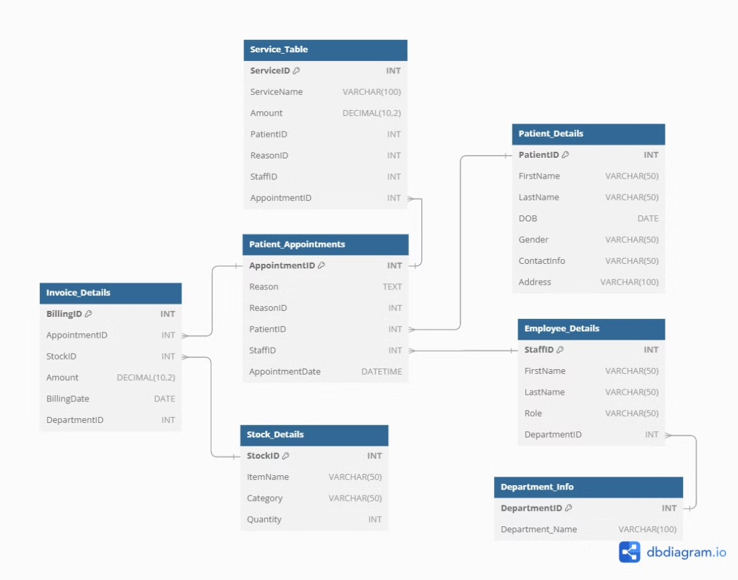

**My SQL Database and Queries:**

**Appointment Table:**

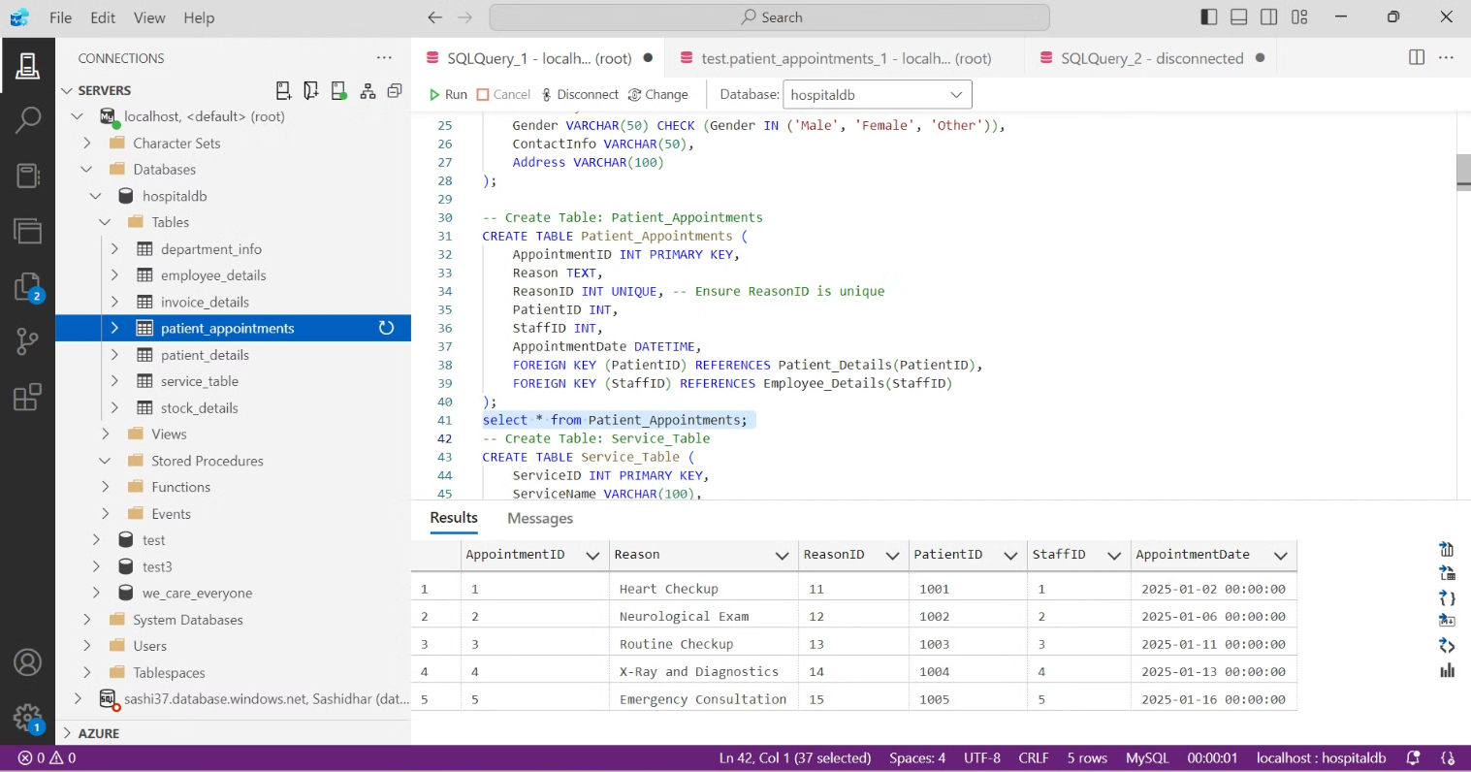

**Department Table:**

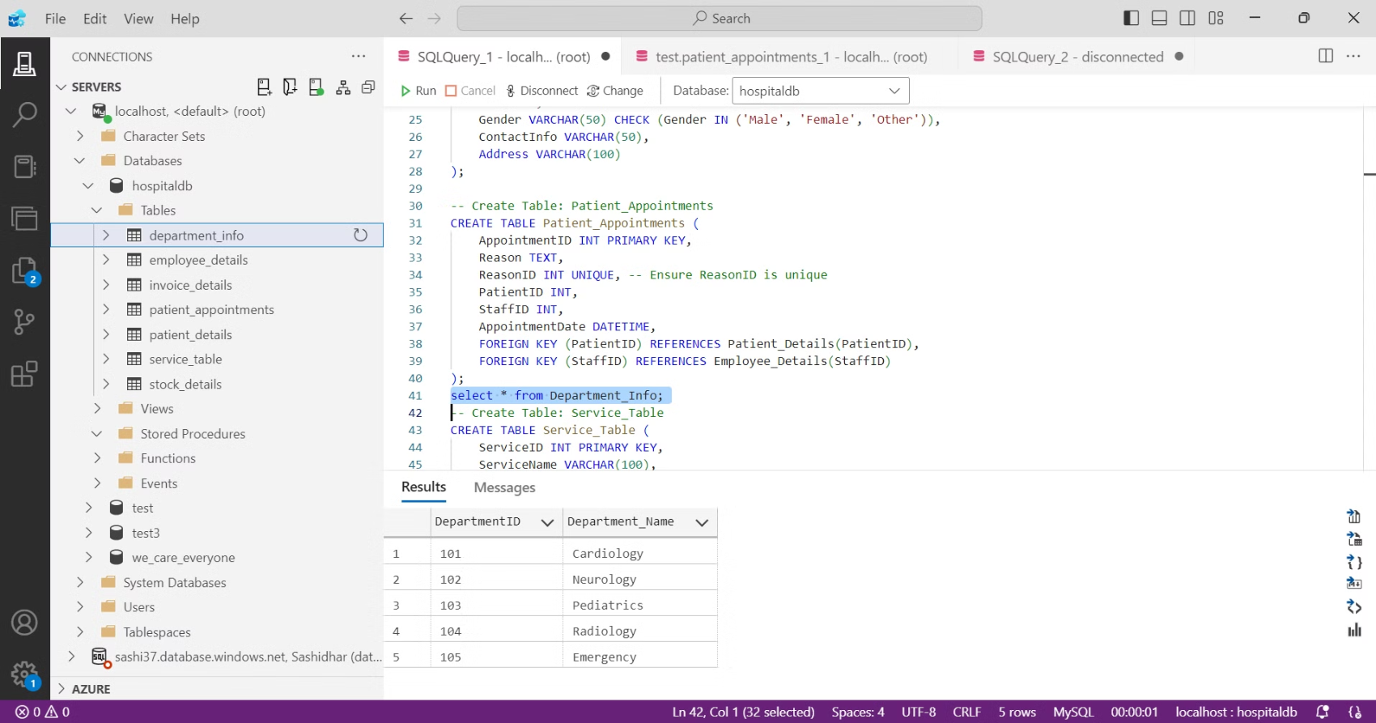

**Service Table:-**

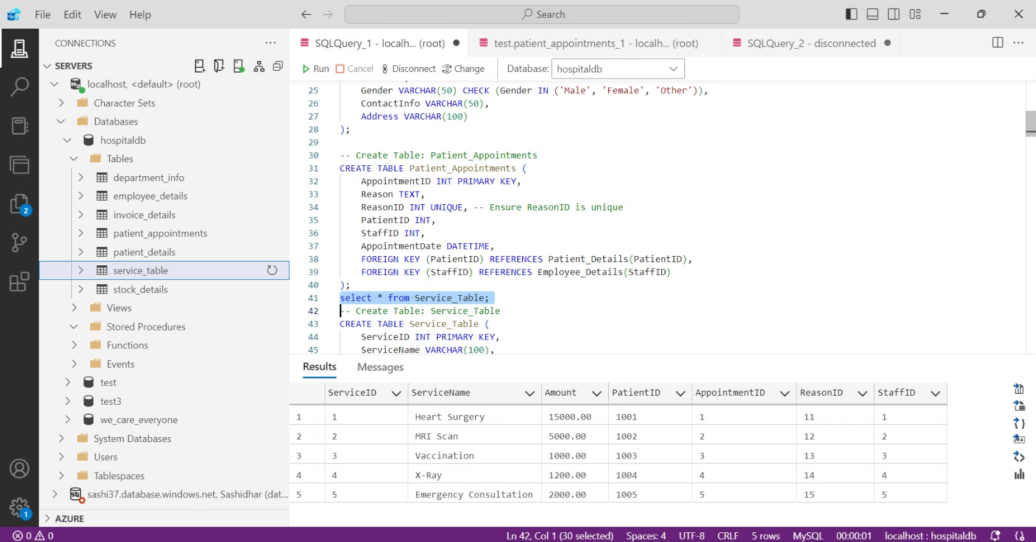

**Patient_Appointment_View**

CREATE VIEW Patient_Appointment_View AS

SELECT

pa.AppointmentID,

    pd.FirstName AS Patient_FirstName,

    pd.LastName AS Patient_LastName,

    ed.FirstName AS Staff_FirstName,

    ed.LastName AS Staff_LastName,

    pa.Reason,

    pa.AppointmentDate

FROM

    Patient_Appointments pa

JOIN

    Patient_Details pd ON pa.PatientID = pd.PatientID

JOIN

    Employee_Details ed ON pa.StaffID = ed.StaffID;

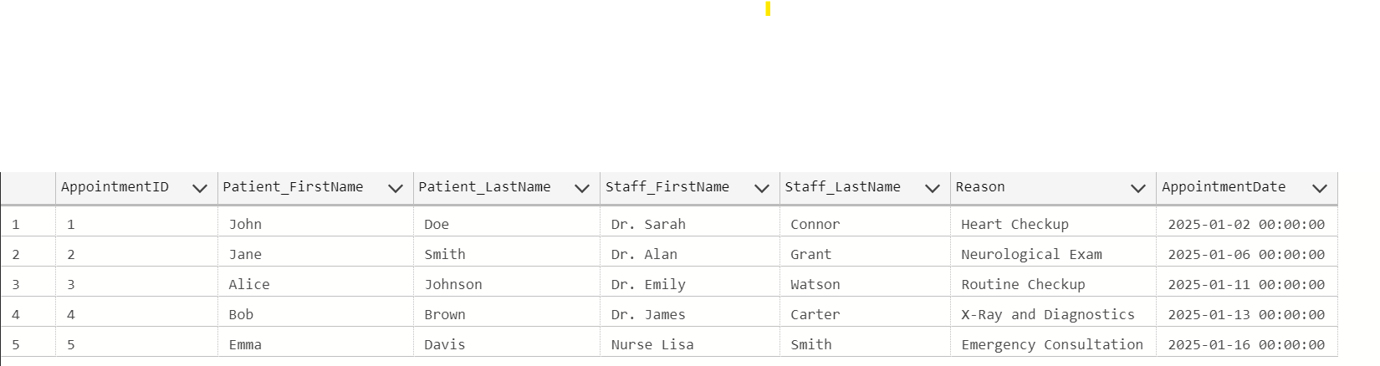

**Patient_Service_History_View:**

CREATE VIEW Patient_Service_History_View AS

SELECT

    st.ServiceID,

    st.ServiceName,

    st.Amount AS Service_Cost,

    pd.FirstName AS Patient_FirstName,

    pd.LastName AS Patient_LastName,

    ed.FirstName AS Staff_FirstName,

    ed.LastName AS Staff_LastName,

    pa.AppointmentDate

FROM

    Service_Table st

JOIN

    Patient_Details pd ON st.PatientID = pd.PatientID

JOIN

    Employee_Details ed ON st.StaffID = ed.StaffID

JOIN

    Patient_Appointments pa ON st.AppointmentID = pa.AppointmentID;

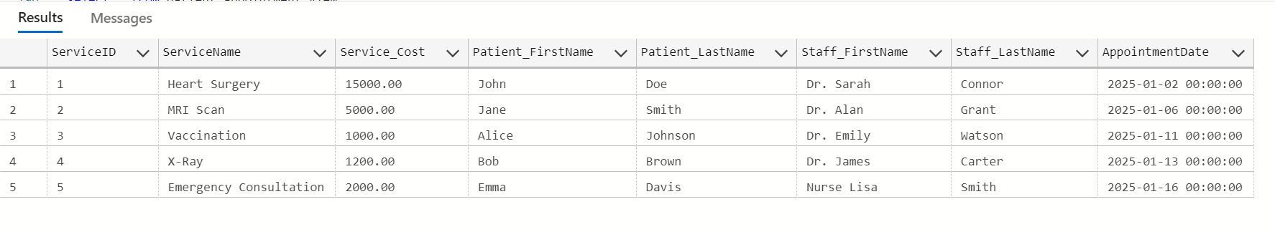

# Conclusion:

A well-designed database is the foundation of a **reliable** and **efficient** hospital management system. This structure will **streamline operations**, **enhance patient care**, and **support strategic decision-making** in the hospital