The teacher needs to mark slots unavailable and schedule a lesson in the calendar:   
  
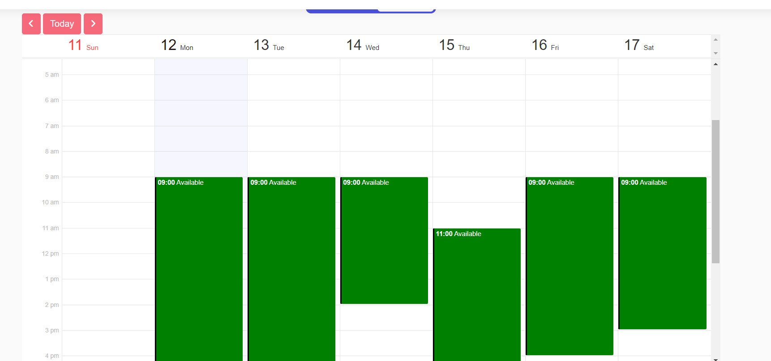  
  
Like here in Merithub:

And we also need the option to schedule a lesson manually via the calendar:  
