Feedback:

Booking Issues:

* When a student cancels a class in less than 24 h before the class is starting the credit is lost and shouldn’t be refunded.   
  I just realized that the credit is refunded. Please change that.

Referral program/ New Registration

* The credit of a referral student is not valid. After purchasing the 5 USD credit, this credit only redirects the student to the current day and time. They can’t book any classes in the future.
* We need to add a pop-up window after a student has registered. After the registration he will see this:

There is no option here to book the trial class.

Can you remove the “Welcome email” for the referred students. It is confusing because they don’t know how to book the trial.

And please change the padding of the Welcome E-Mail.

* A screenshot of a black screen

  Description automatically generated

Please add this pop-up: The “Book now” button should redirect to the cart with the discount applied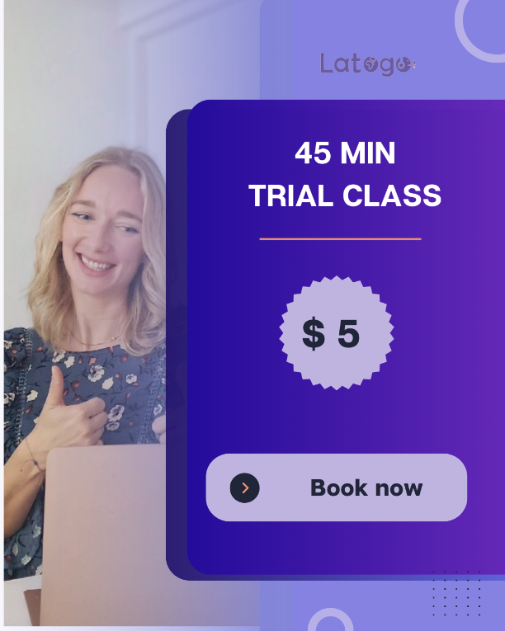

Please replace the button in the E-Mail template and the highlighted part through the pop up with the button.   
  
Either way the student should be redirected after the first log in to the check out page with the discount applied.

Please take the Enter coupon field out for the referral students and change the red text to:  
  
5 $ instead of 35$

Credit issues:

* I need to have an overview of the credit withdrawal and added history like in Merithub.

Calendar Issues:

* The available slots are not displayed correctly. There are always less slots than it should be.
* The name of the months is not set up correctly.
* Can we add the google calendar integration?   
  So the calendar is connected to the google calendar for students and teachers?

The padding of Thomas profile is still not correct:

Remove the number of classes the teacher taught at the booking process and change the package price for a single class price. This is confusing.

* Change the button text to: Book now:

When I select several slots in one week, I can book them with one click.   
But when I select a slot and change the week, choose another slot. There will be only booked the last class and not the previous selected ones.



* Subscription plans are not set up yet.   
    
  Please check this example:   
    
  https://www.lingoda.com/en/pricing/
* A screenshot of a web page

  Description automatically generated