**Current design & structre:**

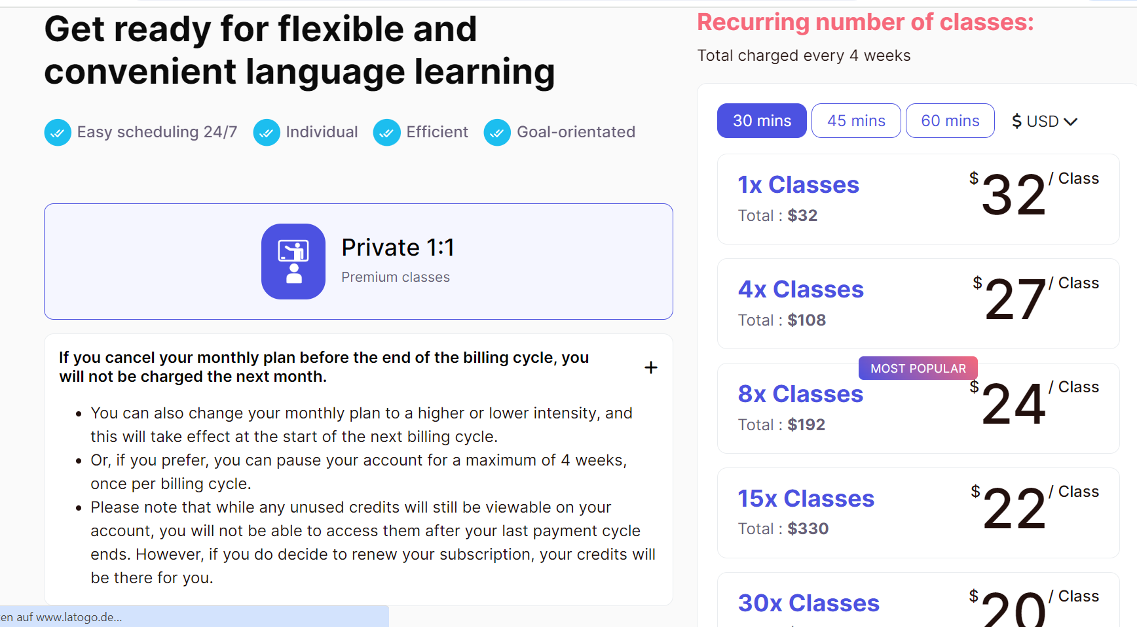



* Kindly set the default state of the drop-down to closed, allowing it to open only upon clicking.
* Revise the format of the monthly plan and Single classes structures as follows:
* Refer to the attached design example for guidance.
* Integrate a banner displaying "X% off" onto each package, maintaining a consistent style with the "most popular" label.
* Rearrange the layout to position the "FAQ section" immediately below the "Single Session" column.
* Enhance the visual appeal by incorporating boxes, frames, or shadows into distinct columns. 

