Date: 10/09/2023

**Homework 2 Report**

Priyanshu A. Shrivastava

NetID: ps1276

Abstract:

In this homework, we are tasked to read a csv file and perform mathematical operations like the ones that we do in an excel file. We are supposed to test our program on various testcases and edge cases using jasmine testing framework.

Introduction:

Moving forward from homework 1 we will now read csv file and then implement mathematical function like SUM(), AVG() and SD() etc., and then test the program with jasmine testing framework. I have started by executing the first homework program initializing the node.js framework with “npm init -y”.

I then installed jasmine in that directory with “npm install --save-dev jasmine” and then initialized jasmine with: “npx jasmine init”. This sets up the environment for programming and testing the required application.

Working:

We first start by taking csv file as input and converting parsing it as variable which is then processed to convert it in a matrix format, and we are making sure that row and columns aren’t uneven:

Then we add the individual cell value inside the map so that it becomes easy to access cell value according to the function.

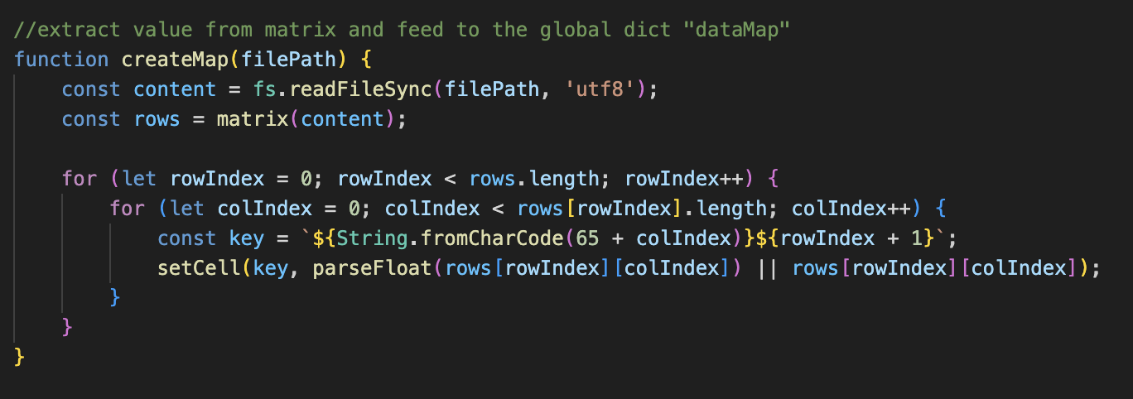

We then take the equation formula from user:

We then evaluate the formula by breaking it down and then accessing the map to extract the user required range of values for the specified mathematical function:

We perform the calculation based on the operation specified

Result:

We will check if the programming running properly by first running the main program “math.js” and then test it using by adding testcases to the “math_test.spec.js” program in the spec folder.

For test1.csv we get the following result:

In our testing environment we check:

-if the values in the csv are numeric

-if number of columns in each row are same

-test all mathematical operation with a test.csv file

For test1.csv

For test3.csv

