**Mini Project Report on**



**FACE EMOTION DETECTION**



**Submitted in partial fulfillment of the requirement for the award of the degree of**

**BACHELOR OF TECHNOLOGY**

**IN**

**COMPUTER SCIENCE & ENGINEERING**

**Submitted by:**

**Student Name:** **University Roll No.:**

**Priyanshu 2016929**

***Under the Mentorship of***

**Mr. Ashwini Kumar**



**Department of Computer Science and Engineering**

**Graphic Era (Deemed to be University)**

**Dehradun, Uttarakhand**

**July-2023**



**CANDIDATE’S DECLARATION**

I hereby certify that the work which is being presented in the project report entitled **“Face Emotion Detection”** in partial fulfillment of the requirements for the award of the Degree of Bachelor of Technology in Computer Science and Engineeringof the Graphic Era (Deemed to be University), Dehradun shall be carried out by the under the mentorship of **Mr. Ashwini Kumar,** Department of Computer Science and Engineering, Graphic Era (Deemed to be University), Dehradun.

Priyanshu 2016929 **signature**

**Table of Contents**

|  |  |  |
| --- | --- | --- |
| **Chapter No.** | **Description** | **Page No.** |
| Chapter 1 | Introduction | **1** |
| Chapter 2 | Literature Survey | **4** |
| Chapter 3 | Methodology | **6** |
| Chapter 4 | Result and Discussion | **10** |
| Chapter 5 | Conclusion and Future Work | **12** |
|  | References | **13** |

**Chapter 1**

**Introduction**



Face emotion detection is a technology or process that uses facial expressions to analyze and recognize human emotions. It entails employing algorithms and machine learning approaches to recognize and interpret facial expressions in order to estimate an individual's emotional state. Face Emotion Detection has been extensively researched using machine learning approaches. Deep learning methods such as Artificial neural network and Convolutional neural network are examples of these.

## **1.1 What is Face Emotion Detection?**

Capturing or entering an image or video of a person's face and analyzing it to determine important facial features such as the position of the brows, eyes, nose, mouth, and other facial landmarks is typical of face emotion detection. These characteristics are then compared to pre-defined patterns or models that have been trained to recognize distinct facial expressions associated with various emotions such as happiness, sorrow, anger, surprise, fear, disgust, and neutrality.

Facial expression recognition can be accomplished by a variety of ways, including standard computer vision techniques and deep learning approaches. Deep learning approaches, notably convolutional neural networks (CNNs), have made substantial progress in this area. CNN models learn and recognize patterns and features by being trained on massive datasets of labelled facial expressions that are indicative of specific emotions.

Applications of face emotion detection technology can be found in various fields, such as human-computer interaction, psychology, market research, and even in some security systems. It can be used to understand and analyze human behavior, improve user experiences in applications like video games or virtual assistants, and provide insights for advertising and marketing campaigns, among other applications.

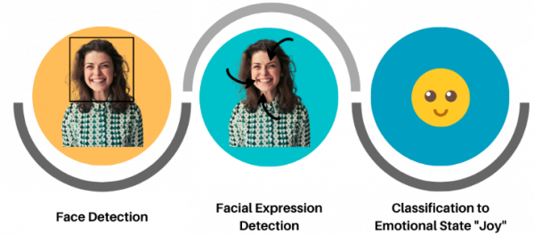

Fig1.1 Overview

### **1.2 Why is Face Emotion Detection Important?**

Face emotion recognition has many practical uses in several fields and industries. Examples that stand out include:

* Emotion detection enables computers, robots, and virtual agents to recognize and react to human emotions, improving human-computer interaction. In applications like virtual assistants, chatbots, and games, this can enhance user experience, personalization, and empathy.
* Identifying facial expressions of emotion can help in mental health assessment and monitoring. It can aid in the detection of mental illnesses, the monitoring of therapeutic progress, and early intervention. This use is especially pertinent to telemedicine, where it is crucial to monitor and analyze emotional well-being remotely.
* Emotion detection technology can be used in market research to determine how consumers would react to certain products, commercials, or marketing initiatives. Businesses can evaluate emotional engagement, discover consumer preferences, and adapt their marketing efforts by analyzing face expressions.
* Security and surveillance: To spot suspicious or threatening behaviors, face emotion detection can be used in security and surveillance systems. It can help identify possible threats, notify security staff, and improve public safety in a variety of contexts by analyzing facial expressions.
* Education & Learning: In the classroom, facial emotion recognition can assist individualized learning experiences. Teachers can gauge a student's degree of engagement, interest, or perplexity by observing their facial expressions throughout a class. In order to improve learning outcomes, this feedback enables adaptive teaching tactics and specific interventions.

**Chapter 2**

**Literature Survey**



Various research has been done in the face emotion detection field. Some of the research papers along with their summary are mentioned below.

**2.1 A Survey on Facial Expression Recognition Techniques**

This study gives an in-depth examination of various facial expression recognition techniques used in emotion detection. It examines several methodologies, such as geometric, appearance-based, and hybrid methods. The survey also includes information on datasets, feature extraction techniques, classification algorithms, and assessment criteria for face expression recognition systems.

**2.2 Deep Convolutional Neural Networks for Facial Expression Recognition: A Survey**

This survey paper focuses on the use of deep convolutional neural networks (CNNs) for facial expression recognition. It provides an overview of CNN architectures and explores their application in emotion detection. The survey discusses various datasets, preprocessing techniques, network architectures, and training strategies used in deep CNN-based approaches. It also highlights challenges and future directions in this area.

**2.3 Real-Time Facial Emotion Recognition using Convolutional Neural Networks**

This research paper proposes a real-time facial emotion recognition system based on convolutional neural networks (CNNs). The authors use a CNN model to extract discriminative features from facial images and classify them into different emotion categories. The proposed system achieves high accuracy and real-time performance, making it suitable for real-world applications such as human-computer interaction and affective computing.

**2.4 Facial Expression Recognition using Local Binary Patterns and Support Vector Machines**

In this paper, the authors present a facial expression recognition approach based on local binary patterns (LBP) and support vector machines (SVM). They extract LBP features from facial images and employ an SVM classifier to recognize different emotions. The proposed method achieves competitive performance on benchmark datasets and demonstrates the effectiveness of combining LBP features with SVM for emotion detection.

**2.5 Emotion Recognition from Facial Expressions using Multimodal Deep Learning**

This research paper explores multimodal deep learning techniques for emotion recognition from facial expressions. The authors propose a deep neural network model that combines visual and audio information to improve emotion classification accuracy. They fuse facial features extracted from images and acoustic features derived from audio signals. The experimental results demonstrate the effectiveness of the multimodal approach in enhancing emotion recognition performance.

**Chapter 3**

**Methodology**



I am using Deep CNN technique to classify the Facial emotions into five categories.

1. Angry
2. Sad
3. Surprise
4. Happy
5. Neutral

**3.1 Dataset**

The FER (Facial Expression Recognition) dataset is a collection of facial images categorized into seven emotion classes: angry, disgusted, fearful, happy, neutral, sad, and surprised. It was created to facilitate research in facial expression recognition and emotion analysis. The dataset contains a diverse range of images captured under various lighting conditions and with different facial poses. With over 35,000 images, it provides a valuable resource for training and evaluating facial expression recognition models. Researchers and practitioners can utilize the FER dataset to develop and test algorithms aimed at accurately recognizing and interpreting human emotions from facial expressions.

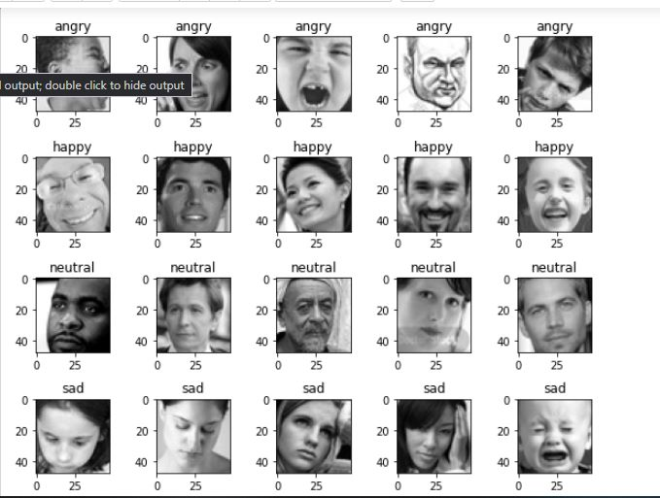

**3.2 EMOTION RECOGNITION PROCESS**

Fig represents the different stages of Face emotion recognition which include collection of documents, preprocessing, feature indexing, feature filtering, different classification algorithm and performance measure.

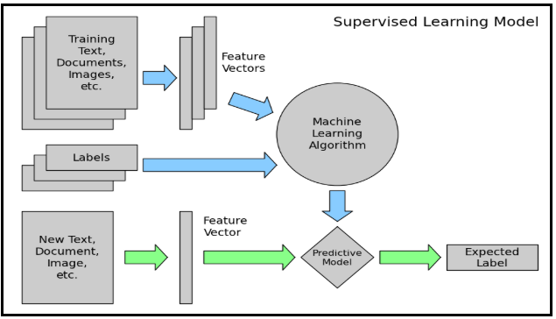

1. **Training text:**It is the input images through which our supervised learning model is able to learn and predict the required class.
2. **Feature Vector:** A feature vector is a vector that contains information describing the characteristics of the input data.
3. **Labels:** These are the predefined categories/classes that our model will predict, 5 in our case
4. **ML Algo:** It is the algorithm through which our model is able to deal with text classification (In our case: Convolutional Neural network)
5. **Predictive Model:** A model which is trained on the historical dataset which can perform label predictions.

**3.3 Preprocessing**

The preprocessing step includes normalizing the image, separating the labels and converting all the images into the same format of arrays so that it can be passed as input to the model.

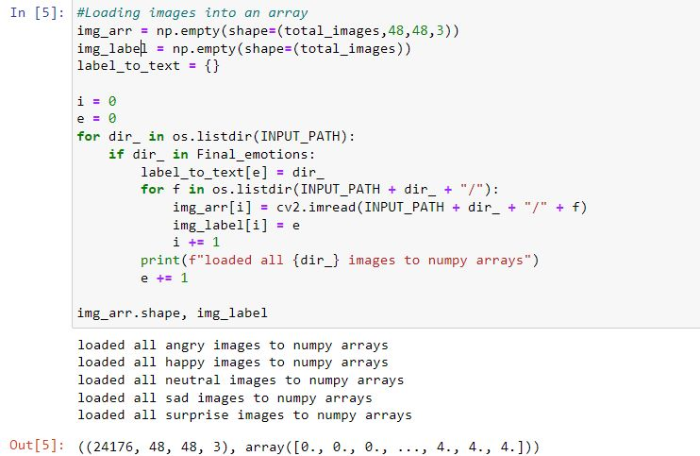

**3.4 Algorithm**

**Convolutional Neural Network (CNN)**

A Convolutional Neural Network (CNN) is a type of deep learning algorithm that is particularly well-suited for image recognition and processing tasks. It is made up of multiple layers, including convolutional layers, pooling layers, and fully connected layers.

The convolutional layers are the key component of a CNN, where filters are applied to the input image to extract features such as edges, textures, and shapes. The output of the convolutional layers is then passed through pooling layers, which are used to down-sample the feature maps, reducing the spatial dimensions while retaining the most important information. The output of the pooling layers is then passed through one or more fully connected layers, which are used to make a prediction or classify the image.

Here is the diagram of CNN process.

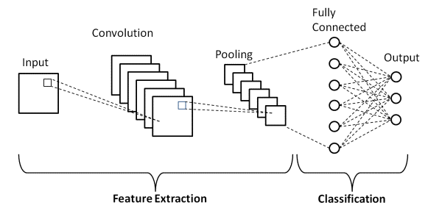

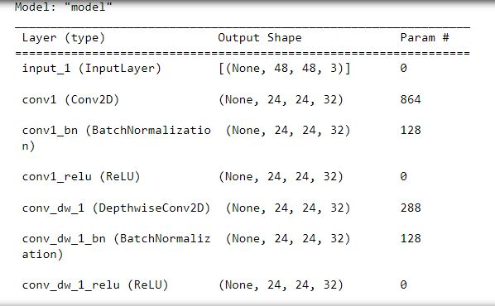

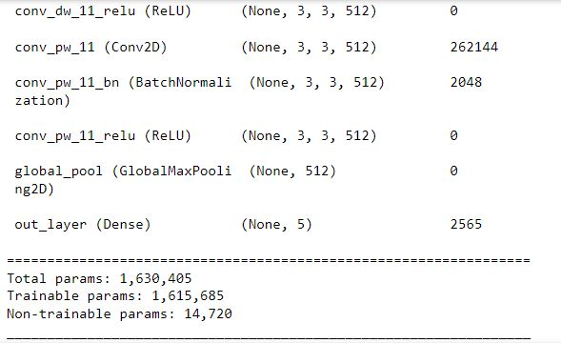

**Chapter 4**

**Result and Discussion**



After the model is created, we found the best accuracy on the Mobile net CNN architecture whose confusion matrix is shown below: -

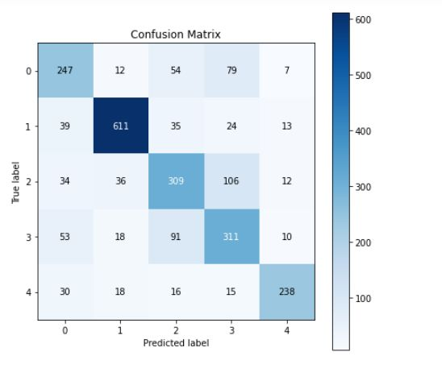

The precision, recall, f1-score, support of each class:

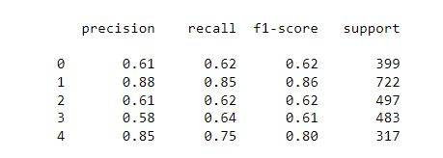

**Prediction model: -**

We saved our model using .h5 format to use it for further prediction so that we don’t have to train our model again and again, we can just load the file and predict the text entered by the user.



**Accuracy: -**

Our model works well with the user provided review on also on the testing data it gave the accuracy of about **74%** which is quite good after considering the large dataset and variations in the dataset. Separate accuracy for different emotions is shown below.

**Designing Website: -**

We created a website to showcase the project properly. Our webpage consists of only one page on which we have a button and we can click on it and it would start a camera then our model can tell to which category it belongs.

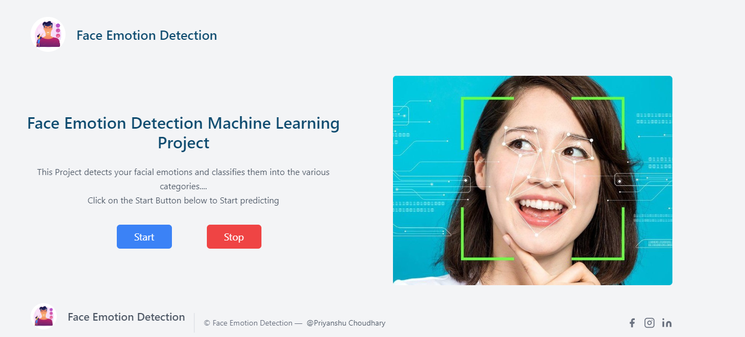

**Chapter 5**

**Conclusion and Future Work**



**CONCLUSION:**

This report on the project Face emotion detection focused on the existing literature and explored the documents representation and an analysis of feature selection methods and deep learning algorithms Term weighting is one of the most vital parts for construct a CNN model. The existing methods are compared based on pros and cons. From the above discussion it is understood that no single representation scheme and model can be mentioned as a general model for any application. Different models perform differently depending on data collection.

Our model gave the accuracy of about 74% on the test data and is working well with the user input.

**FUTURE WORK:**

* This project can be extended to more classes as our model now works only for 5 classes.
* We can try to play with the model to find out different models and check if we get more accuracy.

**References**

[1] K. S. Prasad, S. C. Satapathy, M. Rajesh, and M. Ahamed, "Face Emotion Recognition using Deep Learning Approaches: A Review," in International Journal of Computational Intelligence Research, vol. 14, no. 6, pp. 1203-1221, 2018. <https://www.ripublication.com/irph/ijcirv14n6_10.pdf>

[2] M. H. Khan, M. Islam, and M. S. Kabir, "A Comprehensive Review of Facial Emotion Recognition," in International Journal of Artificial Intelligence & Applications, vol. 5, no. 1, pp. 1-11, 2014.: <https://airccj.org/CSCP/vol5/csit53201.pdf>

[3] Sebastiani.F, “Machine Learning in Automated Face emotion recognition”, ACM Computing Survey. pp.1-47, 2002

[4] Kaggle. [“Sentiment Analysis: Emotion in Face”](https://oreil.ly/Imbhb)

[5] Joulin, Armand, Edouard Grave, Piotr Bojanowski, Matthijs Douze, Hérve Jégou, and Tomas Mikolov. [“Fasttext.zip: Compressing Emotion recognition models”](https://oreil.ly/LEf1y).

[6] [www.wikipedia.com](http://www.wikipedia.com)

[7] [www.geeksforgeeks.com](http://www.geeksforgeeks.com)

[8] [www.kaggle.com](http://www.kaggle.com)