# **ClassRoom Allocation Tables**

## E-R Diagram

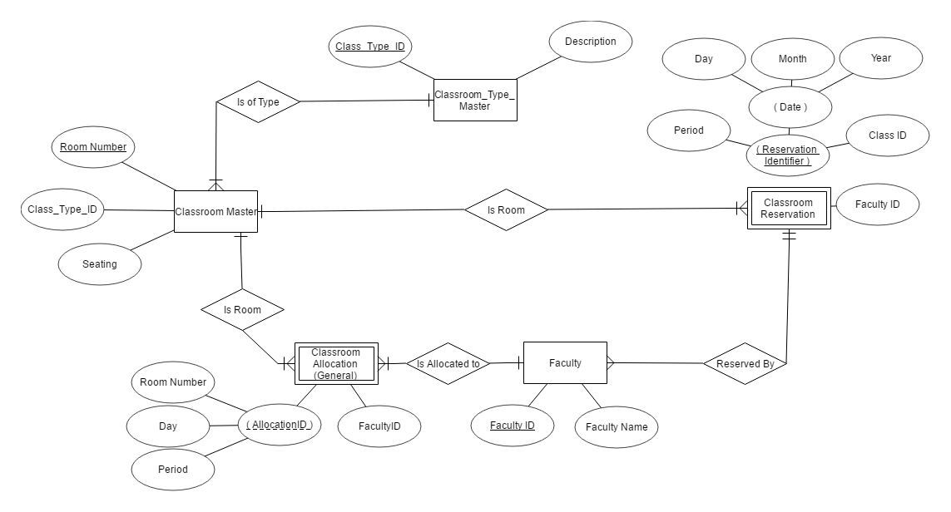

## Relational Schema

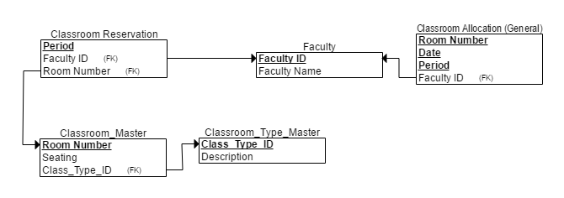

## Data Dictionary

Classroom Type Master

## 

Classroom Master



Classroom Normal Allocation

## 

Classroom Reservation

## 

# **Notifications Tables**

## E-R Diagram

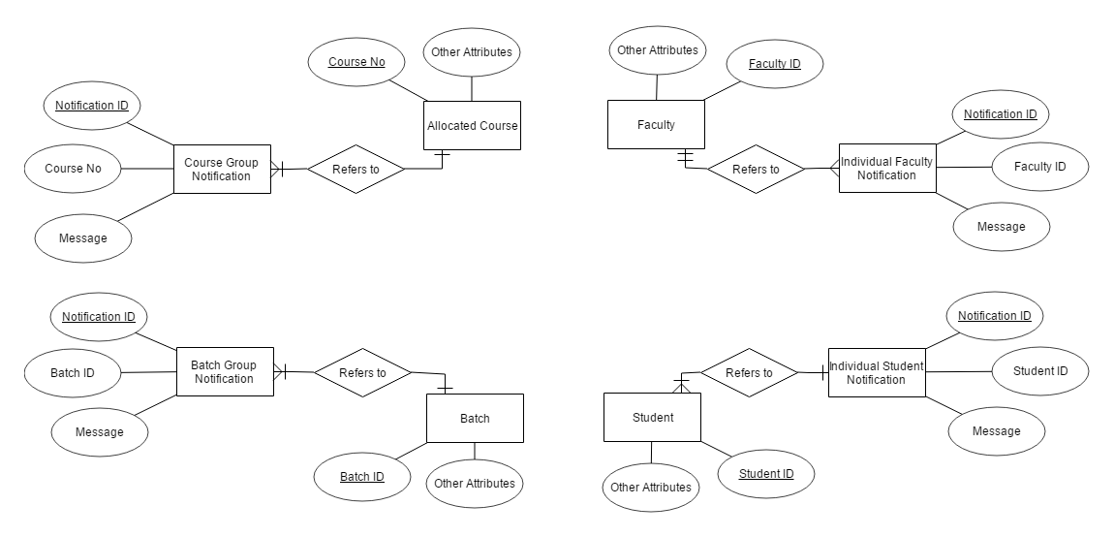

## Relational Schema

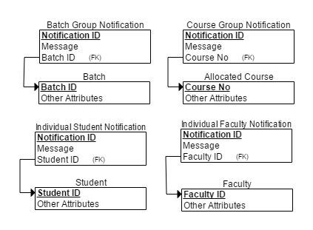

## Data Dictionary

Course Group



Batch Group



Individual Student



Individual Faculty

