Uttaranchal Institute of Technology, Dehradun, Uttarakhand
Department of Computer Science & Engineering
Assignment-IV
Image Processing and Pattern Recognition (TCS-361), B. Tech. (CSE), VIrd Semester, (7th and 8th Section)
Date of Creation: 29 April 2026 Date of Submission: 08 May 2026

Instructions:
- ANSWER NEATLY AND LEGIBLY on A4 sheets if available.
- Sketch diagrams wherever relevant. Explain your notations explicitly and clearly.
- An incomplete assignment is NOT acceptable for submission.
- Once you submit your assignment, you will be expected to answer all the questions there
INDEPENDENTLY.
- Page number your answer sheets sequentially.
- On the top of your fist sheet, write your Name, Year, Section, and Roll Number.

Q1 Attempt any three questions:
Question (A)
Explain different types of image features: color, texture, shape, and local features with suitable examples.
Question (B)
Describe the working principle of
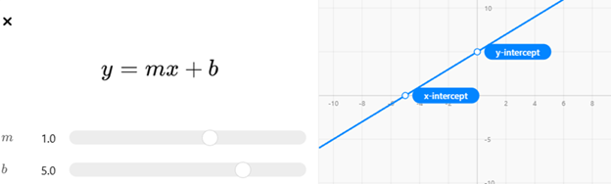

(used conceptually for line representation) and explain the role of the Hough Transform in line detection.
Question (C)
Explain Principal Component Analysis (PCA) for dimensionality reduction. Discuss its advantages and limitations.
Question (D)
Elaborate the purpose of morphological processing in images.

