**Date**: 225/10/2024

**Roll No. and Name**: 24ITK080, Priyanshu Doshi

**Division:** K3

**Course Code and Name:** 1CS201CC23/1CS201 - Introduction to Web Programming

**PRACTICAL NO. - 5**

**AIM:** **Design a shopping website that provides information about various products to the visitor. A visitor can register to the shopping website if he wishes to purchase some item(s) now or in future. The registration form should collect necessary information of a visitor in order to deliver the product if order placed. Moreover, design a web page to place orders by the registered user. Validate all the fields of the registration form and order form using JavaScript**

**Methodology followed:**

**1)Home page**

<!DOCTYPE html>

<html lang="en">

<head>

    <title>Cartify - Landing Page</title>

    <style>

        body {

            margin: 0;

            font-family: Arial, sans-serif;

            background-color: #f4f4f4;

            color: #333333;

        }

        nav {

            background: #ffffff;

            display: flex;

            justify-content: space-between;

            align-items: center;

            padding: 10px 20px;

            margin-bottom: 20px;

            border-bottom: 1px solid #e0e0e0;

            box-shadow: 0 2px 4px rgba(0, 0, 0, 0.1);

        }

        nav h1 {

            margin: 0;

            color: #007bff;

            font-size: 1.8em;

        }

        nav ul {

            list-style-type: none;

            padding: 0;

            margin: 0;

            display: flex;

            justify-content: center;

            flex-grow: 1;

        }

        nav ul li {

            margin-left: 20px;

        }

        nav ul li a {

            color: #333333;

            text-decoration: none;

            font-size: 1.2em;

            padding: 5px 10px;

        }

        nav ul li a:hover {

            color: #0056b3;

        }

        .landing-section {

            text-align: center;

            padding: 100px 20px;

            background-image: url('images/2.jpg');

            background-size: cover;

            background-position: center;

            color: #ffffff;

            background-color: rgba(0, 0, 0, 0.5); /* Dark overlay for better contrast */

            background-blend-mode: overlay;

        }

        .landing-section h2 {

            font-size: 3em;

            margin-bottom: 20px;

            text-shadow: 2px 2px 4px rgba(0, 0, 0, 0.5); /* Add shadow for better visibility */

        }

        .landing-section p {

            font-size: 1.5em;

            margin-bottom: 40px;

            text-shadow: 2px 2px 4px rgba(0, 0, 0, 0.5);

        }

        .btn {

            background-color: #007bff;

            color: #ffffff;

            padding: 15px 30px;

            text-decoration: none;

            font-size: 1.2em;

            border-radius: 5px;

            display: inline-block;

        }

        .btn:hover {

            background-color: #0056b3;

        }

        footer {

            background: #ffffff;

            padding: 20px 0;

            text-align: center;

            margin-top: 20px;

            border-top: 1px solid #e0e0e0;

        }

        footer p {

            margin: 0;

            color: #666666;

        }

    </style>

</head>

<body>

    <nav>

        <h1>Cartify</h1>

        <ul>

            <li><a href="index.html">Home</a></li>

            <li><a href="products.html">Products</a></li>

            <li><a href="about.html">About</a></li>

            <li><a href="registration1.html">Registration</a></li>

        </ul>

    </nav>

    <section class="landing-section">

        <h2>Welcome to Cartify</h2>

        <p>Your one-stop shop for the latest and greatest products.</p>

        <a href="products.html" class="btn">Shop Now</a>

    </section>

    <footer>

        <p>&copy; 2024 Cartify. All rights reserved.</p>

    </footer>

</body>

</html>

**Input/output:**

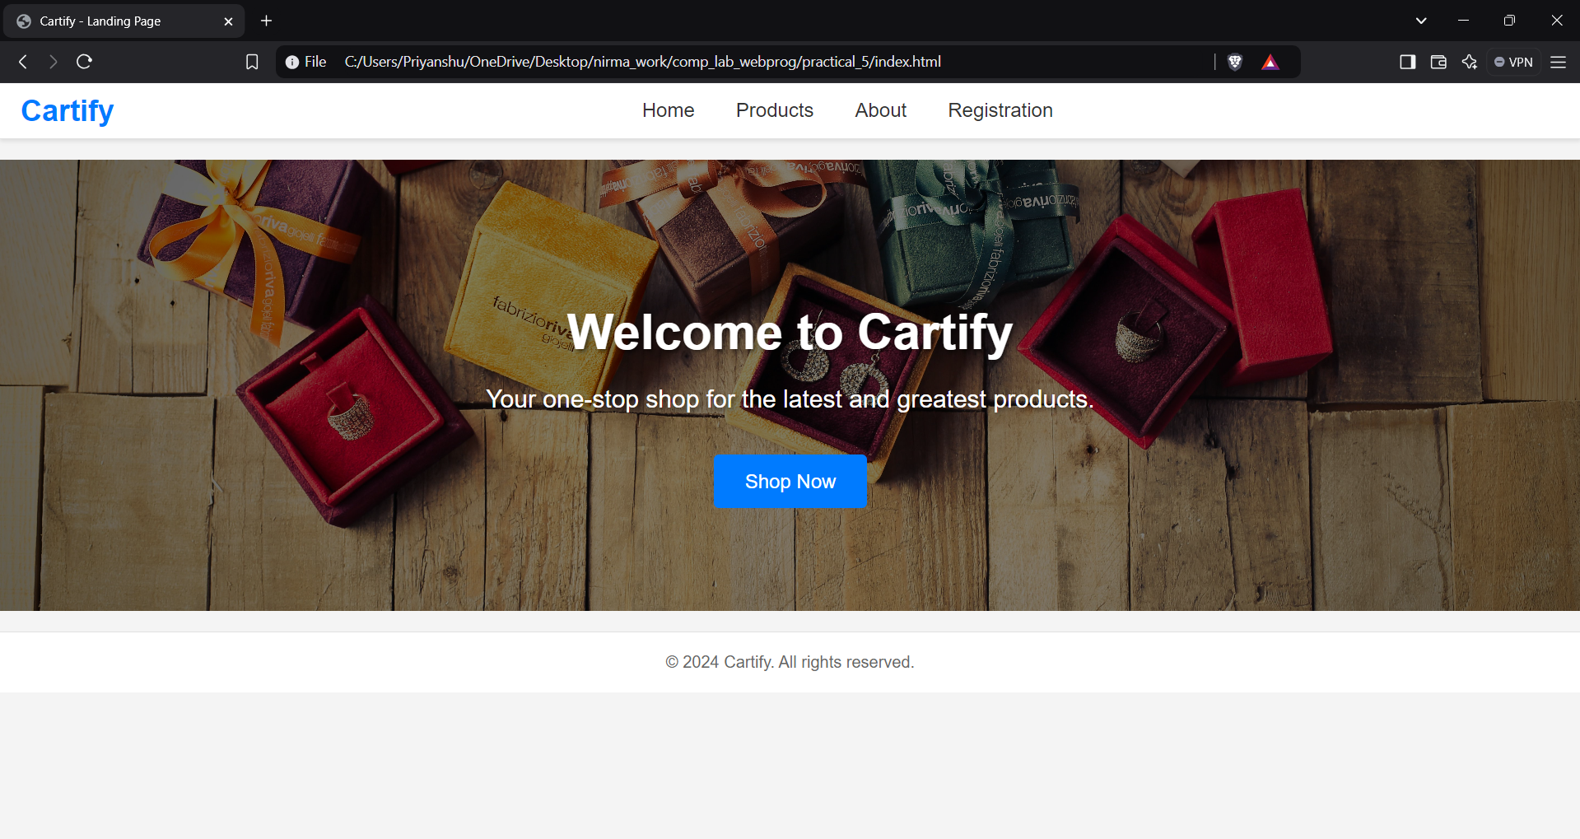

**2)Product Page**

**Theoretical Principles:** Using JAVASCRIPT and its different attributes like declaration of the variable and using of the for loop