**Assignment-1: Network Theory Lab**

Aim: To calculate the Vs and Is matrices using the text file containing the expression of the circuit in a pre-specified manner.

Input: Text File

Output: Vs and Is Matrices

List of Central Expressions to the calculation of result

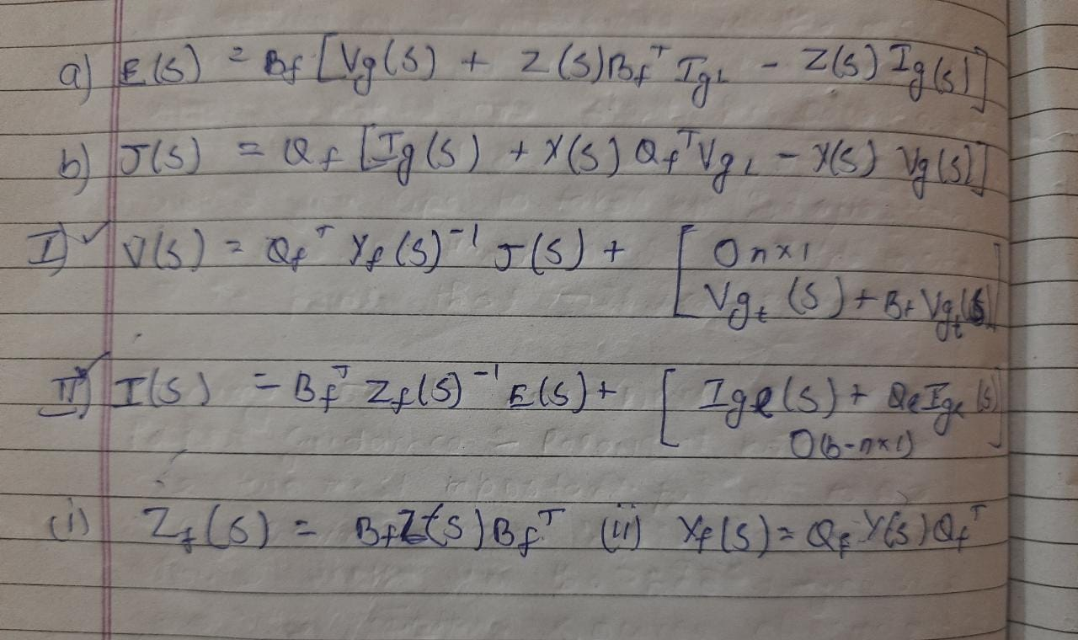

Flow of the document:

* Instructions for constructing the text file
* Block Diagram for the calculation of result
* Functions Used and their works
* Detailed explanation of the functions
* Some examples
* Assignment Question

Instructions for Constructing the text file:

i) The data will be entered in a tabular manner

1. First column indicating the source node
2. Second column indicating the destination node
3. Third column indicating the inductance
4. Fourth column indicating the resistance.
5. Fifth column indicating the capacitance
6. Sixth Seventh Eighth column for any Voltage source
   1. Sixth for the Amplitude of the voltage source in V
   2. Seventh for the frequency in kHz
   3. Eighth for the phase in degrees

1. Ninth Tenth and Eleventh column for any current sources
   1. Sixth for the Amplitude of the Current source in mA
   2. Seventh for the frequency in kHz
   3. Eighth for the phase in degrees

ii) The columns must contain only numbers without units

iii) The columns must be separated by a single space.

iv) Mention twigs followed by links i.e if there are 5 nodes and 12 branches then first info of 4 twigs should be entered followed by links

v) Mention all inputs as sine waves with appropriate phases.

Block Diagram for Calculating of Is and Vs

Twig Current source & Link Current source

Twig voltage source & link voltage source

Admittance Matrix

Fundamental cutset matrix Qf

Zf

Current Source Matrix

Yf

Voltage Source Matrix

Impedance Matrix Z

Fundamental Loop Matrix Bf

Master Matrix

Text File

Functions created and their assigned tasks:

* 1. MasterMatrixCreater
     1. Takes in the values as a simple list of no. entered in the text file
     2. Returns the master matrix i.e. the matrix which was originally entered in the text file with an additional column for numbering branches.

2. bgenerator

1. Takes in the Master Matrix created previously and returns the fundamental loop matrix (The most difficult function in my opinion.

3. looptocutset

i. Takes in the loop matrix and returns the fundamental cutset matrix.

4. zgenerator

1. Takes in the master matrix and returns a matrix having branch no. along with the corresponding impedance and also whether it is R,L,C;

5. Impedance_Matrix

i) Takes in the input as the output of zgenerator and returns the proper Impedance matrix

6. Y_Generator

i) Takes in the Impedance Matrix and creates the admittance matrix.

7. Vg_Generator

i) Takes in the Master matrix and creates the proper Vg Matrix

7. Ig_Generator

i) Takes in the Master matrix and creates the proper Ig Matrix

8. J_Generator

i) Takes in four matrices created previously namely Q, Ig, Y,Vg and returns the matrix J.

9. LHMV_Generator

i) LHMV stands for left hand matrix for Voltage. As we can see from the expression of Vs there are two matrices added to give the final result so this function creates the matrix on the left

ii) This matrix takes in as Input three matrices Q, Y, J and returns the left-hand matrix for voltage

10. RHMV_Generator

i) RHMV stands for left hand matrix for Voltage. As we can see from the expression of Vs there are two matrices added to give the final result so this function creates the matrix on the right

ii) This matrix takes in as Input three matrices Vg, B, MasterMatrix and returns the right-hand matrix for voltage

11. LHMI_Generator

i) LHMI stands for left hand matrix for Current. As we can see from the expression of Is there are two matrices added to give the final result so this function creates the matrix on the left

ii) This matrix takes in as Input three matrices B, Z, E and returns the left-hand matrix for voltage

12. RHMI_Generator

i) RHMI stands for left hand matrix for Voltage. As we can see from the expression of Is there are two matrices added to give the final result so this function creates the matrix on the right

ii) This matrix takes in as Input three matrices Ig, Q, MasterMatrix and returns the right-hand matrix for voltage.

13. Vs_Generator

I Generates Vs by adding LHMV and RHMV.

14. Is Generator

I Generates Is by adding LHMI and RHMI.

Detailed Explanation of Functions

I) Master Matrix Creater: This functions gets as input a column vector having all the values. Ex, first values of first row is written followed by values of second row and so on. What this function does is it creates a Matrix of size b*12 where b is no. pf branches. B is calculated by total no. of entries by 12. After partitioning into sets of 12 we attach another column at the beginning just to give each branch its no. . The matrix thus created is returned.

II) bgenerator This generates the B matrix from the Master matrix. B matrix is created using the function browgenerator. This creates a row of the matrix B corresponding to a link. What the function browgenerator does is. It defines two variables destination node and Curr node. We assume ourselves to be standing at the Curr node and the function works until curr node is not equal to the destination node. This function searches for the next node to move from the curr node by searching for the branches who have one node as the curr node as one of its node. It also stores values of all the nodes it moves to the curr node list and branches it moves to in the curr branch list. For specifying whether 1 or -1 will be entered we take care while filling the curr branch list if we move from source to node we insert the branch no. as positive and negative otherwise. If there are more than one prospective branches then we move to each one of the branch and see whether we can get the source node or not. This B generator works only for tree which are either paths or trees which don’t have, more than one such node in any loop made in which, more than two twigs intersect at one node.

III Impedance Matrix

This Function takes that matrix generated by z generator and looks for the branch no., the impedance in the branch and the kind of impedance present in the branch and accordingly creates the impedance matrix.

III) Vg Generator This function first of all looks whether the source is DC or AC by looking at the frequency and accordingly takes in values of the phase and amplitude and creates the laplace transform of the variables. Similarly the Ig generator works.

IV) J Generator This function just computes the value off the J matrix using the expression for the J matrix.

V) E Generator Works similar to the J Generator

VI) LHMV,RHMV and LHMI,RHMI generators also generate the respective matrices by the expressions listed above.

Examples

I)

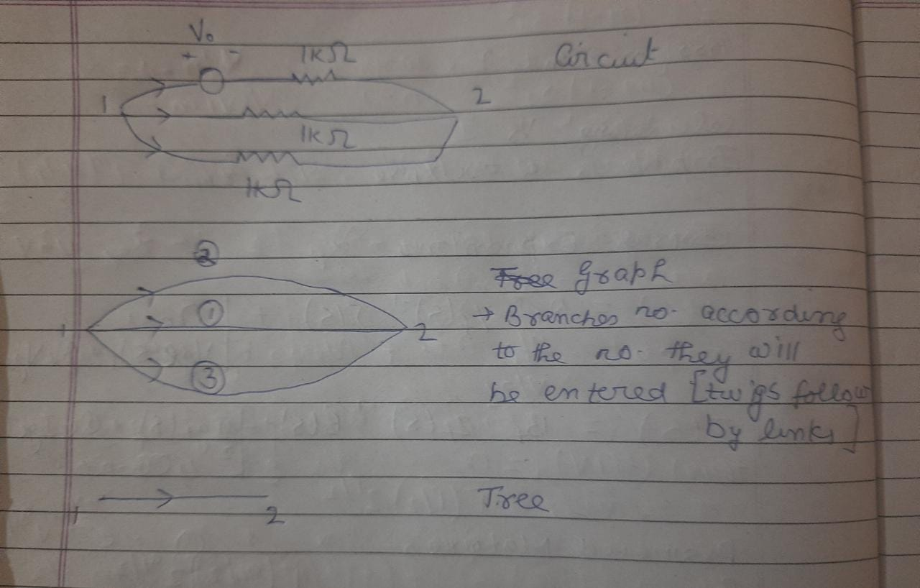

This is the work to be done by hand n0065t to be done by hand.