Beta = 0.2
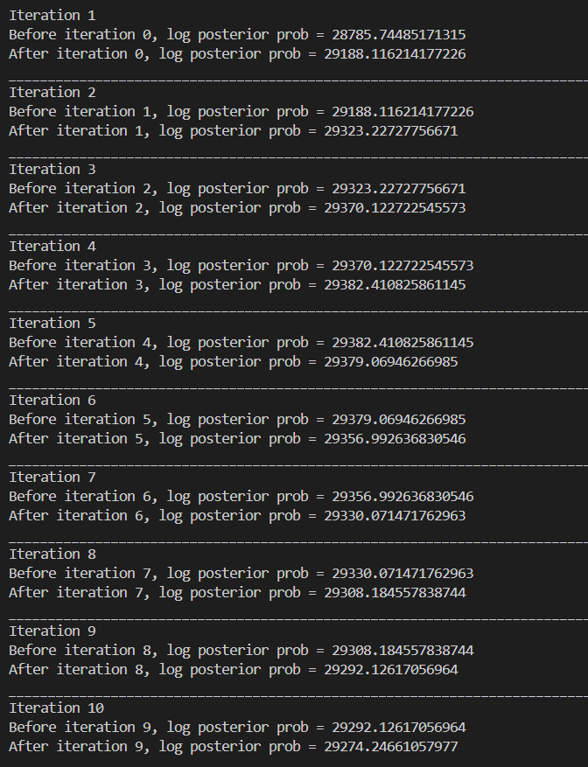

Iteration 5 started decreasing

Max value = 29382.41

Beta = 0.1
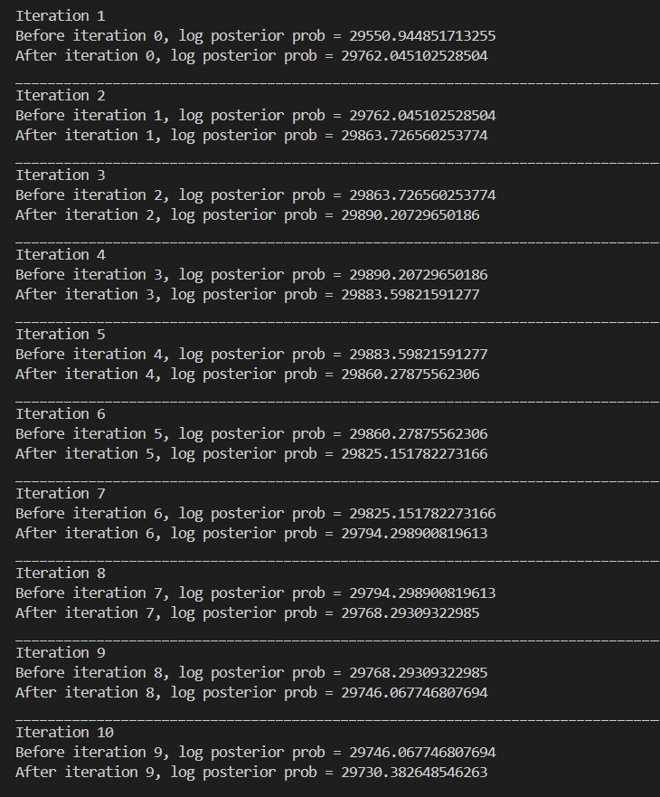

Iteration 4 started decreasing

Max value = 29890.21

Beta = 0.1 and random initialization of labels, mu and sigma
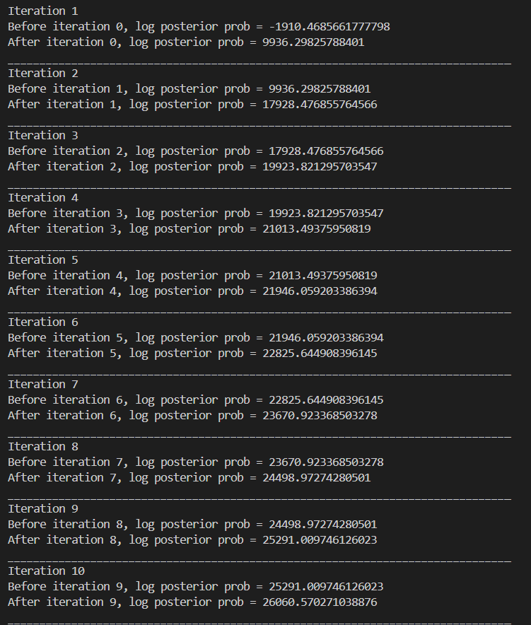
Max value = 26060.57

Beta = 0
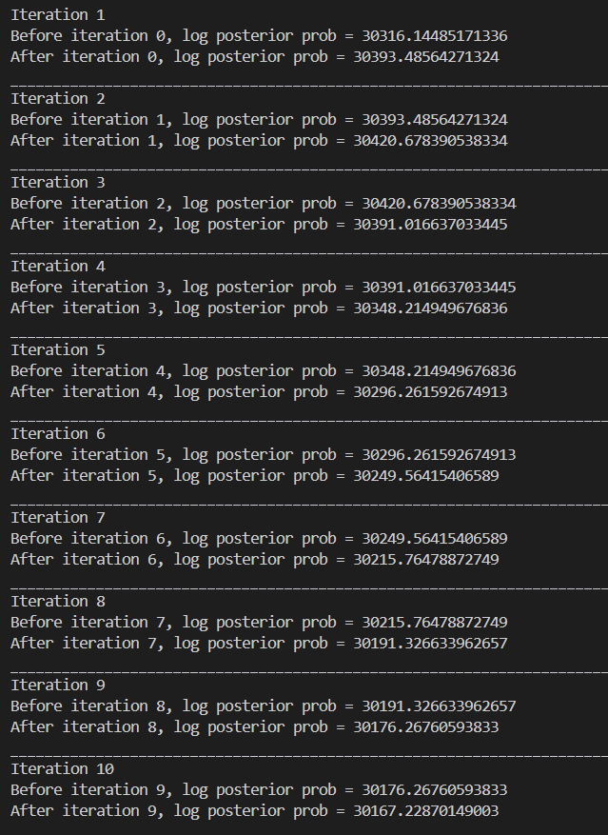

Iter 3
Max value = 30420.68

Beta = 0.05
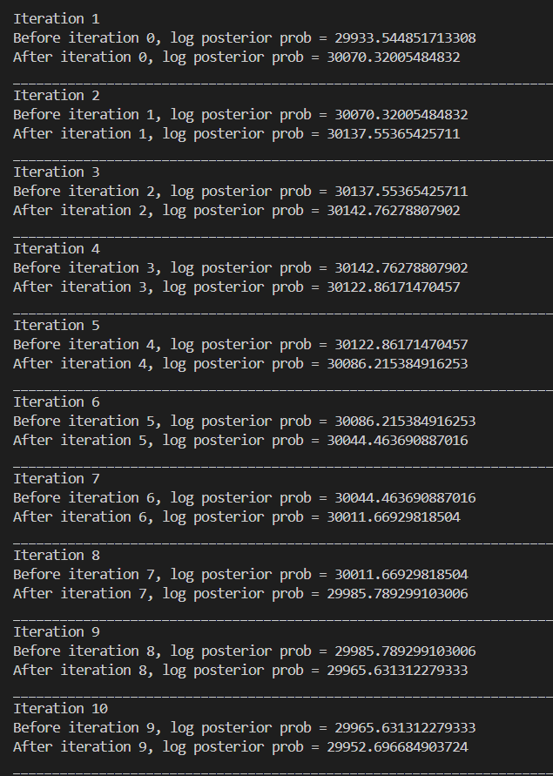
Iter 4
Max value = 30142.76

Beta = 0.06
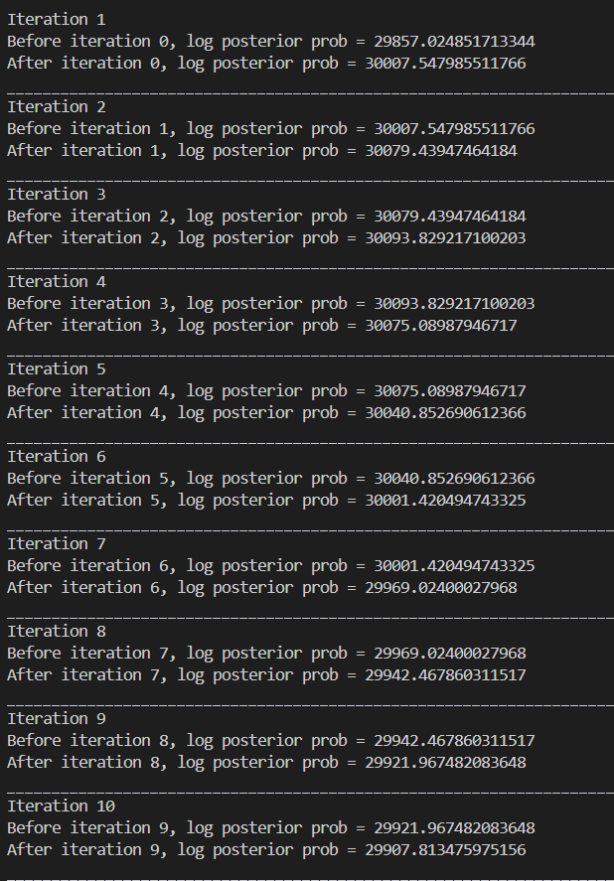

Iter 4
Max value = 30093.83

Beta = 0.04
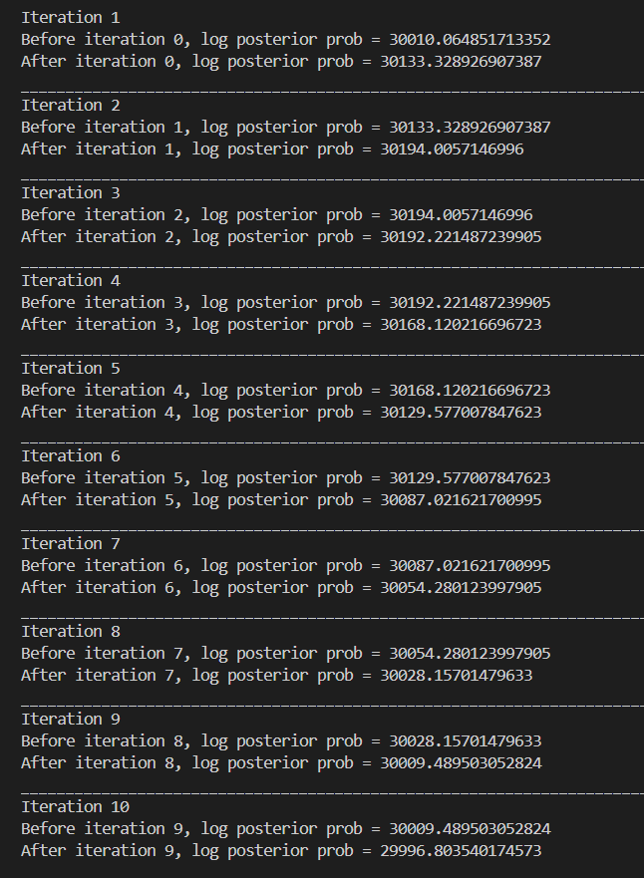
Iter 3
Max value = 30194

Beta = 0.02
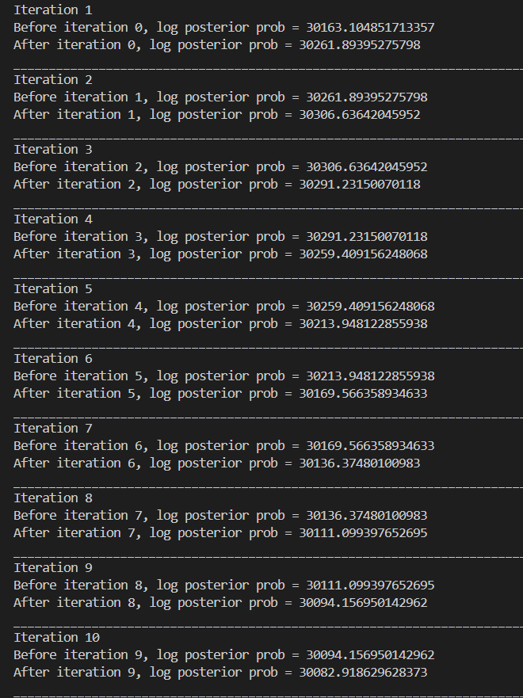
Iter 3
Max value = 30306

Beta = 0.01
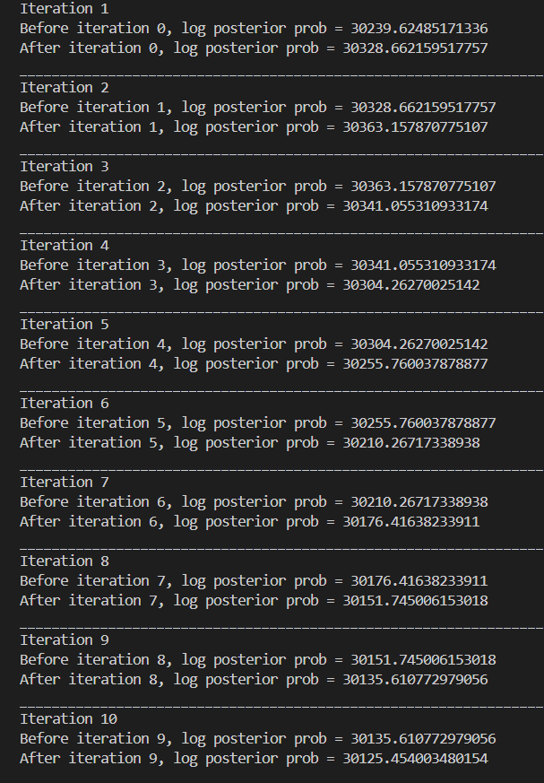
Iter 3
Max value = 30363

Report the following
Beta = 0.01
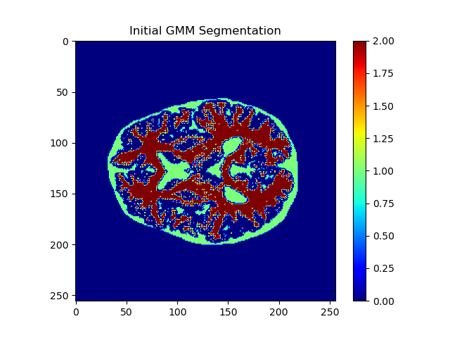
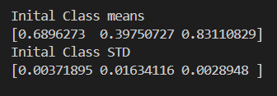
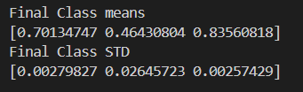
https://www.mdpi.com/2075-4418/13/18/3007
