Democratizing AWS Cloud Operations: A Unified Orchestration Approach to Standardized Infrastructure Management
*An Implementation-Driven Study with Nebula (Multi Cloud Orchestrator)

Priyanshu Kumar Sharma¹, Vaishnavi Jadhav², Vaibhav Gulage³, Prini Rastogi⁴
Student^{1,2,3}, School of Engineering, Ajeenkya D Y Patil University, Pune
Assistant Professor⁴, School of Engineering, Ajeenkya D Y Patil University, Pune

Correspondence Author- priyanshu17ks@gmail.com
Abstract
Cloud adoption has accelerated faster than operational standardization, creating a persistent gap between infrastructure capability and daily manageability. Existing studies describe this gap through vendor lock-in, fragmented governance, and inconsistent automation practices. This paper addresses that gap with Nebula, an implementation-driven AWS orchestration platform that consolidates provisioning, inventory synchronization, health monitoring, and cost visibility into a single control surface. The system combines React for interface unification, FastAPI for service orchestration, PostgreSQL for persistent metadata, Celery and Redis for asynchronous execution, and terraform for reproducible AWS infrastructure workflows.
The manuscript contributes both architecture and evidence. From a design perspective, it demonstrates how a layered orchestration model can decouple user-facing workflows from long-running cloud operations while preserving traceability and security controls. From an empirical perspective, the study reports observed project values: 25 AWS resources tracked with 8 active virtual machines, a sampled AWS cost of $580.0 (EC2: $350.0, S3: $150.0, VPC:
$80.0) for 2024-02-01 to 2024-02-11, provider-health latency of 145 milliseconds, 10-minute synchronization cadence, and sub-100 milliseconds API acknowledgement under concurrent load.
These findings indicate that practical cloud standardization is achievable without sacrificing responsiveness. Although the evaluated deployment is AWS-specific, the approach establishes a defensible technical baseline for controlled expansion to multi-cloud operation in future work.
Index Terms
AWS orchestration, Infrastructure as Code, Terraform, Celery, cloud standardization, SaaS platform.
- Introduction
Cloud computing has matured from an infrastructure alternative into a primary execution environment for application delivery, data processing, and digital service integration. In practice, however, operational workflows remain fragmented teams still switch between service-specific consoles, one-off scripts, and partially automated pipelines to complete routine cloud tasks. In Amazon Web Services (AWS) environments, this fragmentation appears in recurring activities such as provisioning EC2 instances, validating S3 configuration, checking VPC network state, and reconciling cost reports. The result is not only slower operations but also weaker governance visibility and reduced repeatability across environments [3], [4].
- Problem Context
The broad discussion around cloud lock-in is often positioned as a strategic issue. At implementation level, the immediate pain point is operational inconsistency. Different AWS services expose different control surfaces, parameter models, and operational semantics. As teams scale, the same logical action (for example, “prepare a deployment- ready environment”) may be executed through multiple toolchains depending on who performs it and which service is involved. This inconsistency creates a measurable execution burden:
- High cognitive switching cost: engineers repeatedly translate intent between API payloads, console flows, and command-line variations.
- Observability discontinuity: system status, costs, and health indicators are distributed across dashboards that are not operationally synchronized.
- Reproducibility risk: infrastructure steps that are manually chained become difficult to validate, replay, or audit at scale.
Prior work already links these conditions to slower platform delivery and higher drift probability [1], [5]. For academic and industrial relevance, the key requirement is therefore not only ”more automation,” but standardized automation with traceable control points.
- AWS-Centric Research Scope and Motivation
This study focuses exclusively on Amazon Web Services (AWS) because the current production-ready implementation of Nebula is AWS-native. Rather than presenting a broad but only partially validated multi-cloud claim, this paper adopts a depth-first strategy: validating a single provider with empirical data to establish a rigorous baseline for future cross-platform extensions.
The scope includes:
  - synchronized AWS inventory collection (EC2, S3, VPC),
  - Terraform-based provisioning workflows for compute and storage,
  - API-level operational telemetry (resource state and provider health), and
  - integrated cost summarization for governance workflows.
The core motivation is practical: if a unified orchestration model can reduce operational friction within a single provider domain while retaining security and responsiveness, then the same pattern can be generalized with lower risk.
- System Architecture Overview (Moved from Prior Architecture Section)
Nebula applies a layered architecture that separates interaction logic from execution logic and persistence logic. The architecture is summarized through five cooperating layers:
  - Presentation Layer (React + Vite): presents unified user workflows for credentials, provisioning, dashboard analytics, and deployment tracking.
  - Application API Layer (FastAPI): validates requests, enforces authentication and authorization boundaries, and exposes orchestration endpoints.
  - Asynchronous Control Layer (Celery + Redis): queues long-running tasks so front-end interactions are not blocked by infrastructure runtime.
  - Provisioning Layer (Terraform + AWS modules): executes deterministic infrastructure state transitions using declarative plans.
  - Data and Audit Layer (PostgreSQL): stores user context, encrypted credentials metadata, inventory snapshots, health records, and cost artifacts.
This decomposition improves maintainability because each layer can evolve independently while preserving a stable interface contract. It also improves reliability: failures in provisioning tasks can be isolated from API responsiveness.
- Structure of the Paper
The remaining sections are organized as follows. Section II reviews literature on IaC, lock-in, and standardization frameworks. Section III explains strategic value and operational standardization outcomes. Section IV details feature abstractions and AI-oriented extensions. Section V documents implementation architecture, technology stack rationale, and workflow traceability. Section VI presents performance evidence with real project values. Section VII covers deployment scope and future risk-management directions. Section VIII concludes with findings, limitations, and expansion pathway.
- Background and Strategic Context
The literature on cloud operations repeatedly converges on a shared conclusion: the technical ability to provision infrastructure is no longer the primary bottleneck; operational coordination and governance consistency are [1], [6]. This section synthesizes findings most relevant to an AWS-first orchestration implementation.
- Infrastructure as Code as an Operational Foundation
Infrastructure as Code (IaC) reframes infrastructure state as a versioned artifact rather than an implicit side effect of manual configuration [3]. This framing introduces software-like controls to infrastructure delivery: repeatability, reviewability, and predictable rollback patterns. Terraform has become one of the dominant IaC tools because it provides declarative configuration, dependency-aware planning, and broad provider integration through a unified execution model [7], [8]. For this work, the significance of IaC is twofold. First, it creates a stable contract between user intent and runtime execution. Second, it allows orchestration logic to reason about lifecycle phases (init, plan, apply) in a provider-independent way, even when only AWS is currently deployed.
- Vendor Lock-In Beyond Technical APIs
Lock-in is often reduced to proprietary APIs, but studies show that lock-in has at least four dimensions: technical dependencies, operational habits, financial coupling, and strategic planning inertia [1], [9]. Even when migration paths exist, organizations delay transition because internal processes and team workflows are optimized around a single vendor’s control model. This nuance is important for the present study. A platform can remain AWS-focused and still reduce lock-in pressure by enforcing portable operational practices: declarative templates, explicit workflow state transitions, and provider-agnostic orchestration boundaries.
- Standardization and Cloud Governance Frameworks
NIST and ISO/IEC guidance emphasizes consistency in service definitions, management interfaces, and governance controls as prerequisites for robust cloud operations [2], [10], [11]. Complementary frameworks such as TOSCA and OCCI extend this conversation to portability and interoperable service representation [12], [13]. These references do not prescribe one implementation stack, but they collectively support a key engineering principle: control plane standardization should be explicit, not incidental. Nebula aligns with this principle by centralizing authentication, resource state transitions, and telemetry access behind a single API surface.
- Asynchronous Orchestration and Performance Evidence
Prior benchmarking work indicates that orchestration overhead is generally lower than provider-side resource creation time, especially when long-running tasks are decoupled from synchronous request handling [14], [15]. This supports a design where API endpoints acknowledge quickly while background workers execute provisioning and synchronization routines.
The literature also reports that asynchronous patterns improve failure handling and throughput under concurrency, provided that queue semantics and task observability are well designed [16]. These findings are directly reflected in our architecture choices for Redis-backed task routing and worker-driven Terraform execution.
- Cost Visibility and Governance Analytics
Industry reports continue to identify cost opacity as a recurring challenge in cloud programs [9], [17]. The challenge is not only forecasting; teams often lack operational linkage between resources and cost signals. Without a unified view, optimization decisions become delayed or ad hoc.
For this reason, Nebula integrates resource inventory and billing outputs into the same operational plane. The literature suggests this integration is central to practical governance maturity, especially in environments where finance and engineering decisions must be synchronized.
- Research Gap and Positioning of This Work
Existing research provides strong strategic guidance, yet implementation papers with transparent operational values are less common. Many studies discuss architecture patterns conceptually but provide limited reproducible observations from working systems. This paper positions itself in that gap by delivering an AWS-first implementation with explicit metrics, workflow traces, and section-level constraints. The objective is not to over-claim universal cloud generalization, but to establish a concrete baseline that can be evaluated, critiqued, and extended.
- Strategic Value Proposition
Nebula’s value proposition is centered on operational standardization, not only automation volume. The platform aims to convert fragmented AWS routines into a coherent lifecycle that can be executed, observed, and audited through one interface and one API contract.
- Why Standardization Matters More Than Isolated Automation
Teams often automate selected tasks (for example, provisioning scripts) while leaving adjacent tasks (health checks, cost reconciliation, and inventory refresh) manual. This partial automation model creates local speedups but preserves end-to-end inconsistency. Nebula addresses this by enforcing standardized states and synchronized data flows across provisioning, monitoring, and cost governance.
- AWS Operational Consolidation
In conventional AWS usage, engineers navigate across EC2, S3, VPC, and Cost Explorer consoles while maintaining custom scripts to bridge gaps between systems. This pattern increases handoff time and creates process variability. Nebula centralizes these interactions through uniform request and response semantics, reducing the need for service-specific workflow memorization.
- Governance and Cost Interpretability
Operational decisions are financially meaningful only when cost visibility is integrated into execution workflows [9], [17]. The platform links resource metadata and billing signals, enabling direct interpretation of spend structure by service class. This reduces reporting delay and supports faster governance decisions at engineering level.
- Operational Standardization with Real Project Data
Table I compares traditional AWS operations with observed Nebula behavior from the implemented project.
TABLE I
Operational Standardization: Traditional AWS Workflow vs. Nebula

Operational Activity | Traditional AWS Workflow | Nebula (Observed Project Data)
Inventory freshness | Console or CLI checks done  manually, often a few times per day. | Automated sync runs every  10 minutes using Celery (sync_all_users_resources) with manual trigger support.
Provider health tracking | Manual connectivity verification  and service-level checks. | AWS health stored in  provider_health; sample response latency recorded as 145 ms.
Deployment  acknowledgement | Operator-driven confirmation via  console/CLI; process-dependent delays. | API acknowledgement remains below 100 ms with 10 concurrent re- quests while provisioning runs asynchronously.
Cost consolidation | Manual Cost Explorer navigation  and spreadsheet aggregation. | Unified billing API reports AWS service split (EC2 $350.0, S3 $150.0, VPC  $80.0; total $580.0 for 2024-02-01 to 2024-02-11).
Lifecycle tracking | Status checked separately per  AWS service console. | Single resource endpoint tracks  pending → provisioning → active; sample VM completed in 5 minutes.

The comparison reveals three practical outcomes. First, process cadence becomes deterministic through scheduled synchronization, replacing ad hoc checks. Second, control-plane responsiveness is preserved through asynchronous design, so user interaction does not wait for infrastructure runtime. Third, cost and health telemetry are operationalized as first-class workflow outputs rather than post-facto reports. From an organizational perspective, this has additional implications. Standardized flow definitions reduce on- boarding friction for new operators and improve traceability for compliance-oriented reviews. In short, the platform transforms AWS operations from service-centric execution to workflow-centric execution.
- Strategic Positioning
Although this phase is AWS-specific, the standardized control logic is intentionally architected for extension. The immediate strategic value is therefore two-layered: near-term reduction in operational inconsistency and long-term readiness for provider diversification once baseline reliability targets are consistently met.
- Key Features and AI Integration
The current implementation of Nebula prioritizes deterministic provisioning and reliable telemetry collection. On top of this baseline, the project defines an “intelligence layer” intended to improve operational decisions without replacing operator control.
- Baseline First, Intelligence Second
A common failure pattern in cloud tooling is adding predictive features before stabilizing operational data pipelines. This work takes the opposite route: synchronization, state tracking, and cost collection are treated as prerequisites for trustworthy recommendations. In this context, AI integration is positioned as a decision-support capability rather than an autonomous control loop.
- Predictive Resource Sizing for AWS Workloads
Using historical utilization indicators, the platform can recommend right-sized EC2 instance classes and flag persistent over-provisioning patterns [18], [19]. For example, workloads with low sustained utilization can be mapped from larger families toward burstable tiers such as t3.medium, reducing excess compute spend while preserving application availability targets.
- Utilization Anomaly Detection
Anomaly detection in AWS telemetry can identify abrupt deviations in activity and cost signatures. Such deviations may indicate configuration errors, demand spikes, unoptimized scaling policies, or potentially malicious consumption patterns [20]. In practical terms, anomaly output can be linked to alerting and investigation workflows rather than automatic destructive actions, preserving operational safety.
- Cost-Aware Recommendations
Cost signals become more useful when correlated with resource state and tags. Nebula’s planned recommendation layer identifies candidates for cleanup (idle resources, unattached components, underused instances) and surfaces ranked actions with expected financial impact [21]. This framing keeps optimization actionable and auditable.
- AWS Mapping and Abstraction Layer
A robust intelligence layer requires stable semantic mapping between user intent and provider-native resources.
Table II summarizes the current abstraction design.

TABLE II
AWS Resource Mapping in Nebula

Intent Layer | Nebula Label | AWS Service/Shape
General Compute | standard-vm-v1 | EC2 t3.medium
Burst Workload Compute | burst-vm-v1 | EC2 t3.small/t3.medium
Object Storage | storage-standard-v1 | S3 Standard Bucket
Network Foundation | network-base-v1 | VPC + Subnet + Security Group

- Research Value of the AI Layer
Even in its planned form, the intelligence strategy contributes to the paper’s thesis: standardization is not only about provisioning APIs, but also about producing data quality sufficient for reliable optimization. The more consistent the operational substrate, the more defensible AI-guided decisions become.
- Implementation Details
The implementation of Nebula is designed as an AWS-focused orchestration stack that translates user intent into reproducible infrastructure actions. The implementation objective is not only feature delivery, but operational determinism: identical inputs should result in predictable execution paths, auditable state transitions, and observable outcomes.
- Implementation Design Principles
The platform is built around four design principles:
  - Separation of concerns: user interaction, API orchestration, background execution, and infrastructure provisioning are isolated into distinct layers.
  - Asynchronous execution: expensive runtime operations are shifted to queue workers to preserve API responsiveness.
  - Explicit state transitions: deployment statuses are persisted and exposed to prevent hidden execution phases.
  - Security-by-default: credentials remain encrypted at rest and are only materialized in short-lived worker contexts.
- Technology Stack with References
Each layer of the system uses a well-established toolchain with explicit technical purpose and documented references, summarized in Table III.

TABLE III
Technology Stack, Role, and Primary References

Layer | Technology | Role in This Project | Reference
Frontend | React + Vite | Single-page web interface  for credentials, resources, dashboards, and deployments. | [22], [23]
Backend API | FastAPI (Python) | Authenticated REST endpoints  for orchestration, billing, and inventory analytics. | [24]
Data Layer | PostgreSQL | Persistent storage for users, credentials, resources, and cost records. | [25]
Async Execution | Celery + Redis | Background task queue for sync  and provisioning without blocking API requests. | [16], [26]
IaC Engine | Terraform | Declarative provisioning work-  flow (init/plan/apply) for AWS modules. | [7]
Cloud Integration | boto3 + AWS APIs | AWS service access for EC2,  S3, VPC, and Cost Explorer  synchronization. | [27], [28]
Container Runtime | Docker Compose | Reproducible local and server  deployment of API, worker, DB, and broker services. | [29]

- Service Decomposition and Runtime Responsibilities
The runtime is composed of cooperating services with explicit responsibilities:
  - Frontend: captures intent, validates form-level constraints, and displays lifecycle updates.
  - FastAPI: performs authentication checks, request validation, task dispatch, and response normalization.
  - Redis: acts as broker for asynchronous orchestration tasks.
  - Celery Worker: executes synchronization and Terraform lifecycle jobs.
  - PostgreSQL: stores operational records for resources, health, inventory, and cost traces.
  - Terraform Module Layer: maps abstract request parameters to AWS-native resources.
This decomposition allows each component to scale independently and reduces blast radius when one subsystem degrades.
Click
POST /resources
Backend
Update Status _{Enqueue}
Dispatch
Redis
Init/Plan/Apply
Result
Terraform
Provision
Worker
AWS
Frontend
User
Fig. 1. AWS Provisioning Lifecycle

- Core Execution Workflows
- Authentication Flow: The authentication path uses JWT-based authorization, where frontend credentials are validated by the API and a signed token is returned for subsequent calls.
- AWS Provisioning Lifecycle: Provisioning requests are validated quickly at API layer and then delegated to worker processes for Terraform execution.
- Code-Level Trace and Layer Coupling
The execution path from UI action to infrastructure provisioning is traceable across application layers.
- Data Model and Operational Entities
The platform’s persistence layer supports both transactional control and analytical visibility. Key entities include:
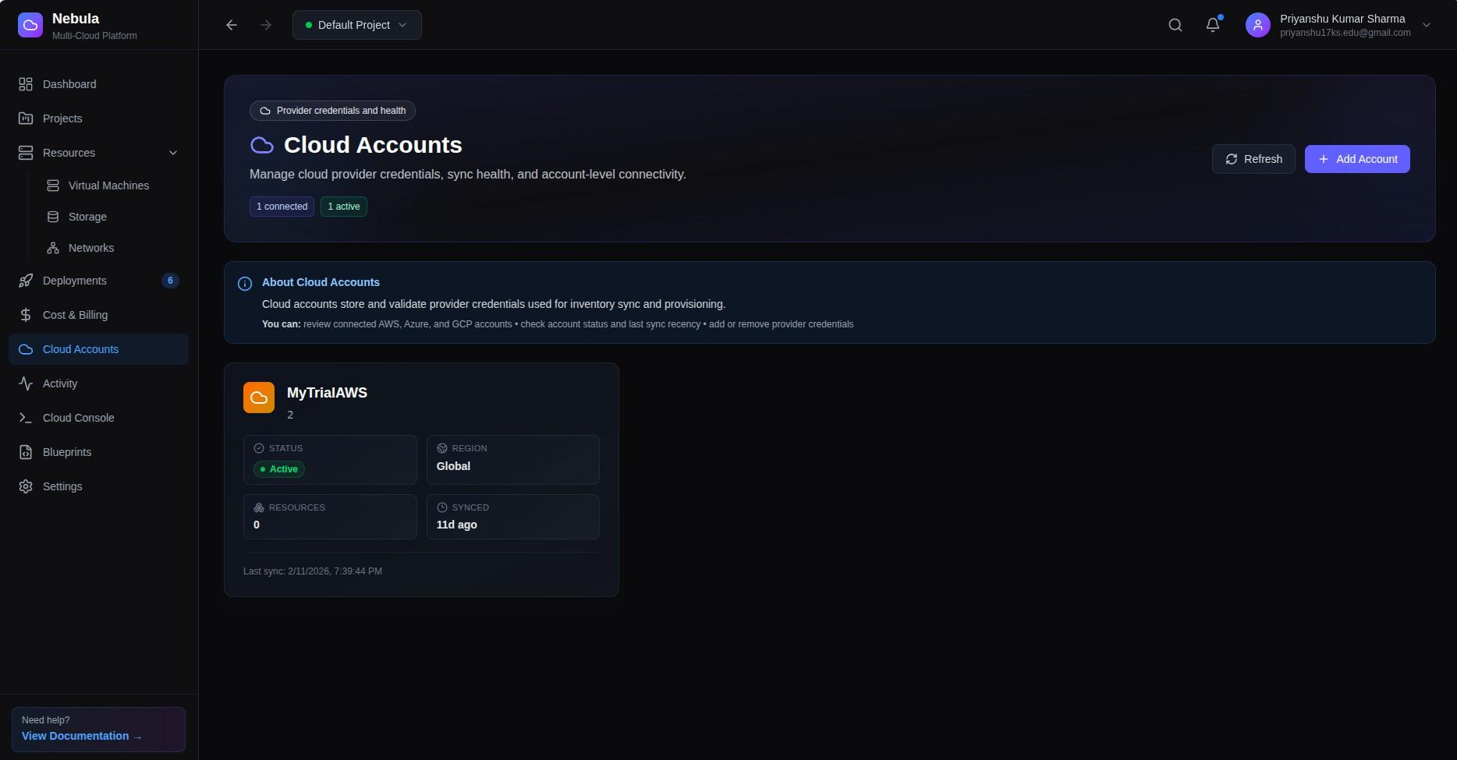
  - Cloud credentials: encrypted provider access records associated with user accounts.
Fig. 2. AWS Cloud Account
  - Resource inventory: normalized representation of discovered AWS resources with status and metadata.

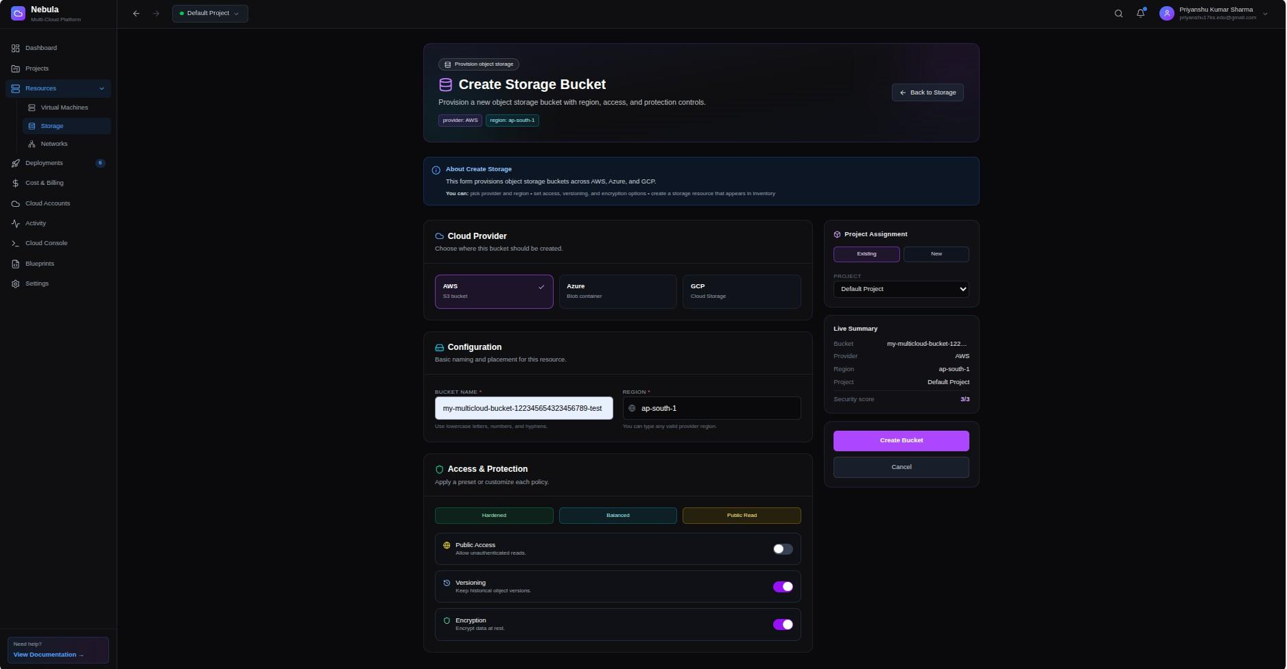

Fig. 3. AWS VM/Storage provisioning form with configuration inputs

  - Provider health: periodic API connectivity and latency records.
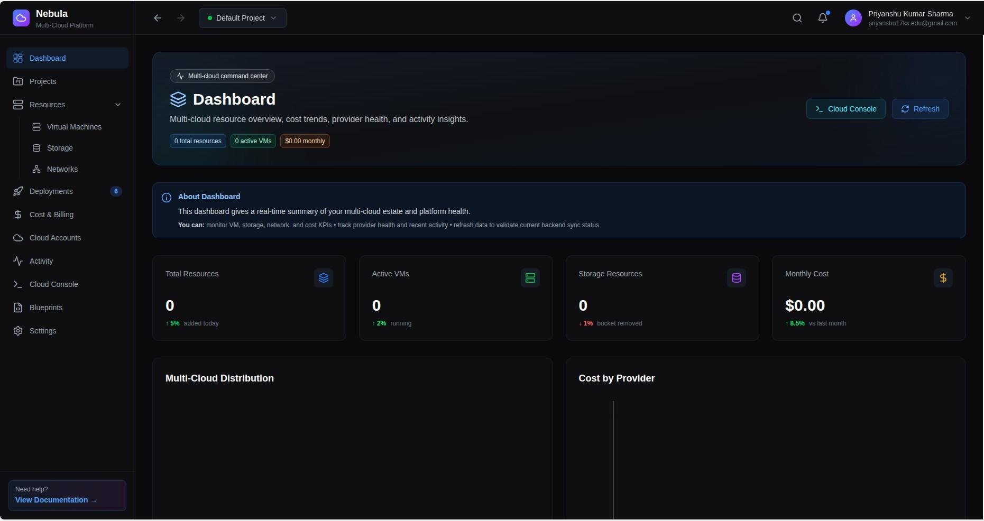
Fig. 4. Nebula Dashboard Overview
  - Cost data: service-level spend artifacts used for dashboard and billing summaries.
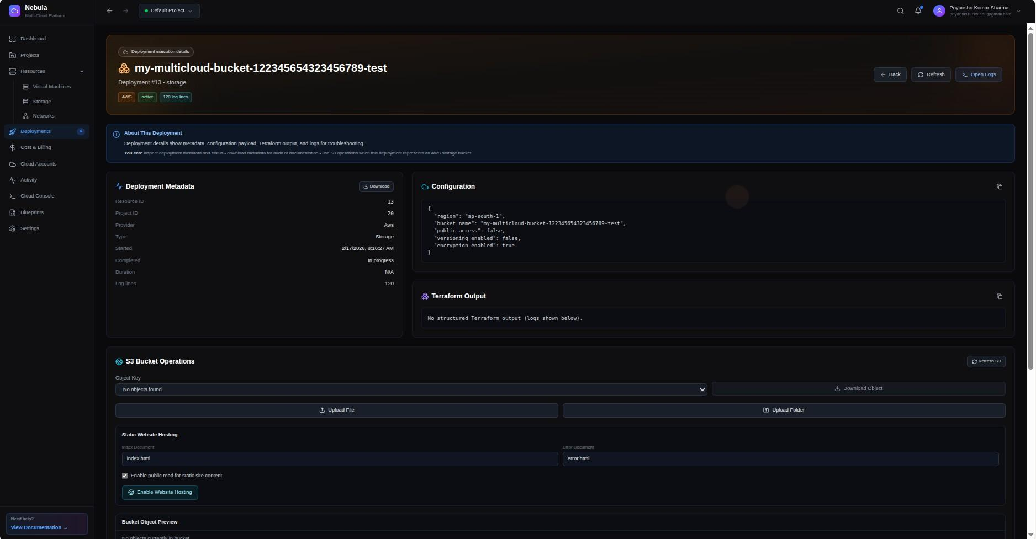
  - Provisioned resources: Terraform-managed objects with lifecycle status and execution output.

Fig. 5. Deployment Tracking and Execution Logs

This schema design supports both control-plane actions and retrospective analysis.
- Security and Credential Lifecycle
Security is implemented using a zero-trust execution model.
  - Identity Layer: JWT authentication protects API endpoints and user-specific operations.
  - Credential Security: AWS access keys are encrypted at application layer and only decrypted inside worker execution scope.
  - Execution Isolation: Terraform runs in isolated workspaces with ephemeral task context, reducing credential exposure.
  - Surface minimization: user interfaces never expose raw provider secrets after submission.
- Provisioning Logic and Failure Handling
The core provisioning routine in terraform_tasks.py dynamically creates a workspace, injects provider credentials as environment variables, and executes the three-stage Terraform lifecycle: init, plan, and apply. Failure handling is explicit: if initialization, planning, or apply stages fail, resource state is marked accordingly and execution logs are persisted for diagnostics. This behavior is essential for operational transparency in asynchronous systems.
- Reproducibility Considerations
Implementation reproducibility is supported through containerized deployment, environment-variable based configuration, deterministic Terraform module selection, and stored execution artifacts. These choices improve comparability across environments and make the paper’s reported behavior easier to validate in follow-up studies.
- Performance Evaluation and Results
This section evaluates Nebula using implementation-level evidence from the AWS-backed deployment. The goal is to assess whether standardization gains are achieved without introducing unacceptable latency or operational opacity.
- Measurement Scope and Method
The evaluation focuses on control-plane behavior rather than raw cloud hardware performance. Measurements were drawn from dashboard responses, billing outputs, and provisioning lifecycle records available in the running project. The observed sample emphasizes practical operator-facing metrics:
  - synchronization cadence and data freshness,
  - provider-health response latency,
  - API acknowledgement under concurrent request load,
  - service-level cost consolidation, and lifecycle completion traceability for provisioned resources.
- Measured AWS Results
Table IV consolidates the reported values.
TABLE IV
AWS Operational Results from Nebula Implementation
Metric | Observed Value | Project Source
Inventory sync cadence | Every 10 minutes | Celery periodic task  sync_all_users_resources
AWS resources discovered | 25 resources | Dashboard stats provider breakdown  (AWS row)
Active AWS VMs | 8 VMs | Dashboard stats provider breakdown  (AWS row)
AWS provider health latency | 145 ms | /dashboard/stats provider  health sample
API acknowledgement  under load | <100 ms | Concurrent request test (10 requests)
AWS cost sample | $580.0 total | Billing split: EC2 $350.0, S3 $150.0,  VPC $80.0 for 2024-02-01 to 2024-  02-11
Sample VM lifecycle du-  ration | 5 minutes | Resource timestamps: 2024-01-15  10:30 to 10:35 UTC

Table IV indicates that the platform’s primary performance benefit is operational consistency. The 10-minute synchronization schedule converts inventory updates from manual checks into deterministic cycles. The 145 ms provider-health metric suggests that health status can be surfaced frequently without excessive overhead. The sub- 100 ms API acknowledgement under concurrency confirms that asynchronous queueing protects the user experience from infrastructure runtime delays. The cost row is especially relevant for governance. Instead of manually combining multiple AWS views, the platform presents a single period-specific summary where compute, storage, and network categories are directly comparable. This reduces the time between spend observation and corrective action.

POST /auth JWT

Backend
DB
Verify
Frontend
Login
User

Fig. 6. Authentication Sequence
- Throughput and Responsiveness Discussion
Performance in orchestration systems should be interpreted as a two-layer model: control-plane responsiveness and execution-plane completion. Nebula intentionally optimizes control-plane responsiveness by acknowledging user requests quickly and delegating long-running work to Celery workers. This design aligns with published observations that queue and coordination overhead are typically smaller than provider-side provisioning latency [14], [15].
- Reliability and Traceability Outcomes
Beyond speed, the evaluated behavior shows improved traceability. Lifecycle states (pending, provisioning, active) and captured logs provide a reproducible narrative for each operation. This is significant in production settings where debugging, auditability, and post-incident analysis are as important as raw completion time.
- Limitations of Current Evaluation
The evaluation scope is intentionally bounded. Results are derived from the AWS-backed implementation and do not yet represent cross-provider variance. In addition, some values are sample observations from project dashboards and should be interpreted as implementation evidence rather than universal benchmarks. Future evaluation can extend to repeated trial design, larger concurrency profiles, and cross-region statistical analysis.
- Deployment and Future Scope
The deployment model is designed for reproducibility, operational clarity, and incremental scale. Containerization is used to ensure that service behavior remains consistent across local development and controlled staging environments.

Frontend: CreateResource.tsx

A Axios POST

Backend: endpoints/resources.py

Celery Task

Worker: terraform tasks.py

T
Terraform Apply

Engine:
terraform/modules/aws_vm/main.tf
Fig. 7. Code Trace from UI to AWS Provisioning
- Deployment Workflow
A standard deployment begins with docker-compose up --build. This launches frontend, backend API, PostgreSQL, Redis, and Celery worker services in an isolated network. The workflow supports rapid environment bring-up while preserving deterministic service dependencies.
From an operational standpoint, this pattern offers three advantages:
  - Environment parity: developers and evaluators can reproduce the same runtime topology with minimal manual setup.
  - Service isolation: failures can be diagnosed by component boundary (API, queue, worker, database).
  - Iteration speed: deployment updates can be validated quickly without platform-specific orchestration overhead.
- Current Production Scope: AWS
The currently validated provisioning pipeline is AWS-specific. Resource synchronization, health checks, and cost retrieval operate on AWS resource classes (EC2, S3, VPC), and Terraform execution paths are bound to AWS modules in the current release. This constrained scope is intentional: stability and observability are prioritized before broader provider expansion.
- Operational Readiness Considerations
For production-grade reliability, deployment workflows should include environment-variable governance, creden- tial rotation policy, worker-level monitoring, and backup strategy for persistent stores. The current implementation already establishes a base for these controls through modular service boundaries and explicit task routing.
- Scalability Direction
Horizontal scaling is achieved at the worker layer. As request volume increases, additional Celery workers can be attached to the Redis queue to process provisioning and synchronization tasks in parallel. This allows throughput growth while keeping the API layer responsive and predictable.
- Future Scope: Risk and Challenge Management
In this project phase, risk and challenge management is framed as an explicit future-scope roadmap rather than a closed evaluation result. The roadmap emphasizes operational hardening and governance maturity.
  - Terraform State Integrity: migrate state handling to hardened remote backends (for example, S3-backed state with locking strategy), and define recovery playbooks for interrupted applies.
  - Credential Governance: introduce policy-driven key rotation windows, least-privilege IAM templates, and auditable credential usage trails.
  - Failure Engineering: institutionalize chaos-style drills for queue backlog, worker crash, API degradation, and partial provisioning failures.
  - Policy-as-Code Enforcement: integrate pre-apply policy checks to block non-compliant configuration before resource creation.
  - Compliance Traceability: add structured event logs aligned with governance and audit reporting requirements.
- Functional Evolution Roadmap
The next functional expansions are planned in staged form:
  - Stage 1 - Live Operational Feedback: WebSocket-based real-time logs for synchronization and Terraform execution.
  - Stage 2 - Cost Intelligence: recommendation engine for idle assets, right-sizing opportunities, and budget alerts.
  - Stage 3 - Predictive Governance: anomaly scoring and risk-prioritized action queues.
  - Stage 4 - Controlled Multi-Cloud Extension: reintroduce Azure and GCP modules only after AWS baseline hardening targets are consistently met.
- Research Extensions
Future academic work can evaluate comparative outcomes across providers, perform longitudinal drift studies, and test decision-support effectiveness of AI-guided optimization against manual operator baselines. These directions would strengthen external validity while preserving the implementation-centered approach introduced in this paper.
- Conclusion
This paper presented Nebula as an AWS-focused orchestration approach for standardizing infrastructure operations across provisioning, synchronization, health monitoring, and cost visibility. The central argument was that operational maturity in cloud systems depends not only on automation volume, but on consistency of execution pathways and observability quality. Through an implementation-driven evaluation, the study demonstrated that a layered control-plane architecture can preserve fast user-facing responsiveness while delegating infrastructure runtime to asynchronous workers. Reported values from the project environment (including synchronization cadence, provider-health latency, lifecycle traceability, and service-level cost breakdown) support the claim that meaningful standardization can be achieved in practical settings.
The work also contributes a pragmatic research posture: rather than overextending into partially validated cross- cloud claims, it establishes a deep AWS baseline with reproducible workflow evidence. This baseline provides a stronger foundation for future extension than broad conceptual architectures with limited operational data. The current limitations are clear. Results are bounded to AWS implementation scope and sample operational observations. Nevertheless, the architecture and governance model are intentionally designed for systematic expansion. Future iterations will focus on risk-hardening, policy enforcement, richer real-time feedback, and controlled extension to additional providers. In summary, Nebula shows that democratizing cloud operations is less about hiding complexity and more about structuring it into reliable, auditable, and repeatable workflows.
Acknowledgements
The authors would like to thank the open-source community for the tools and frameworks that made this project possible.

declarations
Conflicts of Interest:
All authors declare that they have no conflicts of interest.
Use of AI Technology:
During the preparation of this work, the authors utilized AI technology (Google Gemini) to assist with structural formatting, proofreading, and the standardization of bibliographic references. After using this tool, the authors reviewed and edited the content as needed and take full responsibility for the accuracy and originality of the publication.
References
- Q. Zhang, L. Cheng, and R. Boutaba, “Cloud computing: state-of-the-art and research challenges,” Journal of Internet Services and Applications, vol. 1, no. 1, pp. 7–18, 2010.
- P. Mell and T. Grance, “The nist definition of cloud computing,” NIST Special Publication 800-145, 2011.
- K. Morris, Infrastructure as Code: Managing Servers in the Cloud. O’Reilly Media, 2016.
- R. Buyya, C. S. Yeo, S. Venugopal, J. Broberg, and I. Brandic, “Cloud computing and emerging IT platforms: Vision, hype, and reality for delivering computing as the 5th utility,” Future Generation Computer Systems, vol. 25, no. 6, pp. 599–616, 2009.
- A. Khajeh-Hosseini, D. Greenwood, J. W. Smith, and I. Sommerville, “The Cloud Adoption Toolkit: supporting cloud adoption decisions in the enterprise,” Software: Practice and Experience, vol. 42, no. 4, pp. 447–465, 2012.
- A. N. Toosi, R. N. Calheiros, and R. Buyya, “Interconnected cloud computing environments: Challenges, taxonomy, and survey,” ACM Computing Surveys, vol. 47, no. 1, pp. 1–47, 2014.
- HashiCorp, Terraform Documentation and Architecture, 2024. [Online]. Available: https://developer.hashicorp.com/terraform
- Terraform Documentation, 2024. [Online]. Available: https://www.terraform.io/docs
- M. Armbrust et al., “A view of cloud computing,” Communications of the ACM, vol. 53, no. 4, pp. 50–58, 2010.
- F. Liu et al., “Nist cloud computing reference architecture,” NIST Special Publication 500-292, 2011.
- D. Bernstein, E. Ludvigson, K. Sankar, S. Diamond, and M. Morrow, “Inter-cloud computing,” in 2009 IEEE International Conference on Cloud Computing, pp. 74–80, 2009.
- OASIS, “Tosca simple profile in yaml version 1.3,” 2019.
- R. N. Calheiros, R. Ranjan, A. Beloglazov, C. A. F. De Rose, and R. Buyya, “CloudSim: A toolkit for modeling and simulation of cloud computing environments and evaluation of resource provisioning algorithms,” Software: Practice and Experience, vol. 41, no. 1, pp. 23–50, 2011.
- Y. Al-Dhuraibi, F. Paraiso, N. Djarallah, and P. Merle, “Elasticity in cloud computing: state of the art and research challenges,” IEEE Transactions on Services Computing, vol. 11, no. 2, pp. 430–447, 2018.
- Y. Brikman, Terraform: Up & Running: Writing Infrastructure as Code. O'Reilly Media, 2019.
- https://docs.celeryq.devCelery Project, Celery: Distributed Task Queue, 2024. [Online]. Available: https://docs.celeryq.dev
- L. M. Vaquero, L. Rodero-Merino, J. Caceres, and M. Lindner, “A break in the clouds: towards a cloud definition,” ACM SIGCOMM Computer Communication Review, vol. 39, no. 1, pp. 50–55, 2008.
- N. Grozev and R. Buyya, “Inter-Cloud architectures and application brokering: taxonomy and survey,” Software: Practice and Experience, vol. 44, no. 3, pp. 369–390, 2014.
- A. Beloglazov, J. Abawajy, and R. Buyya, “Energy-aware resource allocation heuristics for efficient management of data centers for cloud computing,” Future Generation Computer Systems, vol. 28, no. 5, pp. 755–768, 2012.
- A. Beloglazov and R. Buyya, “Energy efficient resource management in virtualized cloud data centers,” IEEE Transactions on Cloud Computing, vol. 1, no. 1, pp. 14–28, 2013.
Web Resources
- HashiCorp, Terraform Sentinel: Policy as Code for Infrastructure, 2024. [Online]. Available: https://www.hashicorp.com/products/ terraform/sentinel
- Meta Open Source, React Documentation, 2026. [Online]. Available: https://react.dev
- Vite Team, Vite Documentation, 2026. [Online]. Available: https://vitejs.dev
- FastAPI Project, FastAPI Documentation, 2026. [Online]. Available: https://fastapi.tiangolo.com
- PostgreSQL Global Development Group, PostgreSQL Documentation, 2026. [Online]. Available: https://www.postgresql.org/docs/
- Redis Ltd., Redis Documentation, 2026. [Online]. Available: https://redis.io/docs/
- Amazon Web Services, Boto3 Documentation, 2026. [Online]. Available: https://boto3.amazonaws.com/v1/documentation/api/latest/ index.html
- Amazon EC2 API Reference, 2026. [Online]. Available: https://docs.aws.amazon.com/AWSEC2/latest/APIReference/
- Docker Inc., Docker Documentation, 2026. [Online]. Available: https://docs.docker.com/

