**TOPIC :**

***UDP Payment Simulator Using JavaFX***

***1. Introduction***

In the contemporary digital economy, instantaneous and secure peer-to-peer (P2P) payment solutions are fundamental. Traditional blockchain networks, while highly secure, often suffer from scalability and latency issues. This makes them less optimal for microtransactions or high-frequency transactions.

To address these limitations, off-chain solutions such as the **Bitcoin Lightning Network** have emerged, enabling fast, scalable, and cost-effective micropayments by shifting transaction processing off the main blockchain.

This project, **UDP Payment Simulator**, replicates the behaviour of such off-chain payment networks by:

* Using **UDP** for low-latency communication.
* Implementing a **JavaFX-based GUI** for user-friendly interaction.
* Simulating crucial aspects like **payment channel management**, **transaction acknowledgment**, **packet loss**, and **latency measurement**.

The goal is to model real-world decentralized payment behaviours in a controlled simulation environment.

***2. Objective***

The main objectives of this project are:

* **Simulation**: Model decentralized peer-to-peer microtransactions over an unreliable network (UDP).
* **GUI Development**: Create a professional and intuitive graphical interface using JavaFX.
* **Acknowledgment Handling**: Implement mechanisms for payment confirmation and timeout detection.
* **Packet Loss Simulation**: Emulate real-world network unreliability by introducing artificial packet drops.
* **Latency Tracking**: Measure and log the round-trip time of payments for analysis.

***3. Problem Statement***

Modern blockchain-based payment systems, though secure, are inherently slow due to the consensus mechanism. For micropayments, these delays and transaction fees are prohibitive.

The project addresses the problem by:

* Simulating an off-chain fast transaction environment.
* Analyzing how unreliable networks (like UDP) affect transaction reliability.
* Testing strategies to mitigate transaction failures (acknowledgment, timeout handling).

This simulation helps understand how decentralized payment systems ensure both **speed** and **reliability** despite network challenges.

***4. Technologies Used***

|  |  |
| --- | --- |
| Technology | Purpose |
| Java 11+ | Core programming language for backend and logic. |
| JavaFX | Graphical User Interface (GUI) framework. |
| UDP Sockets (java.net) | Peer-to-peer communication channel. |
| CSV Files | Persistent logging of transaction data. |
| Traffic Simulation | Packet loss and delay simulation within UDP communication. |

***5. Project Features***

* **Open/Close Payment Channels**: Simulation of enabling and disabling the ability to transact.
* **Send Payment Requests**: Send payments via UDP packets formatted as lightweight JSON objects.
* **Receive Acknowledgments**: Confirm transaction delivery with acknowledgment packets.
* **Packet Loss Simulation**: Randomly discard 20% of outgoing packets to emulate real-world network instability.
* **Latency Measurement**: Record time between sending a request and receiving an acknowledgment.
* **Transaction Logging**: Save all transaction attempts (successes and failures) into a structured CSV file.
* **GUI with Status Feedback**: Provide real-time feedback to users via an auto-updating, scrollable log display.

***6. Working Principle***

***6.1 Sender App Workflow***

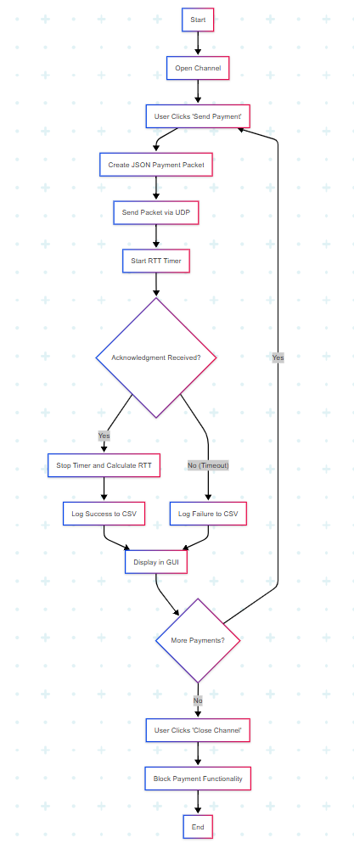

1. **Channel Initialization**:  
   Upon "Open Channel" command, sender can start sending payments.
2. **Payment Request Sending**:  
   A JSON packet containing payment details is created and sent via UDP.
3. **Waiting for Acknowledgment**:  
   A timer starts to measure RTT. If acknowledgment is received within timeout, success is logged. Otherwise, transaction failure is logged.
4. **Channel Closure**:  
   After payments are done, the "Close Channel" command halts further transmission.

***6.2 Receiver App Workflow***

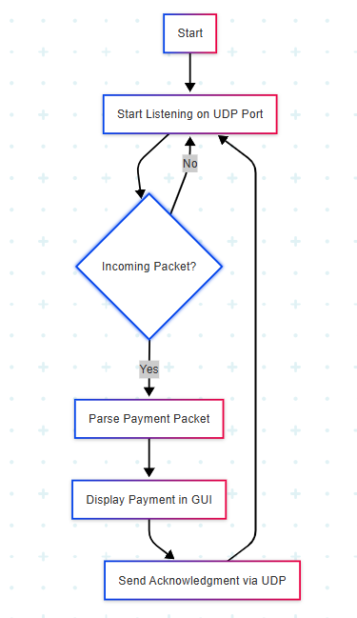

1. **Listening for Packets**:  
   The receiver stays in a loop, continuously monitoring the UDP port for incoming payment packets.
2. **Acknowledgment Handling**:  
   Upon receiving a payment packet, the receiver sends back a simple acknowledgment packet immediately.
3. **User Interface Updates**:  
   Received payments and sent acknowledgments are logged and displayed on the receiver's GUI in real-time.

***7. System Architecture Diagram***

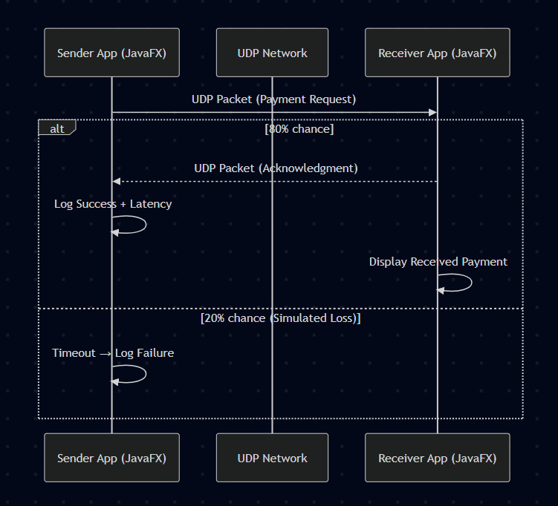

***8. Outputs shown in a separate file attached after.***

***9. Why UDP is Used***

UDP is selected as the communication protocol because:

* **No Handshakes**:  
  Minimal connection overhead ensures fast communication.
* **Low Latency**:  
  UDP allows quicker message delivery without waiting for network setup.
* **Lightweight Headers**:  
  Less data overhead compared to TCP improves transmission speed.
* **Resembling Lightning Network Characteristics**:  
  Similar to Bitcoin’s Lightning Network philosophy where speed is prioritized over reliability (handled cryptographically, not by the transport layer).

**Real-World Comparison:**

* **Lightning Network**: Guarantees reliability through cryptographic contracts.
* **UDP Payment Simulator**: Simulates fast, possibly unreliable communication, where responsibility lies at application logic.

***10. Risk of Money Loss Discussion***

In this simulation:

* Packet loss results in missing transactions without real-world financial loss.
* CSV log records failed attempts for analysis.

In actual Lightning Network systems:

* Loss of acknowledgment does not necessarily mean monetary loss because of **Hashed Timelock Contracts (HTLCs)**.
* If a payment is not confirmed within a timelock, it is **automatically refunded** to the sender.
* Cryptographic rules ensure **either payment completion or no fund movement**.

Thus, real systems are significantly more resilient than the simple UDP simulator.

***11. How This Project Relates to Real Bitcoin Lightning Network***

|  |  |
| --- | --- |
| Simulator Feature | Lightning Network Concept |
| Channel Management | Channel opening/closing |
| Payment Sending | Off-chain transaction |
| Acknowledgment Processing | Cryptographic receipt |
| Packet Loss Simulation | Node failure or unstable routing paths |
| Latency Measurement | Tracking transaction finalization time |
| Transaction Logging | Maintaining payment records (commitment states) |

***12. Future Improvements***

* **Add Encryption**:  
  Introduce DTLS (Datagram TLS) to encrypt UDP traffic.
* **Retry Mechanism**:  
  Implement retransmissions for unacknowledged packets based on timeout.
* **Multi-client System**:  
  Extend to support concurrent multi-peer payment sessions.
* **Data Visualization**:  
  Integrate charting libraries to plot transaction statistics (e.g., success/failure rate, latency distribution).
* **Blockchain Integration**:  
  Connect with a Bitcoin testnet to simulate on-chain channel settlements.
* **Mobile Compatibility**:  
  Extend GUI to Android or lightweight platforms using JavaFX Mobile.

***13. Conclusion***

The **UDP Payment Simulator** successfully models the key principles of decentralized, real-time payment systems, focusing on speed, packet loss handling, and acknowledgment verification.  
It serves as an educational tool to understand network behaviour in unreliable environments and offers a foundational prototype that can be enhanced into a real-world payment layer system with further cryptographic and blockchain integrations.

By providing insights into transaction behaviour over unreliable mediums, this project bridges academic learning with modern decentralized finance concepts.