**SVKM’s NMIMS**

**Mukesh Patel School of Technology Management & Engineering, Mumbai**

A.Y. 2023 - 24

**Course: Database Management Systems**

**Project Report**

|  |  |  |
| --- | --- | --- |
| Program | MBA Tech Data Science | |
| Semester | III | |
| Name of the Project: | Airline Reservation System | |
|  | | |
| Details of Project Members |  |  |
| Batch | Roll No. | Name |
| J2 | S040 | Priyanshu Padhi |
| J2 | S046 | Rishi Ponda |
| J2 | S024 | Khushi Parihar |
| Date of Submission: 02/04/2024 | | |

**Contribution of each project Members:**

|  |  |  |
| --- | --- | --- |
| Roll No. | Name: | Contribution |
| S024 | Khushi Parihar | Normalisation |
| S040 | Priyanshu Padhi | Relational Model |
| S046 | Rishi Ponda | ER Diagram |

**Github link of your project:**

**LEFT TO DO**

**Note:**

1. Create a readme file if you have multiple files
2. All files must be properly named (Example:R004_DBMSProject)
3. Submit all relevant files of your work ( Report, all SQL files, Any other files)
4. **Plagiarism is highly discouraged (Your report will be checked for plagiarism)**

**Rubrics for the Project evaluation:**

|  |  |
| --- | --- |
| First phase of evaluation:  Innovative Ideas (5 Marks)  Design and Partial implementation (5 Marks) | 10 marks |
| Final phase of evaluation  Implementation, presentation and viva, Self-Learning and Learning Beyond classroom | 10 marks |

**Project Report**

**Airline Reservation System**

**by**

**Khushi Parihar, Roll number: S024**

**Priyanshu Padhi, Roll number: S040**

**Rishi Ponda, Roll number: S046**

**Course: DBMS**

**AY: 2023-24**

**Table of Contents**

|  |  |  |
| --- | --- | --- |
| **Sr no.** | **Topic** | **Page no.** |
| **1** | Storyline |  |
| **2** | Components of Database Design |  |
| **3** | Entity Relationship Diagram |  |
| **4** | Relational Model |  |
| **5** | Normalization |  |
| **6** | SQL Queries |  |
| **7** | Learning from the Project |  |
| **8** | Project Demonstration |  |
| **9** | Self-learning beyond classroom |  |
| **10** | Learning from the project |  |
| **11** | Challenges faced |  |
| **12** | Conclusion |  |

**I. Storyline**

Imagine a web-based platform for booking and searching flights by travelers. In order to maintain their profiles and booking history, users can register and establish accounts. Airlines, with their own names, identities, and maybe contact details, run the flights. Particulars about a flight include the airports of departure and arrival (identified by unique numbers), the times of departure and arrival, and the seats that are available. Flights can be found by users using a variety of search parameters, including origin, destination, date, and passenger count. After choosing a preferred flight, users have the option to reserve seats and enter passenger details. The system records passenger information, handles reservations, and streamlines payment processing.

**II. Components of Database Design**

Describe all entities along with their attributes here. Also, mention the primary keys for each entity.

Entities

Describe all relationships among various entities. Also, specify the cardinality and participation for all relationships.

Relationships

LEFT TO DO

**III. Entity Relationship Diagram**

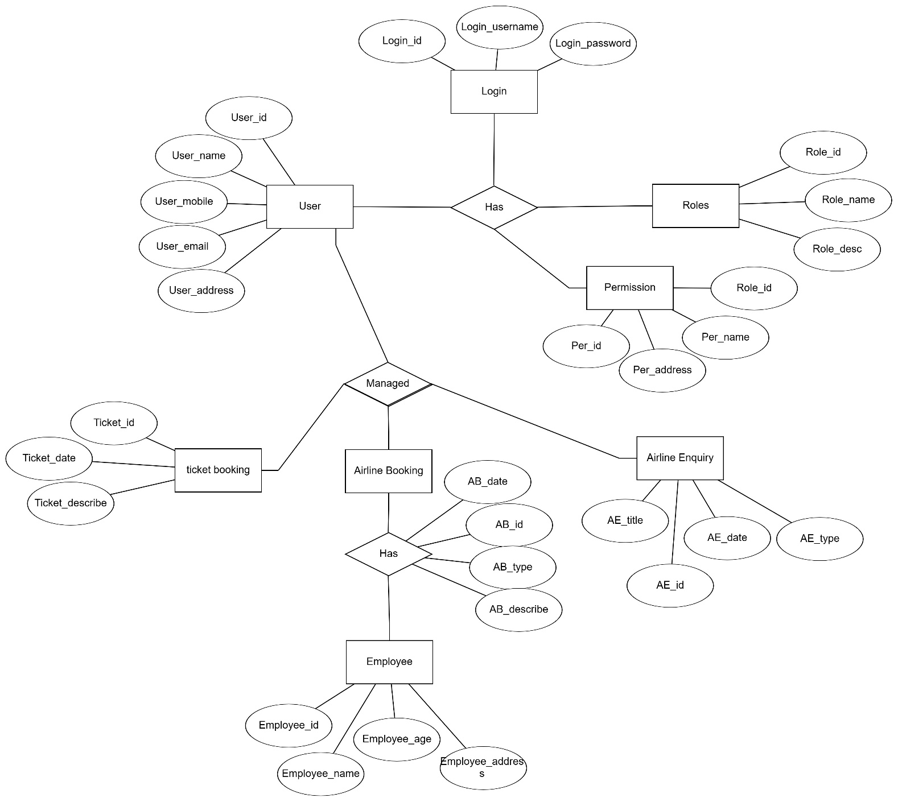

**IV. Relational Model**

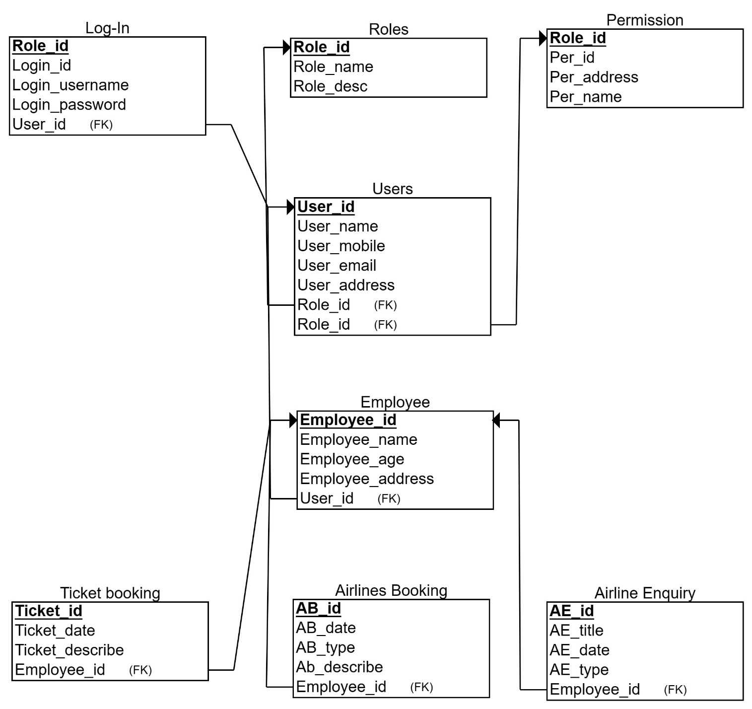

**V. Normalization**

LEFT TO DO

**VI. SQL Queries**

SQL for ER diagram and Tables

CREATE TABLE Users (

User_id INT PRIMARY KEY,

User_name VARCHAR(255) NOT NULL,

User_mobile VARCHAR(255) NOT NULL,

User_email VARCHAR(255) NOT NULL,

User_address VARCHAR(255) NOT NULL

);

CREATE TABLE Roles (

Role_id INT PRIMARY KEY,

Role_name VARCHAR(255) NOT NULL,

Role_desc VARCHAR(255) NOT NULL

);

CREATE TABLE Login (

Login_id INT PRIMARY KEY,

Login_username VARCHAR(255) NOT NULL,

Login_password VARCHAR(255) NOT NULL,

User_id INT FOREIGN KEY REFERENCES Users(User_id)

);

CREATE TABLE Employee (

Employee_id INT PRIMARY KEY,

Employee_name VARCHAR(255) NOT NULL,

Employee_age INT NOT NULL,

Employee_address VARCHAR(255) NOT NULL,

User_id INT FOREIGN KEY REFERENCES Users(User_id)

);

CREATE TABLE Permission (

Per_id INT PRIMARY KEY,

Per_name VARCHAR(255) NOT NULL,

Per_address VARCHAR(255) NOT NULL

);

CREATE TABLE Roles_Permission (

Role_id INT FOREIGN KEY REFERENCES Roles(Role_id),

Per_id INT FOREIGN KEY REFERENCES Permission(Per_id),

PRIMARY KEY (Role_id, Per_id)

);

CREATE TABLE Ticket_booking (

Ticket_id INT PRIMARY KEY,

Ticket_date DATE NOT NULL,

Ticket_describe VARCHAR(255) NOT NULL,

Employee_id INT FOREIGN KEY REFERENCES Employee(Employee_id)

);

CREATE TABLE Airlines_Booking (

AB_id INT PRIMARY KEY,

AB_date DATE NOT NULL,

Ab_describe VARCHAR(255) NOT NULL,

Employee_id INT FOREIGN KEY REFERENCES Employee(Employee_id)

);

CREATE TABLE Airline_Enquiry (

AE_id INT PRIMARY KEY,

AE_title VARCHAR(255) NOT NULL,

AE_date DATE NOT NULL,

AE_type VARCHAR(255) NOT NULL

);

LEFT TO DO FOR NORMALISATION

Using a DBMS software (SQLite3 or MySQL or any other of your choice):

* Create the tables
* Populate the tables (insert some meaningful data, at least 10 tuples for each relation)
* Run SQL queries (minimum 20) covering **all concepts** learned in the class

This section should contain the question, SQL code, and the output snapshot for each query.

**VI. Project demonstration**

* ERDPlus software used for constructing the ER diagram and the relational database model.
* [ER Diagram for the Airline Reservation System - javatpoint](https://www.javatpoint.com/er-diagram-for-the-airline-reservation-system) - reference website used as an example for our project.
* MySQL Workbench 8.0 CE used for the query codes of the ER diagram and the normalization.

**VII. Self -Learning beyond classroom**

:

Advanced Data Modeling Techniques: In situations when typical relational models might not be the best option, consider modeling approaches like entity-attribute-value (EAV) modeling or complex object modeling.   
Data Warehousing and Business Intelligence: Learn about the principles and methods of data warehousing for the purpose of keeping and evaluating past airline reservation data in order to obtain knowledge about flight performance, consumer behavior, and other related topics.   
SQL Databases: Examine and contrast SQL and relational databases, taking into account which is better suited for particular use cases in airline reservation systems (managing large amounts of real-time booking data, for example).   
Airline sector legislation: Learn about the pertinent legislation governing the airline sector that may affect the way your reservation system collects, stores, and handles data security.

**VIII. Learning from the Project**

Understanding Database Design Principles: This assignment helped you gain a firm grasp of relational tables, entity-relationship modeling, and normalization as database design principles.

Data Modeling for Complex Systems: You gained experience in data modeling for complicated systems, such as airline reservation systems, which have numerous entities and interactions.

Transforming Requirements into a Database Design: Translating actual airline reservation requirements into a tangible database structure was a step in the database design process.

Problem-Solving Ability: You showed problem-solving ability when you designed the database by identifying entities, relationships, and possible problems.

**IX. Challenges Faced**

Data Security Considerations: When handling passenger information and payment details, data security and user convenience must be balanced.   
Scalability and Performance: Organizing the database design to handle future increases in the number of flight options, reservations, and users.   
Integrating with External Systems: Taking into account any potential requirements for the reservation system to communicate with other airline systems or outside providers.

**X. Conclusion**

Important Takeaways (Continued): and using analytical abilities to build a workable database for an airline reservation system.

Prospective Uses: The skills acquired from this project can be used to create databases for different reservation systems (like those used by hotels or rental cars) or other applications where managing reservations and transactions is necessary.