Till Now

**Modules Used for Calculation (Python):-**

1. *Numpy*
2. *Scripy*
3. *Counter*
4. *matPlot Lib*

**Mapping DataSet taken from Protein Sequence Metric Reseach Paper:-**

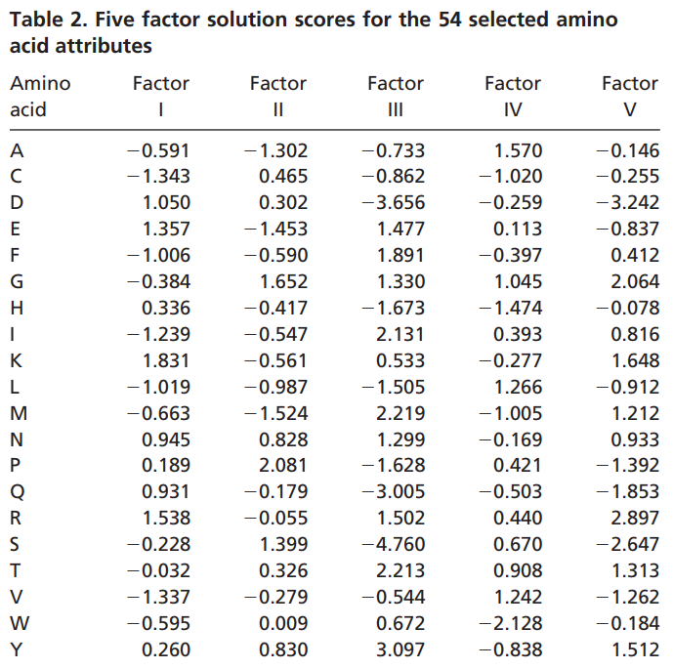

**Sequences Used to test During Programming:-**

1. **PDB ID:- 1EZG (Repitita Paper)** link :- <https://www.rcsb.org/structure/1EZG>
2. **The repeating protein sequences that here is taken (3TWQ|Chains A, B|Tankyrase-2|Homo sapiens (9606)) from PDB**

Link:- <https://www.rcsb.org/structure/3TWQ>

**Basic Outline of the Code:-**

1. The first Step we did was to map the **DataSet taken from Protein Sequence Metric Reseach Paper..** Using dictionary we Implemented this.
2. After Mapping we retrieved the value of the sequence via a list.
3. After list was formed

* We calculated the FFT of the sequence as of now we used the inbuilt Library of the FFT, the implementation of FFT is shown Below.

We were able to come with it by **Equation 4 in repitita Paper**

4.We Calcuted FFT for all 5 properties.

5.After step 4 the results are as follows:-

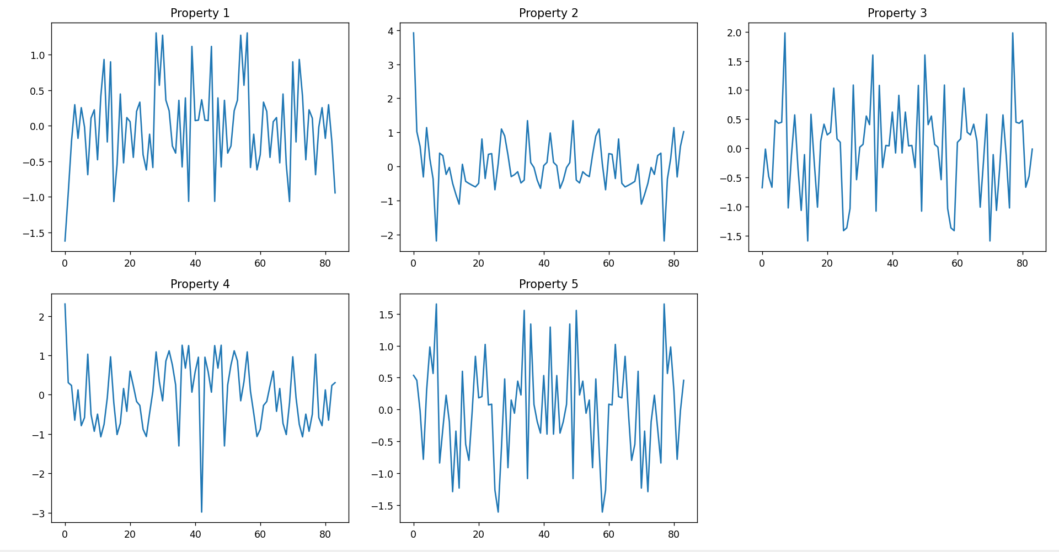

This is before step 4 and the equation used for this step was:-

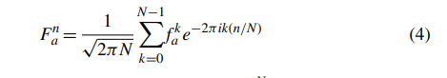

And the function/module used in python was **(np.fft.fft)**

6.**We apply Normalization step as mentioned in paper at equation 5:-**

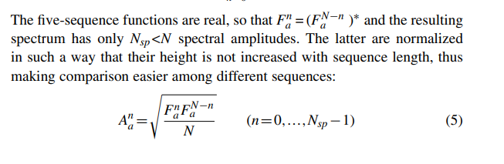

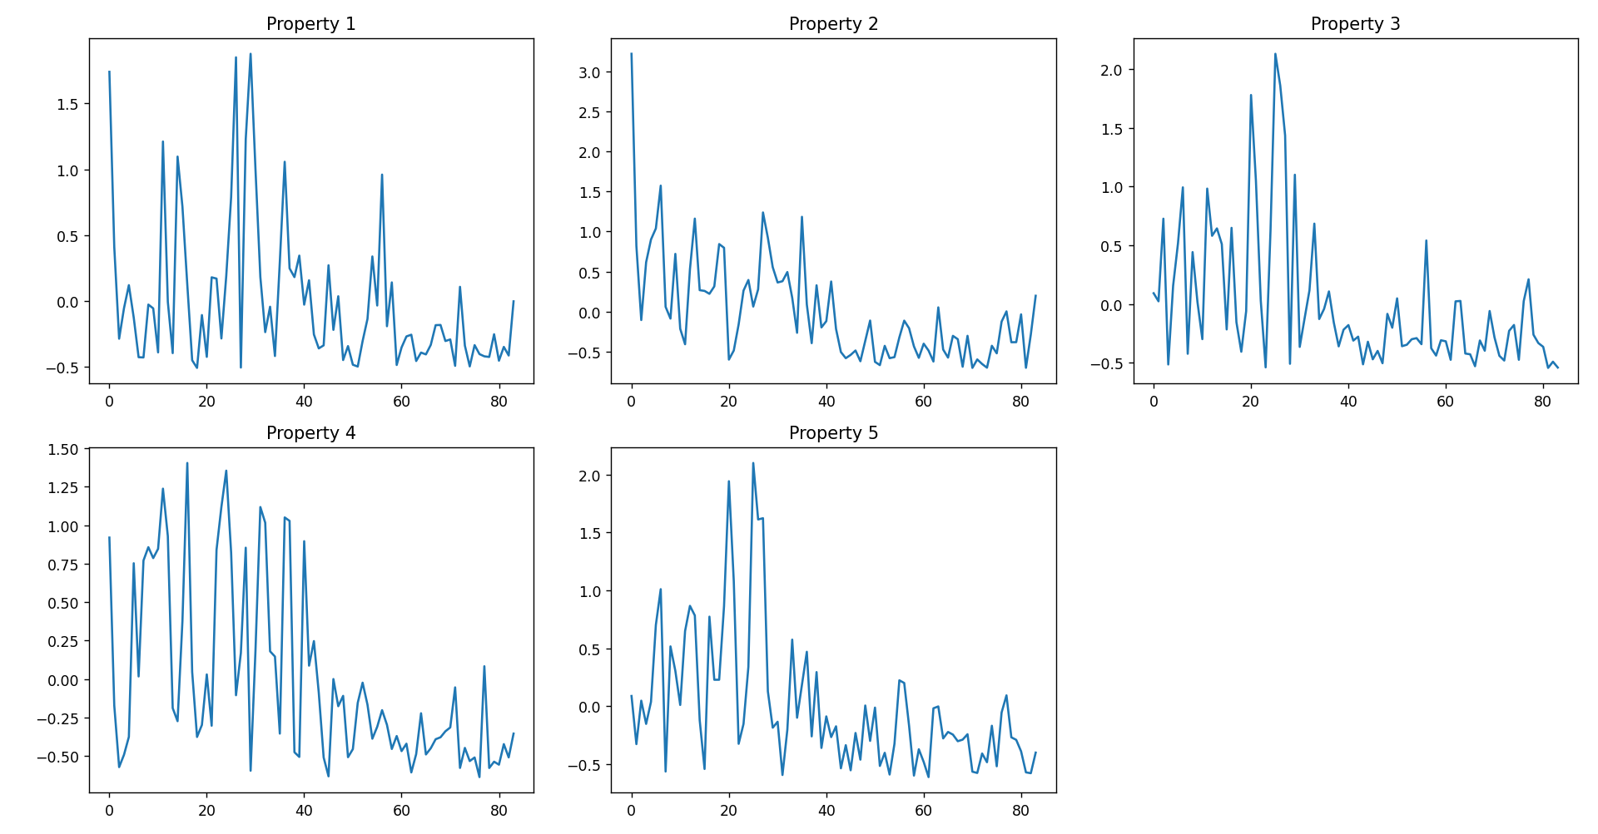

The above plot is for sequence with both real and imaginary numbers

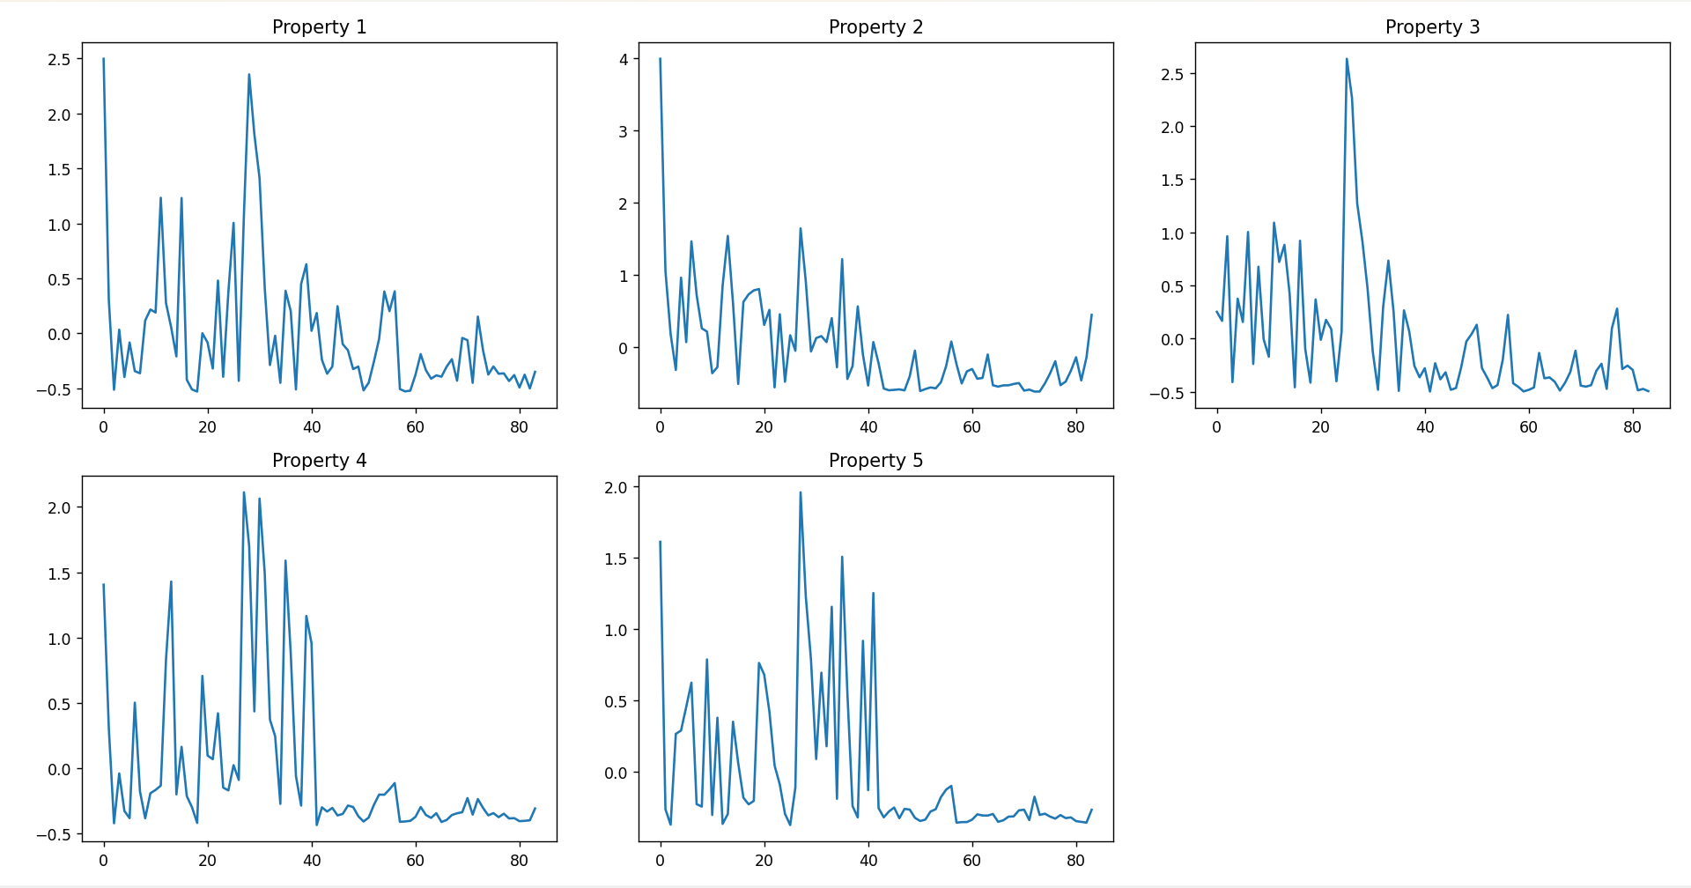

The above plot is for sequence with only real numbers

The module used here was **numpy and cmath.**

7.Calcution of ZSCORE was done by 2 ways

* One with the custom function that we wrote by using the formula of ZScore from euation 7.

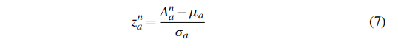

This was simply implemented with 2 functions separately

Mean

A from the FFT sequence

* The second was using the Inbuilt library of python from **MODULE SCRIPY**

The implementation of the program was same when checked its documentation

The output as of now stands at:-

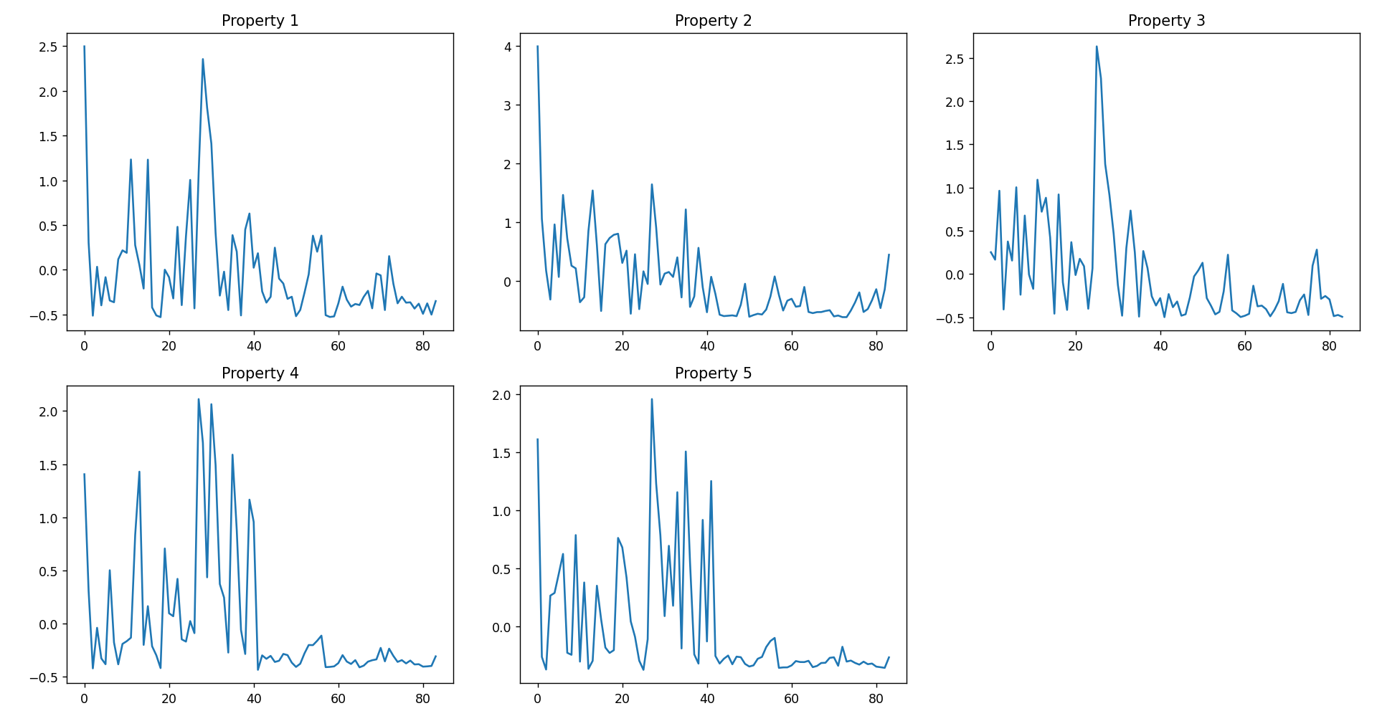

Property 1:-Polarity Index

Property2:- Secondary Structure Factor

Property 3:- Volume

Property 4:-Composition of amino acids

Property 5:- Electrostatic Charge