
Docker
DEVOPS | Assignment
SUBMISSION GUIDELINES
• Complete all tasks and document your work in a doc (Google Doc or Microsoft Word) with screenshots/commands and explanations.
• Create one folder named Docker_YourName.
• Put your complete project source code and all files inside this folder.
• Add your documentation file (with screenshots and explanations) inside the same folder.
• Compress the folder into a .zip file (Docker_YourName.zip).
• Upload the .zip file on the submission portal.
Zip File Must Contain
• Your complete project source code and all files
• Document with terminal screenshots and explanation
• All project code/files pushed to GitHub
• Docker images uploaded to Docker Hub
• GitHub repository link
⚠ Your full project code MUST be submitted inside this .zip file. Screenshots (terminal / commands / output) are mandatory. Also share your GitHub repository link.
Do NOT upload separate files.
Do NOT submit without compressing into a .zip file.

Objective: Containerize a full-stack application — a Node.js/Express frontend and a Flask backend — using Docker and Docker Compose, then push the images to Docker Hub and the code to GitHub.

1. Frontend (Node.js with Express)
- Create a frontend using Express and Node.js.
- Include a form similar to the one from the Flask Assignment
- Configure the form to send a request to the Flask backend.
The frontend was developed using Node.js and Express.js.
The application provides a student registration form with three input fields:
Student Name
Email Address
Course Name
The Express server receives form submissions and forwards the data to the Flask backend.
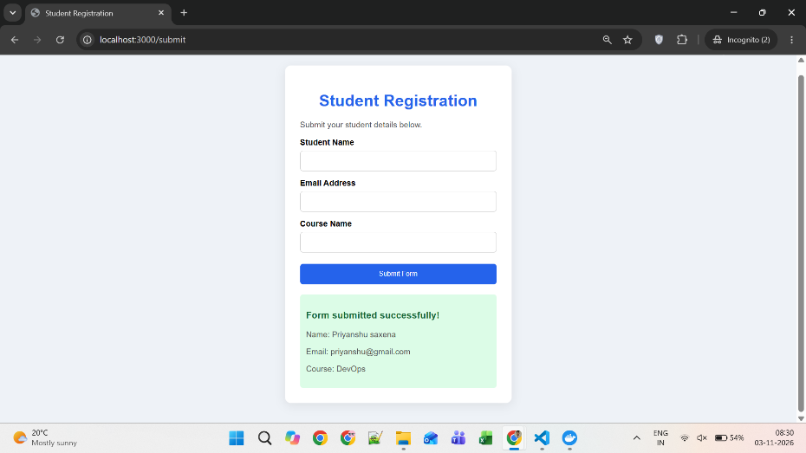
2. Backend (Flask)
- Use the Flask backend to handle the form submission and process the data.
The backend was developed using Python and Flask.
It provides a POST API endpoint /submit that receives JSON data from the frontend.
The backend validates the submitted fields and returns a success or error response.
3. Folder Structure
- Organize the project with separate folders for the frontend and backend.
The project contains two main directories:

Frontend:
server.js
package.json
Dockerfile
views/index.ejs
public/style.css

Backend:
app.py
requirements.txt
Dockerfile

The root directory contains docker-compose.yaml and .gitignore.
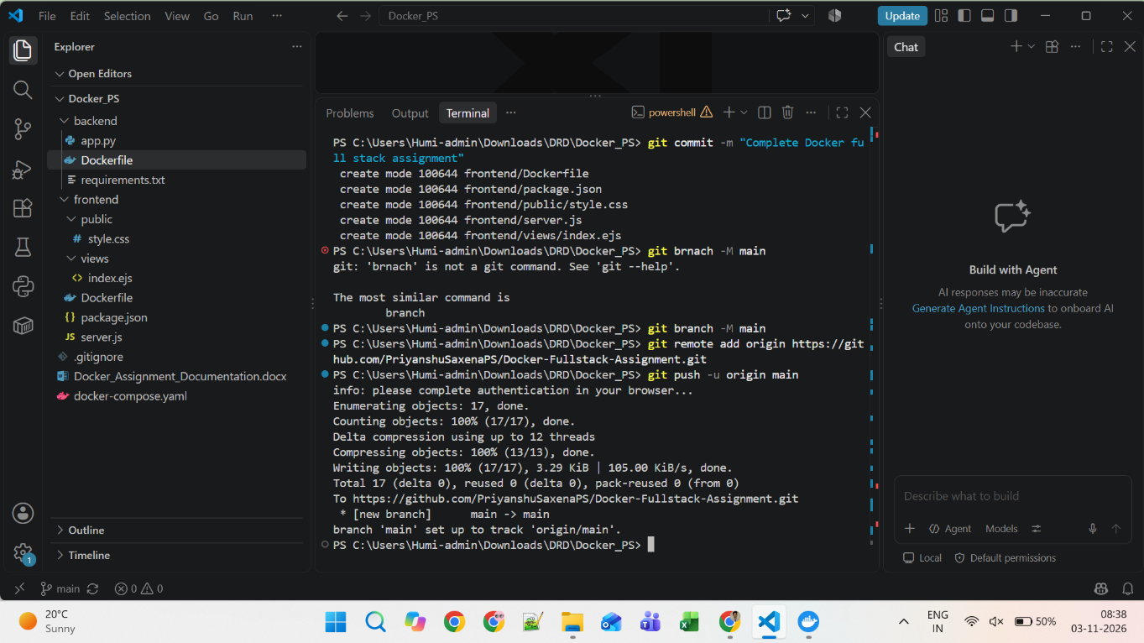
4. Docker Configuration
- Create a Dockerfile for both the frontend and backend.
- Write a .yaml file (Docker Compose) to connect both services in the same network.
- Upload both images to Docker Hub, and push your whole code to GitHub. Add node_modules and other non-required files (e.g., .vscode) to .gitignore.
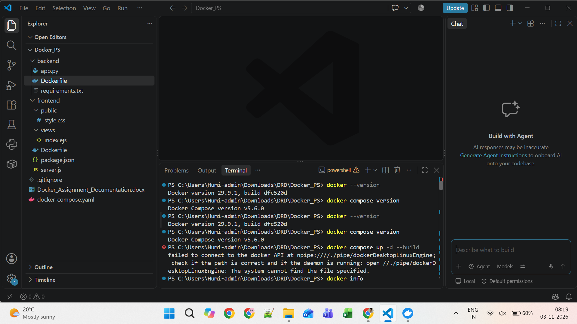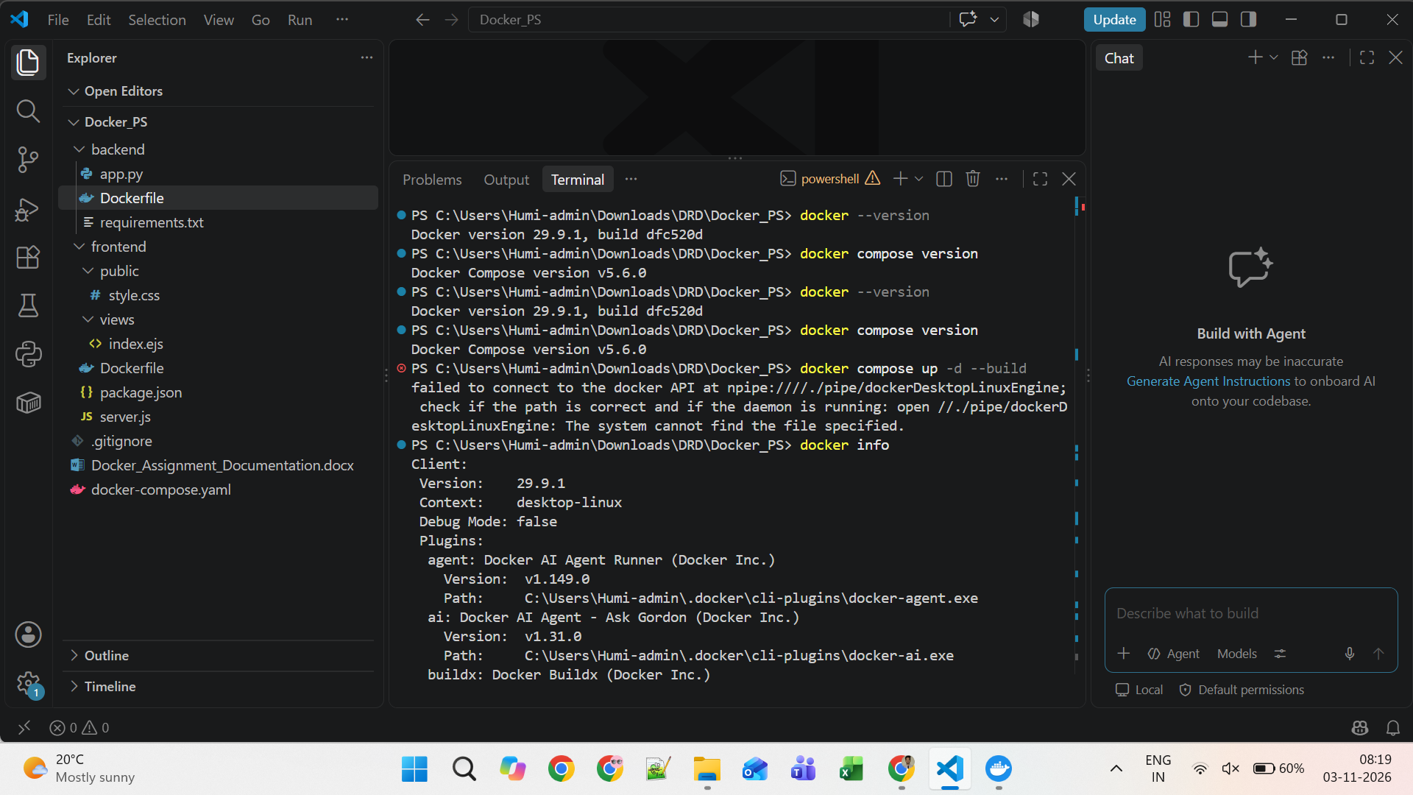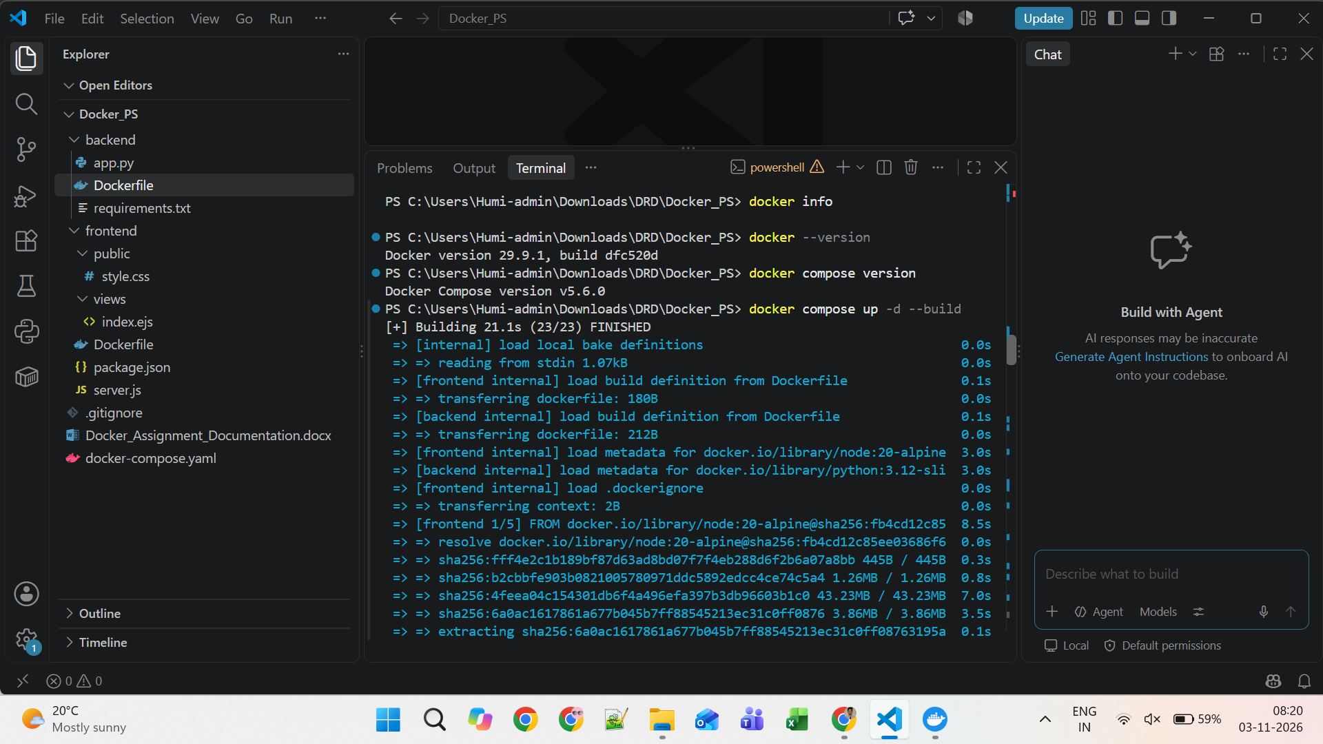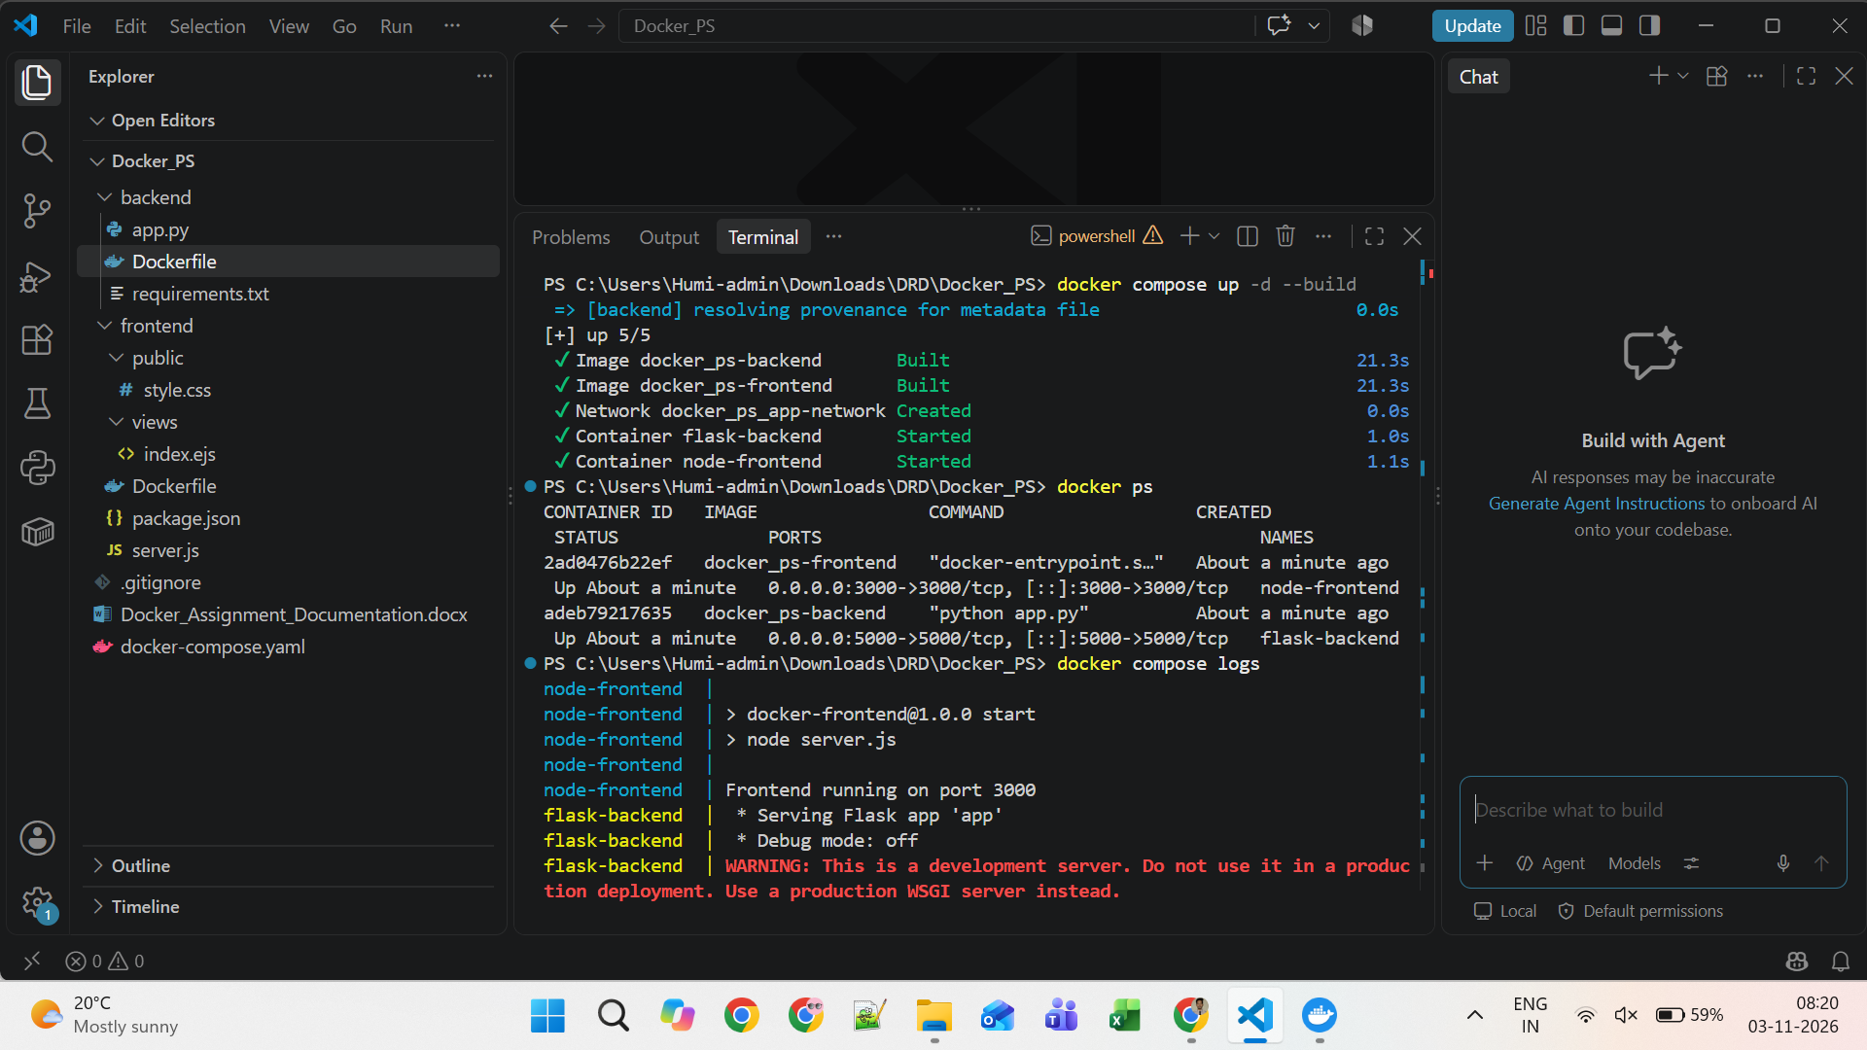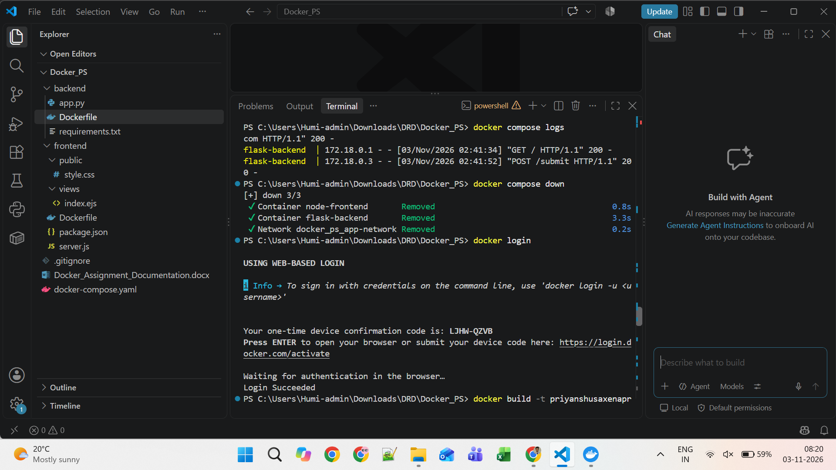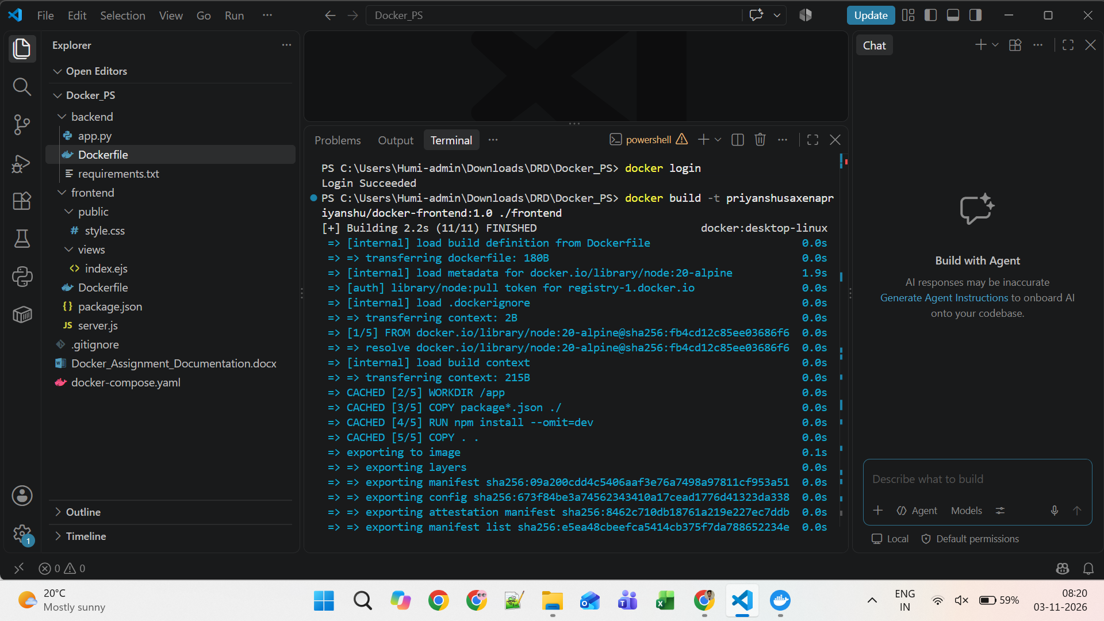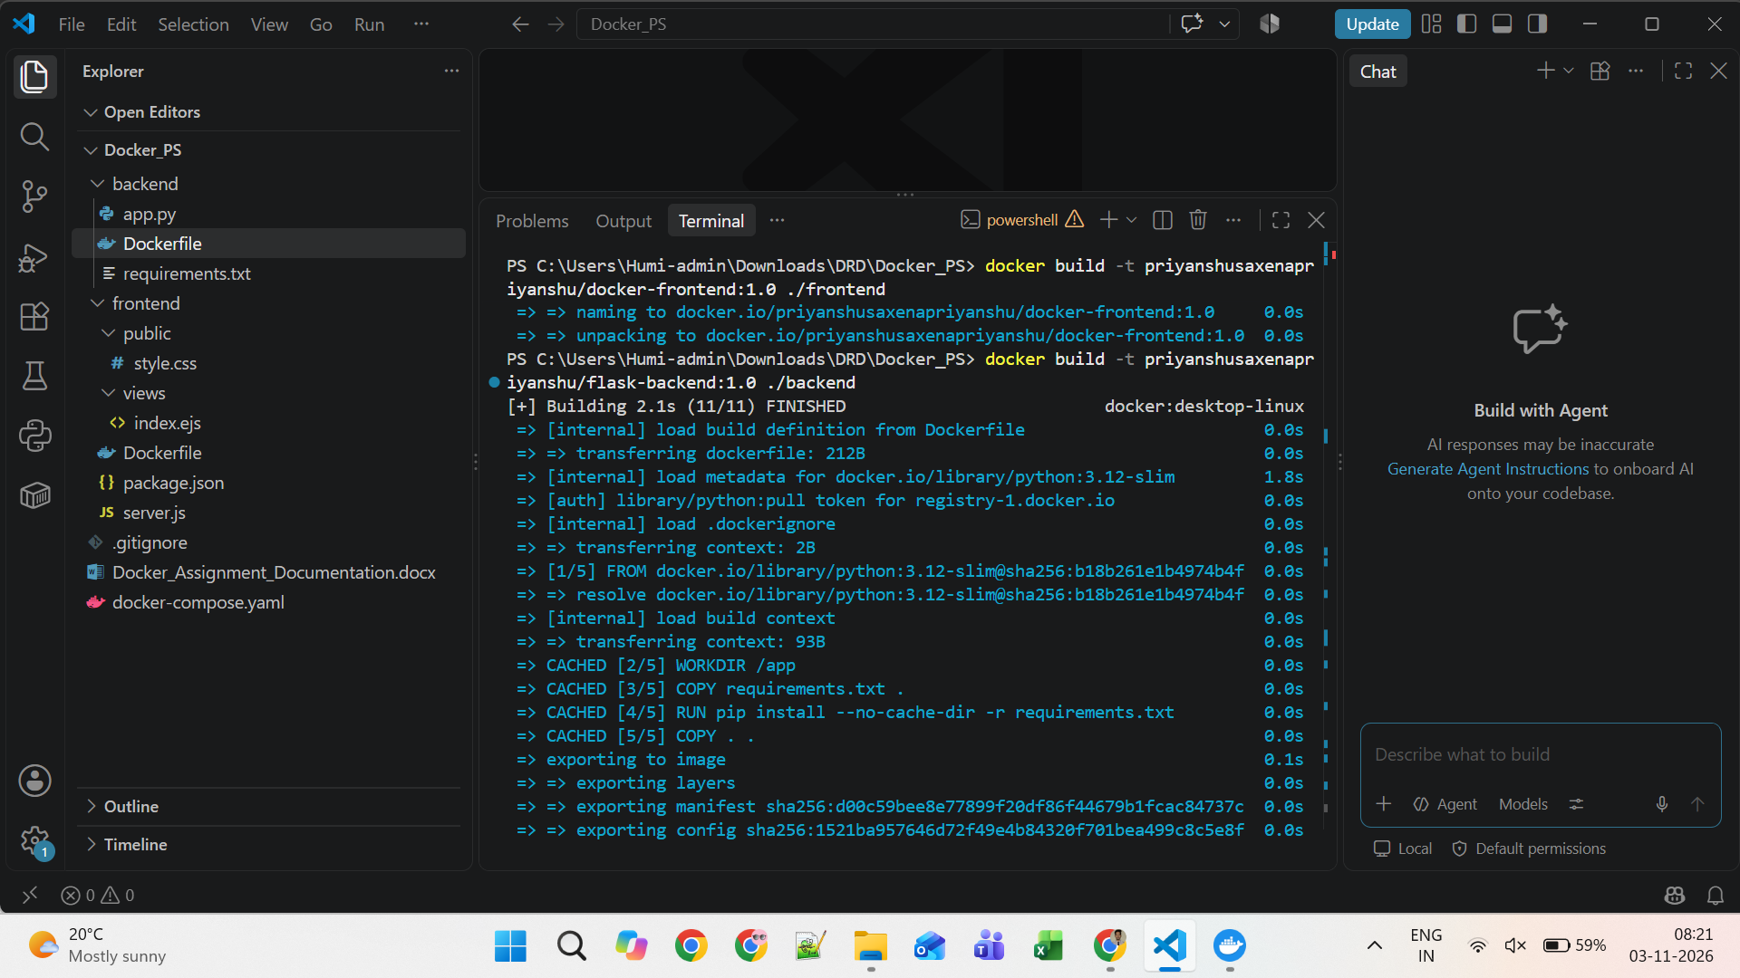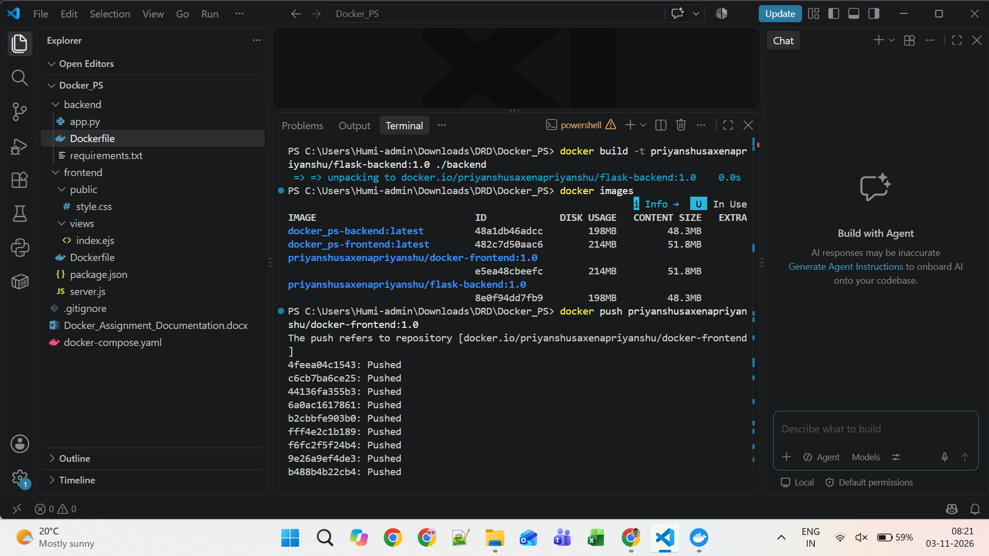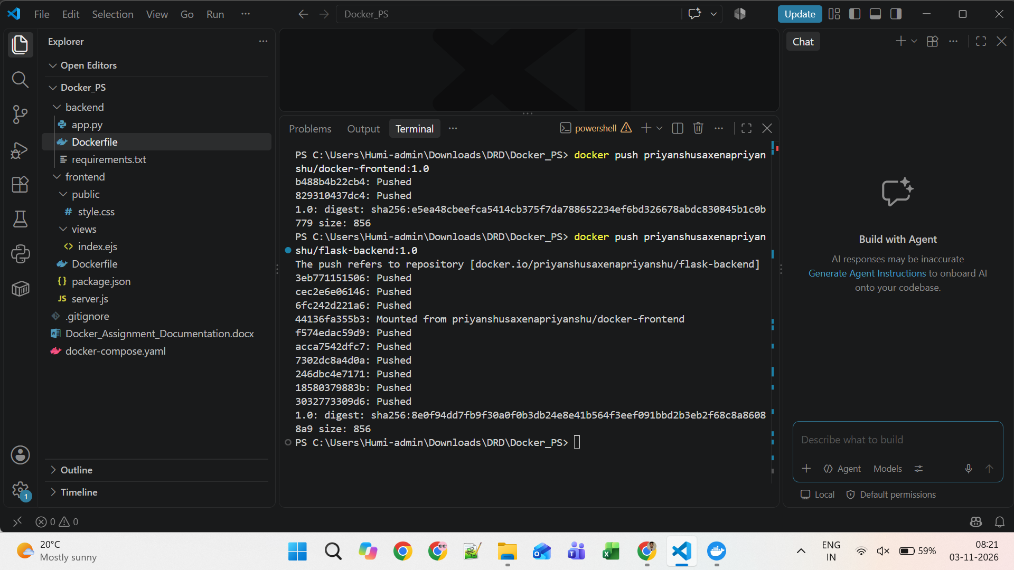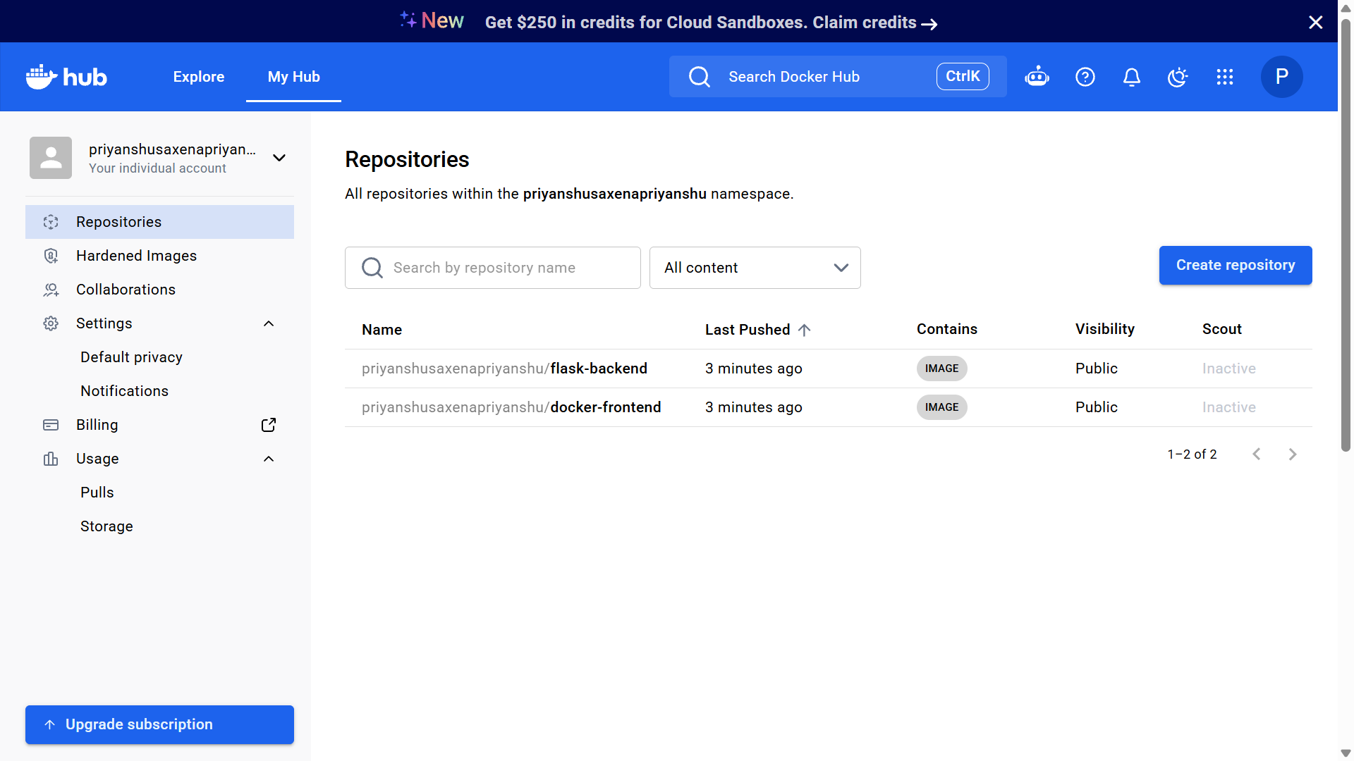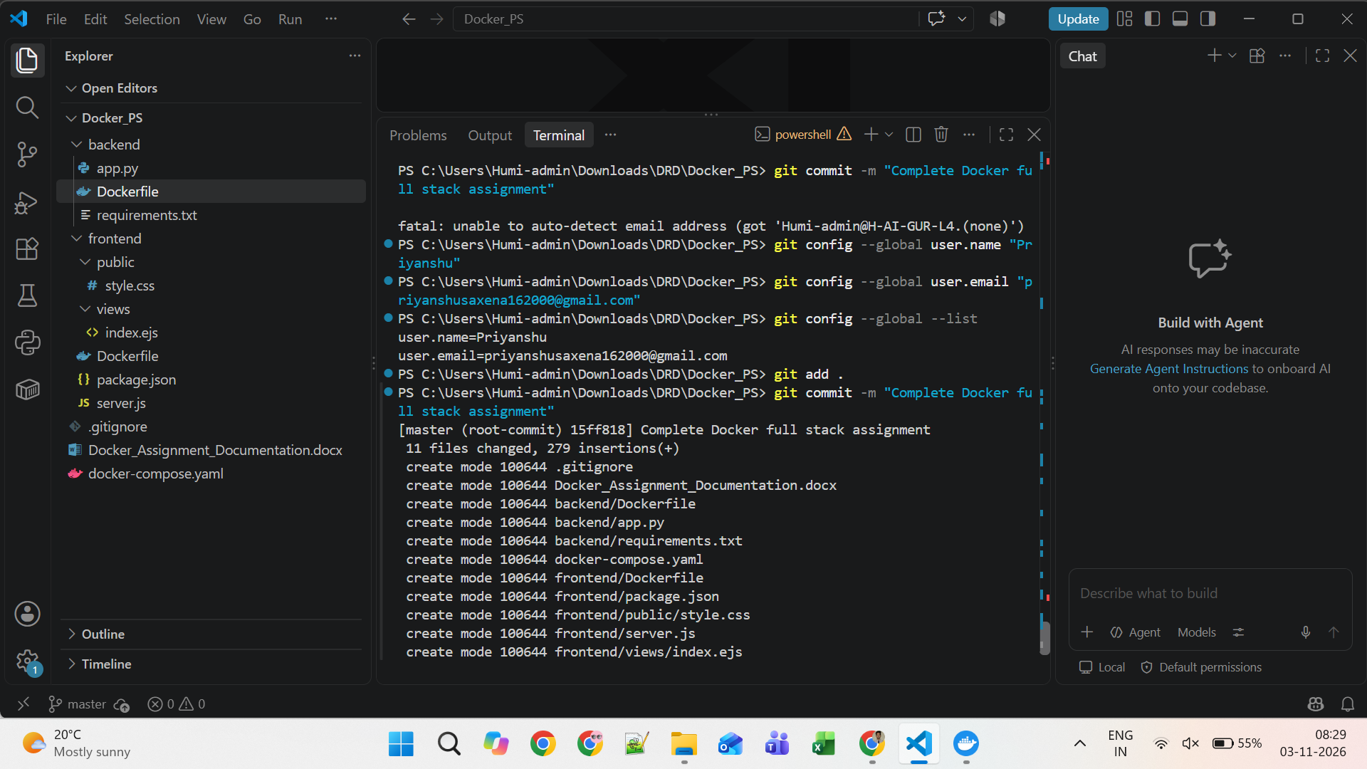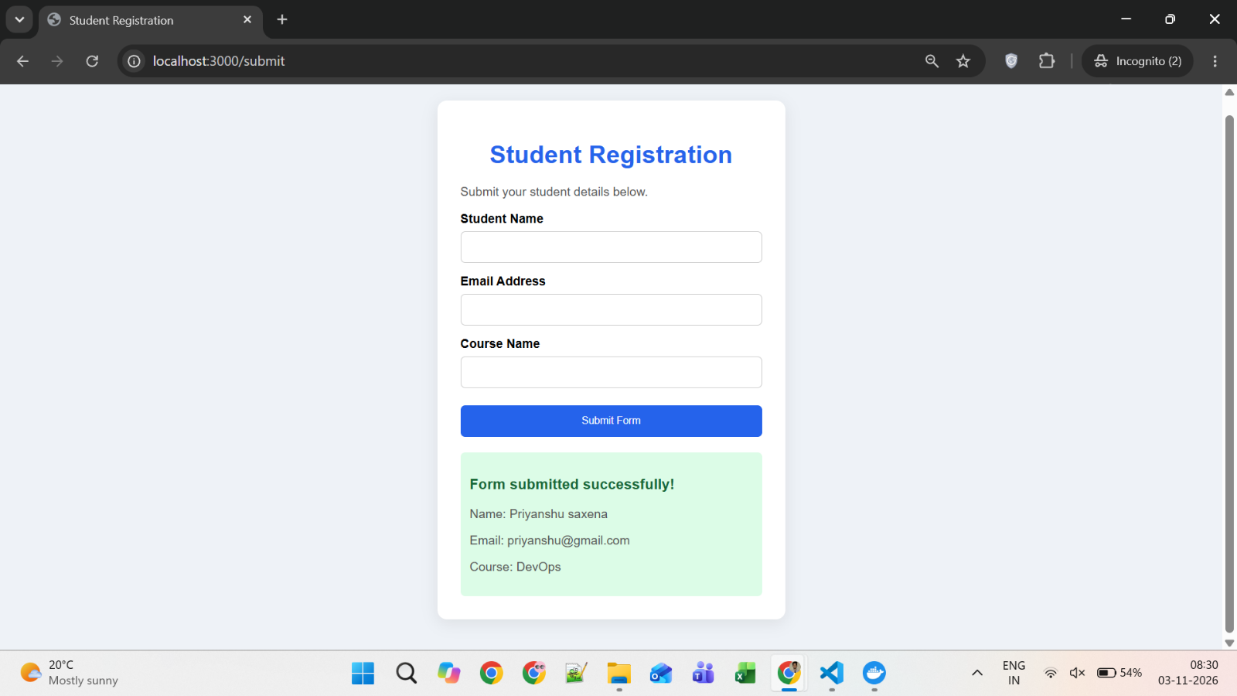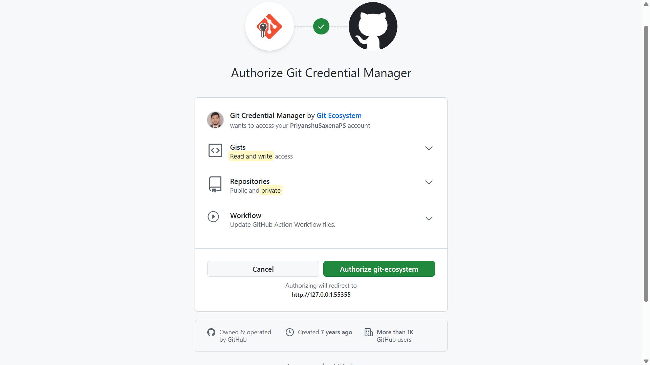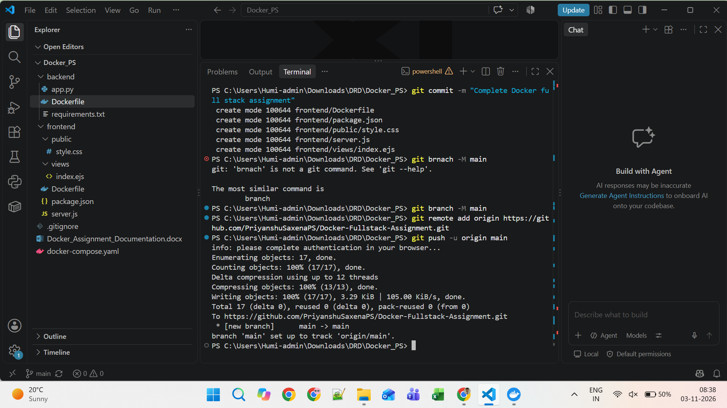
GitHub Repo URL: https://github.com/PriyanshuSaxenaPS/Docker-Fullstack-Assignment
Reference: https://github.com/Toto3107/flaskp
If you have any doubt, you can directly contact the Tutedude mentor.

