Full Stack Development with MERN

Frontend Development Report

Date: 15/04/2025

Team ID: SWTID1743520385

Project Name: Book a Doctor Platform

Maximum Marks:

# Project Title: Book a Doctor Platform

Date: 15/04/2024

Prepared by: SWTID1743520385

# Objective

The objective of this report is to document the frontend development progress and key aspects of the user interface implementation for the Book a Doctor web platform.

# Technologies Used

• Frontend Framework: React.js, HTML  
• State Management: React Hooks, useState/useEffect  
• UI Framework/Libraries: Tailwind CSS, JavaScript  
• API Libraries: Axios for GET/POST requests

# Project Structure

Book a Doctor is a responsive and intuitive doctor appointment platform with key routes such as Home, Doctors, Contact Us, and Admin Panel. The application supports theme toggling between light and dark modes to enhance accessibility.  
  
From the landing page, users can register or log in. Once authenticated, patients can browse doctors by specialization, book appointments, and view their dashboard. Admins can monitor platform data and users from their dashboard.  
  
The Contact Us page provides a form for patient inquiries, which, upon submission, confirms with a pop-up message that the team will respond soon.

# Key Components

1. App.js  
 • Handles routing and main application layout.  
2. /components  
 • Contains reusable UI components (e.g., Header, Footer, DoctorCard).  
3. /pages  
 • Home Page  
 • Doctors Page  
 • Appointment Booking Page  
 • Contact Us Page  
 • Admin Dashboard Page  
 • Login/Register Pages

# Routing

Routing is managed using React Router DOM:  
• /home – Landing page of the application  
• /doctors – List and search doctors  
• /dashboard – Patient dashboard  
• /admin – Admin dashboard  
• /contact – Contact page

# State Management

State management is handled using React's built-in Hooks (useState, useEffect). For shared/global state, Context API or Redux (if used) may be integrated.

# Integration with Backend

The frontend communicates with backend REST APIs hosted on Render. Key endpoints include:  
• GET /api/doctors – Fetch list of available doctors  
• POST /api/users/login – Handles user login  
• POST /api/appointments – Submits new appointment data

# User Interface (UI) Design

The UI supports light and dark themes:  
• Light Mode – White background, pink primary buttons  
• Dark Mode – Navy background, pink primary buttons  
Designed using HTML, Tailwind CSS, and responsive design best practices.

# Third-Party Integrations

• Axios – For API requests  
• React Router – For navigation  
• react-toastify – For user-friendly toast notifications  
• Cloudinary (optional) – For profile image uploads

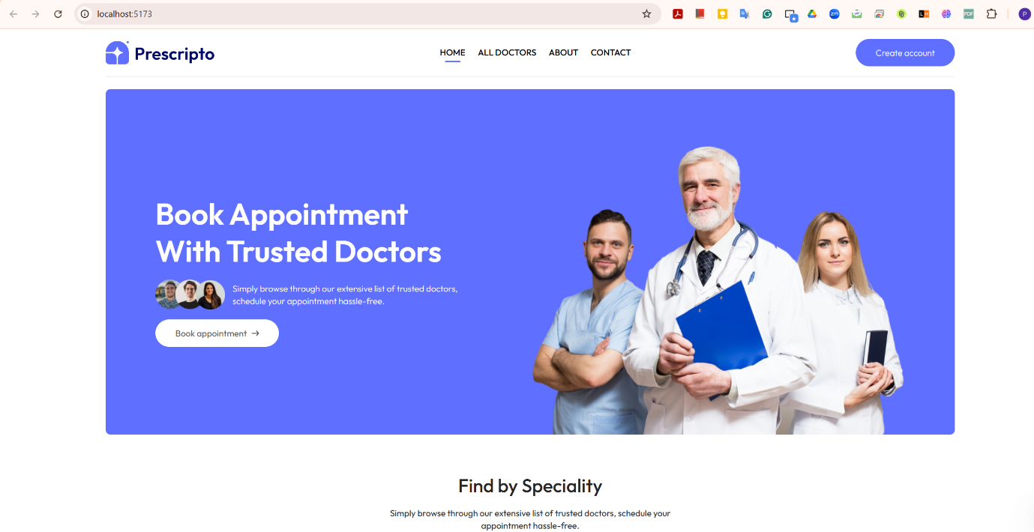

***Home Page***

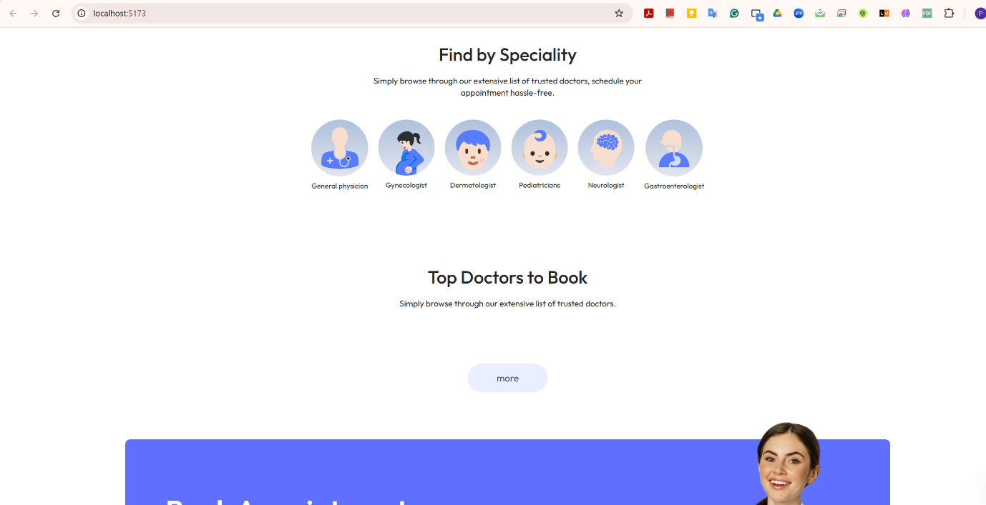

***Home Page***

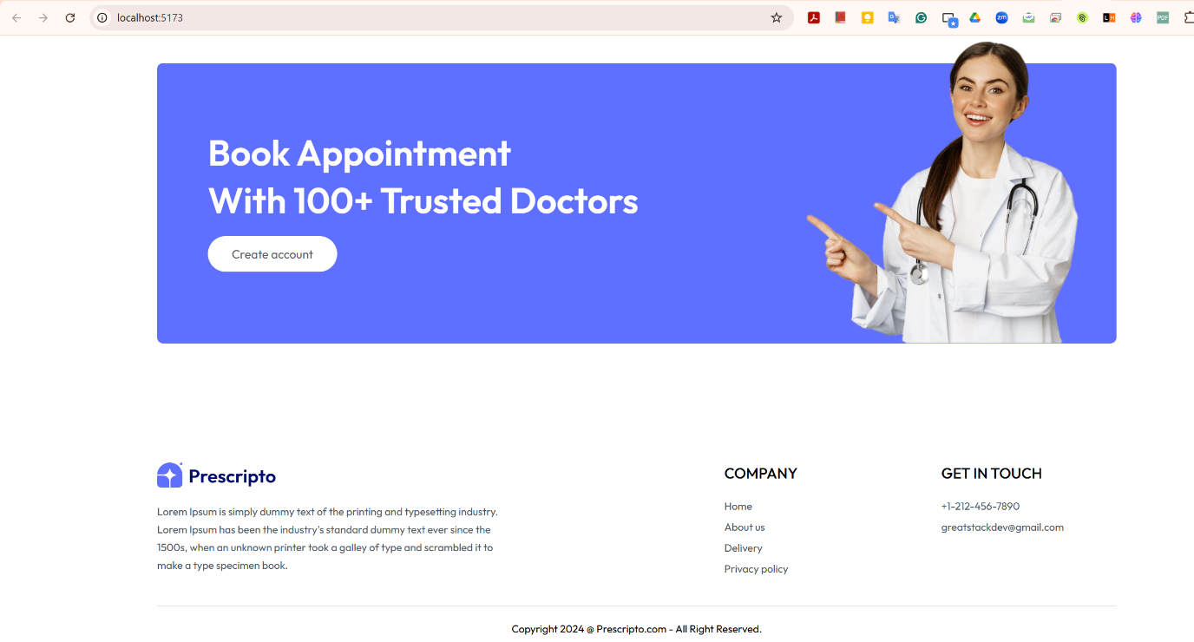

***Home Page***

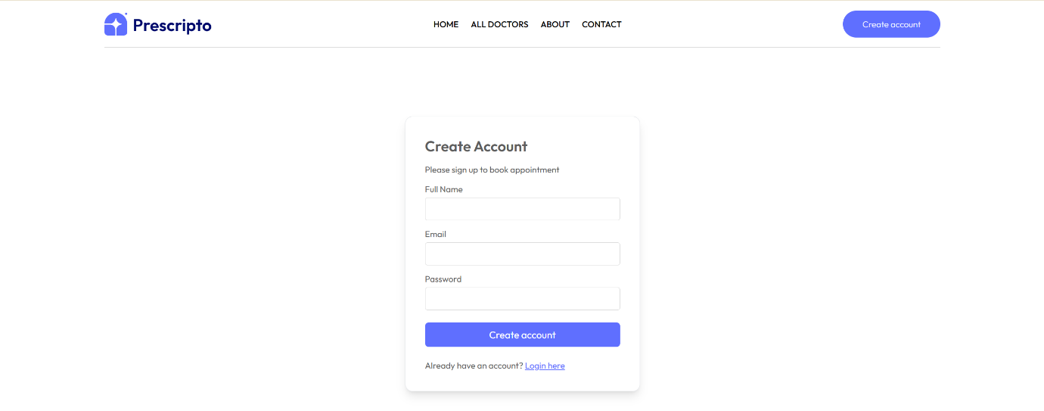

***Create Account Page***

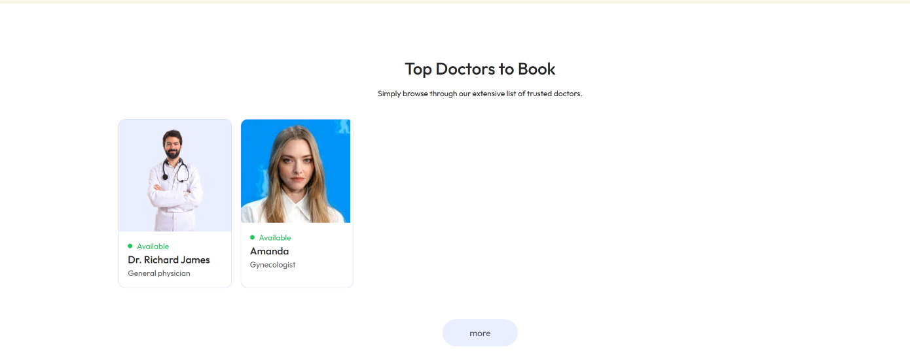

***All Doctors Page***

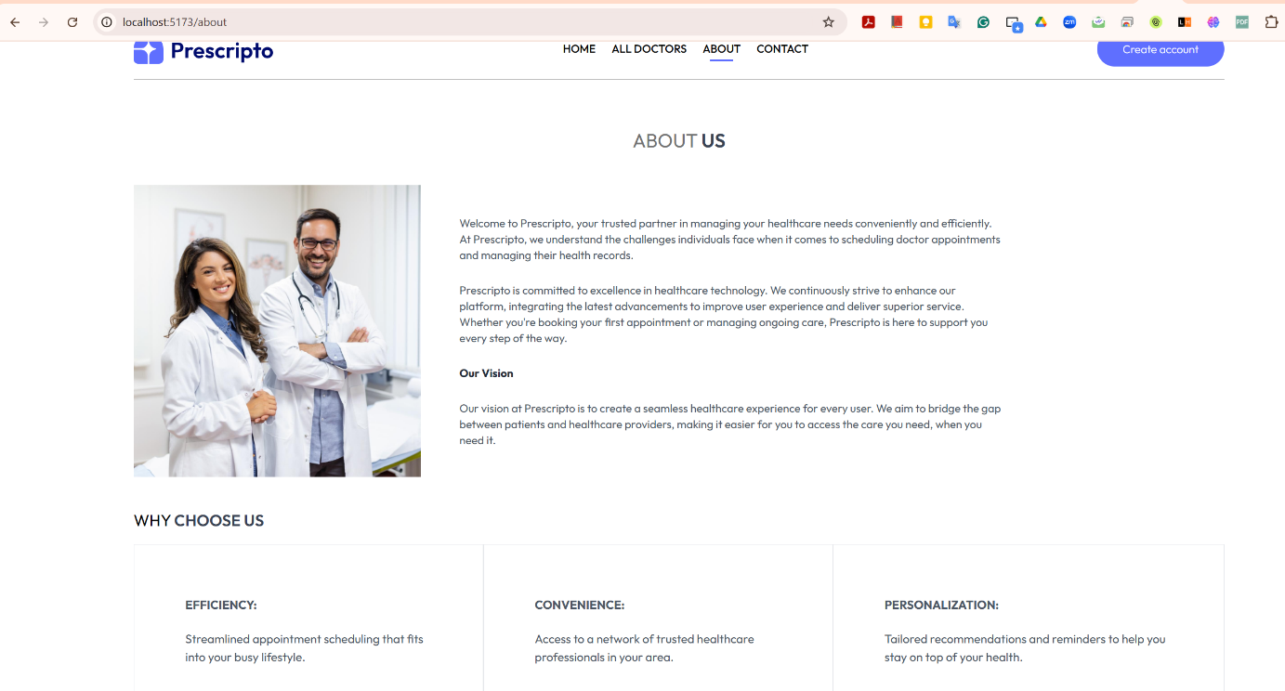

***About Us Page***

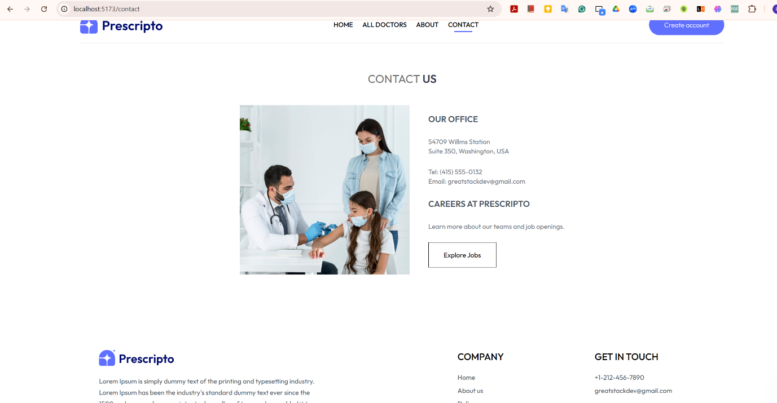

***Contact Us Page***

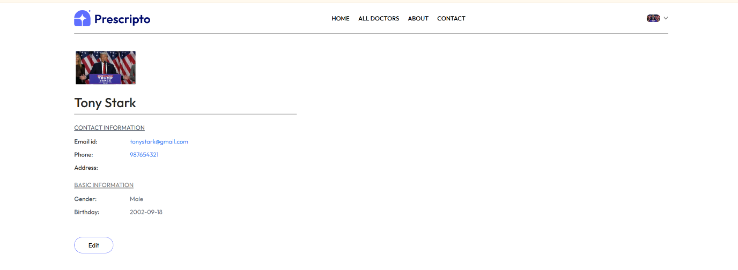

***Patient Details Page***

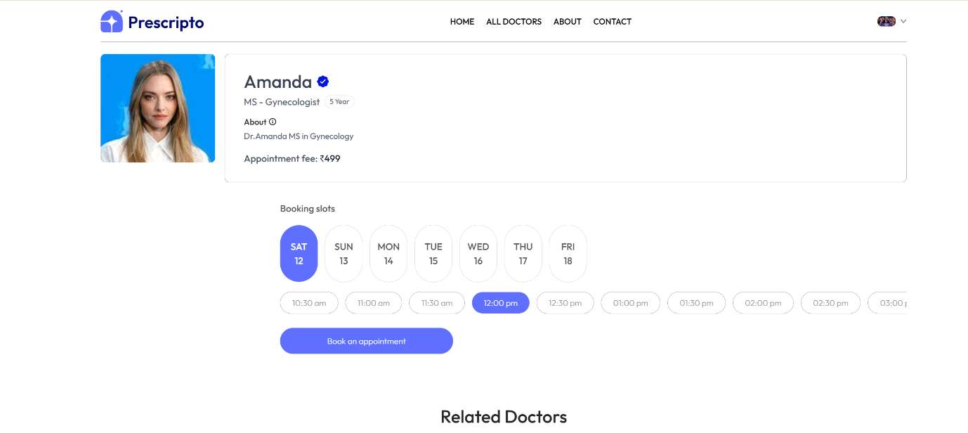

***Appointment Page***

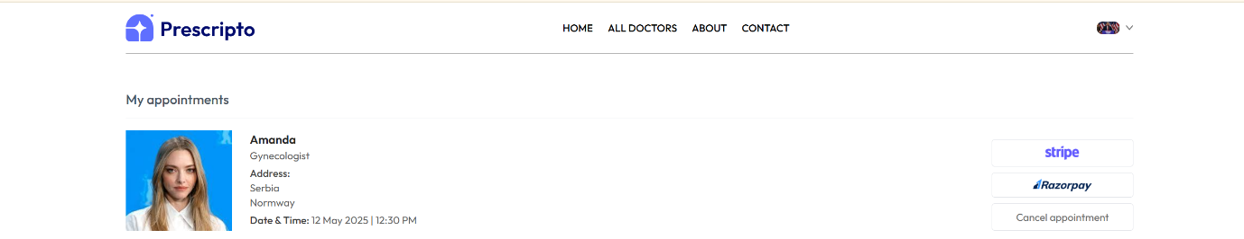

***Appointment Fees Payment Interface***

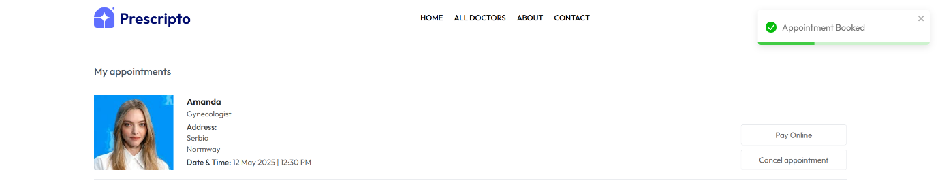

***Appointment Confirmation***

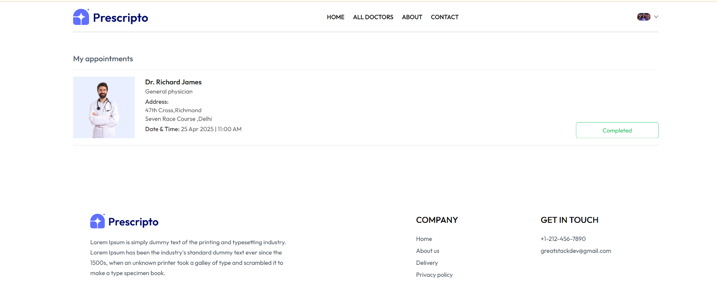

***My Appointments Page***

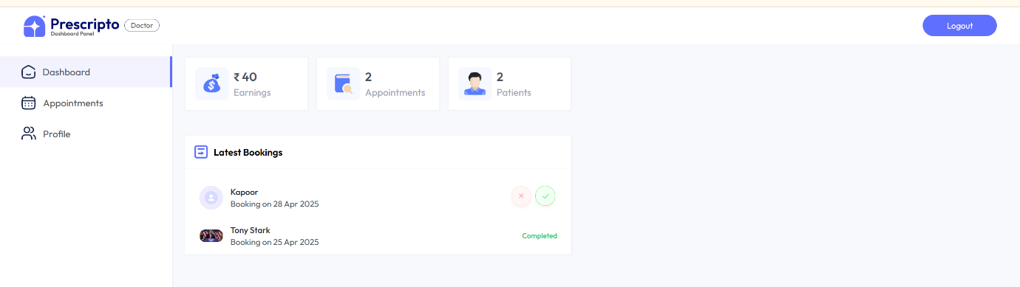

***Doctor Dashboard Login***

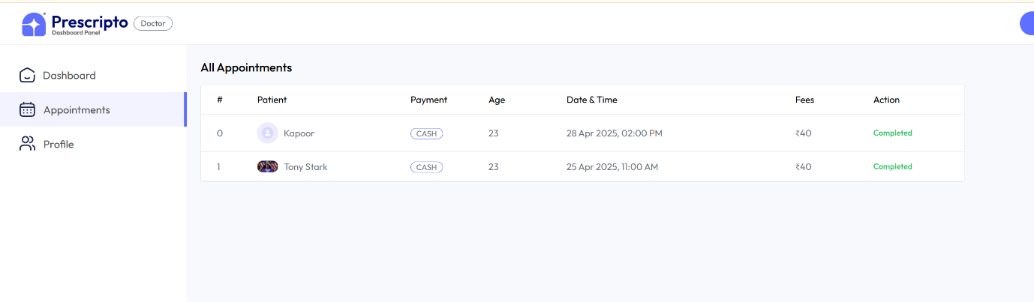

***Appointment Page (Doctor Interface)***

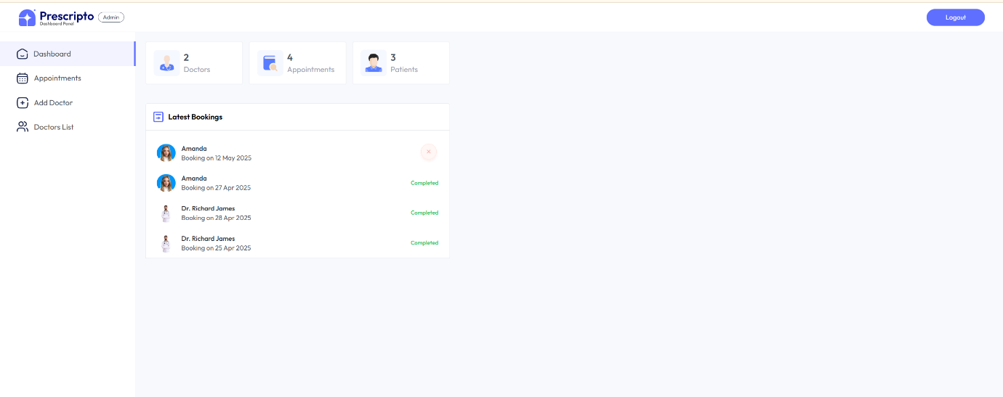

***Dashboard Interface (Admin)***

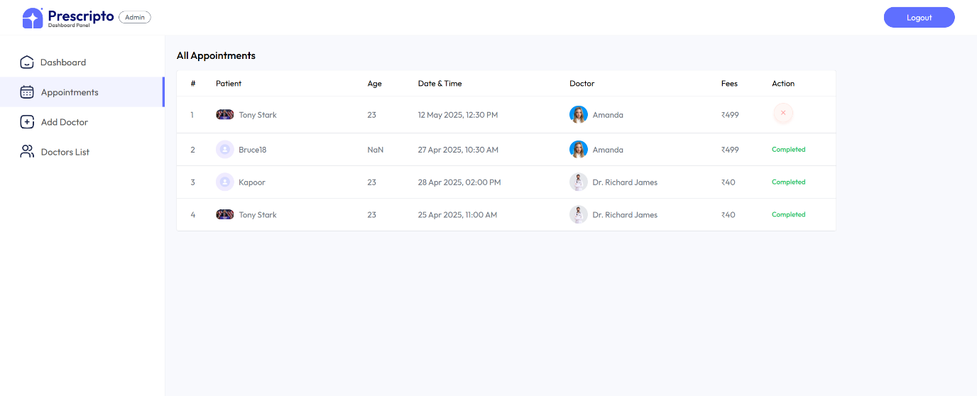

***Appointment Page (Admin)***

