# Analysis Report

This is an automatically generated LSAT weight of evidence (WoE) analysis report.

## General Information

|  |  |
| --- | --- |
| Project name | E:\LSM\Rasuwa |
| Time and date | 2023-07-09 03:53 |
| Subsampling type | 1 - No subsampling |
| Sample size [%] | 100 |
| Number of subsamples | 1 |

## Input Data

### Input feature

|  |  |
| --- | --- |
| Source | E:\LSM\Rasuwa\data\inventory\training\inventory_training.shp |
| Geometry | POINT |
| Number of Events | 544 |

### Input raster

|  |  |
| --- | --- |
| Source | E:\LSM\Rasuwa\data\params\aspect_rc.tif |
| Dimensions (cols, rows) | (2364 , 1288) |
| Minimum | 1.0 |
| Maximum | 5.0 |
| Mean | 3.12 |
| Std | 1.312 |
| Cell size [x, y] | [29.995634731696267, -29.995634731696267] |
| NoData | -9999.0 |
| Number of Unique Values | 5 |

#### Raster Attribute Table

|  |  |  |
| --- | --- | --- |
| VALUE | COUNT | DESCR |
| 1 | 49690 | 0.00 - 72.00 |
| 2 | 73413 | >72.00 - 144.00 |
| 3 | 97891 | >144.00 - 216.00 |
| 4 | 71330 | >216.00 - 288.00 |
| 5 | 72579 | >288.00 - 360.00 |

## Analysis Results

### Visualized Results

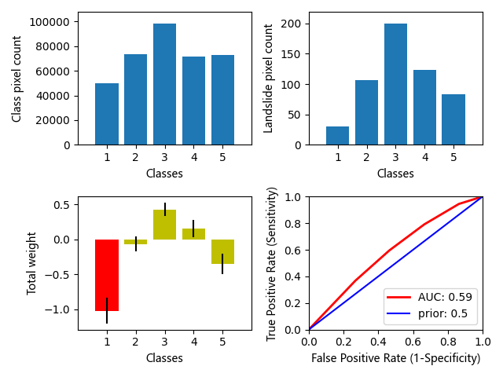

Fig. 1 Results overview: a) Class distribution; b) Landslide in class distribution; c) Weight distribution; d) Analysis ROC curve

### Raster values sorted by weight

The significance has two directions. In general weights > 1 are significantly positive and weights < -1 are significantly negative.

|  |  |  |
| --- | --- | --- |
| Raster value | Weight | STD |
| 3 | 0.427 | 0.096 |
| 4 | 0.156 | 0.124 |
| 2 | -0.069 | 0.107 |
| 5 | -0.351 | 0.147 |
| 1 | -1.024 | 0.183 |

### All Results

|  |  |  |  |  |  |  |  |  |  |  |  |  |
| --- | --- | --- | --- | --- | --- | --- | --- | --- | --- | --- | --- | --- |
| Class | Landslides | W_POS | VAR_POS | W_NEG | VAR_NEG | Variance | Contrast | Weight | Posterior | sPost | Expected | sExpec |
| 49690 | 30 | -0.8992738 | 0.03335347 | 0.08947203 | 0.0019601248 | 0.03335347 | -0.98874587 | -1.0243725 | 0.00053278677 | 0.00011303935 | 26 | 5 |
| 73413 | 106 | -0.026488408 | 0.0094476035 | 0.0065623783 | 0.0023022864 | 0.011407728 | -0.033050787 | -0.06867744 | 0.0013843195 | 0.00019948842 | 101 | 14 |
| 97891 | 199 | 0.31621376 | 0.0050353617 | -0.1464726 | 0.0029277266 | 0.009297773 | 0.46268636 | 0.4270597 | 0.0022706313 | 0.00028477 | 222 | 27 |
| 71330 | 123 | 0.15132183 | 0.008144124 | -0.040491447 | 0.0023957556 | 0.015334262 | 0.19181328 | 0.15618663 | 0.0017327743 | 0.00024115788 | 123 | 17 |
| 72579 | 83 | -0.25996217 | 0.012061987 | 0.055302992 | 0.0021868323 | 0.02164788 | -0.31526518 | -0.35089183 | 0.0010442873 | 0.00016007364 | 75 | 11 |