# Analysis Report

This is an automatically generated LSAT weight of evidence (WoE) analysis report.

## General Information

|  |  |
| --- | --- |
| Project name | E:\LSM\Rasuwa |
| Time and date | 2023-07-09 03:53 |
| Subsampling type | 1 - No subsampling |
| Sample size [%] | 100 |
| Number of subsamples | 1 |

## Input Data

### Input feature

|  |  |
| --- | --- |
| Source | E:\LSM\Rasuwa\data\inventory\training\inventory_training.shp |
| Geometry | POINT |
| Number of Events | 544 |

### Input raster

|  |  |
| --- | --- |
| Source | E:\LSM\Rasuwa\data\params\hillshade_rc.tif |
| Dimensions (cols, rows) | (2364 , 1288) |
| Minimum | 1.0 |
| Maximum | 5.0 |
| Mean | 1.316 |
| Std | 0.938 |
| Cell size [x, y] | [29.995634731696267, -29.995634731696267] |
| NoData | -9999.0 |
| Number of Unique Values | 5 |

#### Raster Attribute Table

|  |  |  |
| --- | --- | --- |
| VALUE | COUNT | DESCR |
| 1 | 2705652 | 1.00 - 51.80 |
| 2 | 26644 | >51.80 - 102.60 |
| 3 | 78787 | >102.60 - 153.40 |
| 4 | 156613 | >153.40 - 204.20 |
| 5 | 77136 | >204.20 - 255.00 |

## Analysis Results

### Visualized Results

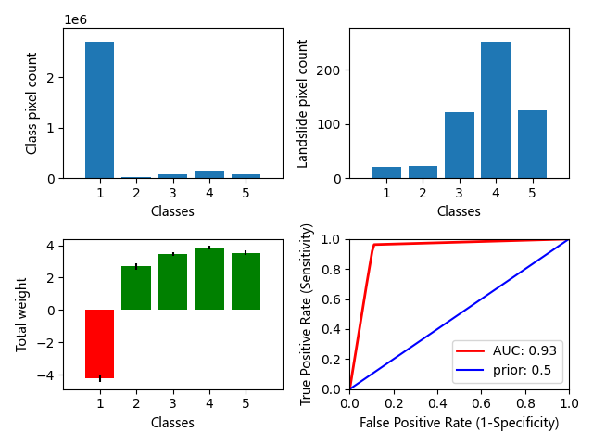

Fig. 1 Results overview: a) Class distribution; b) Landslide in class distribution; c) Weight distribution; d) Analysis ROC curve

### Raster values sorted by weight

The significance has two directions. In general weights > 1 are significantly positive and weights < -1 are significantly negative.

|  |  |  |
| --- | --- | --- |
| Raster value | Weight | STD |
| 4 | 3.864 | 0.101 |
| 5 | 3.534 | 0.133 |
| 3 | 3.471 | 0.11 |
| 2 | 2.701 | 0.213 |
| 1 | -4.253 | 0.224 |

### All Results

|  |  |  |  |  |  |  |  |  |  |  |  |  |
| --- | --- | --- | --- | --- | --- | --- | --- | --- | --- | --- | --- | --- |
| Class | Landslides | W_POS | VAR_POS | W_NEG | VAR_NEG | Variance | Contrast | Weight | Posterior | sPost | Expected | sExpec |
| 2705652 | 20 | -3.1797545 | 0.05000037 | 2.1583605 | 0.0019223386 | 0.05000037 | -5.3381147 | -4.252776 | 2.5278587e-06 | 6.2956195e-07 | 6 | 1 |
| 26644 | 23 | 1.5813979 | 0.043515824 | -0.034661014 | 0.0019308333 | 0.045438163 | 1.616059 | 2.7013977 | 0.0026409775 | 0.00062235584 | 70 | 16 |
| 78787 | 121 | 2.1581836 | 0.008277175 | -0.22698434 | 0.0023812896 | 0.012130347 | 2.3851678 | 3.4705067 | 0.0056814416 | 0.0008003277 | 447 | 63 |
| 156613 | 252 | 2.2048657 | 0.0039746496 | -0.5742645 | 0.003460554 | 0.0102091115 | 2.7791302 | 3.864469 | 0.008401648 | 0.0010103562 | 1315 | 158 |
| 77136 | 125 | 2.2119696 | 0.008012985 | -0.23711169 | 0.0024041831 | 0.017708 | 2.4490814 | 3.53442 | 0.0060541467 | 0.00084663794 | 466 | 65 |