Problem Statement: Walmart wants to analyze customer purchase behavior and determine whether female customers spend more than male customers during Black Friday, using statistical techniques like confidence intervals and CLT.

Dataset Import code
Import pandas as pd
df = pd.read_csv(‘walmart_data.csv)
df.head()

Basic Analysis
df.shape
df.info()
df.describe()
- Dataset contains —550K rows and 10+ columns
- Target variable: Purchase (amount spent)
Categorical variables: Gender, Age, City_Category, etc. No major datatype issues
Product ID e
Gender
Age 0
Occupation
City_Category 0
Stay_In_Current_City_Years 0
Marital Status
Product_Category Purchase e dtype : int64
import seaborn as sns import matplotlib. pyplot as PI t
sns . ' Purchase ' ] )
PI t. show()
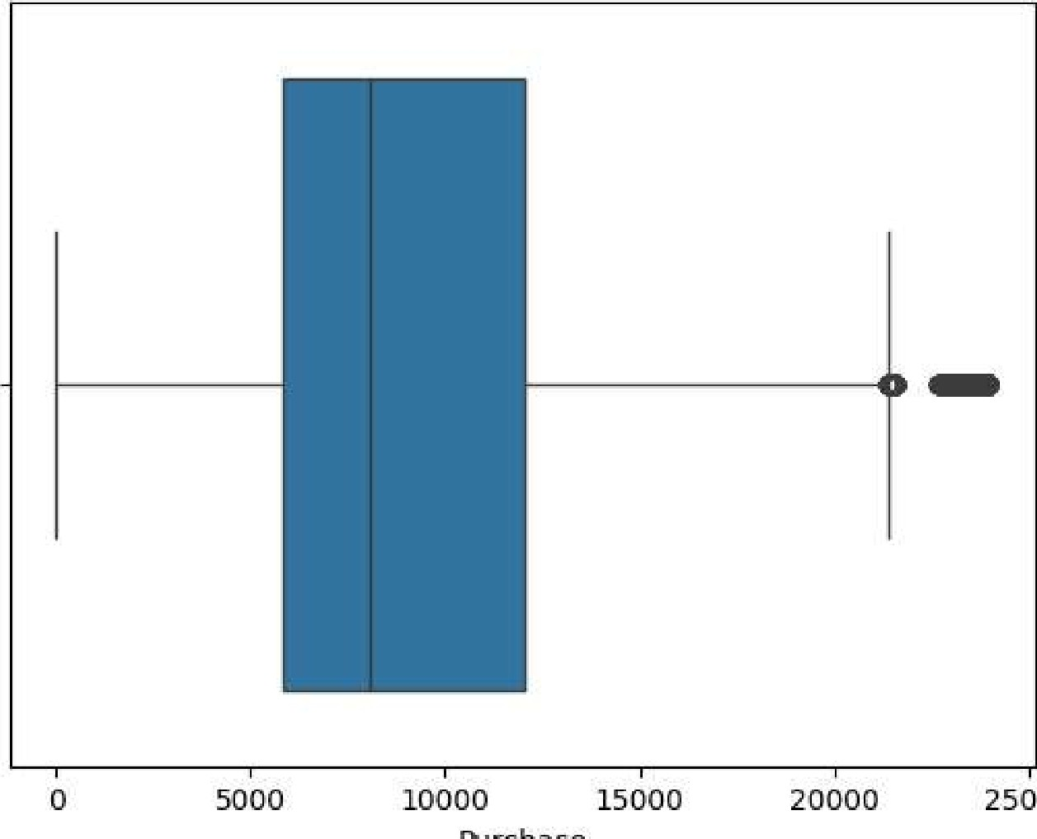
25000
Purchase
- No significant missing values
- Purchase shows right-skewed distribution (few high spenders)
- Outliers exist but are valid (real high purchases)

UNIVARIATE ANALYSIS
- Purchase Distribution
In [12] : sns.histplot(df[ Purchase' ] , kde=True)
PI t. show()

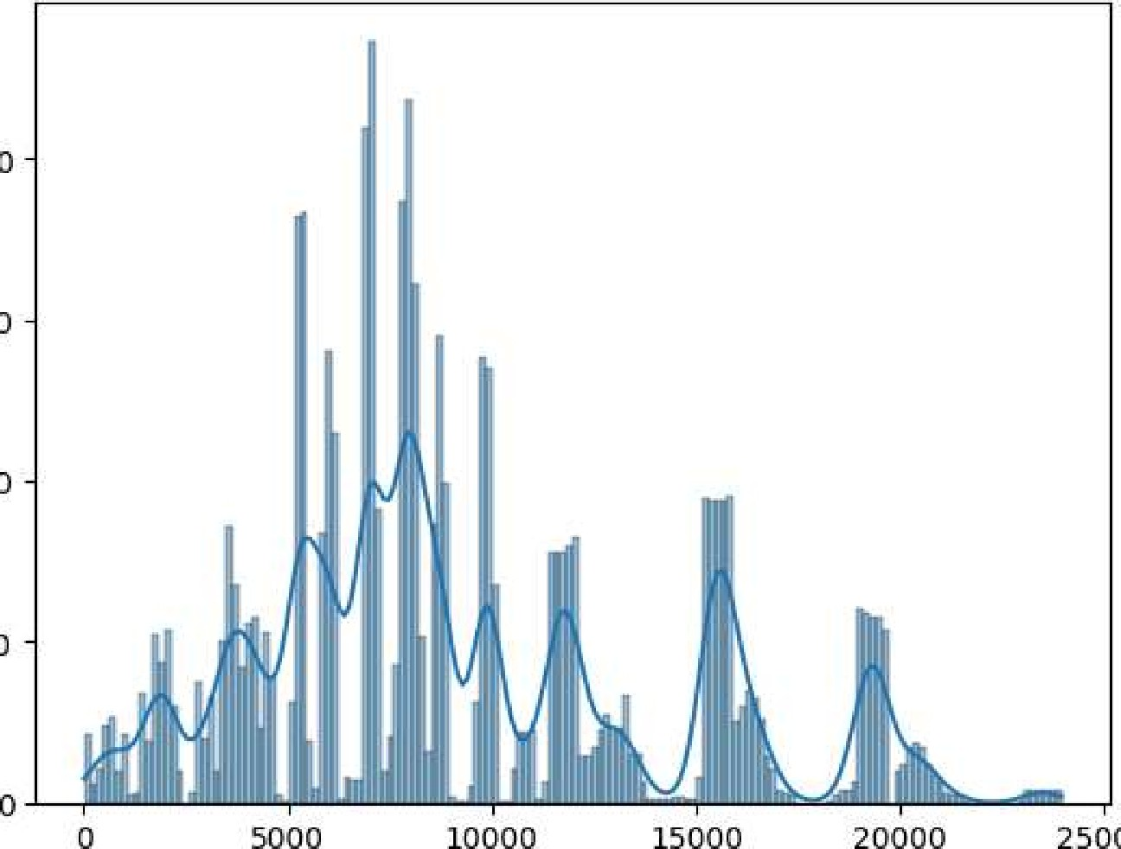
20000
25000
15000
10000
5000
Purchase
- Most purchases are in low to medium range
- Few high-value transactions

BIVARIATE ANALYSIS
In [11] : | df.groupby( 'Gender' ) [ 'Purchase' ] . mean()
Out [11] :  In [10] : | Gender  F 8734. 565765  9437. 526040  Name: Purchase, dtype: float64  PI t. show()
- Gender vs Purchase

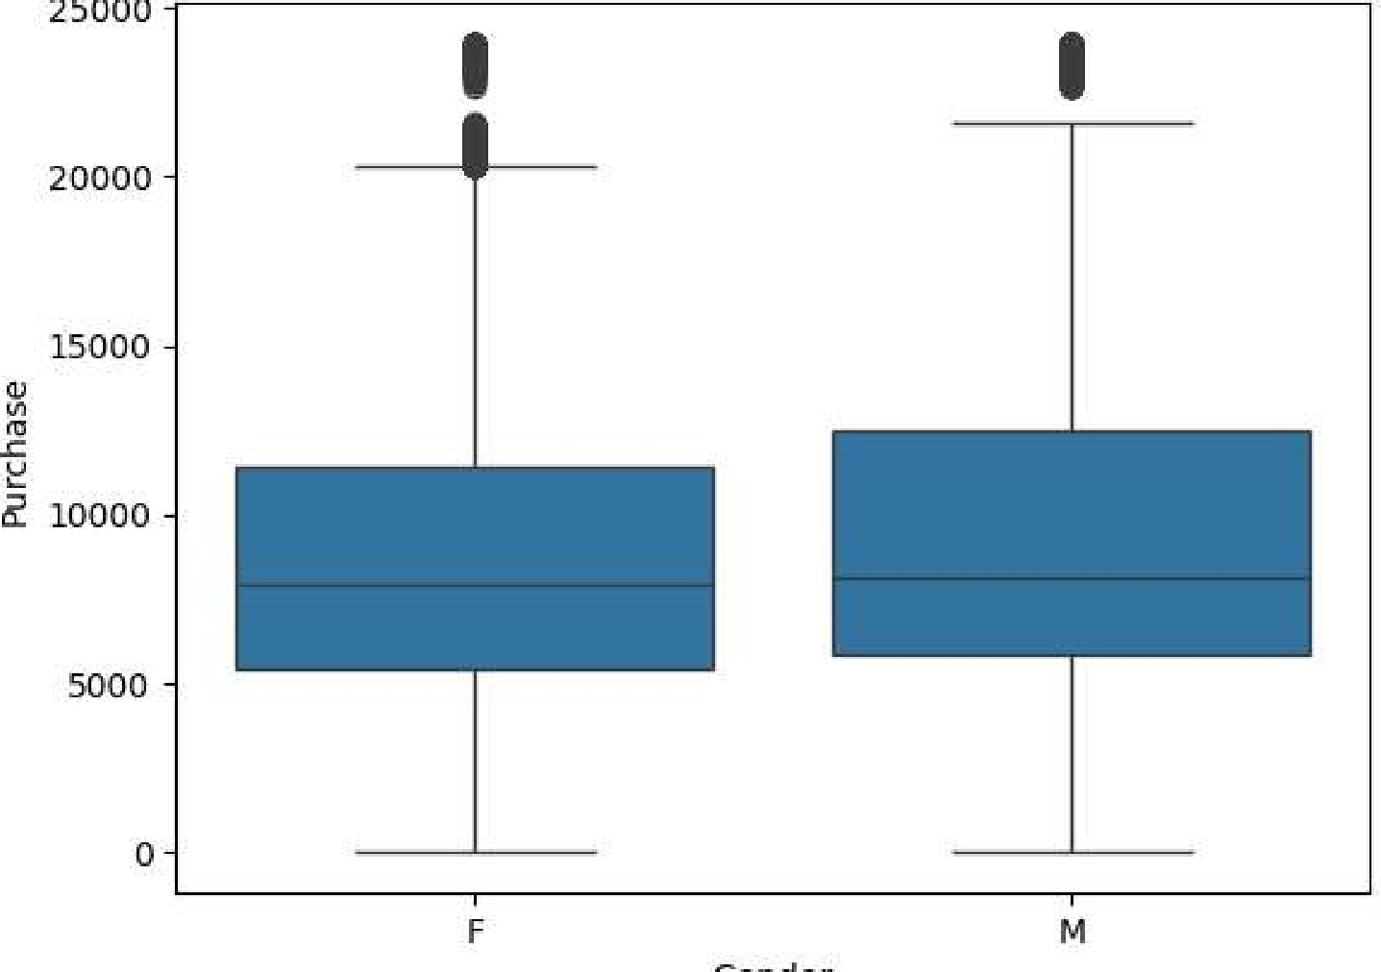
Gender
- Male customers spend slightly more on average than females
- Distribution overlap is high difference is not huge
CLT & CONFIDENCE INTERVAL
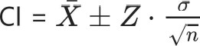

SAMPLE MEANS
In [13] : male
male. mean(), female. mean()
Out [13] : (np.f10at64(9437.526040472265), np.f10at64(8734.565765155476))

Confidence Interval (95%)
import numpy as np
def : mean = np.mean(data) std np.std(data) n = len(data) z = 1.96
lower = mean - z* (std/np.sqrt(n)) upper - mean + z* (std/np.sqrt(n))
return lower, upper
confidence_interval (male), confidence_interval (female)
Out[141 : | ((np.f10at64(9422.019181136464), np.f10at64(9453.032899808066)),  (np.f10at64(8709.21117458943), np.f10at64(8759.92035572152)))  - Confidence intervals of male and female spending overlap significantly  - Hence, there is no strong statistical evidence that women spend more than men  CLT EXPLANATION  - By Central Limit Theorem:  - Sample mean distribution becomes normal  - Even if original data is skewed  - Larger sample size more accurate estimate  Are women spending more than men?  - Answer:  - No, male customers have slightly higher average spending. However, the difference is small and distributions overlap.  Do conf^{i} dence intervals overlap?  - Answer:  - Yes, confidence intervals overlap no significant difference.  MARRIED VS UNMARRIED
In [16] : | df. groupby( 'Marital_Status ' ) [ ' Purchase' ] . mean()
Out [16] : | Marital Status  - 9265.907619  - 9261.174574  Name: Purchase, dtype: float64  Spending pattern slightly differs but not drastic  AGE ANALYSIS

In [18] : df.groupby( ' Age ' ) [ 'Purchase' ] . mean()
-1
Out [18] : Age
0-17 8933.464640
18-25 9169.663606
26-35 9252.690633
36-45 9331.350695
46-50 9208.625697 51-55 9534.808031
55+ 9336.280459
Name: Purchase, dtype: float64
Middle-age groups tend to spend more

FINAL INSIGHT
- Male customers spend slightly more than females
- Purchase distribution is right-skewed
- Age group 26—45 contributes highest spending
- No strong statistical difference between genders

BUSINESS RECOMMENDATIONS
- Target both genders equally (no strong difference)
- Focus marketing on high-spending age groups
- Create personalized offers instead of gender-based targeting
- Promote premium products to high spenders

