**PRODUCT REALIZATION FLOW CHART**

1. **Student Team**
   1. Priyam Seth (Roll No._B19188)
   2. Priyanshu Shubham (Roll No._B19189)
   3. Priyanshu Singh (Roll No._B19190)
   4. Ravi Kumar (Roll No._B19191)
2. **Group:** C7
3. **Name of Product:** Hacksaw Blades  
   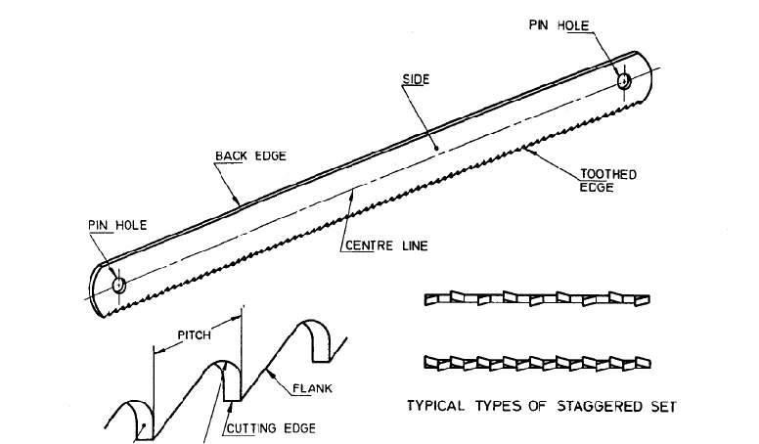  
   *Figure 1: Hacksaw Blade (Source:* *https://www.researchgate.net/figure/Hacksaw-Blade-11-Dimensions-of-specimen-Well-prepared-Mild-Steel-flat-of-Dimensions_fig1_286912451/download)*
4. **Material Selection:** High Speed Steel for harder materials and High Carbon Steel for general cutting purposes.

They are ceramics due to which High Speed Steel are very hard and wear resistance which helps in smooth cutting for almost any material. However, they are very expensive, so High Carbon Steel are used for all light duty work as they are less expensive and can cut all relatively soft materials.

1. **Application/use of product:** 
   1. .
2. **Product Realization Technology Flow Chart:**

**s**

1. **Industries Manufacturing the Product(1 or 2):**
   1. T
2. **Summary (50-80 words):** Heating is required to take the billet beyond the hot working temperature. Forging is a metal forming process in which shape of the work piece is changed by applying force to induce stress beyond yield stress. Electroplating is required to provide corrosion resistance.