**PRODUCT REALIZATION FLOW CHART**

1. **Student Team**
   1. Student name_1 (Roll No._1)
   2. Student name_2 (Roll No._2)
   3. Student name_3 (Roll No._3)
   4. Student name_4 (Roll No._4)
   5. Student name_5 (Roll No._5)
2. **Group: X1**
3. **Name of Product:** Spanner

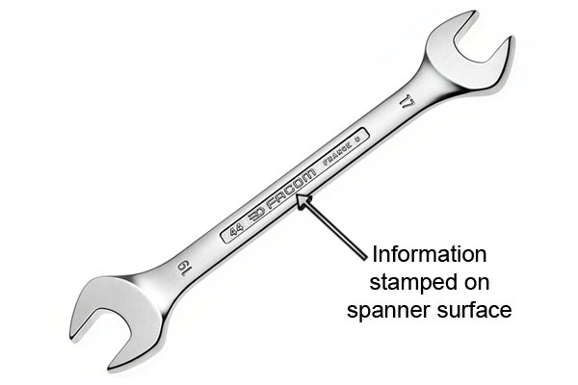

Figure : A spanner (Source: https://www.wonkeedonkeetools.co.uk/media/wysiwyg/29SP-Spanners-Rebecca/SP2908/29SP-8-4_TBI_stamped_info_.jpg)

1. **Material Selection:** Chrome Vanadium Steel (Alloy Steel)

Chromium increases hardness and provides wear resistance whereas Vanadium provides structural strength, ductility and toughness.

1. **Application/use of product:** 
   1. Tightening/loosening fasteners like nuts/bolts etc.
2. **Product Realization Technology Flow Chart:**

Billet of alloy steel

Heating billet beyond 1000 °C

Drop forging

Finishing the trim lines

Preparation of surface

Electroplating

Spanner

1. **Industries Manufacturing the Product (1 or 2):**
   1. TATA Agrico
2. **Summary (50-80 words):** Heating is required to take the billet beyond the hot working temperature. Forging is a metal forming process in which shape of the work piece is changed by applying force to induce stress beyond yield stress. Electroplating is required to provide corrosion resistance.

**x-x-x-x**