Experiment 1

Step1: Creating database
create database 2CSE7_1026;
show databases;
use 2CSE7_1026;
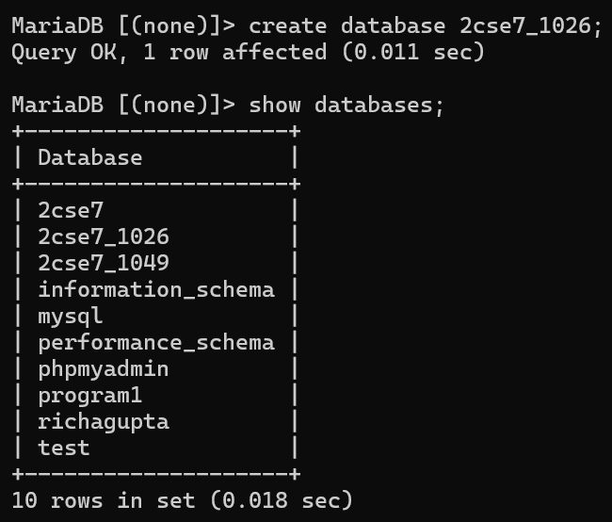

Step2: Creating DEPARTMENT TABLE AND INSERTING VALUES
create table DEPARTMENT(DEPTNO INT(2) primary key,DNAME VARCHAR(15) not null);
desc DEPARTMENT;
insert into DEPARTMENT values(10,"RESEARCH"), (20,"ACCOUNTING"), (30,"SALES"), (40,"OPERATIONS");
select *from DEPARTMENT;
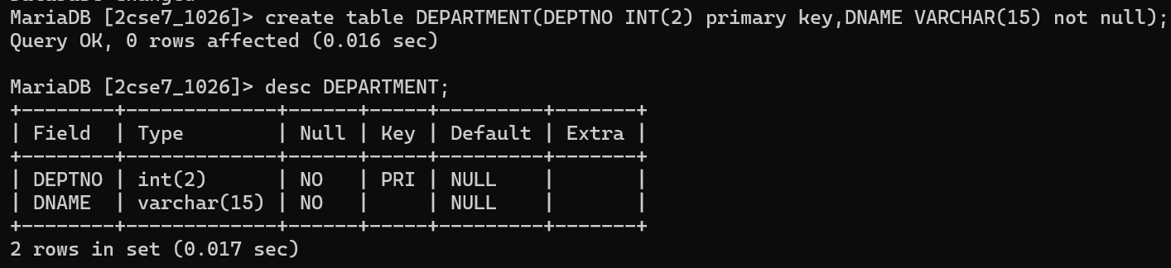
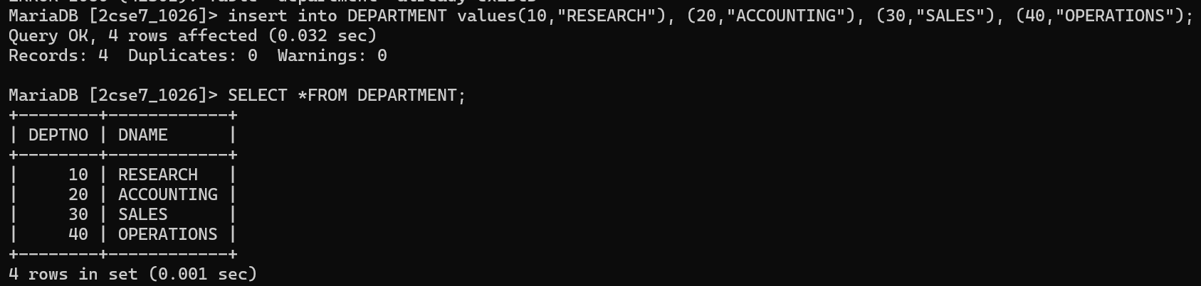

Step3: Creating table EMPLOYEE and inserting values
- create table EMPLOYEE(EMPNO int(4) primary key,ENAME varchar(20) not null,JOB varchar(20),MGR int(4),HIREDATE date,SAL int(10),COMM int(7),DEPTNO int(2),constraint fk_deptno foreign key(DEPTNO) references DEPARTMENT(DEPTNO));
- desc EMPLOYEE;
- insert into EMPLOYEE VALUES(7369,"SMITH","CLERK",7902,'1980-12-17',800,NULL,20),(7499,"ALLEN","SALESMAN",7698,'1981-02-20',1600,300,30),(7521,"WARD","SALESMAN",7698,'1981-02-22',1250,300,30),(7566,"JONES","MANAGER",7839,'1981-04-02',2975,NULL,20),(7654,"MARTIN","SALESMAN",7698,'1981-09-28',1250,1400,30),(7698,"BLAKE","MANAGER",7839,'1981-05-01',2850,NULL,30),(7782,"CLARK","MANAGER",7839,'1981-06-09',2450,NULL,20),(7788,"SCOTT","ANALYST",7566,'1982-12-09',3000,NULL,40),(7839,"KING","PRESIDENT",NULL,'1981-11-17',5000,NULL,20),(7844,"TURNER","SALESMAN",7698,'1981-09-08',1500,0,30),(7876,"ADAMS","CLERK",7788,'1983-01-12',1100,NULL,20),(7900,"JAMES","CLERK",7698,'1981-12-03',950,NULL,30),(7902,"FORD","ANALYST",7566,'1981-12-03',3000,NULL,20)(7934,"MILLER","CLERK",7782,'1982-01-23',1300,NULL,10);
- select *from EMPLOYEE;

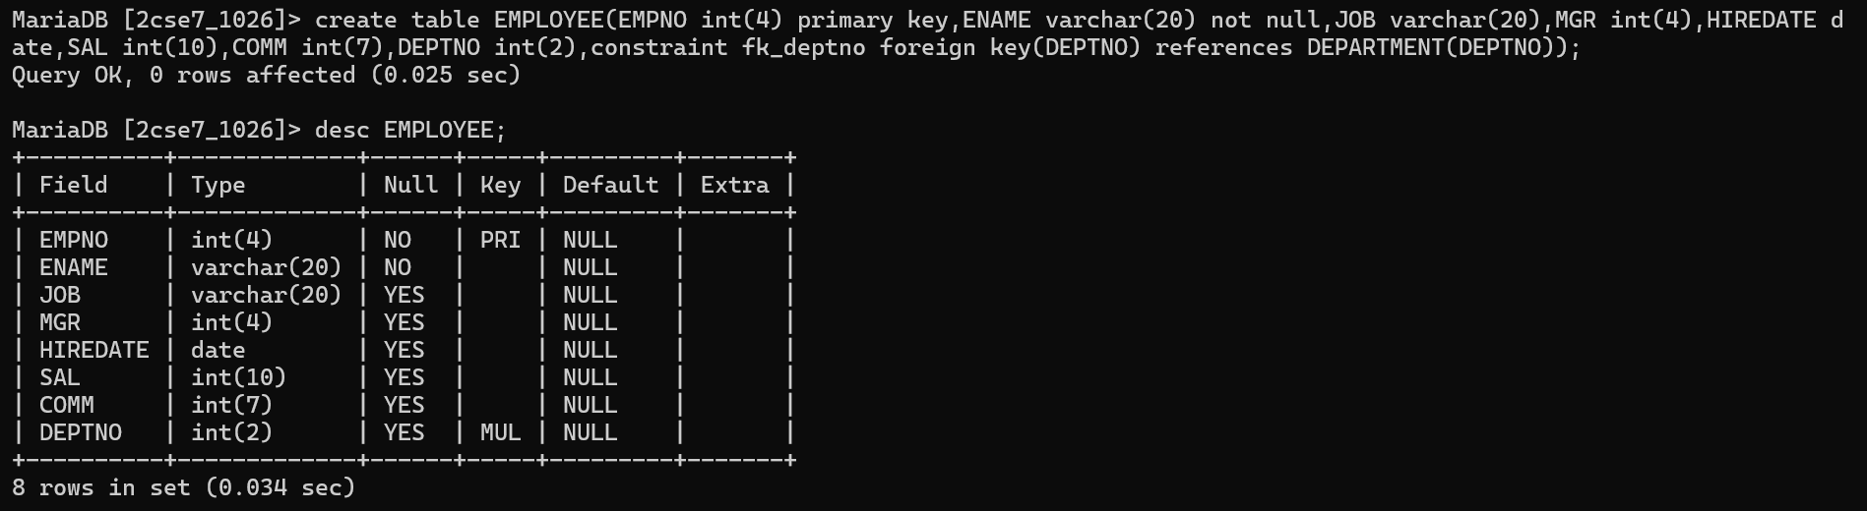
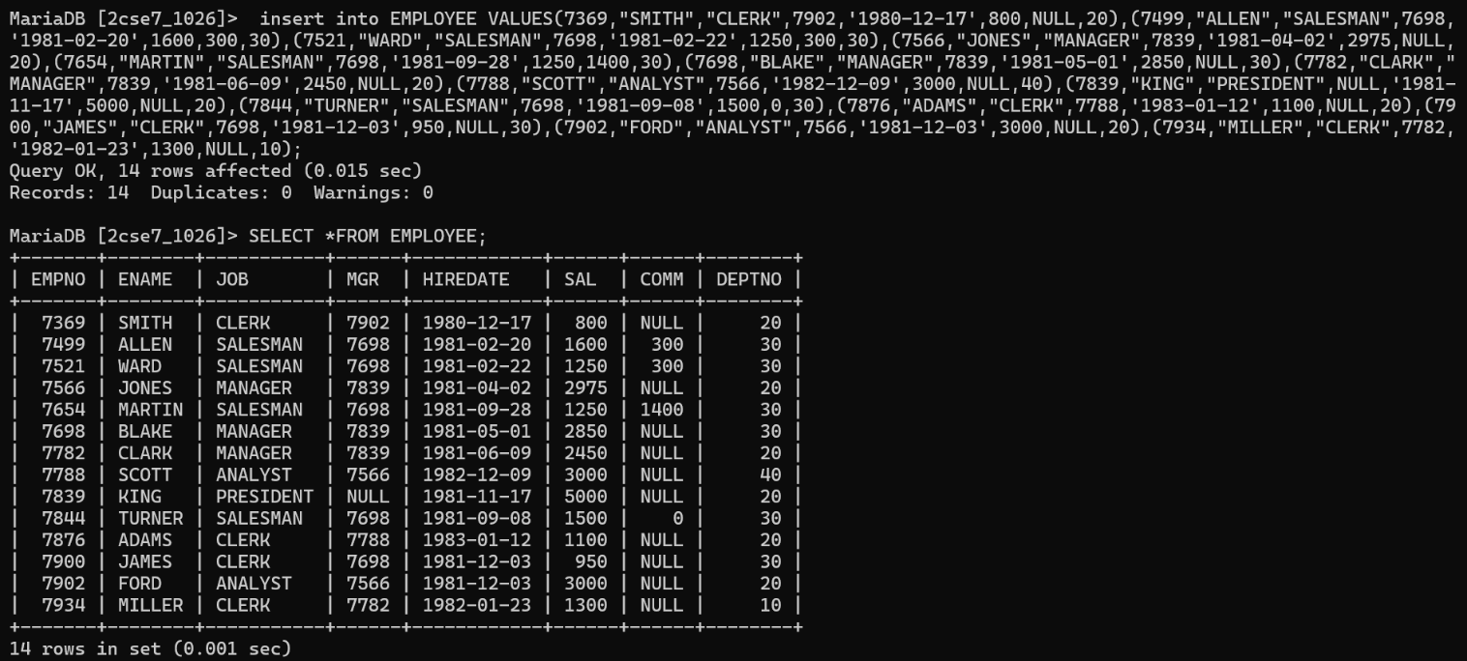

Experiment questions:
- Create Employee_master table with data using Employee table.
create table EMPLOYEE_MASTER as select *from EMPLOYEE;
show tables;
select *from EMPLOYEE_MASTER;

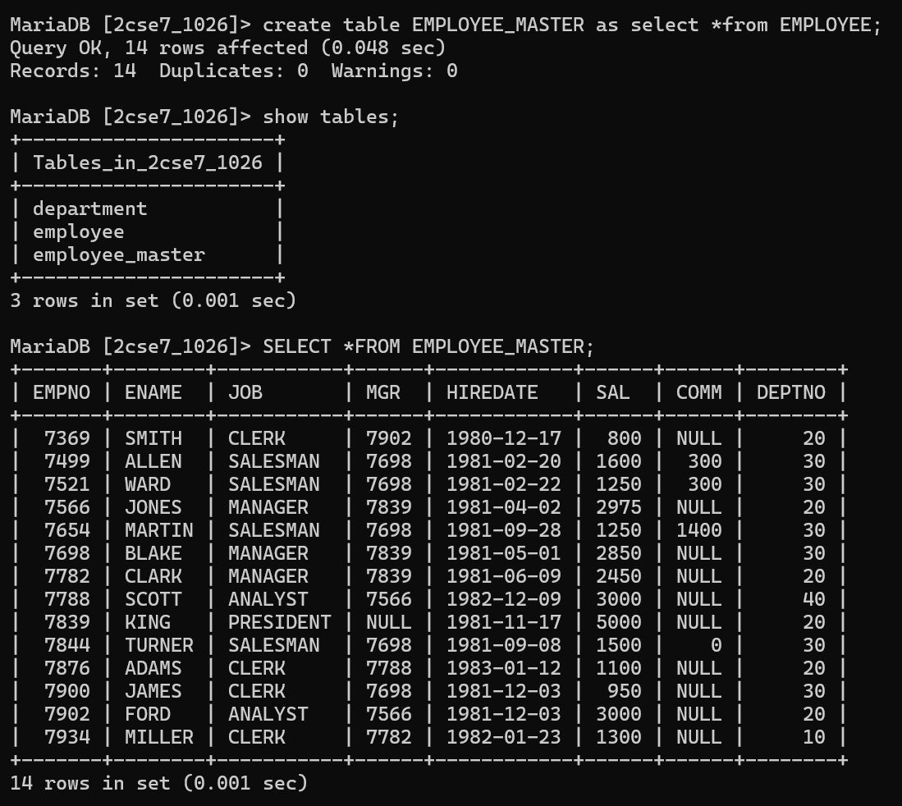

- Delete all record into Employee_master whose DeptNo is 10
delete from EMPLOYEE_MASTER where DEPTNO=10;
select *from EMPLOYEE_MASTER;
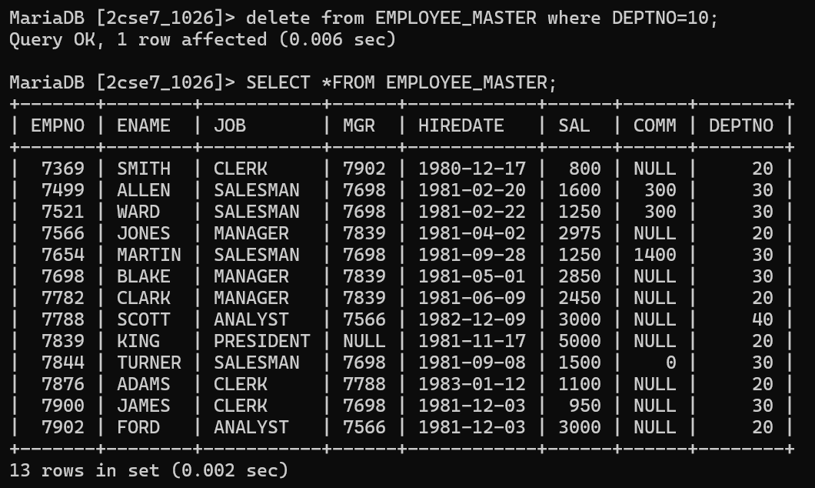

- Update 10% in his salary of DEPTNO 20 into Employee_Master.
update EMPLOYEE_MASTER set SAL=SAL*1.10 where DEPTNO=20;
select *from EMPLOYEE_MASTER;
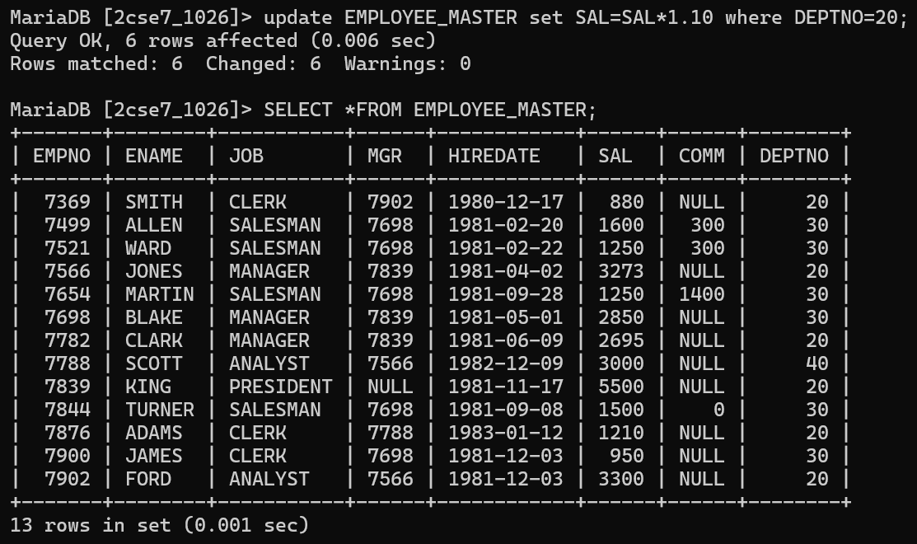

- Alter SAL with size 10,2 in Employee_Master.
alter table EMPLOYEE_MASTER modify SAL DECIMAL(10,2);
select *from EMPLOYEE_MASTER;
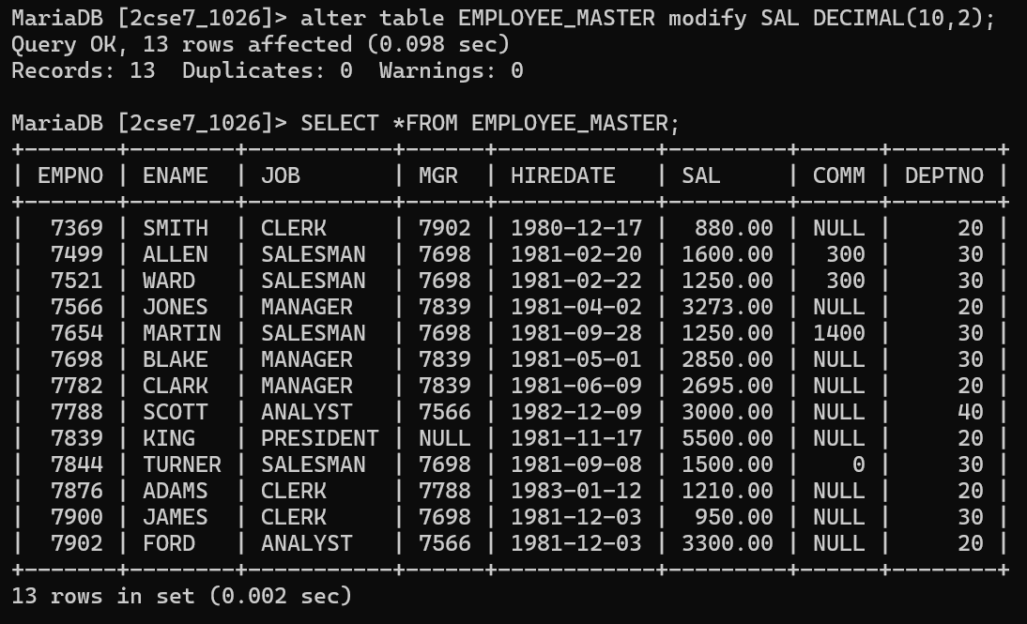

- Drop Employee_master Table.
drop table EMPLOYEE_MASTER;
show tables;

